Taiwan Business Indicators in March 2015

Press Release

National Development Council (NDC)

April 27, 2015

In March 2015, the Taiwan Business Indicators showed that the domestic economy was still on a moderate growth path, but risks increasing. Among the indicators compiled by the National Development Council (NDC), the trend-adjusted leading index decreased by 0.47%, the trend-adjusted coincident index decreased by 0.32% from the previous month, and the overall monitoring indicator flashed the " yellow-blue " signal.

1. The Monitoring Indicators: Total scores in March 2015 decreased by three points to 21, flashing the “yellow-blue” signal for the first month. Among the nine components, the nonagricultural employment gained one point to change its individual light from “yellow-blue” to “green”, while the TAIEX average closing price changed its individual light from “ yellow-red” to “green”, the customs-cleared exports changed its individual light from “yellow-blue” to “blue”, each lost one point, and the imports of machineries and electrical equipments lost two points to change its individual light form “yellow-red” to “yellow-blue”. The light signal for the rest of five components remained unchanged.
2. Leading Indicators: With revised data, the trend-adjusted leading index stood at 98.62, down by 0.47% from February 2015. Among the seven indicators making up the trend-adjusted index, SEMI book-to-bill ratio, and TAIEX average closing price had positive cyclical movements from the previous month, while the index of export orders, building permits, net accession rate of employees on payrolls of industry and services, the TIER manufacturing sector composite indicator , and real monetary aggregates M1B had negative cyclical movements.
3. Coincident Indicators: With revised data, the trend-adjusted coincident index stood at 100.08, down by 0.32% from February 2015. Among the seven indicators making up the trend-adjusted index, nonagricultural employment and electric power consumption had positive cyclical movements from the previous month, while real machineries electrical equipments imports, real customs-cleared exports, sales of trade and food services, the index of producer’s shipment for manufacturing, and the industrial production index had negative cyclical movements.
4. Lagging Indicators: With revised data, the trend-adjusted lagging index stood at 101.81, up by 0.66% from February 2015. Among the six indicators making up the trend-adjusted index, the manufacturing unit output labor cost index, the inventories to sales ratio for manufacturing, the unemployment rate (inverted), regular employees on payrolls in industry and services, and loans and investments of monetary financial institutions had positive cyclical movements from the previous month, while the interbank overnight call-loan rate had negative cyclical movement.

**T~~ The next release is scheduled for May 27 2015 ~~T**

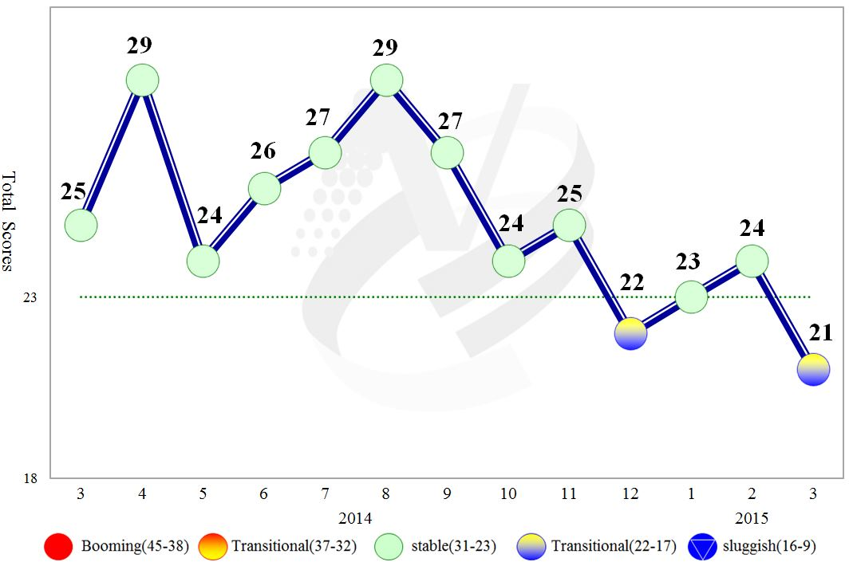

**Figure 1 Total Scores in the Past Year**

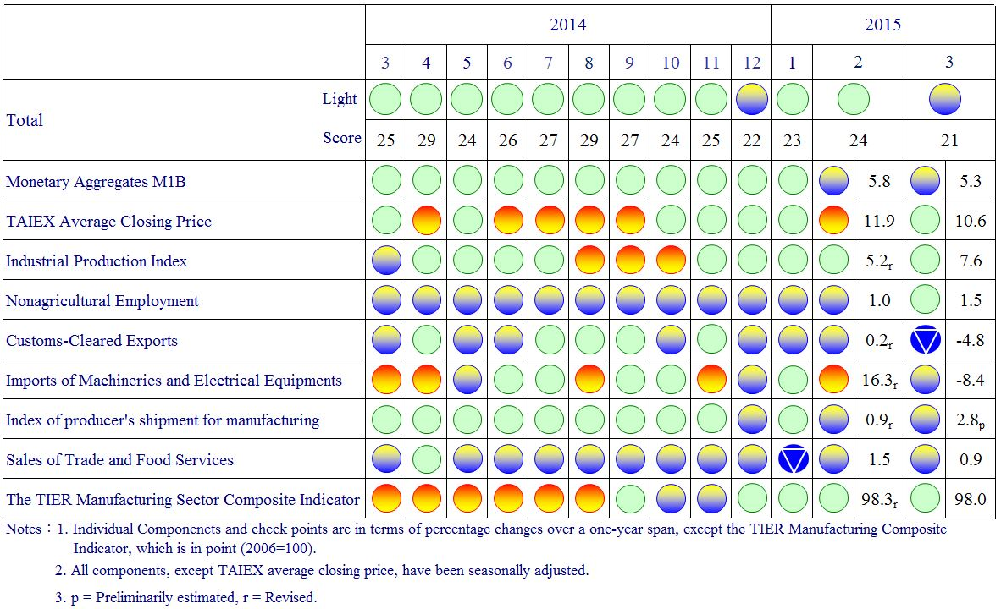

**Figure 2 Monitoring Indicators**

**Table 1 Leading Indicators**

Index

|  |  |  |  |  |  |  |  |
| --- | --- | --- | --- | --- | --- | --- | --- |
|  | 2014 | | | | 2015 | | |
| Sep | Oct | Nov | Dec | Jan | Feb | Mar |
| **Trend adjusted index** | 100.26 | 100.12 | 99.97 | 99.77 | 99.48 | 99.08 | 98.62 |
| Change from preceding month (%) | -0.12 | -0.14 | -0.15 | -0.20 | -0.29 | -0.40 | -0.47 |
| **Components1** |  |  |  |  |  |  |  |
| Index of export orders | 101.00 | 101.31 | 101.39 | 101.20 | 100.74 | 100.11 | 99.40 |
| Real monetary aggregates M1B | 100.03 | 100.07 | 100.13 | 100.17 | 100.20 | 100.21 | 100.21 |
| TAIEX average closing price | 100.18 | 100.11 | 100.08 | 100.07 | 100.09 | 100.13 | 100.17 |
| Net accession rate of employees on payrolls of industry and services 2 | 100.04 | 100.02 | 100.00 | 99.99 | 99.97 | 99.94 | 99.88 |
| Building permits 3 | 99.73 | 99.58 | 99.45 | 99.30 | 99.13 | 98.92 | 98.68 |
| SEMI Book-to-Bill Ratio | 99.71 | 99.64 | 99.65 | 99.73 | 99.86 | 100.03 | 100.22 |
| The TIER manufacturing sector composite indicator | 100.13 | 99.84 | 99.63 | 99.53 | 99.49 | 99.48 | 99.47 |

Note：1.All components are passed through seasonal adjustment, trend-removal, smoothing and normalization.

2. Net accession rate is equal to accession rate minus separation rate.

3. Including only housing, mercantile, business and service, industry warehousing.

2004.3(P) 2005.2(T) 2008.3(P) 2009.2(T) 2011.2(P) 2012.1(T)

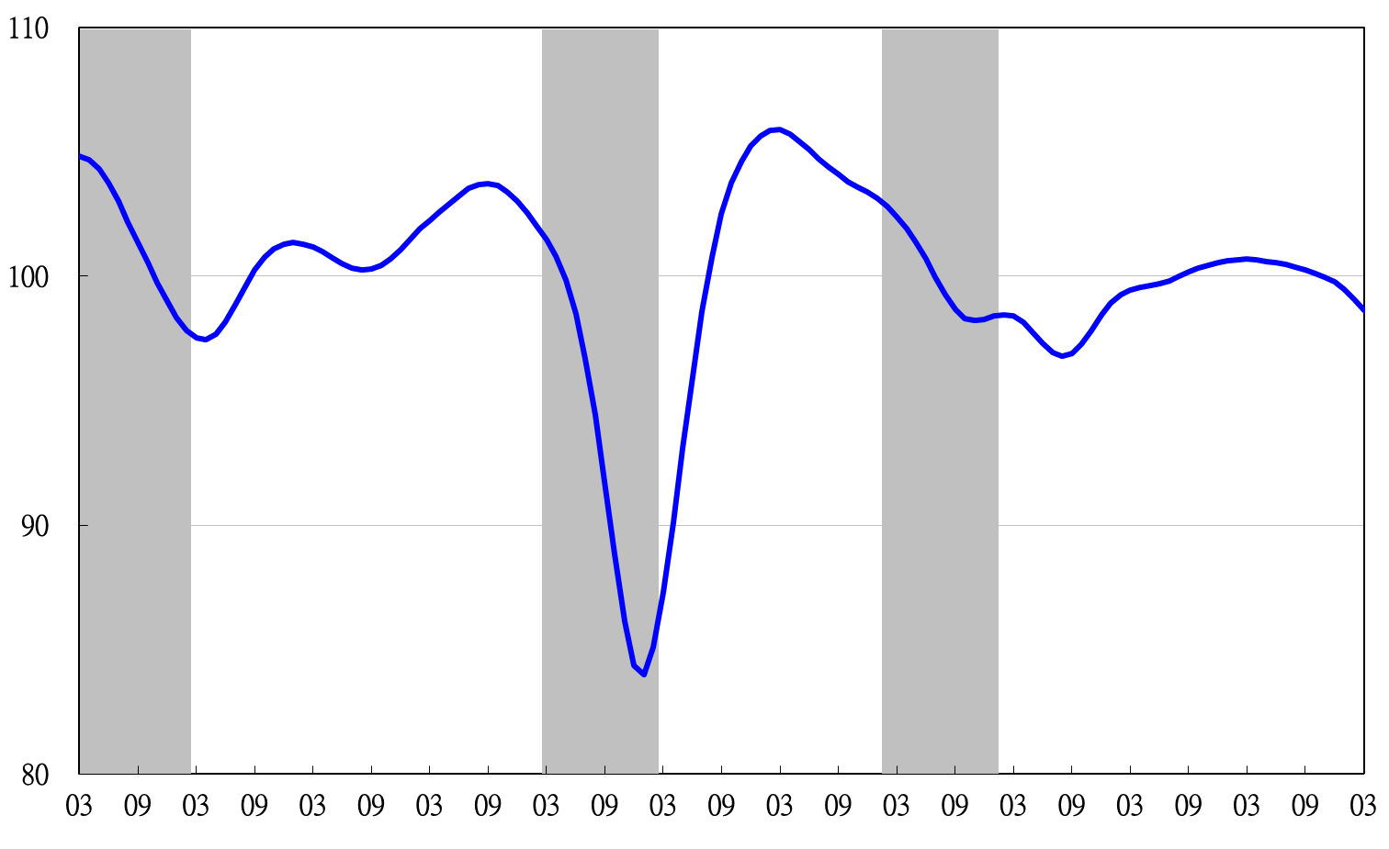

Note: Shaded areas represent recessions.

2004 2005 2006 2007 2008 2009 2010 2011 2012 2013 2014 2015

**Figure 3 Trend-adjusted Leading Index**

**Table 2 Coincident Indicators**

Index

|  |  |  |  |  |  |  |  |  |
| --- | --- | --- | --- | --- | --- | --- | --- | --- |
|  | 2014 | | | | 2015 | | | |
| Sep | Oct | Nov | Dec | | Jan | Feb | Mar |
| **Trend adjusted index** | 101.33 | 101.34 | 101.26 | 101.03 | | 100.72 | 100.41 | 100.08 |
| Change from preceding month (%) | 0.10 | 0.02 | -0.09 | -0.22 | | -0.30 | -0.32 | -0.32 |
| **Components** |  |  |  |  | |  |  |  |
| Industrial production index | 100.55 | 100.61 | 100.62 | 100.59 | | 100.52 | 100.46 | 100.40 |
| Electric power consumption | 100.33 | 100.27 | 100.12 | 99.92 | | 99.76 | 99.69 | 99.70 |
| Index of producer’s shipment for manufacturing | 100.40 | 100.39 | 100.37 | 100.33 | | 100.29 | 100.23 | 100.16 |
| Sales of trade and food services | 100.16 | 100.13 | 100.08 | 99.99 | | 99.85 | 99.68 | 99.50 |
| Nonagricultural employment | 99.60 | 99.65 | 99.72 | 99.81 | | 99.94 | 100.10 | 100.28 |
| Real customs-cleared exports | 100.36 | 100.32 | 100.24 | 100.12 | | 99.96 | 99.74 | 99.48 |
| Real machineries and electrical equipments imports | 100.52 | 100.59 | 100.62 | 100.53 | | 100.32 | 100.06 | 99.73 |

2004.3(P) 2005.2(T) 2008.3(P) 2009.2(T) 2011.2(P) 2012.1(T)

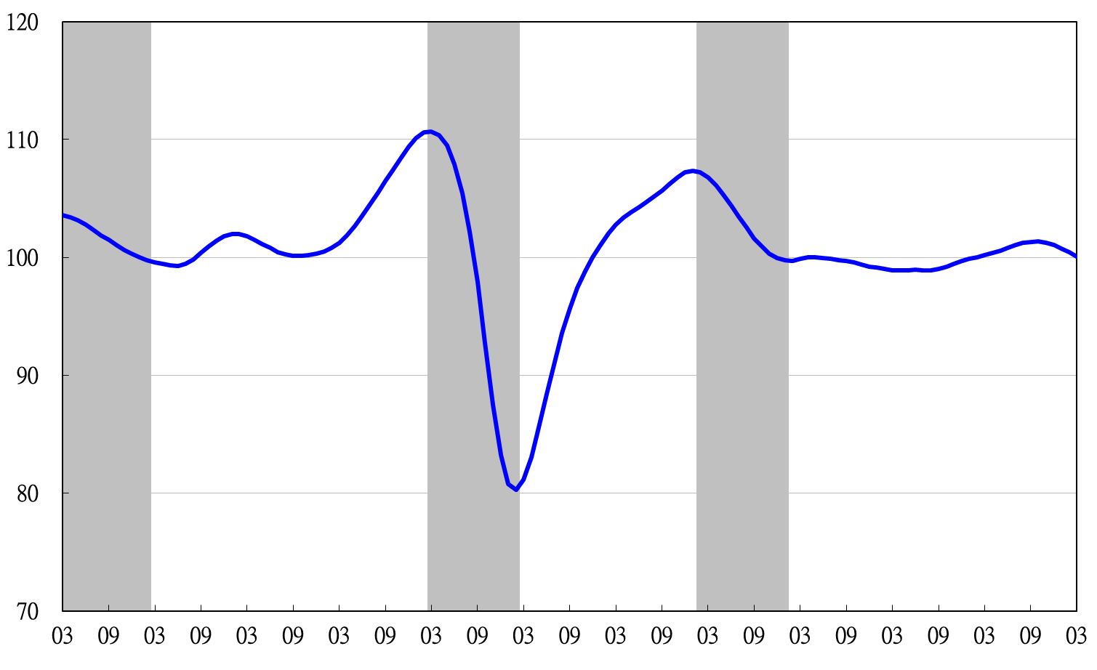

2004 2005 2006 2007 2008 2009 2010 2011 2012 2013 2014 2015

**Figure 4 Trend-adjusted Coincident Index**

**Table 3 Lagging Indicators**

Index

|  |  |  |  |  |  |  |  |  |
| --- | --- | --- | --- | --- | --- | --- | --- | --- |
|  | 2014 | | | | 2015 | | | |
| Aug | Sep | Oct | Nov | | Dec | Jan | Feb |
| **Trend adjusted index** | 98.60 | 98.79 | 99.15 | 99.66 | | 100.38 | 101.15 | 101.81 |
| Change from preceding month (%) | 0.01 | 0.19 | 0.36 | 0.52 | | 0.72 | 0.77 | 0.66 |
| **Components** |  |  |  |  | |  |  |  |
| Unemployment rate | 99.89 | 99.94 | 99.99 | 100.05 | | 100.12 | 100.18 | 100.23 |
| Regular employees on payrolls  in industry & services | 99.91 | 99.94 | 99.97 | 99.99 | | 100.00 | 100.02 | 100.03 |
| The manufacturing unit output labor cost index | 99.15 | 99.08 | 99.20 | 99.51 | | 100.08 | 100.73 | 101.28 |
| Interbank overnight call-loan rate | 99.97 | 99.97 | 99.96 | 99.96 | | 99.96 | 99.953 | 99.950 |
| Loans and investments of monetary financial institutions | 99.93 | 99.89 | 99.85 | 99.82 | | 99.81 | 99.81 | 99.82 |
| Inventories to sales ratio for manufacturing | 99.52 | 99.77 | 100.04 | 100.28 | | 100.48 | 100.65 | 100.81 |

2004.3(P) 2005.2(T) 2008.3(P) 2009.2(T) 2011.2(P) 2012.1(T)

2004 2005 2006 2007 2008 2009 2010 2011 2012 2013 2014 2015

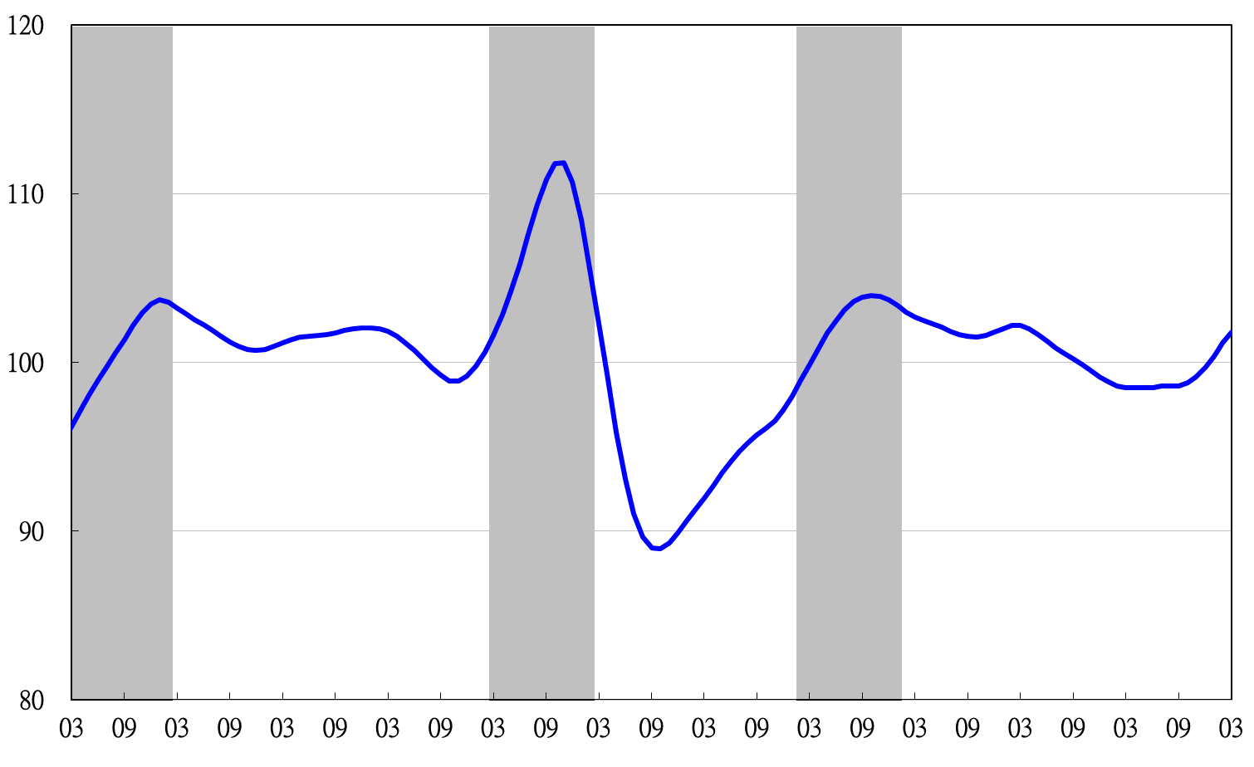

**Figure 5 Trend-adjusted Lagging Index**

2003 2004 2005 2006 2007 2008 2009 2010 2011 2012 2013 2014