Taiwan Business Indicators in October 2014

Press Release

National Development Council (NDC)

November 27, 2014

In October 2014, the Taiwan Business Indicators showed that the domestic economy continued its steady growth. Among the indicators compiled by the National Development Council (NDC), the trend-adjusted leading index decreased by 0.18%, the trend-adjusted coincident index increased by 0.15% from the previous month, and the overall monitoring indicator flashed the "green" signal for the ninth consecutive month.

1. The Monitoring Indicators: The total score in October 2014 decreased by three points to 24, flashing the “green” signal for the ninth month. Among the nine components, the TAIEX average closing price lost one point to change its individual light signal from “yellow-red” to “green”, while the customs-cleared exports and the TIER manufacturing sector composite indicator each lost one point to change its individual light signal form “green” to “yellow-blue”. The light signal for the rest of six components remained unchanged.
2. Leading Indicators: With revised data, the trend-adjusted leading index stood at 99.68, down by 0.18% from September 2014. Among the seven indicators making up the trend-adjusted index, the index of export orders had positive cyclical movement from the previous month, while the TIER manufacturing sector composite indicator, SEMI book-to-bill ratio, building permits, TAIEX average closing price, net accession rate of employees on payrolls of industry and services, and real monetary aggregates M1B had negative cyclical movements.
3. Coincident Indicators: With revised data, the trend-adjusted coincident index stood at 101.66, up by 0.15% from September 2014. Among the seven indicators making up the trend-adjusted index, the industrial production index, electric power consumption, the index of producer’s shipment for manufacturing, and nonagricultural employment had positive cyclical movements from the previous month, while sales of trade and food services, real machineries electrical equipments imports, and real customs-cleared exports had negative cyclical movements.
4. Lagging Indicators: With revised data, the trend-adjusted lagging index stood at 98.31, down by 0.27% from September 2014. Among the six indicators making up the trend-adjusted index, the inventories to sales ratio for manufacturing, the unemployment rate (inverted), and regular employees on payrolls in industry and services had positive cyclical movements from the previous month, while the manufacturing unit output labor cost index, loans and investments of monetary financial institutions, and the interbank overnight call-loan rate had negative cyclical movements.

**T~~ The next release is scheduled for December 26 2014 ~~T**

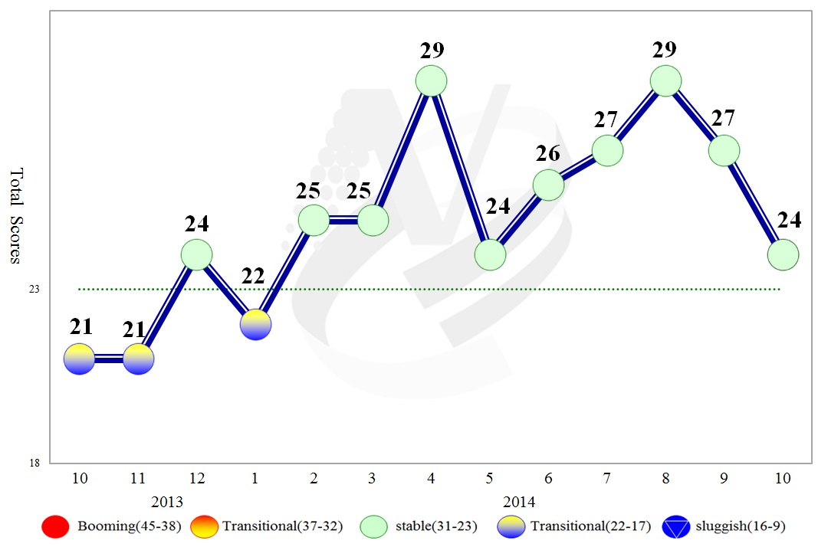

**Figure 1 Total Scores in the Past Year**

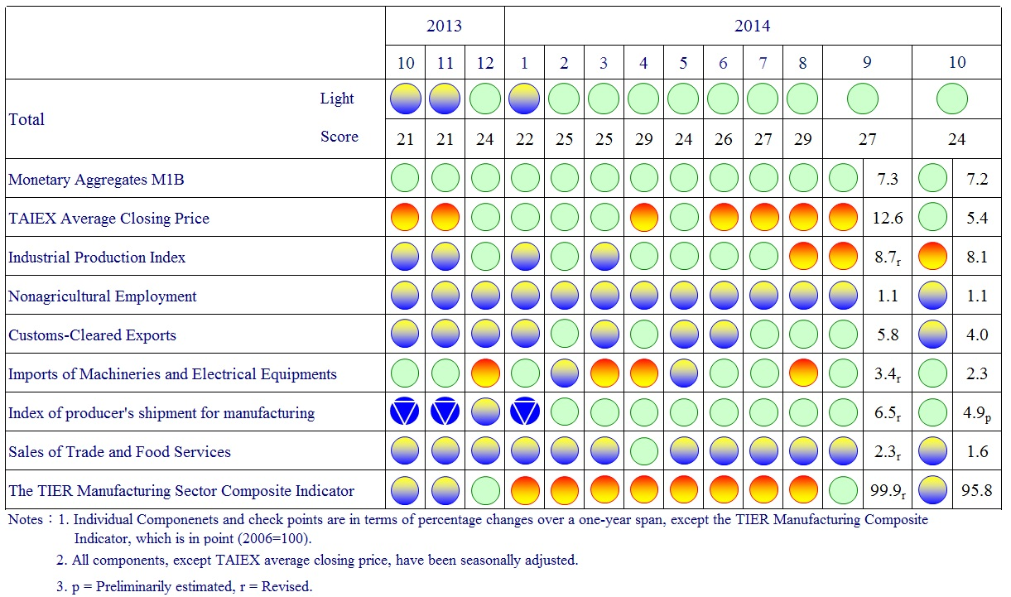

**Figure 2 Monitoring Indicators**

**Table 1 Leading Indicators**

Index

|  |  |  |  |  |  |  |  |
| --- | --- | --- | --- | --- | --- | --- | --- |
|  | 2014 | | | | | | |
| Apr | May | Jun | Jul | Aug | Sep | Oct |
| **Trend adjusted index** | 100.52 | 100.41 | 100.31 | 100.18 | 100.03 | 99.87 | 99.68 |
| Change from preceding month (%) | -0.07 | -0.11 | -0.10 | -0.12 | -0.15 | -0.17 | -0.18 |
| **Components1** |  |  |  |  |  |  |  |
| Index of export orders | 99.77 | 99.78 | 99.91 | 100.19 | 100.66 | 101.30 | 101.99 |
| Real monetary aggregates M1B | 100.10 | 100.09 | 100.09 | 100.10 | 100.09 | 100.09 | 100.09 |
| TAIEX average closing price | 100.24 | 100.30 | 100.35 | 100.35 | 100.32 | 100.25 | 100.16 |
| Net accession rate of employees on payrolls of industry and services 2 | 100.27 | 100.18 | 100.09 | 100.03 | 99.99 | 99.96 | 99.94 |
| Building permits 3 | 99.98 | 99.81 | 99.67 | 99.53 | 99.37 | 99.19 | 98.99 |
| SEMI Book-to-Bill Ratio | 100.22 | 100.19 | 100.14 | 100.01 | 99.80 | 99.53 | 99.25 |
| The TIER manufacturing sector composite indicator | 100.68 | 100.70 | 100.64 | 100.48 | 100.20 | 99.83 | 99.42 |

Note：1.All components are passed through seasonal adjustment, trend-removal, smoothing and normalization.

2. Net accession rate is equal to accession rate minus separation rate.

3. Including only housing, mercantile, business and service, industry warehousing.

2004.3(P) 2005.2(T) 2008.3(P) 2009.2(T) 2011.2(P) 2012.1(T)

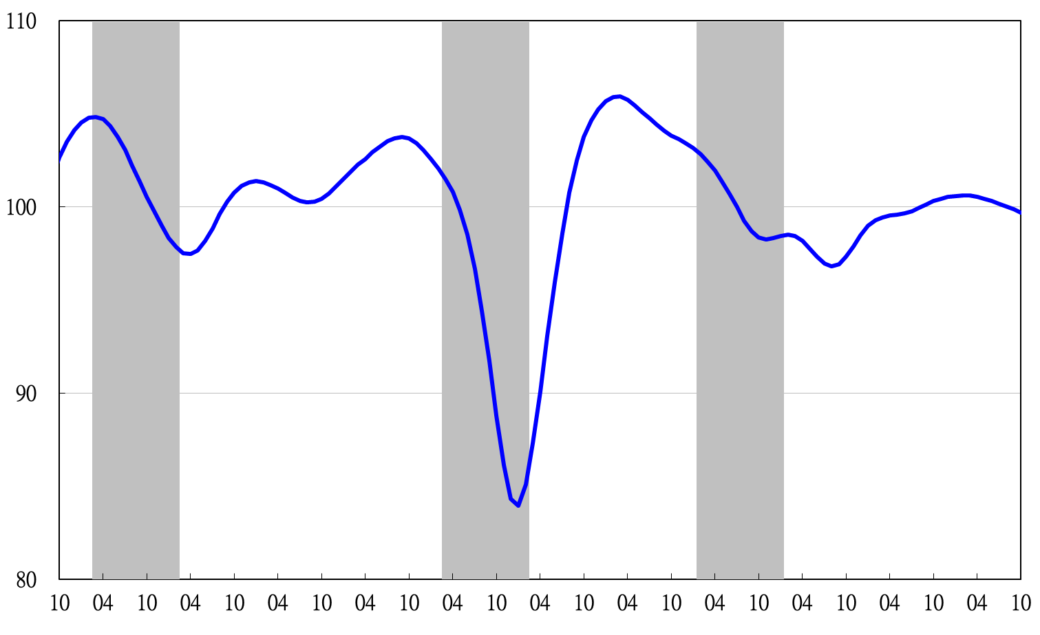

Note: Shaded areas represent recessions.

2003 2004 2005 2006 2007 2008 2009 2010 2011 2012 2013 2014

**Figure 3 Trend-adjusted Leading Index**

**Table 2 Coincident Indicators**

Index

|  |  |  |  |  |  |  |  |
| --- | --- | --- | --- | --- | --- | --- | --- |
|  | 2014 | | | | | | |
| Apr | May | Jun | Jul | Aug | Sep | Oct |
| **Trend adjusted index** | 100.36 | 100.58 | 100.83 | 101.09 | 101.32 | 101.50 | 101.66 |
| Change from preceding month (%) | 0.20 | 0.21 | 0.25 | 0.25 | 0.23 | 0.18 | 0.15 |
| **Components** |  |  |  |  |  |  |  |
| Industrial production index | 99.90 | 100.09 | 100.31 | 100.53 | 100.74 | 100.96 | 101.17 |
| Electric power consumption | 99.45 | 99.61 | 99.80 | 100.05 | 100.29 | 100.49 | 100.68 |
| Index of producer’s shipment for manufacturing | 100.17 | 100.30 | 100.42 | 100.52 | 100.60 | 100.69 | 100.78 |
| Sales of trade and food services | 100.29 | 100.28 | 100.23 | 100.14 | 100.05 | 99.96 | 99.87 |
| Nonagricultural employment | 99.70 | 99.65 | 99.61 | 99.59 | 99.59 | 99.61 | 99.63 |
| Real customs-cleared exports | 99.97 | 100.05 | 100.15 | 100.23 | 100.27 | 100.27 | 100.25 |
| Real machineries and electrical equipments imports | 100.37 | 100.32 | 100.33 | 100.34 | 100.33 | 100.29 | 100.22 |

2004.3(P) 2005.2(T) 2008.3(P) 2009.2(T) 2011.2(P) 2012.1(T)

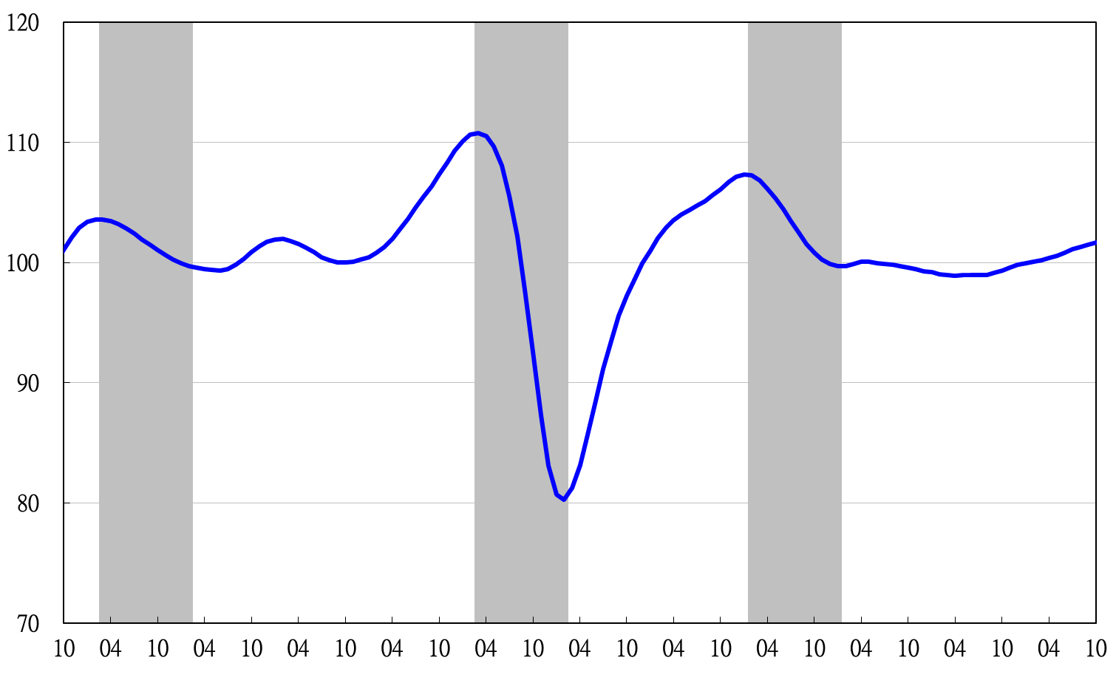

2003 2004 2005 2006 2007 2008 2009 2010 2011 2012 2013 2014

**Figure 4 Trend-adjusted Coincident Index**

**Table 3 Lagging Indicators**

Index

|  |  |  |  |  |  |  |  |
| --- | --- | --- | --- | --- | --- | --- | --- |
|  | 2014 | | | | | | |
| Apr | May | Jun | Jul | Aug | Sep | Oct |
| **Trend adjusted index** | 98.95 | 99.04 | 99.06 | 99.05 | 98.87 | 98.58 | 98.31 |
| Change from preceding month (%) | 0.08 | 0.09 | 0.02 | -0.00 | -0.18 | -0.30 | -0.27 |
| **Components** |  |  |  |  |  |  |  |
| Unemployment rate | 99.77 | 99.82 | 99.86 | 99.90 | 99.95 | 100.00 | 100.05 |
| Regular employees on payrolls  in industry & services | 99.76 | 99.78 | 99.81 | 99.84 | 99.88 | 99.93 | 99.97 |
| The manufacturing unit output labor cost index | 100.13 | 100.22 | 100.16 | 100.02 | 99.62 | 99.06 | 98.52 |
| Interbank overnight call-loan rate | 99.98 | 99.97 | 99.96 | 99.96 | 99.95 | 99.94 | 99.94 |
| Loans and investments of monetary financial institutions | 99.89 | 99.89 | 99.89 | 99.88 | 99.86 | 99.83 | 99.79 |
| Inventories to sales ratio for manufacturing | 99.26 | 99.21 | 99.22 | 99.30 | 99.44 | 99.60 | 99.77 |

2004.3(P) 2005.2(T) 2008.3(P) 2009.2(T) 2011.2(P) 2012.1(T)

2003 2004 2005 2006 2007 2008 2009 2010 2011 2012 2013 2014

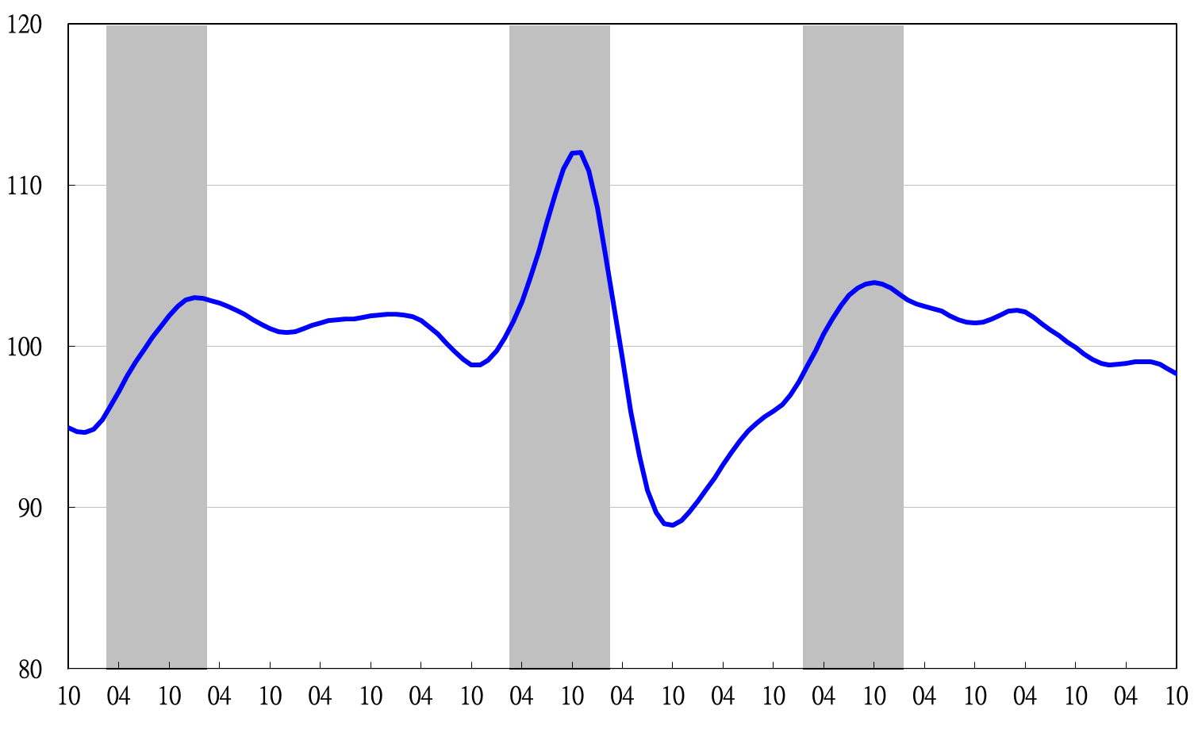

**Figure 5 Trend-adjusted Lagging Index**

2003 2004 2005 2006 2007 2008 2009 2010 2011 2012 2013 2014