Taiwan Business Indicators in February 2014

Press Release

National Development Council (NDC)

March 27, 2014

In February 2014, the Taiwan Business Indicators showed that the economy continued its recovery. Among the indicators compiled by the National Development Council (NDC), the trend-adjusted leading index increased by 0.19%, the trend-adjusted coincident index increased by 0.30% from the previous month, and the overall monitoring indicator returned to flash the "green" signal.

1. Leading Indicators: With revised data, the composite leading index stood at 104.53, up by 0.31% from January 2014. Its trend-adjusted index increased by 0.19% to 101.35. Among the seven indicators making up the trend-adjusted index, net accession rate of employees on payrolls of industry and services, the TIER manufacturing sector composite indicator, building permits, TAIEX average closing price, and real monetary aggregates M1B had positive cyclical movements from the previous month, while the index of export orders and SEMI book-to-bill ratio had negative cyclical movements.
2. Coincident Indicators: With revised data, the coincident index stood at 104.17, up by 0.43% from January 2014. Its trend-adjusted index increased by 0.30% to 101.00. Among the seven indicators making up the trend-adjusted index, the index of producer’s shipment for manufacturing, electric power consumption, the industrial production index, sales of trade and food services, real customs-cleared exports, and nonagricultural employment had positive cyclical movements from the previous month, while real machineries and electrical equipments imports had negative cyclical movements.
3. Lagging Indicators: With revised data, the lagging index stood at 100.00, down by 0.42% from January 2014. Its trend-adjusted index decreased by 0.55% to 96.96. Among the six indicators making up the trend-adjusted index, the unemployment rate(inverted) had positive cyclical movement from the previous month, while the manufacturing unit output labor cost index, the inventories to sales ratio for manufacturing, loans and investments of monetary financial institutions, regular employees on payrolls in industry and services, and the interbank overnight call-loan rate had negative cyclical movements.
4. The Monitoring Indicators: The total score in February 2014 increased by three points to 25, flashing the “green” signal. Among the nine components, the industrial production index and the customs-cleared exports changed its individual light signal from “yellow-blue” to “green”, each gained one point, the index of producer’s shipment for manufacturing gained two points to change its individual light signal from “blue” to “green”, while the imports of machineries and electrical equipments lost one point to change its individual light signal form “green” to “yellow-blue”. The light signal for the rest of five components remained unchanged.

**T~~ The next release is scheduled for April 28 2014 ~~T**

# **Table 1 Leading Indicators**

Seasonally adjusted

|  |  |  |  |  |  |  |  |  |
| --- | --- | --- | --- | --- | --- | --- | --- | --- |
|  | 2013 | | | | | 2014 | | |
| Aug | Sep | Oct | Nov | Dec | | Jan | Feb |
| **Composite Index** | 102.51 | 102.91 | 103.27 | 103.59 | 103.91 | | 104.20 | 104.53 |
| Change from preceding month (%) | 0.37 | 0.38 | 0.35 | 0.32 | 0.31 | | 0.28 | 0.31 |
| Trend adjusted index | 100.15 | 100.41 | 100.63 | 100.82 | 101.00 | | 101.16 | 101.35 |
| Change from preceding month (%) | 0.24 | 0.26 | 0.22 | 0.19 | 0.18 | | 0.16 | 0.19 |
| **Components** |  |  |  |  |  | |  |  |
| Index of export orders (2011=100) | 105.6 | 108.3 | 109.0 | 112.3 | 118.8 | | 107.2 | 109.2 |
| Real monetary aggregates M1B (NT$ billion) | 12,661 | 12,668 | 12,760 | 12,863 | 12,944 | | 13,059 | 12,978 |
| TAIEX average closing price (1966=100)* | 7,932 | 8,193 | 8,366 | 8,237 | 8,431 | | 8,567 | 8,496 |
| Net accession rate of employees on payrolls of industry and services ** (%) | 0.15 | 0.21 | 0.14 | 0.29 | 0.08 | | 0.20 | 0.33p |
| Building permits *** (1,000m2) | 3,299 | 3,501 | 3,296 | 2,302 | 2,964 | | 2,605 | 3,448 |
| SEMI Book-to-Bill Ratio | 0.98 | 0.97 | 1.05 | 1.11 | 1.02 | | 1.04 | 1.00 |
| The TIER manufacturing sector composite indicator (2006=100) | 98.78 | 97.99 | 96.20 | 95.81 | 98.76 | | 101.23 | 101.31 |

Note：1. p = Preliminarily estimated.

2. * TAIEX average closing price is not seasonally adjusted.

** Net accession rate is equal to accession rate minus separation rate.

*** Including only housing, mercantile, business and service, industry warehousing.

# **Table 2 Coincident Indicators**

Seasonally adjusted

|  |  |  |  |  |  |  |  |
| --- | --- | --- | --- | --- | --- | --- | --- |
|  | 2013 | | | | | 2014 | |
| Aug | Sep | Oct | Nov | Dec | Jan | Feb |
| **Composite Index** | 101.41 | 101.78 | 102.23 | 102.74 | 103.26 | 103.72 | 104.17 |
| Change from preceding month (%) | 0.26 | 0.36 | 0.44 | 0.50 | 0.51 | 0.44 | 0.43 |
| Trend adjusted index | 99.07 | 99.31 | 99.62 | 100.00 | 100.38 | 100.70 | 101.00 |
| Change from preceding month (%) | 0.13 | 0.24 | 0.32 | 0.37 | 0.38 | 0.32 | 0.30 |
| **Components** |  |  |  |  |  |  |  |
| Industrial production index (2011=100) | 100.0 | 99.9 | 101.2 | 102.2 | 104.3 | 102.5 | 103.9 |
| Electric power consumption (billion kWh) | 11.92 | 11.94 | 11.81 | 11.91 | 11.70 | 12.10 | 12.14 |
| Index of producer’s shipment for manufacturing (2011=100) | 99.0 | 97.7 | 99.2 | 99.3 | 101.9 | 97.7 | 102.4p |
| Sales of trade and food services (NT$ billion) | 1,186 | 1,196 | 1,206 | 1,217 | 1,228 | 1,227 | 1,208 |
| Nonagricultural employment (thousand persons) | 10,423 | 10,441 | 10,452 | 10,463 | 10,471 | 10,483 | 10,497 |
| Real customs-cleared exports (NT$ billion) | 784.3 | 783.7 | 792.6 | 780.7 | 800.1 | 780.0 | 803.2 |
| Real machineries and electrical equipments imports (NT$ billion) | 194.3 | 217.8 | 209.2 | 207.0 | 245.4 | 214.9 | 204.3 |

# **Table 3 Lagging Indicators**

Seasonally adjusted

|  |  |  |  |  |  |  |  |
| --- | --- | --- | --- | --- | --- | --- | --- |
|  | 2013 | | | | | 2014 | |
| Aug | Sep | Oct | Nov | Dec | Jan | Feb |
| **Composite Index** | 102.22 | 101.92 | 101.62 | 101.25 | 100.83 | 100.42 | 100.00 |
| Change from preceding month (%) | -0.32 | -0.30 | -0.30 | -0.36 | -0.41 | -0.41 | -0.42 |
| Trend adjusted index | 99.87 | 99.45 | 99.02 | 98.54 | 98.01 | 97.49 | 96.96 |
| Change from preceding month (%) | -0.44 | -0.42 | -0.43 | -0.49 | -0.54 | -0.53 | -0.55 |
| **Components** |  |  |  |  |  |  |  |
| Unemployment rate* (%) | 4.18 | 4.18 | 4.18 | 4.15 | 4.14 | 4.07 | 4.05 |
| Regular employees on payrolls  in industry & services (thousand persons) | 6,976 | 6,986 | 6,997 | 7,009 | 7,013 | 7,026 | 7,032p |
| The manufacturing unit output labor cost index  (2011=100) | 104.2 | 102.4 | 106.1 | 103.7 | 100.7 | 101.6 | 100.0p |
| Interbank overnight call-loan rate**  (percent per annum) | 0.386 | 0.386 | 0.387 | 0.386 | 0.387 | 0.388 | 0.387 |
| Loans and investments of monetary financial institutions (NT$ billion) | 26,411 | 26,532 | 26,617 | 26,745 | 26,695 | 26,886 | 27,002 |
| Inventories to sales ratio for manufacturing (%) | 66.9 | 67.8 | 66.6 | 67.0 | 65.8 | 66.7 | 65.6p |

Note： * This series is inverted while aggregating composite lagging index.

** Interbank overnight call-loan rate is not seasonally adjusted.

2004.3(P) 2005.2(T) 2008.3(P) 2009.2(T)

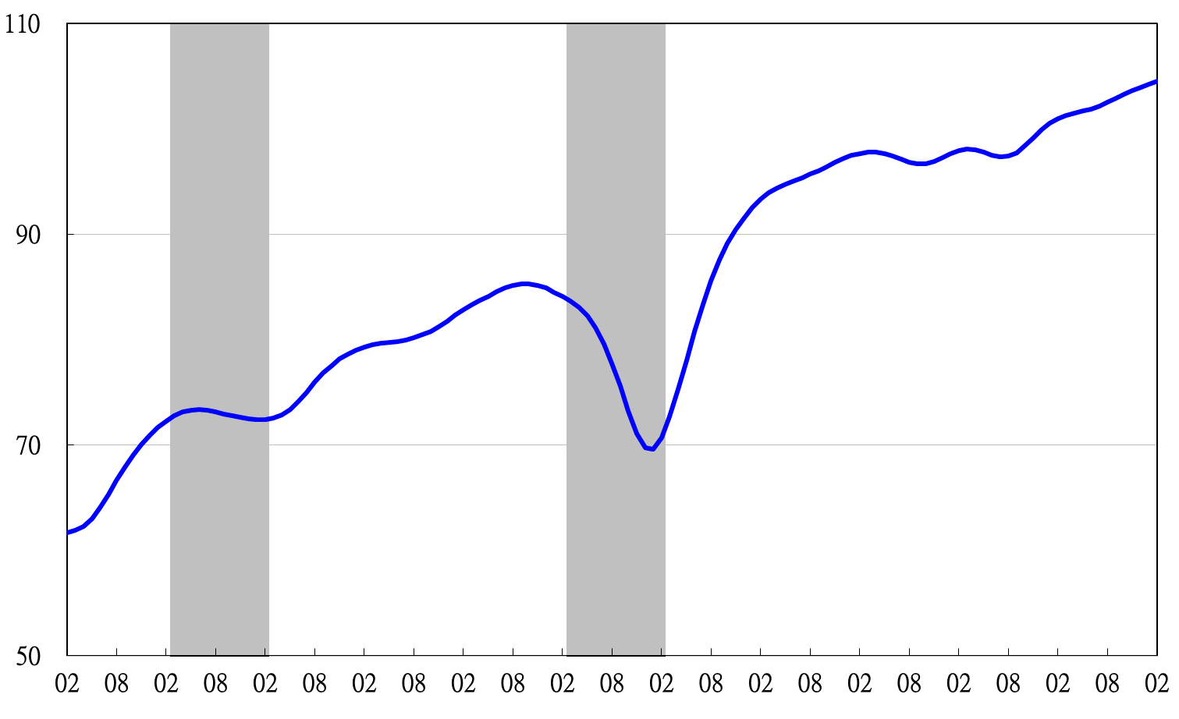

Note: Shaded areas represent recessions.

2003 2004 2005 2006 2007 2008 2009 2010 2011 2012 2013 2014

**Figure 1 Composite Leading Index**

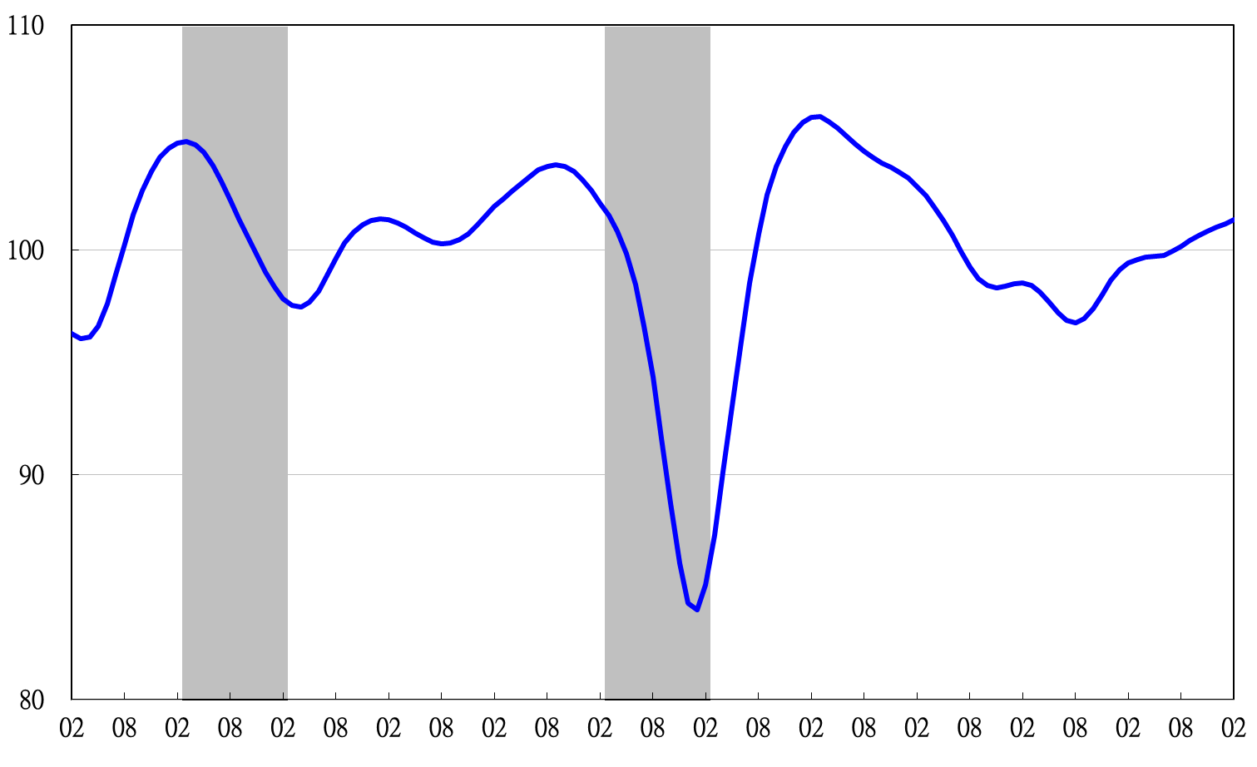

2003 2004 2005 2006 2007 2008 2009 2010 2011 2012 2013 2014

**Figure 2 Trend-adjusted Composite Leading Index**

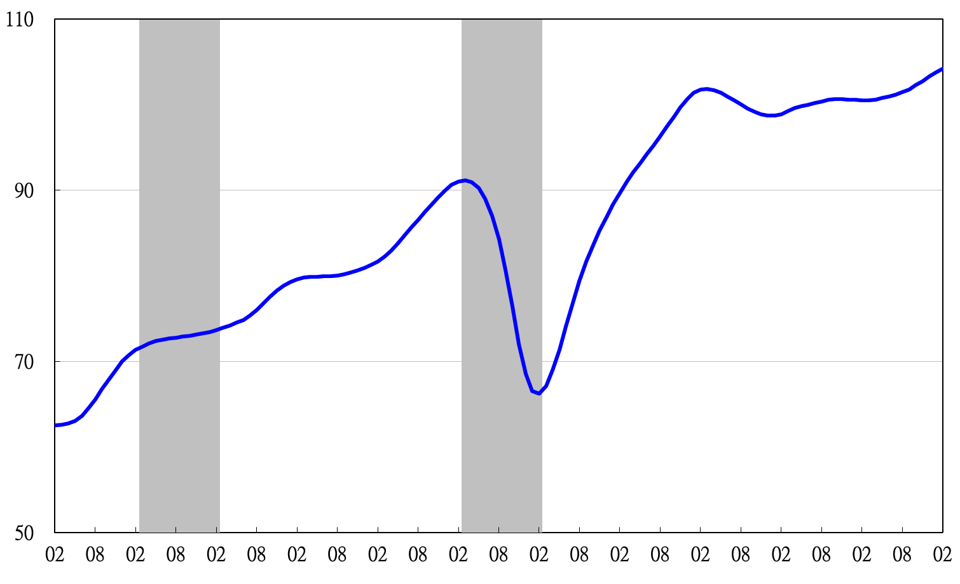

2004.3(P) 2005.2(T) 2008.3(P) 2009.2(T)

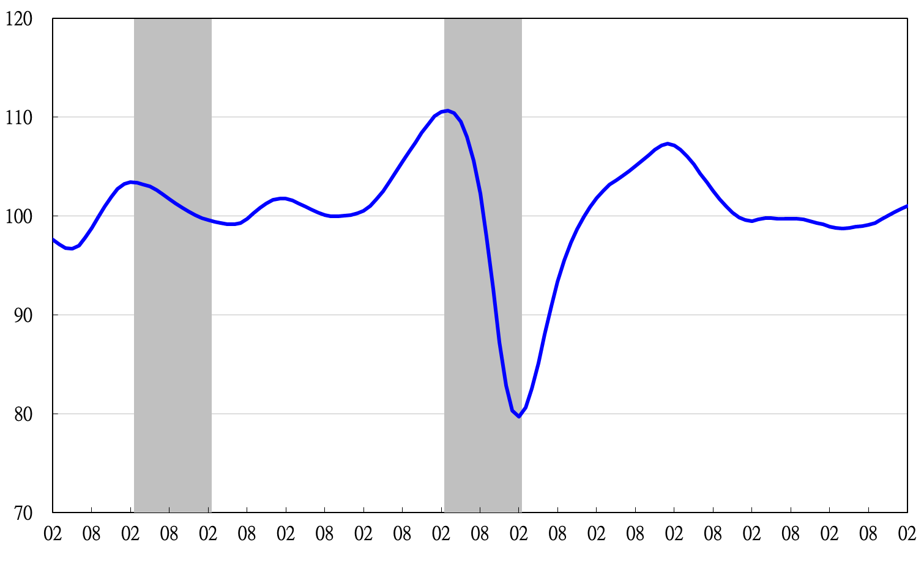**Figure 3 Composite Coincident Index**

2003 2004 2005 2006 2007 2008 2009 2010 2011 2012 2013 2014

**Figure 4 Trend-adjusted Composite Coincident Index**

2003 2004 2005 2006 2007 2008 2009 2010 2011 2012 2013 2014

2004.3(P) 2005.2(T) 2008.3(P) 2009.2(T)

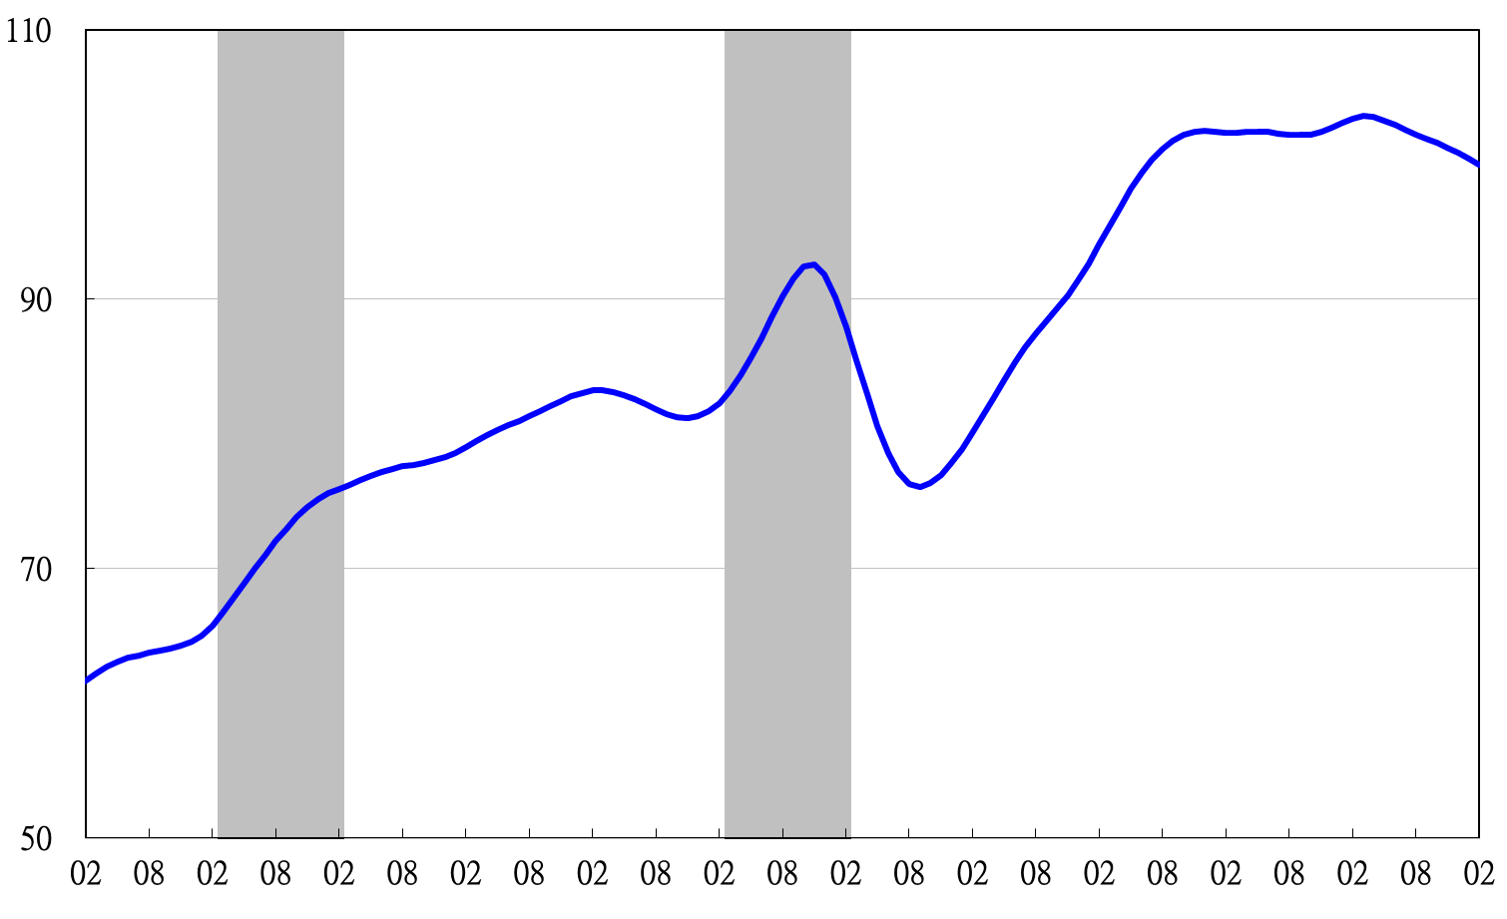

2003 2004 2005 2006 2007 2008 2009 2010 2011 2012 2013 2014

**Figure 5 Composite Lagging Index**

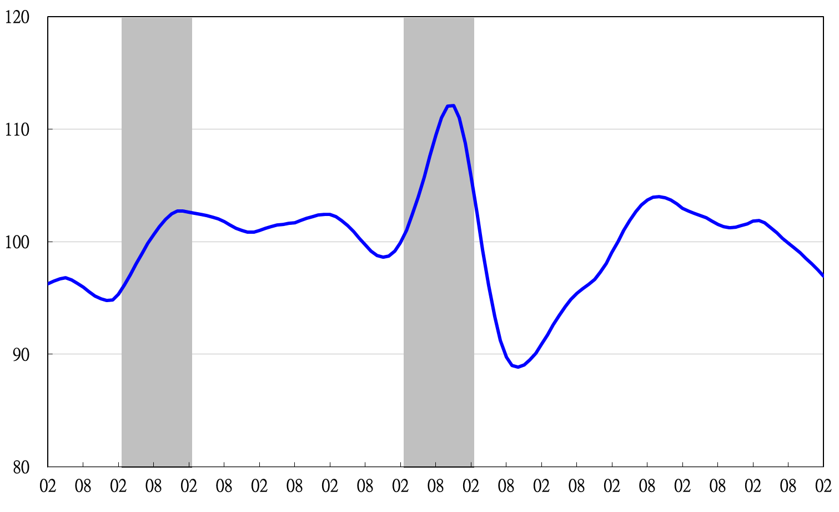

2003 2004 2005 2006 2007 2008 2009 2010 2011 2012 2013 2014

**Figure 6 Trend-adjusted Composite Lagging Index**

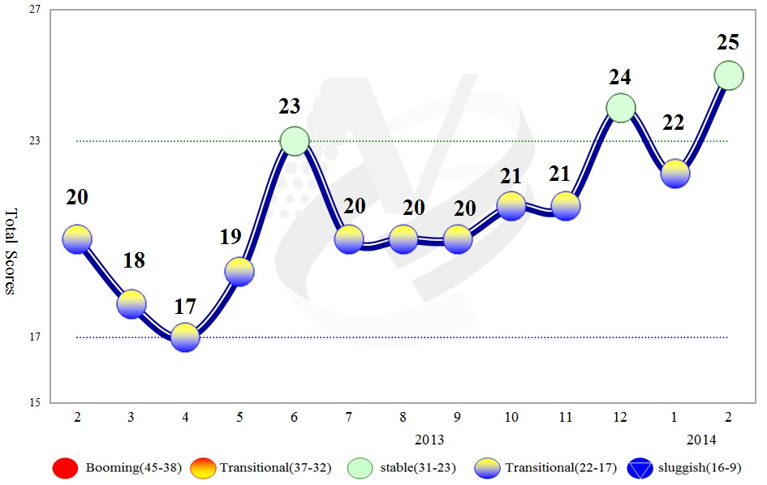

**Figure 7 Total Scores in the Past Year**

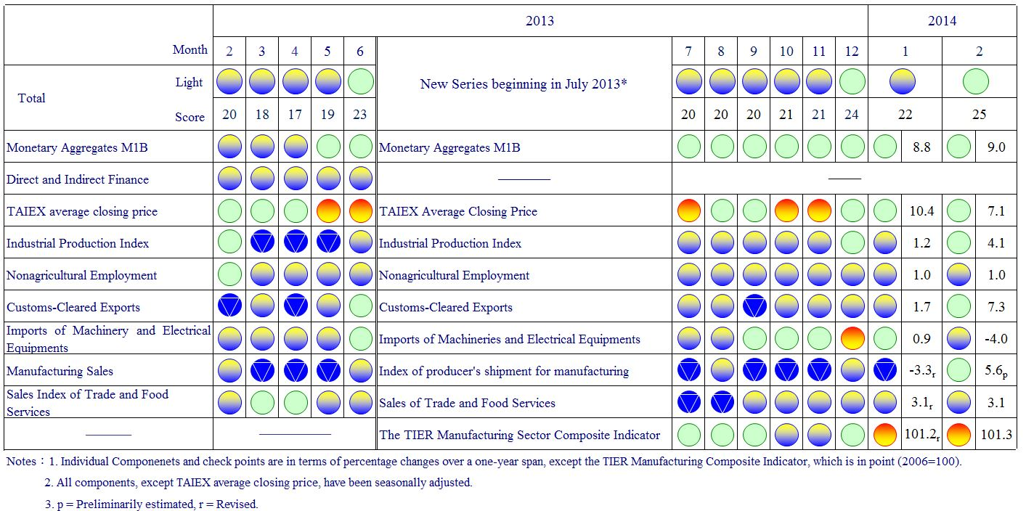

**Figure 8 Monitoring Indicators**