Taiwan Business Indicators in August 2014

Press Release

National Development Council (NDC)

September 26, 2014

In August 2014, the Taiwan Business Indicators showed that the domestic economy continued its steady growth. Among the indicators compiled by the National Development Council (NDC), the trend-adjusted leading index decreased by 0.13%, the trend-adjusted coincident index increased by 0.41% from the previous month, and the overall monitoring indicator flashed the "green" signal for the seventh consecutive month.

1. The Monitoring Indicators: The total score in August 2014 increased by two points to 29, flashing the “green” signal for the seventh month. Among the nine components, the industrial production index and the imports of machineries and electrical equipments each gained one point to change its individual light signal form “green” to “yellow-red”. The light signal for the rest of eight components remained unchanged.
2. Leading Indicators: With revised data, the trend-adjusted leading index stood at 100.00, down by 0.13% from July 2014. Among the seven indicators making up the trend-adjusted index, TAIEX average closing price, and real monetary aggregates M1B had positive cyclical movements from the previous month, while building permits, net accession rate of employees on payrolls of industry and services, the index of export orders, the TIER manufacturing sector composite indicator, and SEMI book-to-bill ratio had negative cyclical movements.
3. Coincident Indicators: With revised data, the trend-adjusted coincident index stood at 101.92, up by 0.41% from July 2014. Among the seven indicators making up the trend-adjusted index, electric power consumption, the industrial production index, real customs-cleared exports, the index of producer’s shipment for manufacturing, and real machineries and electrical equipments imports had positive cyclical movements from the previous month, while sales of trade and food services and nonagricultural employment had negative cyclical movements.
4. Lagging Indicators: With revised data, the trend-adjusted lagging index stood at 99.68, down by 0.38% from July 2014. Among the six indicators making up the trend-adjusted index, the manufacturing unit output labor cost index, the inventories to sales ratio for manufacturing, the unemployment rate (inverted), regular employees on payrolls in industry and services, and loans and investments of monetary financial institutions had positive cyclical movements from the previous month, while the interbank overnight call-loan rate had negative cyclical movement.

**T~~ The next release is scheduled for October 27 2014 ~~T**

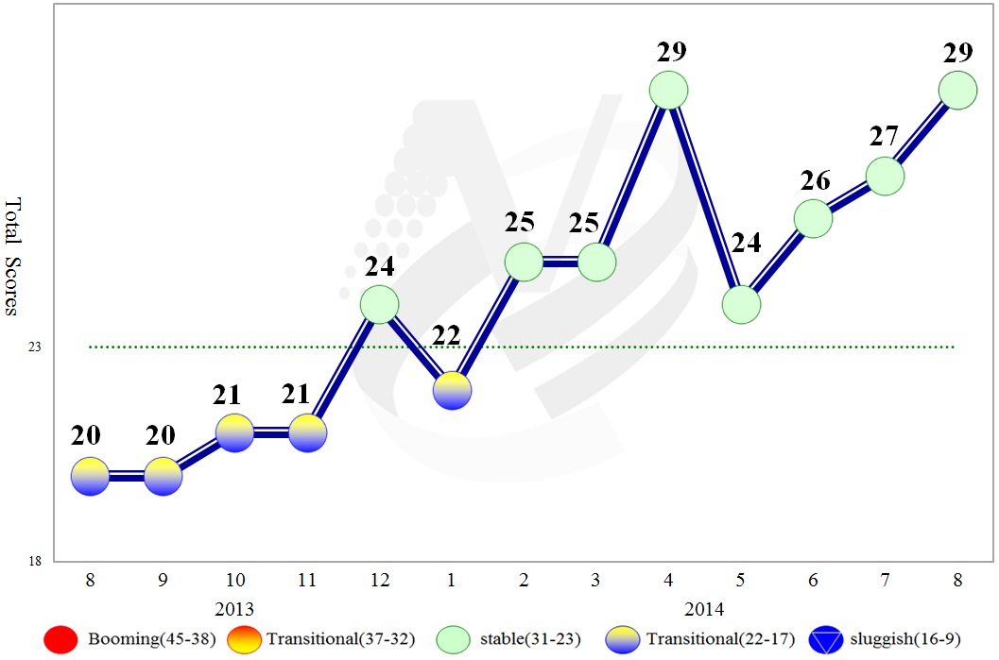

**Figure 1 Total Scores in the Past Year**

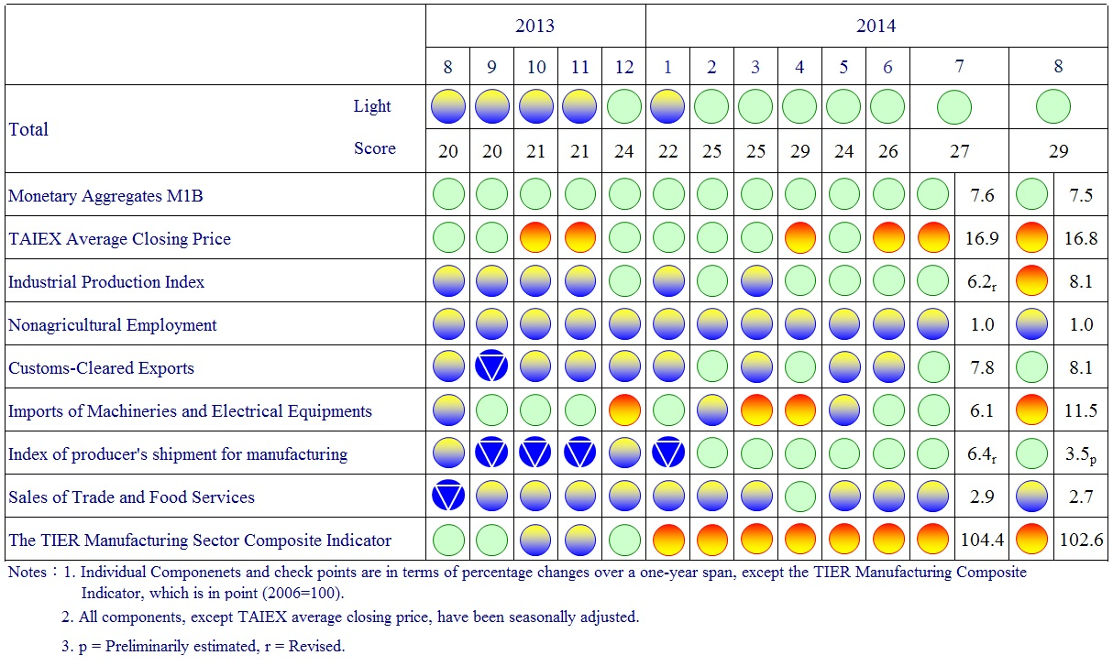

**Figure 2 Monitoring Indicators**

**Table 1 Leading Indicators**

Index

|  |  |  |  |  |  |  |  |
| --- | --- | --- | --- | --- | --- | --- | --- |
|  | 2014 | | | | | | |
| Feb | Mar | Apr | May | Jun | Jul | Aug |
| **Trend adjusted index** | 100.64 | 100.60 | 100.51 | 100.38 | 100.26 | 100.14 | 100.00 |
| Change from preceding month (%) | 0.03 | -0.04 | -0.09 | -0.13 | -0.12 | -0.13 | -0.13 |
| **Components** |  |  |  |  |  |  |  |
| Index of export orders | 100.42 | 100.36 | 100.32 | 100.26 | 100.20 | 100.12 | 100.06 |
| Real monetary aggregates M1B | 100.13 | 100.12 | 100.11 | 100.11 | 100.12 | 100.13 | 100.14 |
| TAIEX average closing price | 100.09 | 100.16 | 100.23 | 100.31 | 100.39 | 100.47 | 100.53 |
| Net accession rate of employees on payrolls of industry and services * | 100.43 | 100.38 | 100.28 | 100.16 | 100.04 | 99.93 | 99.86 |
| Building permits ** | 100.06 | 99.95 | 99.79 | 99.61 | 99.47 | 99.34 | 99.19 |
| SEMI Book-to-Bill Ratio | 100.04 | 100.02 | 100.01 | 100.02 | 100.04 | 100.04 | 100.03 |
| The TIER manufacturing sector composite indicator | 100.29 | 100.41 | 100.49 | 100.55 | 100.58 | 100.58 | 100.57 |

Note：* Net accession rate is equal to accession rate minus separation rate.

** Including only housing, mercantile, business and service, industry warehousing.

2004.3(P) 2005.2(T) 2008.3(P) 2009.2(T)

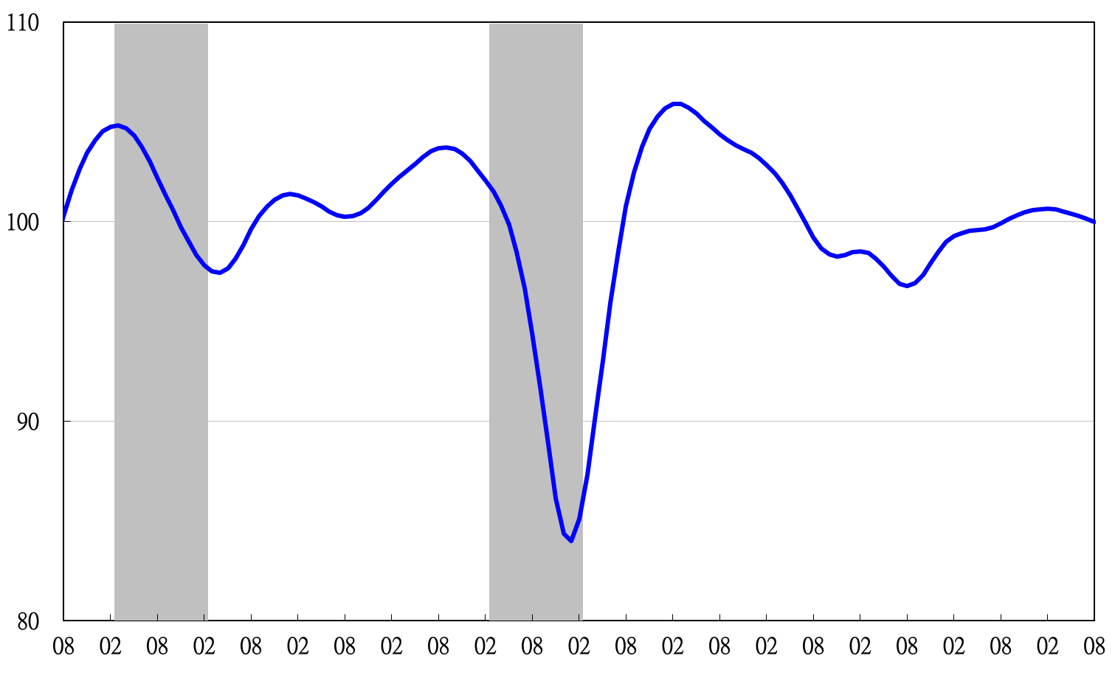

Note: Shaded areas represent recessions.

2003 2004 2005 2006 2007 2008 2009 2010 2011 2012 2013 2014

**Figure 3 Trend-adjusted Leading Index**

**Table 2 Coincident Indicators**

Index

|  |  |  |  |  |  |  |  |
| --- | --- | --- | --- | --- | --- | --- | --- |
|  | 2014 | | | | | | |
| Feb | Mar | Apr | May | Jun | Jul | Aug |
| **Trend adjusted index** | 100.13 | 100.28 | 100.50 | 100.77 | 101.11 | 101.50 | 101.92 |
| Change from preceding month (%) | 0.12 | 0.14 | 0.23 | 0.27 | 0.34 | 0.39 | 0.41 |
| **Components** |  |  |  |  |  |  |  |
| Industrial production index | 99.84 | 99.94 | 100.10 | 100.31 | 100.55 | 100.79 | 101.05 |
| Electric power consumption | 99.38 | 99.36 | 99.46 | 99.66 | 99.96 | 100.37 | 100.84 |
| Index of producer’s shipment for manufacturing | 100.03 | 100.17 | 100.32 | 100.44 | 100.55 | 100.64 | 100.72 |
| Sales of trade and food services | 100.25 | 100.26 | 100.28 | 100.26 | 100.20 | 100.10 | 100.00 |
| Nonagricultural employment | 99.74 | 99.71 | 99.66 | 99.59 | 99.51 | 99.42 | 99.33 |
| Real customs-cleared exports | 99.74 | 99.83 | 99.95 | 100.08 | 100.27 | 100.48 | 100.70 |
| Real machineries and electrical equipments imports | 100.39 | 100.40 | 100.39 | 100.37 | 100.41 | 100.46 | 100.52 |

2004.3(P) 2005.2(T) 2008.3(P) 2009.2(T)

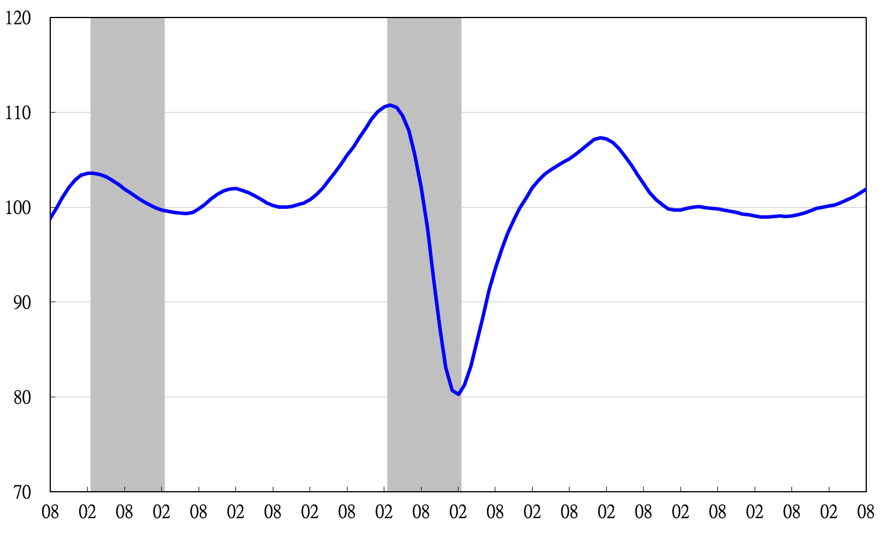

2003 2004 2005 2006 2007 2008 2009 2010 2011 2012 2013 2014

**Figure 4 Trend-adjusted Coincident Index**

**Table 3 Lagging Indicators**

Index

|  |  |  |  |  |  |  |  |
| --- | --- | --- | --- | --- | --- | --- | --- |
|  | 2014 | | | | | | |
| Feb | Mar | Apr | May | Jun | Jul | Aug |
| **Trend adjusted index** | 98.27 | 98.29 | 98.42 | 98.64 | 98.91 | 99.30 | 99.68 |
| Change from preceding month (%) | -0.15 | 0.03 | 0.13 | 0.22 | 0.28 | 0.40 | 0.38 |
| **Components** |  |  |  |  |  |  |  |
| Unemployment rate | 99.70 | 99.74 | 99.78 | 99.83 | 99.87 | 99.90 | 99.93 |
| Regular employees on payrolls  in industry & services | 99.72 | 99.74 | 99.75 | 99.77 | 99.80 | 99.83 | 99.86 |
| The manufacturing unit output labor cost index | 99.28 | 99.40 | 99.60 | 99.85 | 100.10 | 100.44 | 100.73 |
| Interbank overnight call-loan rate** | 99.98 | 99.97 | 99.97 | 99.96 | 99.95 | 99.94 | 99.94 |
| Loans and investments of monetary financial institutions | 99.85 | 99.84 | 99.84 | 99.84 | 99.86 | 99.88 | 99.90 |
| Inventories to sales ratio for manufacturing | 99.46 | 99.34 | 99.24 | 99.18 | 99.17 | 99.20 | 99.27 |

2004.3(P) 2005.2(T) 2008.3(P) 2009.2(T)

2003 2004 2005 2006 2007 2008 2009 2010 2011 2012 2013 2014

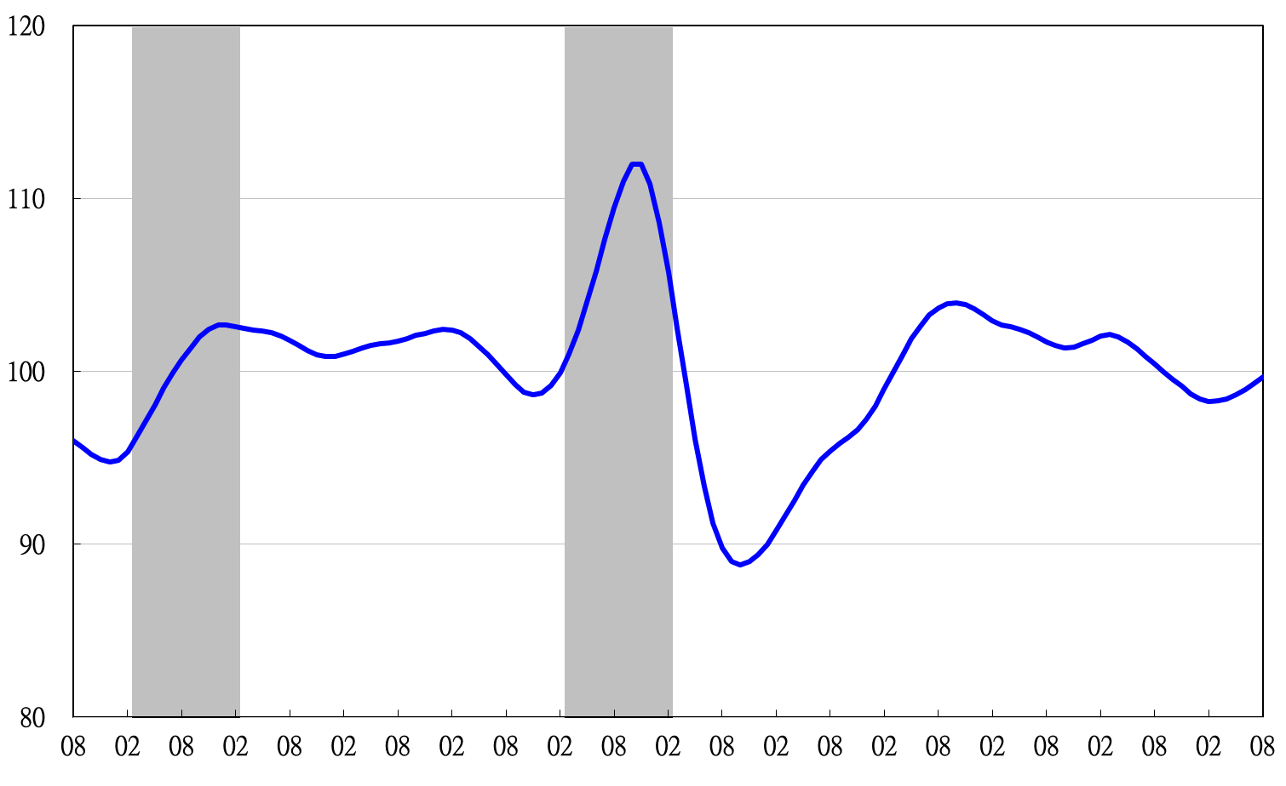

**Figure 5 Trend-adjusted Lagging Index**

2003 2004 2005 2006 2007 2008 2009 2010 2011 2012 2013 2014