Taiwan Business Indicators in October 2013

Press Release

Council for Economic Planning and Development, Executive Yuan

November 27, 2013

In October 2013, the Taiwan Business Indicators showed the economic recovery to remain on the slower track. Among the indicators compiled by the Cabinet’s Council for Economic Planning and Development (CEPD), the trend-adjusted leading index increased by 0.34%, the trend-adjusted coincident index increased by 0.01% from the previous month, and the overall monitoring indicator flashed the "yellow-blue" signal.

1. Leading Indicators: With revised data, the composite leading index stood at 103.76, up by 0.45% from September 2013. Its trend-adjusted index increased by 0.34% to 101.39. Among the seven indicators making up the trend-adjusted index, building permits, the index of export orders, net accession rate of employees on payrolls of industry and services, TAIEX average closing price, and real monetary aggregates M1B had positive cyclical movements from the previous month, while the TIER manufacturing sector composite indicator and SEMI book-to-bill ratio had negative cyclical movements.
2. Coincident Indicators: With revised data, the coincident index stood at 101.37, up by 0.11% from September 2013. Its trend-adjusted index increased by 0.01% to 99.06. Among the seven indicators making up the trend-adjusted index, the index of producer’s shipment for manufacturing, sales of trade and food services, and the industrial production index had positive cyclical movements from the previous month, while electric power consumption, real customs-cleared exports, nonagricultural employment, and real machineries and electrical equipments imports had negative cyclical movements.
3. Lagging Indicators: With revised data, the lagging index stood at 100.33, down by 0.36% from September 2013. Its trend-adjusted index decreased by 0.47% to 98.04. All six indicators making up the trend-adjusted index had negative cyclical movements from previous month, which were the inventories to sales ratio for manufacturing, the manufacturing unit output labor cost index, the unemployment rate (inverted), regular employees on payrolls in industry and services, loans and investments of monetary financial institutions, and the interbank overnight call-loan rate.
4. The Monitoring Indicators: The total score in September was adjusted upward by one point to 20, following the revision of the sales of trade and food services. The total score in October remained at 20, flashing the “yellow-blue” signal for the fourth month. Among the nine components, TAIEX average closing price gained one point to change its individual light signal from “green” to “yellow-red”. The TIER manufacturing sector composite indicator lost one point to change its individual light signal from “green” to “yellow-blue”. The light signals for the rest of seven components remained unchanged.

**T~~ The next release is scheduled for December 27 2013 ~~T**

# **Table 1 Leading Indicators**

Seasonally adjusted

|  |  |  |  |  |  |  |  |
| --- | --- | --- | --- | --- | --- | --- | --- |
|  | 2013 | | | | | | |
| Apr | May | Jun | Jul | Aug | Sep | Oct |
| **Composite Index** | 101.73 | 101.93 | 102.13 | 102.43 | 102.84 | 103.30 | 103.76 |
| Change from preceding month (%) | 0.24 | 0.19 | 0.19 | 0.30 | 0.40 | 0.45 | 0.45 |
| Trend adjusted index | 100.06 | 100.14 | 100.23 | 100.42 | 100.71 | 101.05 | 101.39 |
| Change from preceding month (%) | 0.13 | 0.08 | 0.08 | 0.19 | 0.29 | 0.34 | 0.34 |
| **Components** |  |  |  |  |  |  |  |
| Index of export orders (2011=100) | 102.8 | 102.9 | 102.9 | 103.4 | 104.9 | 106.9 | 107.7 |
| Real monetary aggregates M1B (NT$ billion) | 12,250 | 12,418 | 12,541 | 12,642 | 12,659 | 12,654 | 12,748 |
| TAIEX average closing price (1966=100)* | 7,893 | 8,272 | 7,989 | 8,102 | 7,932 | 8,193 | 8,366 |
| Net accession rate of employees on payrolls of industry and services ** (%) | 0.16 | 0.10 | 0.02 | -0.01 | 0.14 | 0.18 | 0.14p |
| Building permits *** (1,000m2) | 3,089 | 3,107 | 2,318 | 2,986 | 3,395 | 3,618 | 3,440 |
| SEMI Book-to-Bill Ratio | 1.08 | 1.08 | 1.10 | 1.00 | 0.98 | 0.97 | 1.05 |
| The TIER manufacturing sector composite indicator (2006=100) | 97.38 | 99.47 | 97.51 | 98.40 | 98.78 | 97.99 | 95.91 |

Note：1. p = Preliminarily estimated.

2. * TAIEX average closing price is not seasonally adjusted.

** Net accession rate is equal to accession rate minus separation rate.

*** Including only housing, mercantile, business and service, industry warehousing.

# **Table 2 Coincident Indicators**

Seasonally adjusted

|  |  |  |  |  |  |  |  |
| --- | --- | --- | --- | --- | --- | --- | --- |
|  | 2013 | | | | | | |
| Apr | May | Jun | Jul | Aug | Sep | Oct |
| **Composite Index** | 100.71 | 100.86 | 100.99 | 101.06 | 101.14 | 101.26 | 101.37 |
| Change from preceding month (%) | 0.07 | 0.14 | 0.13 | 0.07 | 0.08 | 0.11 | 0.11 |
| Trend adjusted index | 99.06 | 99.09 | 99.11 | 99.07 | 99.04 | 99.05 | 99.06 |
| Change from preceding month (%) | -0.04 | 0.03 | 0.02 | -0.04 | -0.03 | 0.01 | 0.01 |
| **Components** |  |  |  |  |  |  |  |
| Industrial production index (2011=100) | 98.2 | 99.0 | 99.7 | 100.5 | 100.3 | 100.5 | 100.9 |
| Electric power consumption (billion kWh) | 11.79 | 11.90 | 12.29 | 11.82 | 11.93 | 11.96 | 11.83 |
| Index of producer’s shipment for manufacturing (2011=100) | 96.3 | 98.0 | 97.6 | 97.1 | 99.5 | 98.1 | 99.6p |
| Sales of trade and food services (NT$ billion) | 1,183 | 1,183 | 1,180 | 1,178 | 1,177 | 1,187 | 1,195 |
| Nonagricultural employment (thousand persons) | 10,406 | 10,409 | 10,418 | 10,417 | 10,423 | 10,441 | 10,453 |
| Real customs-cleared exports (NT$ billion) | 765.2 | 784.9 | 807.7 | 771.8 | 783.7 | 782.8 | 777.7 |
| Real machineries and electrical equipments imports (NT$ billion) | 207.4 | 214.7 | 217.2 | 207.4 | 192.2 | 217.8 | 208.3 |

# **Table 3 Lagging Indicators**

Seasonally adjusted

|  |  |  |  |  |  |  |  |
| --- | --- | --- | --- | --- | --- | --- | --- |
|  | 2013 | | | | | | |
| Apr | May | Jun | Jul | Aug | Sep | Oct |
| **Composite Index** | 102.56 | 102.27 | 101.89 | 101.49 | 101.08 | 100.69 | 100.33 |
| Change from preceding month (%) | -0.11 | -0.29 | -0.37 | -0.39 | -0.40 | -0.39 | -0.36 |
| Trend adjusted index | 100.88 | 100.47 | 100.00 | 99.49 | 98.99 | 98.50 | 98.04 |
| Change from preceding month (%) | -0.22 | -0.40 | -0.48 | -0.50 | -0.51 | -0.50 | -0.47 |
| **Components** |  |  |  |  |  |  |  |
| Unemployment rate* (%) | 4.19 | 4.19 | 4.17 | 4.18 | 4.19 | 4.18 | 4.17 |
| Regular employees on payrolls  in industry & services (thousand persons) | 6,827 | 6,834 | 6,841 | 6,846 | 6,854 | 6,862 | 6,871p |
| The manufacturing unit output labor cost index  (2006=100) | 85.2 | 84.4 | 84.0 | 83.7 | 84.6 | 82.1 | 84.5p |
| Interbank overnight call-loan rate**  (percent per annum) | 0.386 | 0.386 | 0.386 | 0.386 | 0.386 | 0.386 | 0.387 |
| Loans and investments of monetary financial institutions (NT$ billion) | 25,986 | 25,979 | 26,160 | 26,349 | 26,423 | 26,547 | 26,638 |
| Inventories to sales ratio for manufacturing (%) | 72.1 | 67.2 | 67.3 | 68.6 | 66.4 | 67.5 | 66.7p |

Note： * This series is inverted while aggregating composite lagging index.

** Interbank overnight call-loan rate is not seasonally adjusted.

2004.3(P) 2005.2(T) 2008.3(P) 2009.2(T)

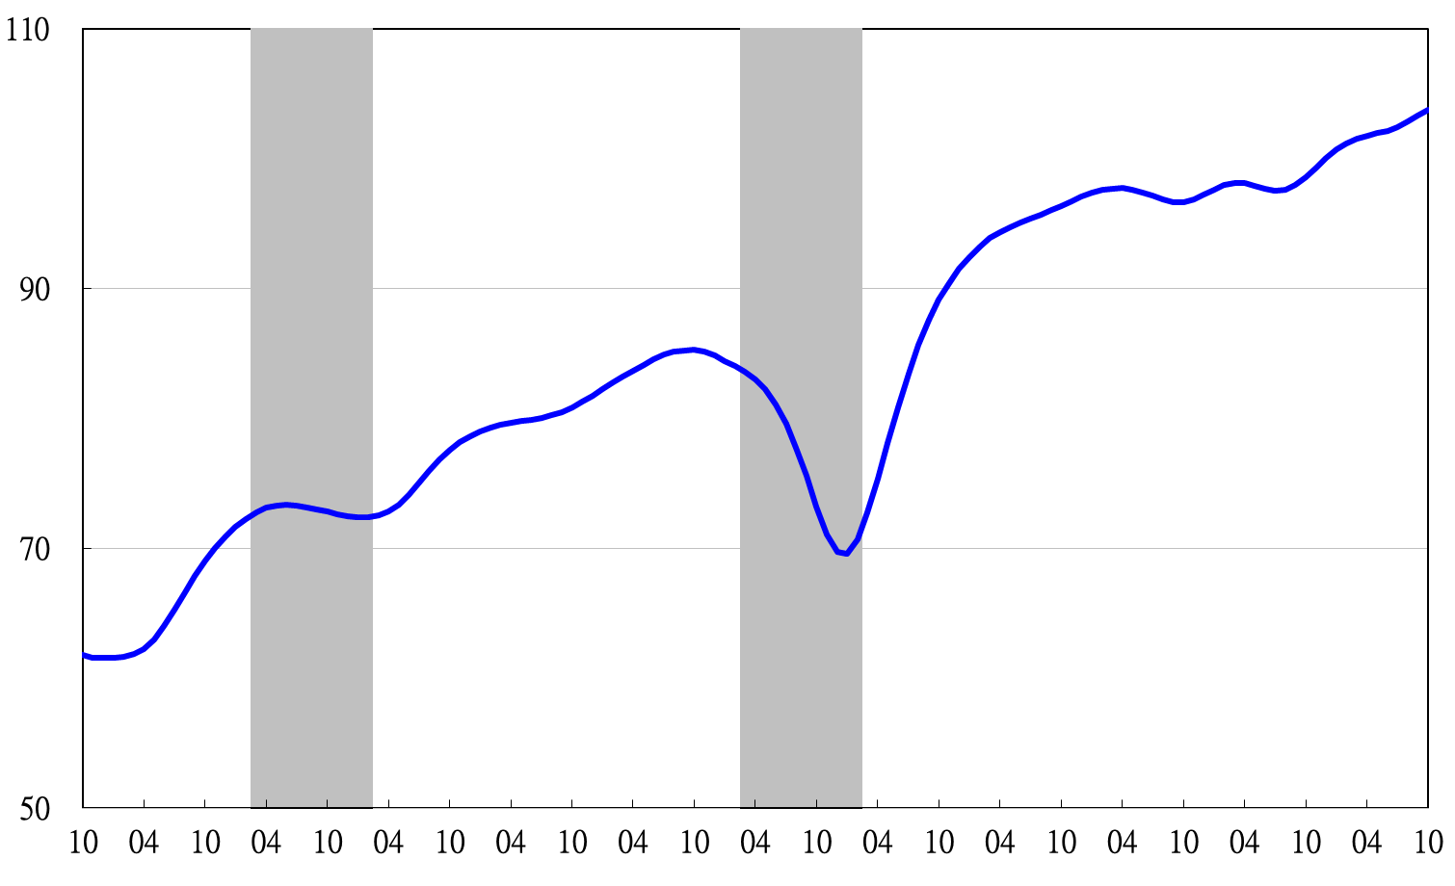

Note: Shaded areas represent recessions.

2002 2003 2004 2005 2006 2007 2008 2009 2010 2011 2012 2013

**Figure 1 Composite Leading Index**

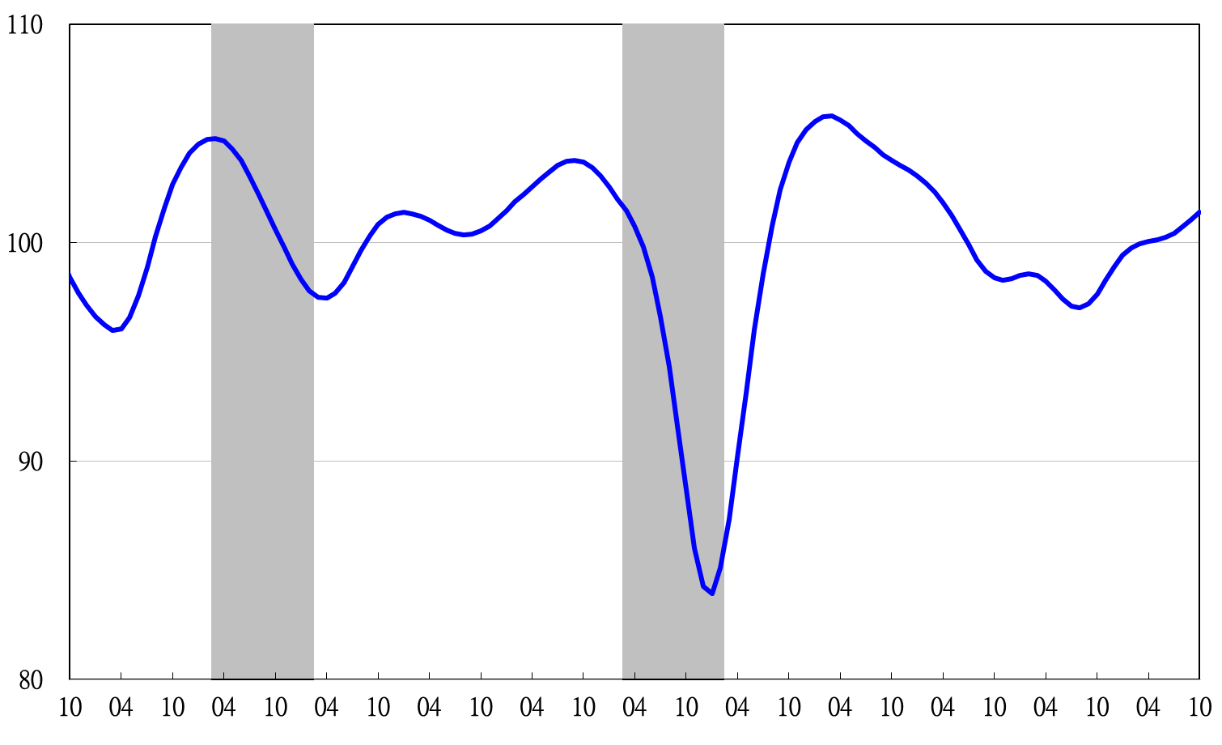

2002 2003 2004 2005 2006 2007 2008 2009 2010 2011 2012 2013

**Figure 2 Trend-adjusted Composite Leading Index**

2004.3(P) 2005.2(T) 2008.3(P) 2009.2(T)

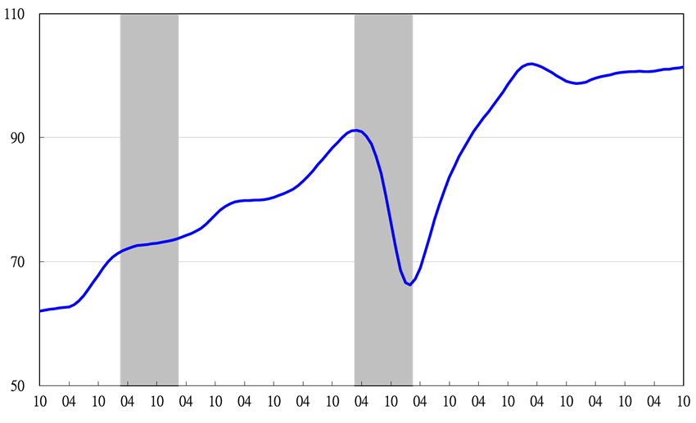

2002 2003 2004 2005 2006 2007 2008 2009 2010 2011 2012 2013

**Figure 3 Composite Coincident Index**

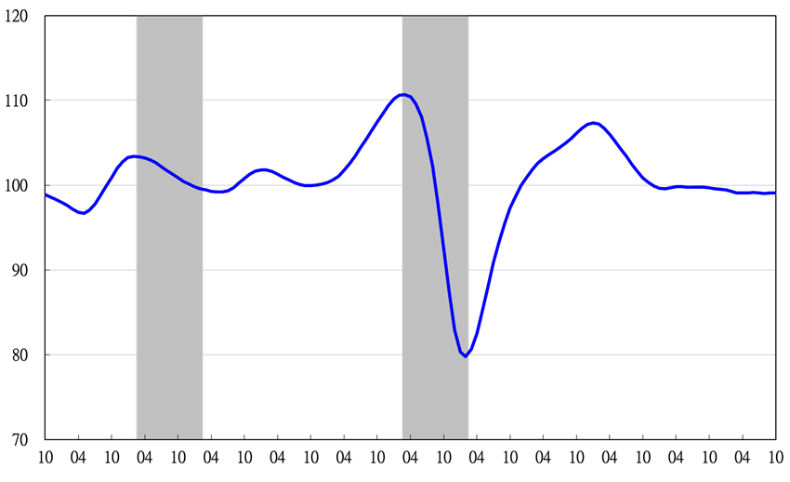

2002 2003 2004 2005 2006 2007 2008 2009 2010 2011 2012 2013

**Figure 4 Trend-adjusted Composite Coincident Index**

2004.3(P) 2005.2(T) 2008.3(P) 2009.2(T)

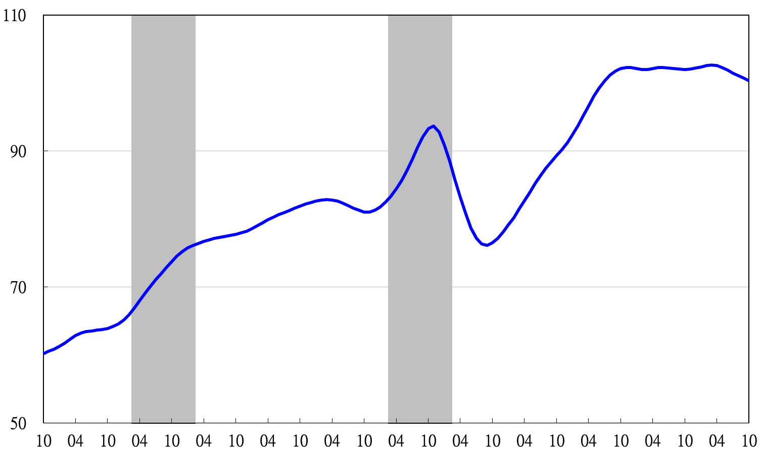

2002 2003 2004 2005 2006 2007 2008 2009 2010 2011 2012 2013

**Figure 5 Composite Lagging Index**

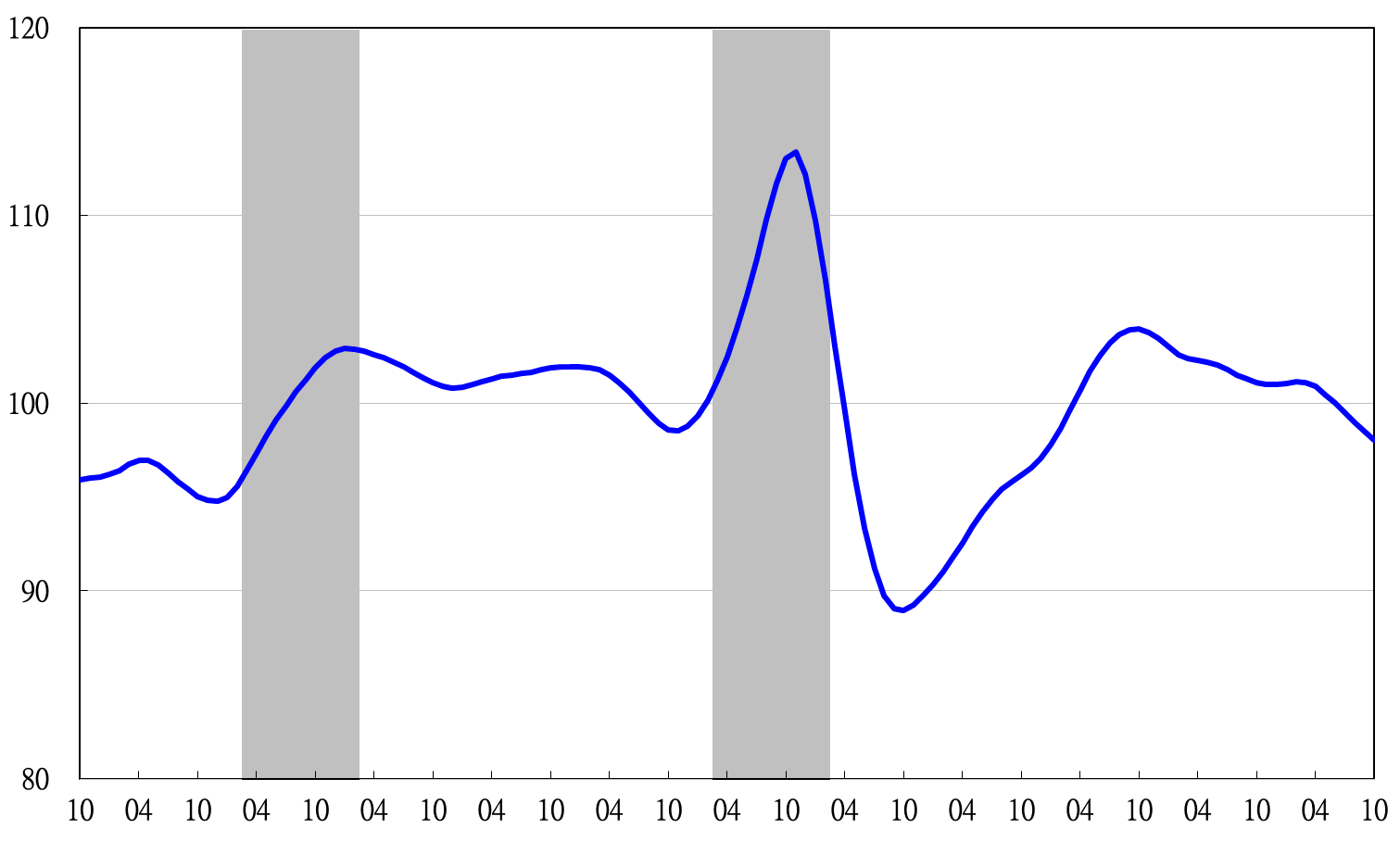

2002 2003 2004 2005 2006 2007 2008 2009 2010 2011 2012 2013

**Figure 6 Trend-adjusted Composite Lagging Index**

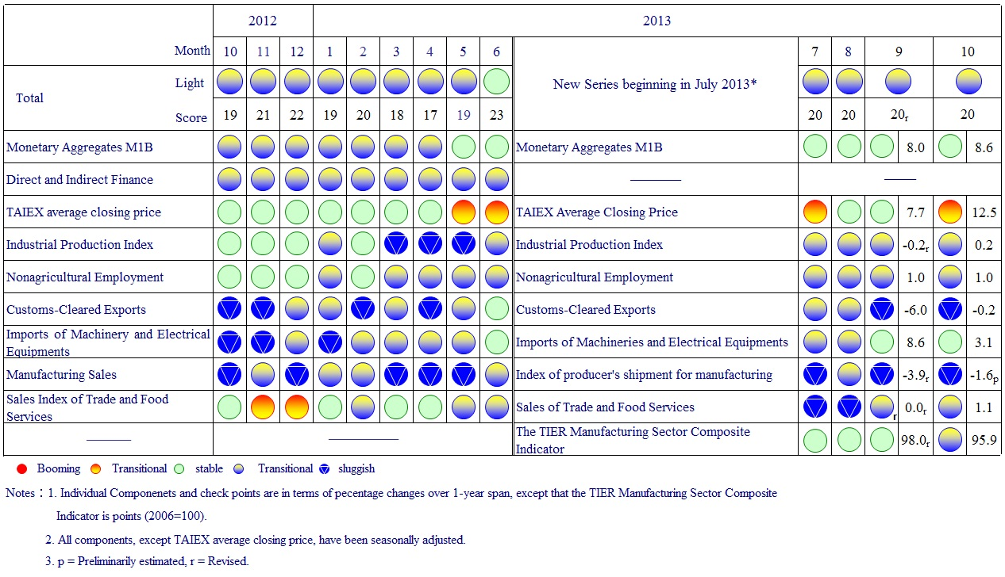

**Figure 7 Monitoring Indicators**