Taiwan Business Indicators in April 2014

Press Release

National Development Council (NDC)

May 27, 2014

In April 2014, the Taiwan Business Indicators showed that the significant recovery was underway. Among the indicators compiled by the National Development Council (NDC), the trend-adjusted leading index increased by 0.18%, the trend-adjusted coincident index increased by 0.25% from the previous month, and the overall monitoring indicator flashed the "green" signal for the third consecutive month.

1. Leading Indicators: With revised data, the composite leading index stood at 104.90, up by 0.31% from March 2014. Its trend-adjusted index increased by 0.18% to 101.31. Among the seven indicators making up the trend-adjusted index, the TIER manufacturing sector composite indicator, TAIEX average closing price, the index of export orders, net accession rate of employees on payrolls of industry and services, and building permits had positive cyclical movements from the previous month, while SEMI book-to-bill ratio and real monetary aggregates M1B had negative cyclical movements.
2. Coincident Indicators: With revised data, the coincident index stood at 104.65, up by 0.38% from March 2014. Its trend-adjusted index increased by 0.25% to 101.07. Among the seven indicators making up the trend-adjusted index, real machineries and electrical equipments imports, real customs-cleared exports, the index of producer’s shipment for manufacturing, sales of trade and food services, and the industrial production index had positive cyclical movements from the previous month, while electric power consumption and nonagricultural employment had negative cyclical movements.
3. Lagging Indicators: With revised data, the lagging index stood at 101.03, down by 0.02% from March 2014. Its trend-adjusted index decreased by 0.15% to 97.58. Among the six indicators making up the trend-adjusted index, the manufacturing unit output labor cost index, the unemployment rate(inverted) , and regular employees on payrolls in industry and services had positive cyclical movements from the previous month, while the inventories to sales ratio for manufacturing, loans and investments of monetary financial institutions, and the interbank overnight call-loan rate had negative cyclical movements.
4. The Monitoring Indicators: The total score in April 2014 increased by four points to 29, flashing the “green” signal for the third month. Among the nine components, the TAIEX average closing price gained one point to change its individual light signal form “green” to “yellow-red”, and the industrial production index, the customs-cleared exports and sales of trade and food services changed its individual light signal from “yellow-blue” to “green”, each gained one point. The light signal for the rest of five components remained unchanged.

**T~~ The next release is scheduled for June 27 2014 ~~T**

# **Table 1 Leading Indicators**

Seasonally adjusted

|  |  |  |  |  |  |  |  |
| --- | --- | --- | --- | --- | --- | --- | --- |
|  | 2013 | | | 2014 | | | |
| Oct | Nov | Dec | Jan | Feb | Mar | Apr |
| **Composite Index** | 103.07 | 103.37 | 103.67 | 103.95 | 104.26 | 104.57 | 104.90 |
| Change from preceding month (%) | 0.32 | 0.29 | 0.29 | 0.27 | 0.30 | 0.30 | 0.31 |
| **Trend adjusted index** | 100.31 | 100.48 | 100.64 | 100.78 | 100.96 | 101.13 | 101.31 |
| Change from preceding month (%) | 0.19 | 0.16 | 0.16 | 0.14 | 0.17 | 0.17 | 0.18 |
| **Components** |  |  |  |  |  |  |  |
| Index of export orders (2011=100) | 109.0 | 112.3 | 118.8 | 107.0 | 108.9 | 110.5 | 114.4 |
| Real monetary aggregates M1B (NT$ billion) | 12,813 | 12,878 | 12,943 | 13,052 | 12,954 | 13,166 | 13,137 |
| TAIEX average closing price (1966=100)* | 8,366 | 8,237 | 8,431 | 8,567 | 8,496 | 8,687 | 8,900 |
| Net accession rate of employees on payrolls of industry and services ** (%) | 0.14 | 0.29 | 0.08 | 0.20 | 0.35 | 0.18 | 0.23p |
| Building permits *** (1,000m2) | 3,256 | 2,267 | 2,929 | 2,603 | 3,589 | 2,983 | 3,050 |
| SEMI Book-to-Bill Ratio | 1.05 | 1.11 | 1.02 | 1.04 | 1.01 | 1.06 | 1.03 |
| The TIER manufacturing sector composite indicator (2006=100) | 96.20 | 95.81 | 98.76 | 101.23 | 101.33 | 102.11 | 101.81 |

Note：1. p = Preliminarily estimated.

2. * TAIEX average closing price is not seasonally adjusted.

** Net accession rate is equal to accession rate minus separation rate.

*** Including only housing, mercantile, business and service, industry warehousing.

# **Table 2 Coincident Indicators**

Seasonally adjusted

|  |  |  |  |  |  |  |  |
| --- | --- | --- | --- | --- | --- | --- | --- |
|  | 2013 | | | 2014 | | | |
| Oct | Nov | Dec | Jan | Feb | Mar | Apr |
| **Composite Index** | 102.39 | 102.82 | 103.25 | 103.60 | 103.92 | 104.25 | 104.65 |
| Change from preceding month (%) | 0.36 | 0.42 | 0.42 | 0.34 | 0.31 | 0.32 | 0.38 |
| **Trend adjusted index** | 99.65 | 99.94 | 100.24 | 100.44 | 100.63 | 100.82 | 101.07 |
| Change from preceding month (%) | 0.24 | 0.29 | 0.29 | 0.21 | 0.18 | 0.19 | 0.25 |
| **Components** |  |  |  |  |  |  |  |
| Industrial production index (2011=100) | 101.2 | 102.2 | 104.3 | 102.5 | 103.8 | 101.8 | 103.5 |
| Electric power consumption (billion kWh) | 11.72 | 11.83 | 11.74 | 12.03 | 12.07 | 11.68 | 11.93 |
| Index of producer’s shipment for manufacturing (2011=100) | 98.9 | 99.0 | 101.7 | 97.6 | 102.0 | 99.3 | 101.9p |
| Sales of trade and food services (NT$ billion) | 1,189 | 1,199 | 1,211 | 1,220 | 1,192 | 1,191 | 1,220 |
| Nonagricultural employment (thousand persons) | 10,452 | 10,463 | 10,471 | 10,483 | 10,496 | 10,499 | 10,513 |
| Real customs-cleared exports (NT$ billion) | 797.5 | 786.1 | 805.3 | 775.6 | 803.5 | 805.6 | 828.5 |
| Real machineries and electrical equipments imports (NT$ billion) | 209.6 | 208.0 | 246.7 | 217.1 | 207.3 | 229.2 | 230.8 |

# **Table 3 Lagging Indicators**

Seasonally adjusted

|  |  |  |  |  |  |  |  |
| --- | --- | --- | --- | --- | --- | --- | --- |
|  | 2013 | | | 2014 | | | |
| Oct | Nov | Dec | Jan | Feb | Mar | Apr |
| **Composite Index** | 102.10 | 101.78 | 101.47 | 101.24 | 101.09 | 101.06 | 101.03 |
| Change from preceding month (%) | -0.28 | -0.31 | -0.31 | -0.23 | -0.14 | -0.03 | -0.02 |
| **Trend adjusted index** | 99.37 | 98.94 | 98.50 | 98.15 | 97.89 | 97.73 | 97.58 |
| Change from preceding month (%) | -0.40 | -0.44 | -0.44 | -0.35 | -0.27 | -0.16 | -0.15 |
| **Components** |  |  |  |  |  |  |  |
| Unemployment rate* (%) | 4.18 | 4.15 | 4.14 | 4.07 | 4.05 | 4.06 | 4.04 |
| Regular employees on payrolls  in industry & services (thousand persons) | 6,996 | 7,008 | 7,013 | 7,026 | 7,033 | 7,043 | 7,056p |
| The manufacturing unit output labor cost index  (2011=100) | 106.2 | 103.8 | 100.6 | 101.7 | 97.7 | 103.8 | 102.7p |
| Interbank overnight call-loan rate**  (percent per annum) | 0.387 | 0.386 | 0.387 | 0.388 | 0.387 | 0.387 | 0.387 |
| Loans and investments of monetary financial institutions (NT$ billion) | 26,617 | 26,745 | 26,695 | 26,886 | 27,006 | 27,126 | 27,271 |
| Inventories to sales ratio for manufacturing (%) | 66.6 | 66.8 | 65.6 | 66.6 | 65.2 | 65.9 | 63.4p |

Note： * This series is inverted while aggregating composite lagging index.

** Interbank overnight call-loan rate is not seasonally adjusted.

2004.3(P) 2005.2(T) 2008.3(P) 2009.2(T)

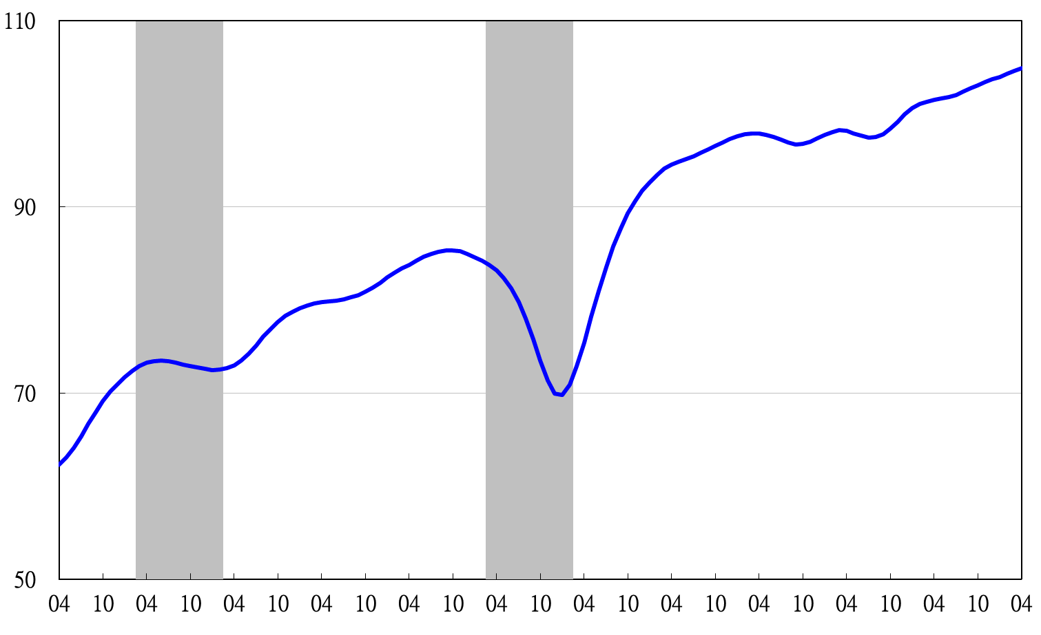

Note: Shaded areas represent recessions.

2003 2004 2005 2006 2007 2008 2009 2010 2011 2012 2013 2014

**Figure 1 Composite Leading Index**

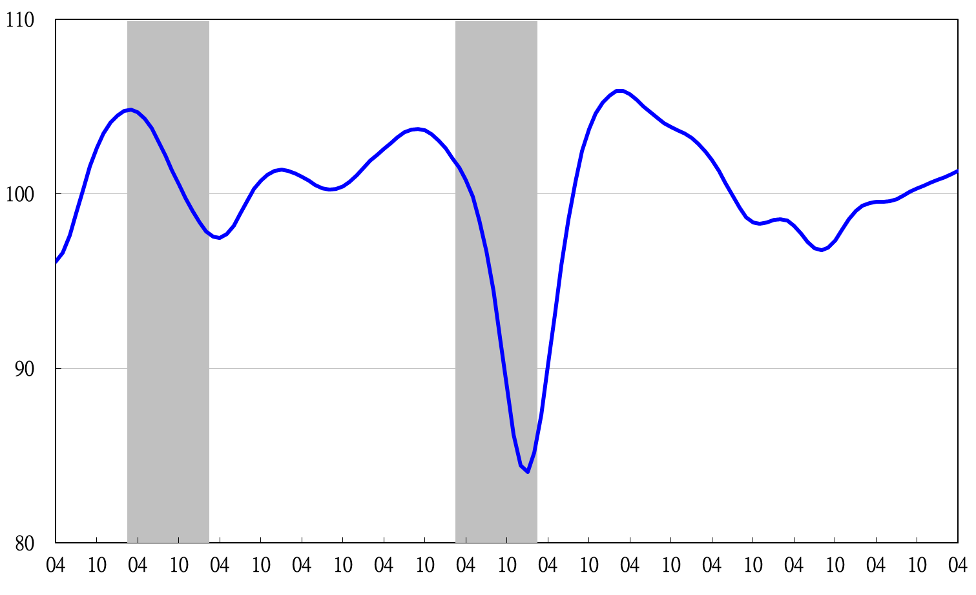

2003 2004 2005 2006 2007 2008 2009 2010 2011 2012 2013 2014

**Figure 2 Trend-adjusted Leading Index**

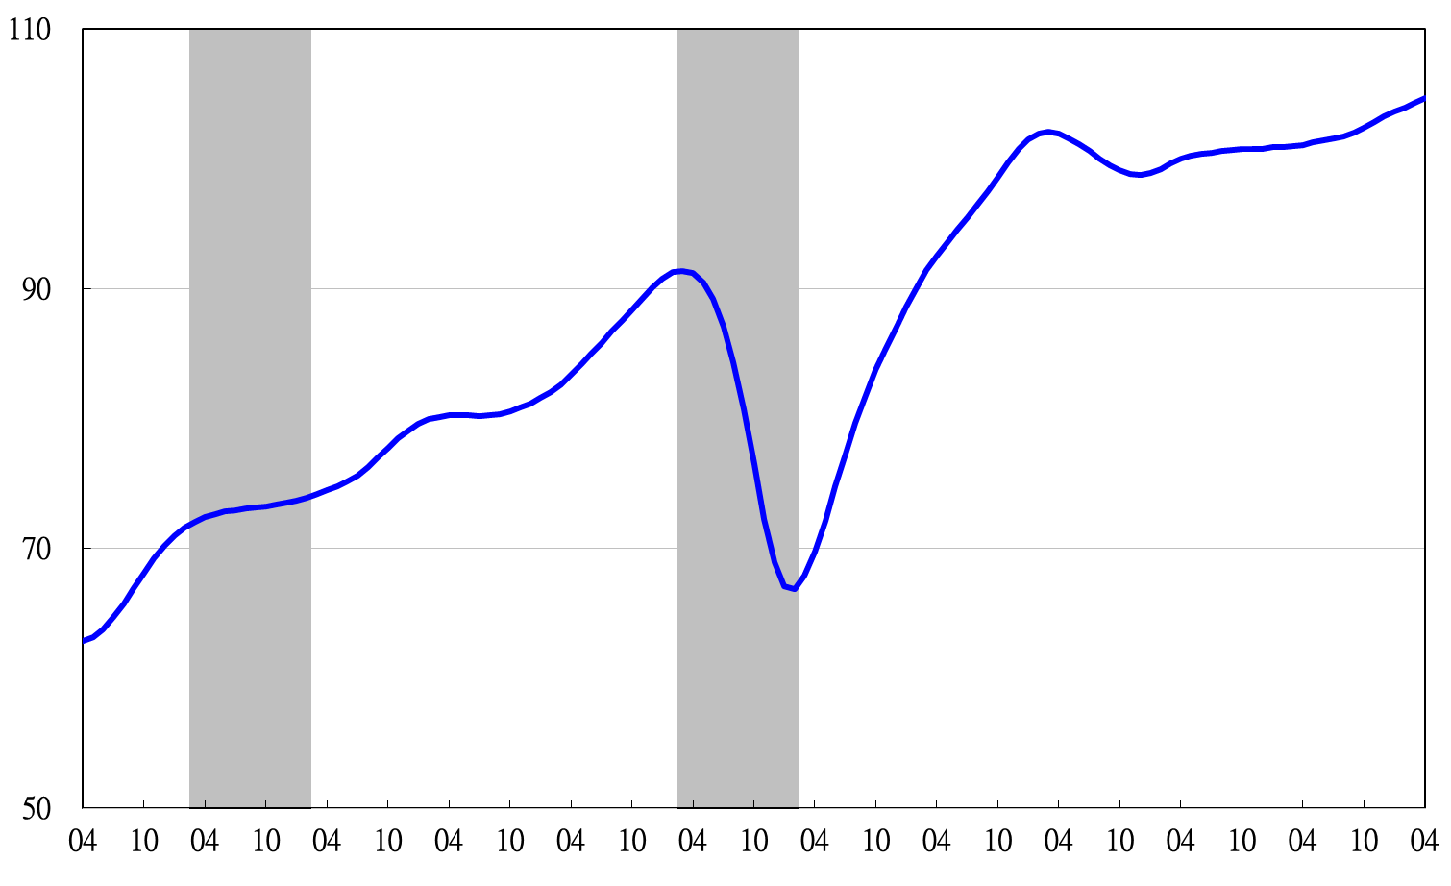

2004.3(P) 2005.2(T) 2008.3(P) 2009.2(T)

2003 2004 2005 2006 2007 2008 2009 2010 2011 2012 2013 2014

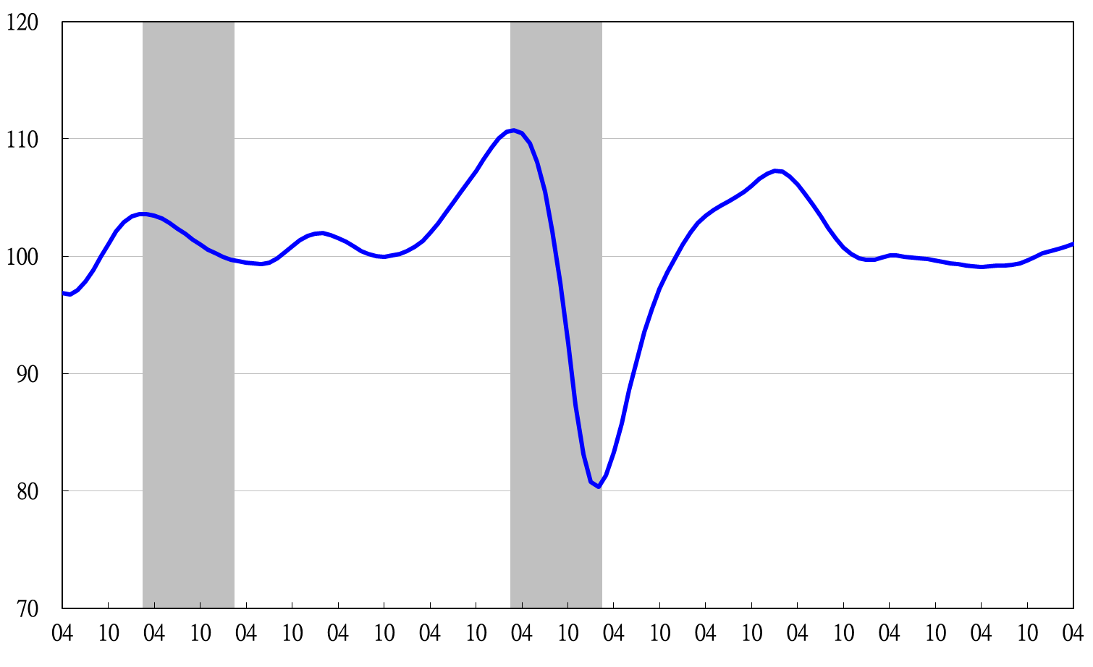**Figure 3 Composite Coincident Index**

**Figure 4 Trend-adjusted Coincident Index**

2003 2004 2005 2006 2007 2008 2009 2010 2011 2012 2013 2014

2004.3(P) 2005.2(T) 2008.3(P) 2009.2(T)

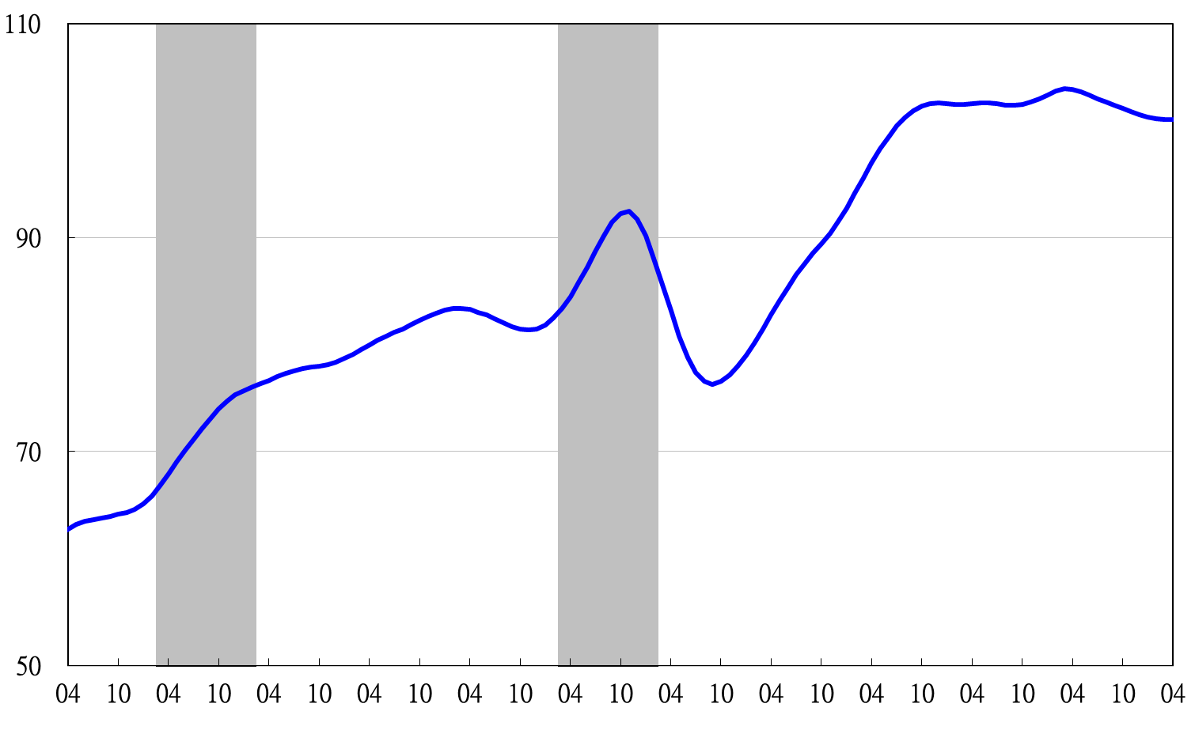

2003 2004 2005 2006 2007 2008 2009 2010 2011 2012 2013 2014

**Figure 5 Composite Lagging Index**

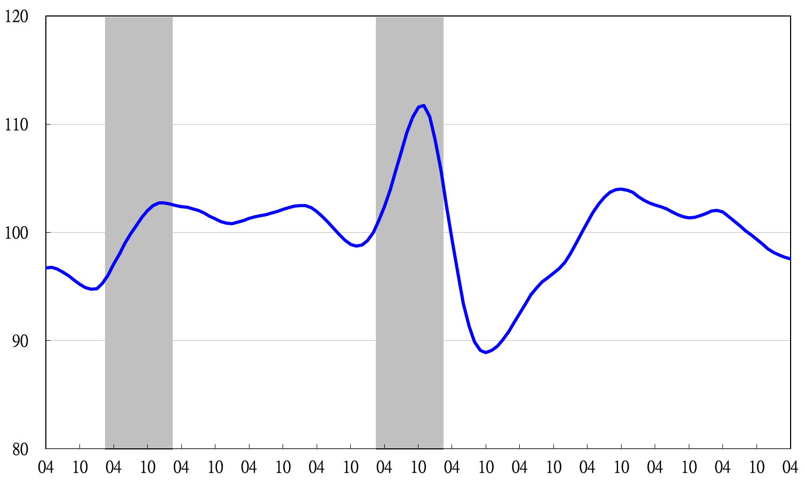

2003 2004 2005 2006 2007 2008 2009 2010 2011 2012 2013 2014

**Figure 6 Trend-adjusted Lagging Index**

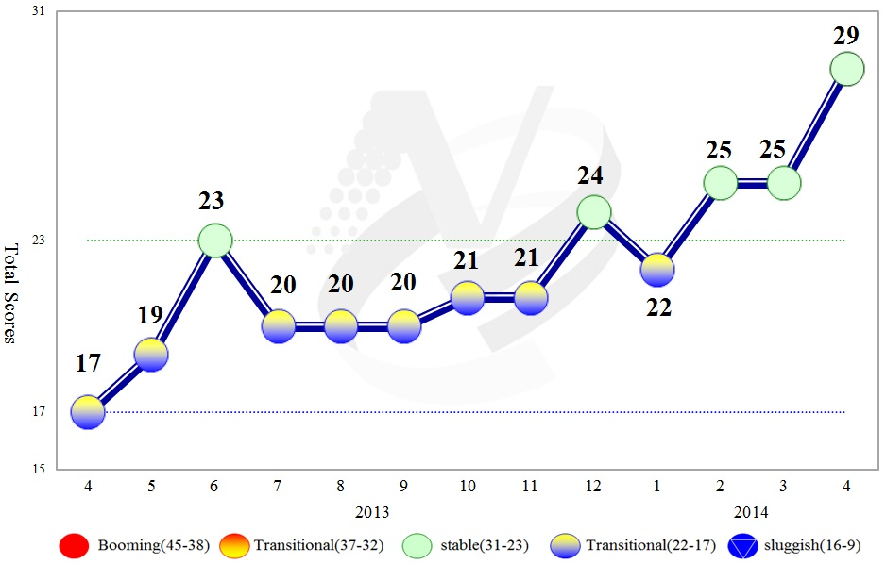

**Figure 7 Total Scores in the Past Year**

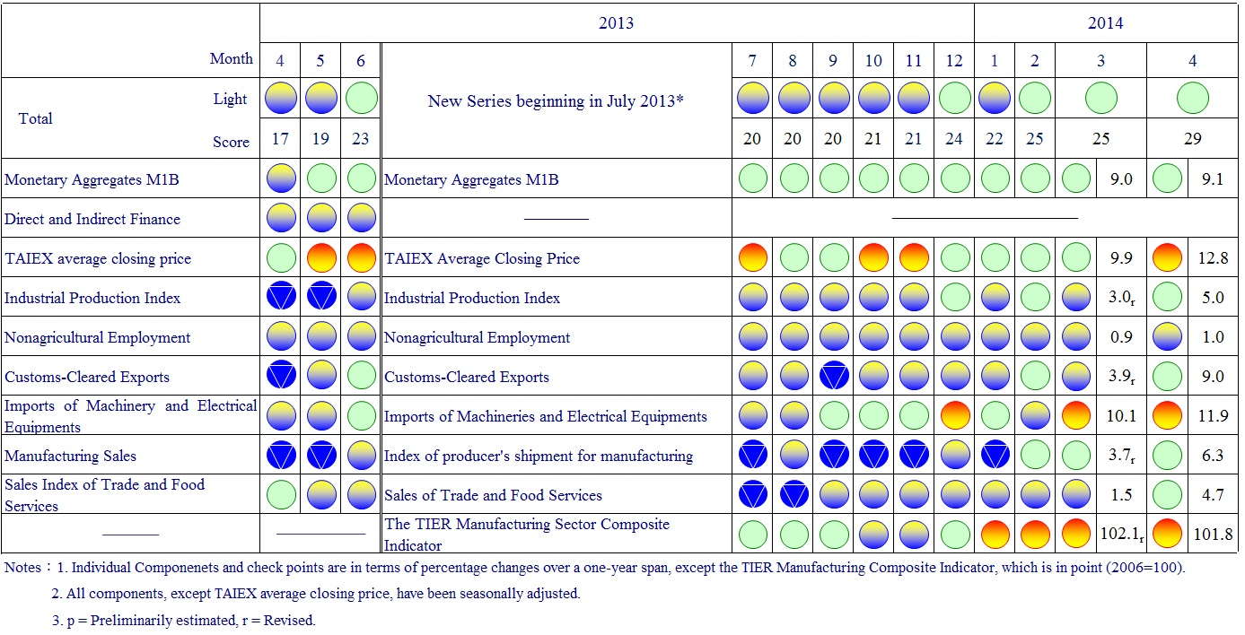

**Figure 8 Monitoring Indicators**