Taiwan Business Indicators in May 2014

Press Release

National Development Council (NDC)

June 27, 2014

In May 2014, the Taiwan Business Indicators showed that the domestic economy was stable, but some risks remained. Among the indicators compiled by the National Development Council (NDC), the trend-adjusted leading index decreased by 0.18%, the trend-adjusted coincident index increased by 0.10% from the previous month, and the overall monitoring indicator flashed the "green" signal for the fourth consecutive month.

1. Leading Indicators: With revised data, the composite leading index stood at 104.34, down by 0.04% from April 2014. Its trend-adjusted index decreased by 0.18% to 100.44. Among the seven indicators making up the trend-adjusted index, the TIER manufacturing sector composite indicator and TAIEX average closing price had positive cyclical movements from the previous month, while building permits, SEMI book-to-bill ratio, net accession rate of employees on payrolls of industry and services, the index of export orders, and real monetary aggregates M1B had negative cyclical movements.
2. Coincident Indicators: With revised data, the coincident index stood at 104.79, up by 0.23% from April 2014. Its trend-adjusted index increased by 0.10% to 100.87. Among the seven indicators making up the trend-adjusted index, the index of producer’s shipment for manufacturing, electric power consumption, sales of trade and food services, and the industrial production index had positive cyclical movements from the previous month, while real machineries and electrical equipments imports, real customs-cleared exports, and nonagricultural employment had negative cyclical movements.
3. Lagging Indicators: With revised data, the lagging index stood at 102.46, up by 0.40% from April 2014. Its trend-adjusted index increased by 0.27% to 98.63. Among the six indicators making up the trend-adjusted index, the manufacturing unit output labor cost index, the unemployment rate (inverted) , and regular employees on payrolls in industry and services had positive cyclical movements from the previous month, while the inventories to sales ratio for manufacturing, loans and investments of monetary financial institutions, and the interbank overnight call-loan rate had negative cyclical movements.
4. The Monitoring Indicators: The total score in May 2014 decreased by five points to 24, flashing the “green” signal for the fourth month. Among the nine components, the TAIEX average closing price lost one point to change its individual light signal form “yellow-red” to “green”, the customs-cleared exports and the sales of trade and food services each lost one point to change its individual light signal from “green” to “yellow-blue”, and the imports of machineries and electrical equipments lost two points to change its individual light signal form “yellow-red” to “yellow-blue”. The light signal for the rest of five components remained unchanged.

**T~~ The next release is scheduled for July 28 2014 ~~T**

# **Table 1 Leading Indicators**

Seasonally adjusted

|  |  |  |  |  |  |  |  |  |
| --- | --- | --- | --- | --- | --- | --- | --- | --- |
|  | 2013 | | | 2014 | | | | |
| Nov | Dec | Jan | | Feb | Mar | Apr | May |
| **Composite Index** | 103.64 | 103.91 | 104.11 | | 104.28 | 104.36 | 104.38 | 104.34 |
| Change from preceding month (%) | 0.29 | 0.26 | 0.19 | | 0.16 | 0.08 | 0.02 | -0.04 |
| **Trend adjusted index** | 100.59 | 100.71 | 100.77 | | 100.80 | 100.74 | 100.62 | 100.44 |
| Change from preceding month (%) | 0.16 | 0.12 | 0.06 | | 0.03 | -0.06 | -0.12 | -0.18 |
| **Components** |  |  |  | |  |  |  |  |
| Index of export orders (2011=100) | 112.28 | 118.80 | 107.04 | | 108.86 | 110.46 | 114.37 | 111.18 |
| Real monetary aggregates M1B (NT$ billion) | 12,878 | 12,943 | 13,052 | | 12,954 | 13,166 | 13,137 | 13,194 |
| TAIEX average closing price (1966=100)* | 8,237 | 8,431 | 8,567 | | 8,496 | 8,687 | 8,900 | 8,936 |
| Net accession rate of employees on payrolls of industry and services ** (%) | 0.29 | 0.08 | 0.19 | | 0.37 | 0.16 | 0.20 | 0.17p |
| Building permits *** (1,000m2) | 2,293 | 2,937 | 2,583 | | 3,592 | 2,885 | 2,968 | 2,535 |
| SEMI Book-to-Bill Ratio | 1.11 | 1.02 | 1.04 | | 1.01 | 1.06 | 1.03 | 1.00 |
| The TIER manufacturing sector composite indicator (2006=100) | 95.81 | 98.76 | 101.23 | | 101.33 | 102.11 | 101.82 | 103.86 |

Note：1. p = Preliminarily estimated.

2. * TAIEX average closing price is not seasonally adjusted.

** Net accession rate is equal to accession rate minus separation rate.

*** Including only housing, mercantile, business and service, industry warehousing.

# **Table 2 Coincident Indicators**

Seasonally adjusted

|  |  |  |  |  |  |  |  |
| --- | --- | --- | --- | --- | --- | --- | --- |
|  | 2013 | | 2014 | | | | |
| Nov | Dec | Jan | Feb | Mar | Apr | May |
| **Composite Index** | 103.01 | 103.44 | 103.75 | 104.02 | 104.27 | 104.54 | 104.79 |
| Change from preceding month (%) | 0.42 | 0.41 | 0.31 | 0.26 | 0.24 | 0.26 | 0.23 |
| **Trend adjusted index** | 99.98 | 100.26 | 100.43 | 100.55 | 100.65 | 100.78 | 100.87 |
| Change from preceding month (%) | 0.29 | 0.27 | 0.17 | 0.12 | 0.10 | 0.13 | 0.10 |
| **Components** |  |  |  |  |  |  |  |
| Industrial production index (2011=100) | 102.2 | 104.3 | 102.5 | 103.8 | 101.8 | 104.0 | 104.8 |
| Electric power consumption (billion kWh) | 11.84 | 11.78 | 12.03 | 12.07 | 11.66 | 11.93 | 12.09 |
| Index of producer’s shipment for manufacturing (2011=100) | 99.0 | 101.8 | 97.5 | 102.0 | 99.5 | 102.3 | 101.5p |
| Sales of trade and food services (NT$ billion) | 1,199 | 1,211 | 1,220 | 1,192 | 1,191 | 1,220 | 1,221 |
| Nonagricultural employment (thousand persons) | 10,463 | 10,471 | 10,482 | 10,496 | 10,499 | 10,512 | 10,520 |
| Real customs-cleared exports (NT$ billion) | 785.9 | 804.4 | 774.9 | 802.6 | 804.0 | 826.6 | 789.9 |
| Real machineries and electrical equipments imports (NT$ billion) | 208.1 | 246.7 | 216.6 | 206.4 | 228.0 | 229.9 | 203.8 |

# **Table 3 Lagging Indicators**

Seasonally adjusted

|  |  |  |  |  |  |  |  |
| --- | --- | --- | --- | --- | --- | --- | --- |
|  | 2013 | | 2014 | | | | |
| Nov | Dec | Jan | Feb | Mar | Apr | May |
| **Composite Index** | 101.93 | 101.64 | 101.49 | 101.50 | 101.71 | 102.04 | 102.46 |
| Change from preceding month (%) | -0.30 | -0.28 | -0.15 | 0.01 | 0.21 | 0.33 | 0.40 |
| **Trend adjusted index** | 98.93 | 98.52 | 98.23 | 98.11 | 98.18 | 98.37 | 98.63 |
| Change from preceding month (%) | -0.44 | -0.42 | -0.29 | -0.13 | 0.08 | 0.19 | 0.27 |
| **Components** |  |  |  |  |  |  |  |
| Unemployment rate* (%) | 4.15 | 4.14 | 4.07 | 4.05 | 4.06 | 4.04 | 3.99 |
| Regular employees on payrolls  in industry & services (thousand persons) | 7,008 | 7,013 | 7,026 | 7,034 | 7,044 | 7,057 | 7,069p |
| The manufacturing unit output labor cost index  (2011=100) | 103.7 | 100.7 | 101.7 | 97.4 | 104.0 | 102.8 | 107.3p |
| Interbank overnight call-loan rate**  (percent per annum) | 0.386 | 0.387 | 0.388 | 0.387 | 0.387 | 0.387 | 0.388 |
| Loans and investments of monetary financial institutions (NT$ billion) | 26,745 | 26,695 | 26,886 | 27,006 | 27,126 | 27,263 | 27,333 |
| Inventories to sales ratio for manufacturing (%) | 66.8 | 65.5 | 66.5 | 65.2 | 65.8 | 63.2 | 63.4p |

Note： * This series is inverted while aggregating composite lagging index.

** Interbank overnight call-loan rate is not seasonally adjusted.

2004.3(P) 2005.2(T) 2008.3(P) 2009.2(T)

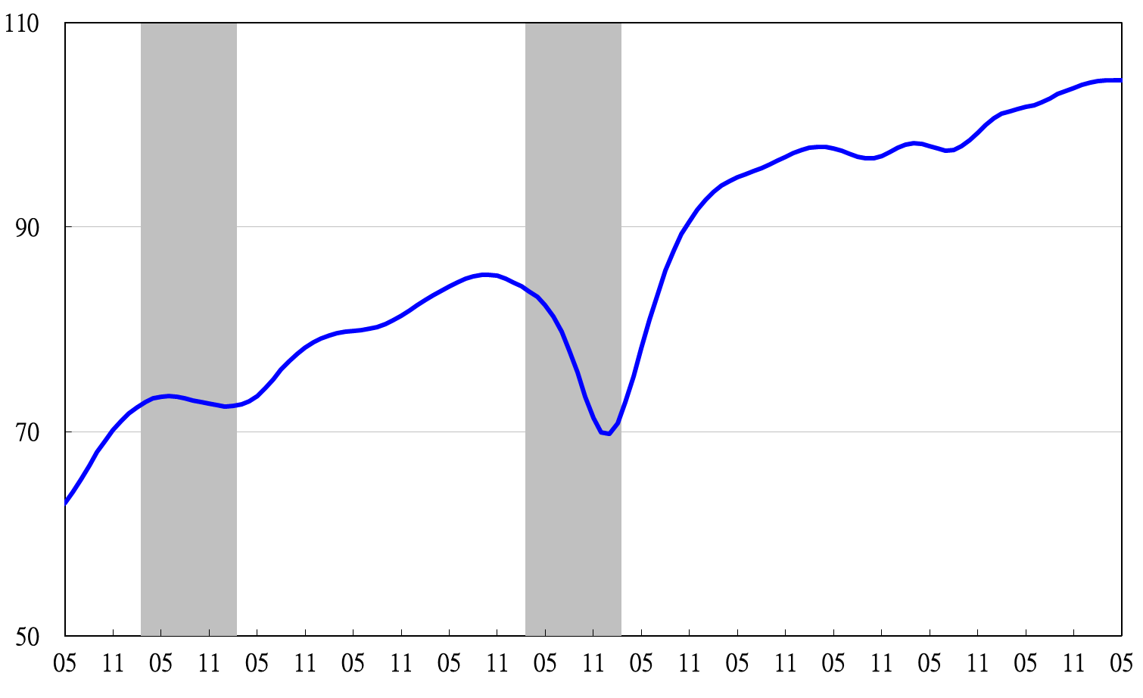

Note: Shaded areas represent recessions.

2003 2004 2005 2006 2007 2008 2009 2010 2011 2012 2013 2014

**Figure 1 Composite Leading Index**

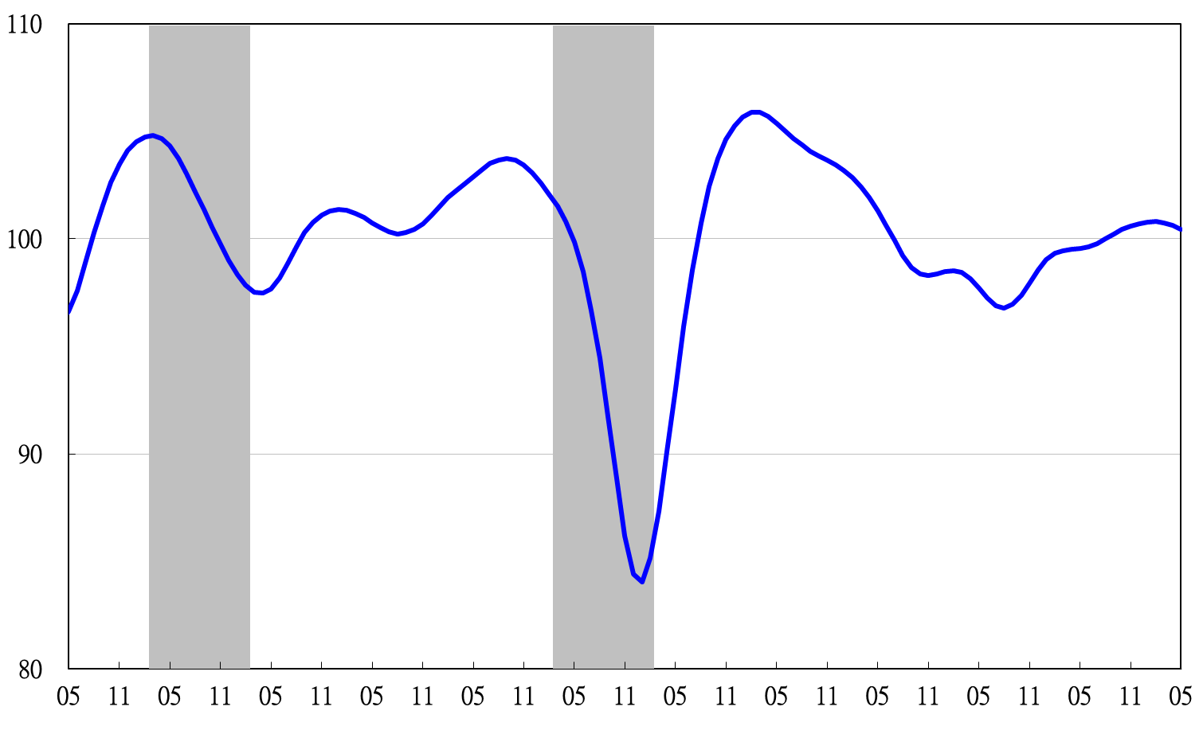

2003 2004 2005 2006 2007 2008 2009 2010 2011 2012 2013 2014

**Figure 2 Trend-adjusted Leading Index**

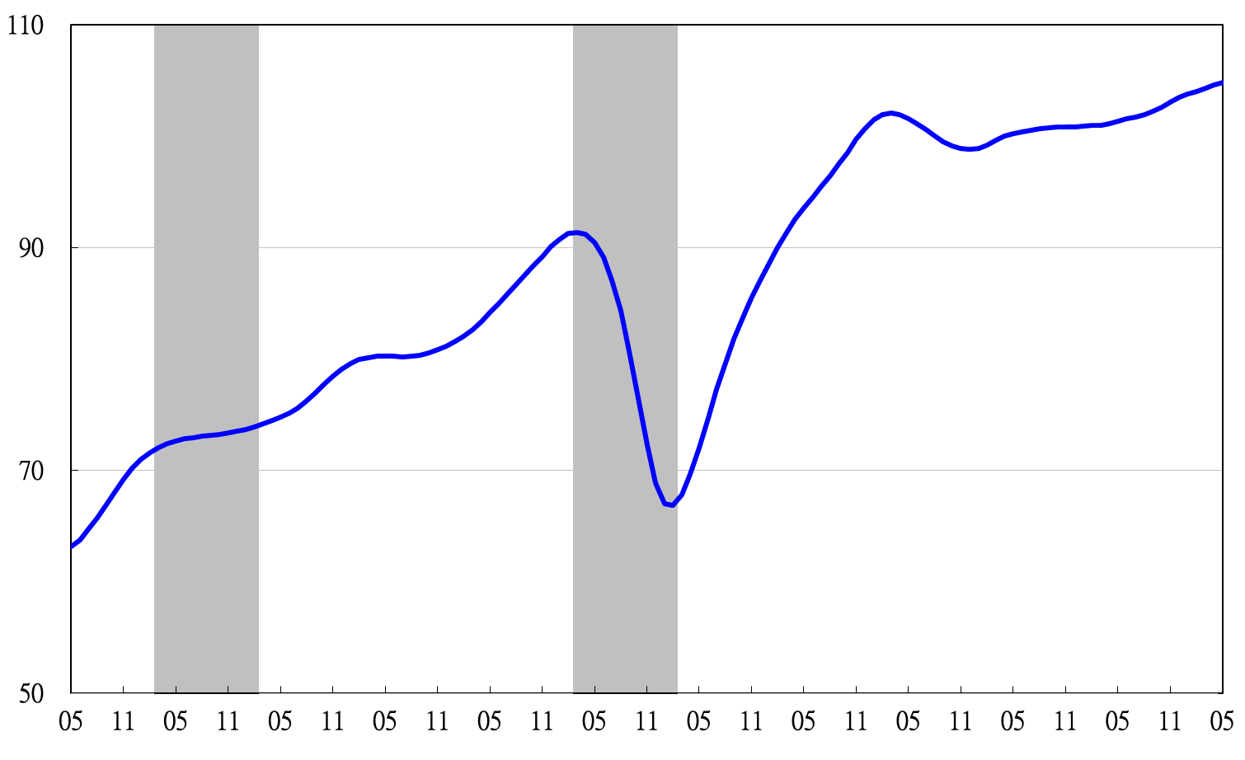

2004.3(P) 2005.2(T) 2008.3(P) 2009.2(T)

**Figure 3 Composite Coincident Index**

2003 2004 2005 2006 2007 2008 2009 2010 2011 2012 2013 2014

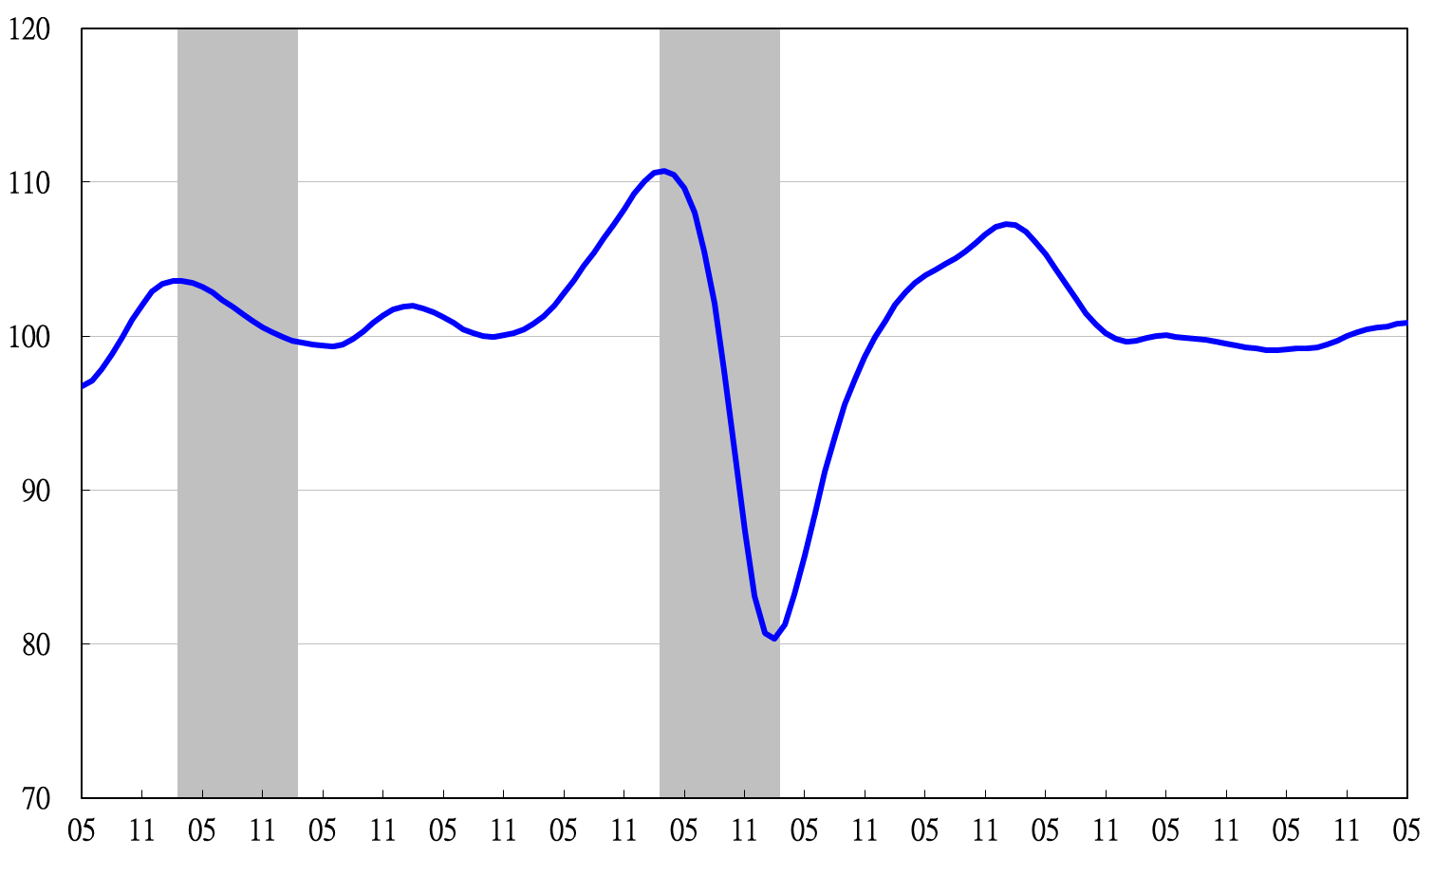**Figure 4 Trend-adjusted Coincident Index**

2003 2004 2005 2006 2007 2008 2009 2010 2011 2012 2013 2014

2003 2004 2005 2006 2007 2008 2009 2010 2011 2012 2013 2014

2004.3(P) 2005.2(T) 2008.3(P) 2009.2(T)

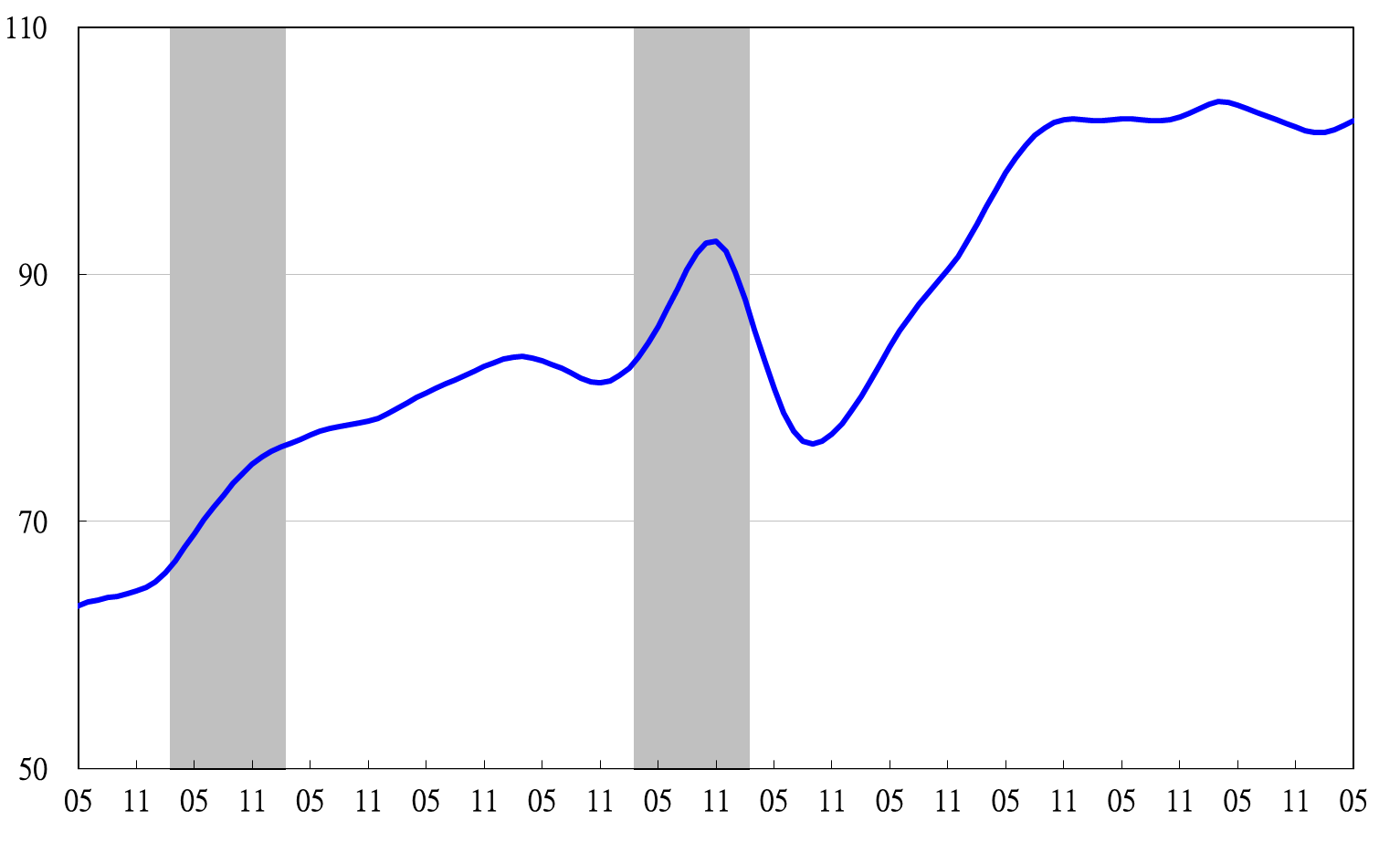

2003 2004 2005 2006 2007 2008 2009 2010 2011 2012 2013 2014

**Figure 5 Composite Lagging Index**

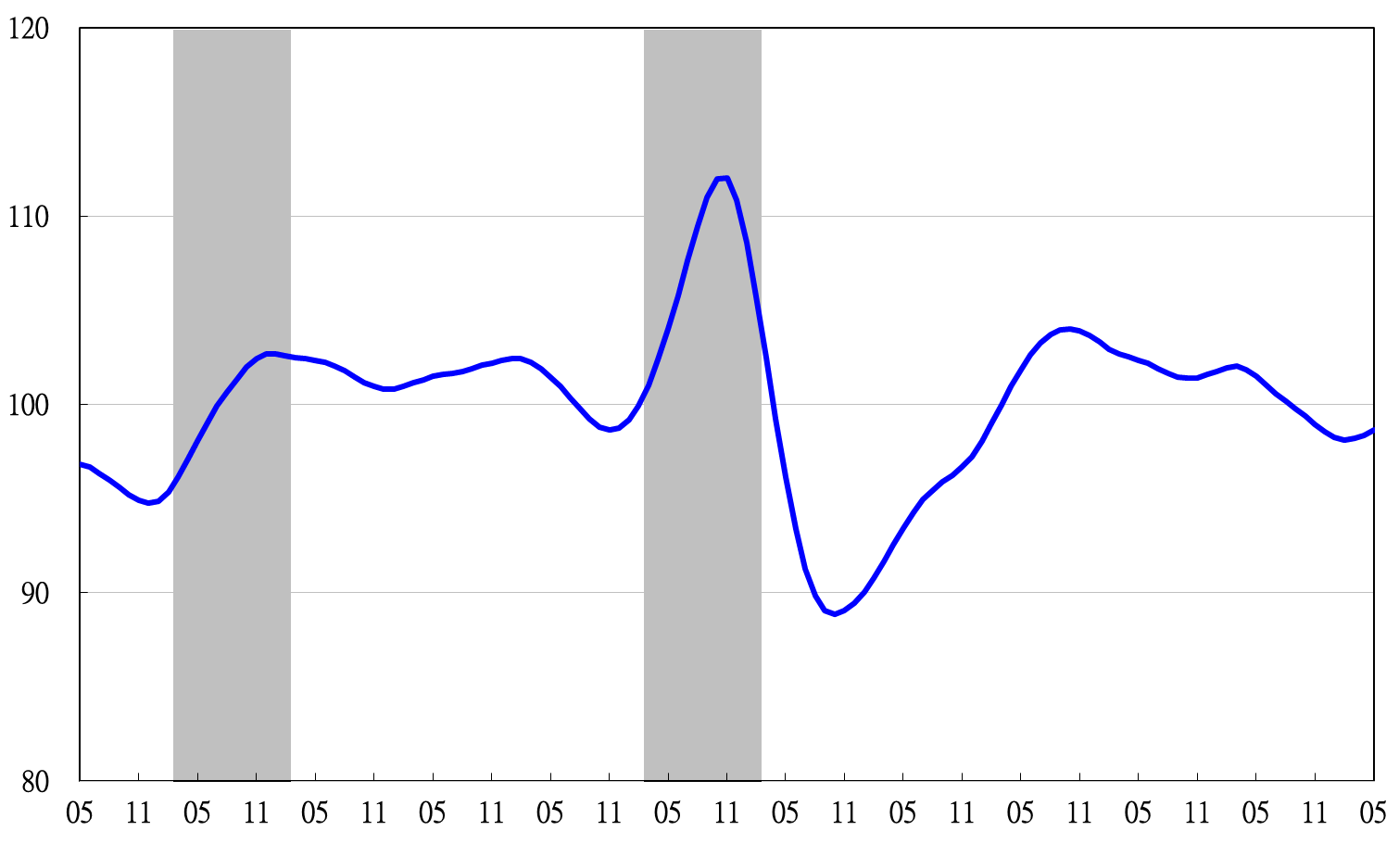

2003 2004 2005 2006 2007 2008 2009 2010 2011 2012 2013 2014

**Figure 6 Trend-adjusted Lagging Index**

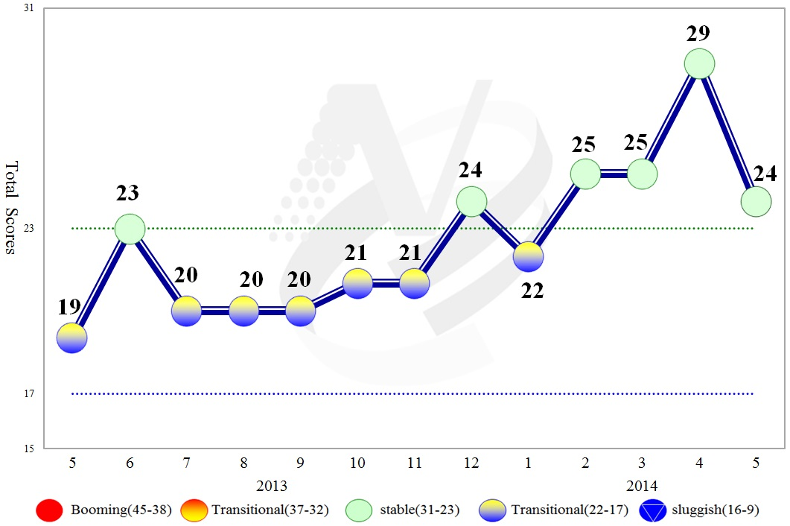

**Figure 7 Total Scores in the Past Year**

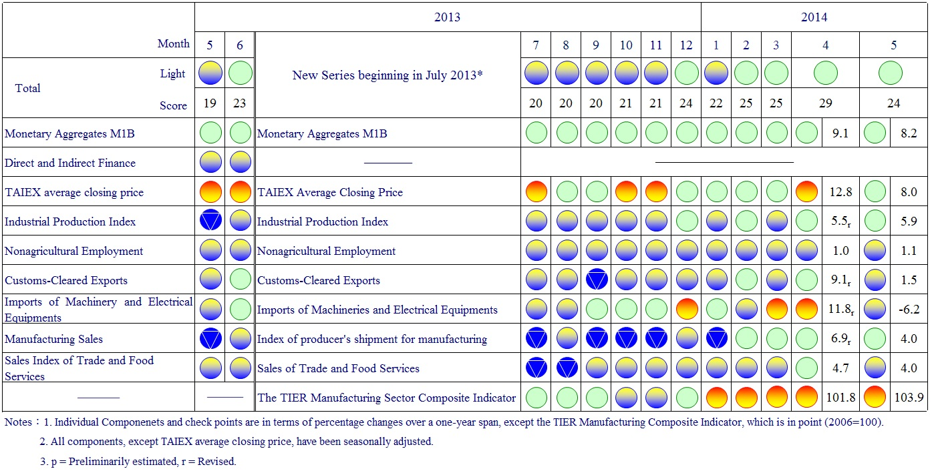

**Figure 8 Monitoring Indicators**