Taiwan Business Indicators in April 2015

Press Release

National Development Council (NDC)

May 27, 2015

In April 2015, Taiwan Business Indicators indicated that the economy has been on the downturn, mainly due to poor export. Among the indicators compiled by the National Development Council (NDC), the trend-adjusted leading index decreased by 0.58%, the trend-adjusted coincident index decreased by 0.55% from the previous month, and the overall monitoring indicator flashed the " blue " signal.

1. The Monitoring Indicators: The total score in March was adjusted upward by one point to 22, following the revision of the index of producer’s shipment for manufacturing. The total score in April decreased by six points to 16, flashing the “blue” signal for the first month. Among the nine components, the industrial production index、the nonagricultural employment、the TIER manufacturing sector composite indicator each lost one point to change its individual light form “green” to “yellow-blue”, while the sales of trade and food services lost one point to change its individual light from “yellow-blue” to “blue”, and the index of producer’s shipment for manufacturing lost two points to change its individual light from “green” to “blue”. The light signal for the rest of four components remained unchanged.
2. Leading Indicators: With revised data, the trend-adjusted leading index stood at 97.74, down by 0.58% from March 2015. Among the seven indicators making up the trend-adjusted index, SEMI book-to-bill ratio, TAIEX average closing price, and real monetary aggregates M1B had positive cyclical movements from the previous month, while building permits, the index of export orders, the TIER manufacturing sector composite indicator, and net accession rate of employees on payrolls of industry and services had negative cyclical movements.
3. Coincident Indicators: With revised data, the trend-adjusted coincident index stood at 99.29, down by 0.55% from March 2015. Among the seven indicators making up the trend-adjusted index, electric power consumption and nonagricultural employment had positive cyclical movements from the previous month, while the industrial production index, real machineries electrical equipments imports, real customs-cleared exports, sales of trade and food services, and the index of producer’s shipment for manufacturing had negative cyclical movements.
4. Lagging Indicators: With revised data, the trend-adjusted lagging index stood at 101.76, up by 0.46% from March 2015. Among the six indicators making up the trend-adjusted index, the manufacturing unit output labor cost index, the inventories to sales ratio for manufacturing, and the unemployment rate (inverted) had positive cyclical movements from the previous month, while loans and investments of monetary financial institutions, regular employees on payrolls in industry and services, and the interbank overnight call-loan rate had negative cyclical movement.

**T~~ The next release is scheduled for June 26 2015 ~~T**

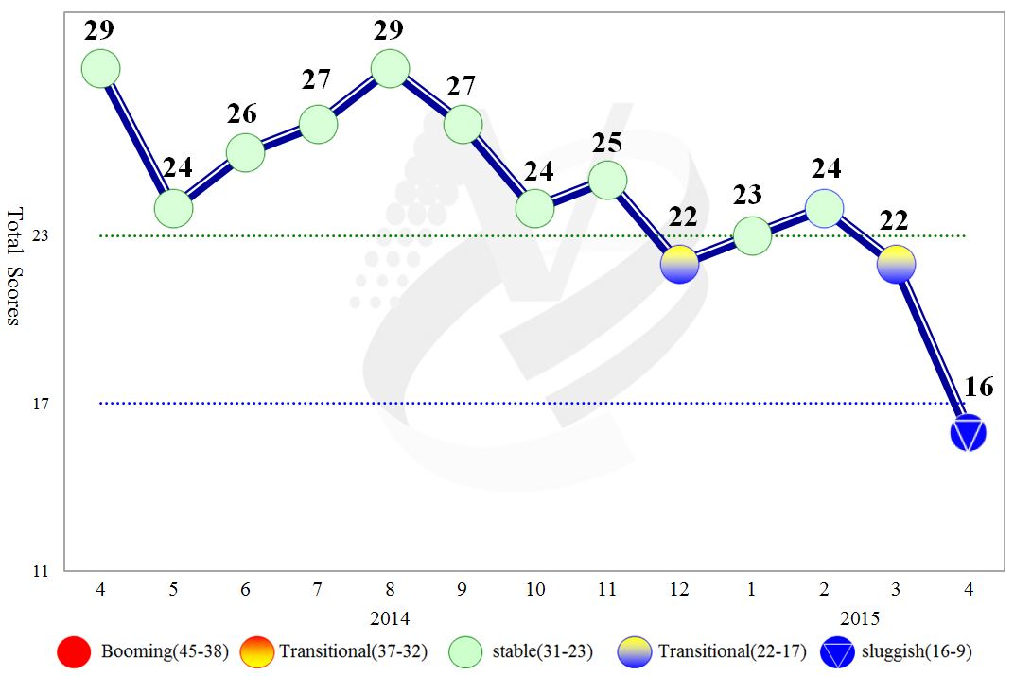

**Figure 1 Total Scores in the Past Year**

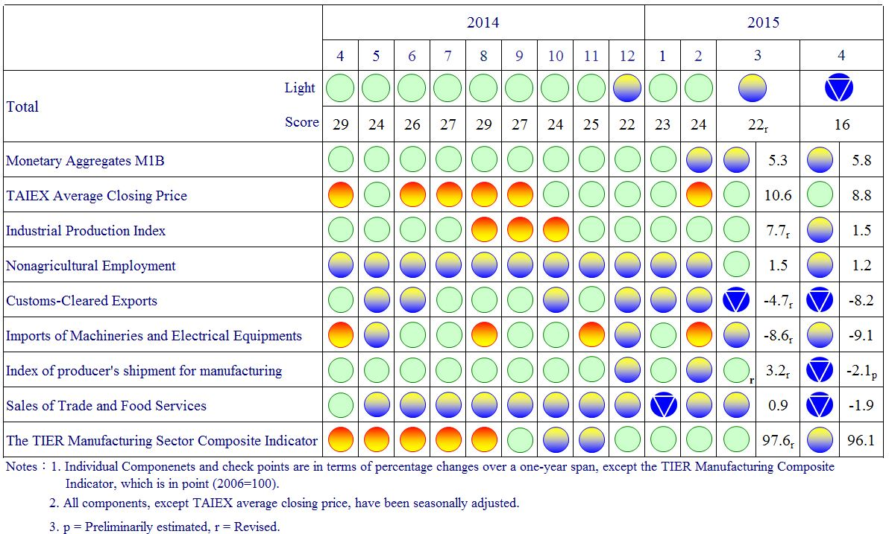

**Figure 2 Monitoring Indicators**

**Table 1 Leading Indicators**

Index

|  |  |  |  |  |  |  |  |
| --- | --- | --- | --- | --- | --- | --- | --- |
|  | 2014 | | | 2015 | | | |
| Oct | Nov | Dec | Jan | Feb | Mar | Apr |
| **Trend adjusted index** | 100.39 | 100.15 | 99.83 | 99.39 | 98.87 | 98.31 | 97.74 |
| Change from preceding month (%) | -0.19 | -0.24 | -0.32 | -0.43 | -0.53 | -0.57 | -0.58 |
| **Components1** |  |  |  |  |  |  |  |
| Index of export orders | 101.37 | 101.33 | 101.03 | 100.51 | 99.94 | 99.44 | 98.98 |
| Real monetary aggregates M1B | 100.04 | 100.09 | 100.13 | 100.16 | 100.17 | 100.17 | 100.18 |
| TAIEX average closing price | 100.09 | 100.05 | 100.05 | 100.07 | 100.11 | 100.16 | 100.21 |
| Net accession rate of employees on payrolls of industry and services 2 | 100.01 | 100.01 | 100.00 | 100.00 | 99.99 | 99.95 | 99.91 |
| Building permits 3 | 99.94 | 99.76 | 99.54 | 99.23 | 98.82 | 98.31 | 97.75 |
| SEMI Book-to-Bill Ratio | 99.66 | 99.67 | 99.73 | 99.83 | 99.95 | 100.07 | 100.17 |
| The TIER manufacturing sector composite indicator | 99.93 | 99.72 | 99.61 | 99.55 | 99.49 | 99.42 | 99.34 |

Note：1.All components are passed through seasonal adjustment, trend-removal, smoothing and normalization.

2. Net accession rate is equal to accession rate minus separation rate.

3. Including only housing, mercantile, business and service, industry warehousing.

2004.3(P) 2005.2(T) 2008.3(P) 2009.2(T) 2011.2(P) 2012.1(T)

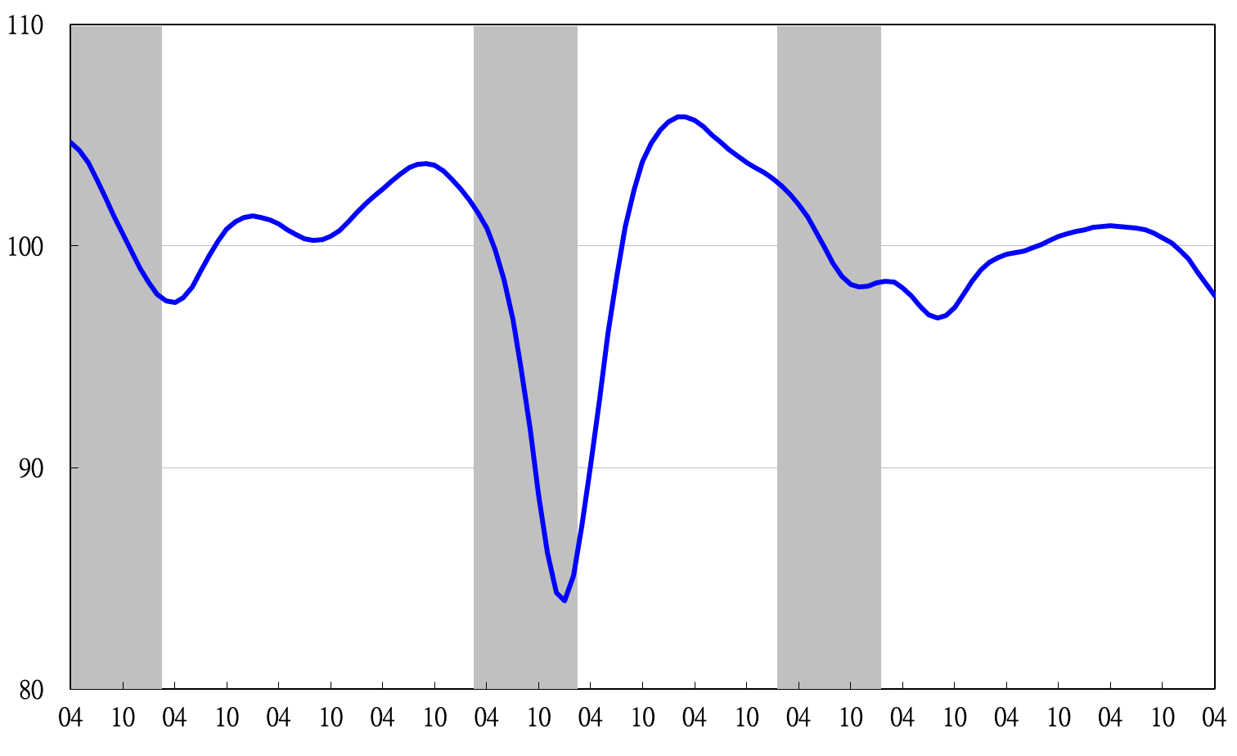

Note: Shaded areas represent recessions.

2004 2005 2006 2007 2008 2009 2010 2011 2012 2013 2014 2015

**Figure 3 Trend-adjusted Leading Index**

**Table 2 Coincident Indicators**

Index

|  |  |  |  |  |  |  |  |
| --- | --- | --- | --- | --- | --- | --- | --- |
|  | 2014 | | | 2015 | | | |
| Oct | Nov | Dec | Jan | Feb | Mar | Apr |
| **Trend adjusted index** | 101.58 | 101.45 | 101.17 | 100.78 | 100.35 | 99.85 | 99.29 |
| Change from preceding month (%) | -0.01 | -0.13 | -0.27 | -0.38 | -0.43 | -0.50 | -0.55 |
| **Components** |  |  |  |  |  |  |  |
| Industrial production index | 100.75 | 100.75 | 100.67 | 100.51 | 100.29 | 100.02 | 99.69 |
| Electric power consumption | 100.22 | 100.06 | 99.87 | 99.73 | 99.72 | 99.82 | 99.93 |
| Index of producer’s shipment for manufacturing | 100.52 | 100.46 | 100.37 | 100.24 | 100.08 | 99.87 | 99.64 |
| Sales of trade and food services | 100.22 | 100.17 | 100.08 | 99.92 | 99.72 | 99.50 | 99.26 |
| Nonagricultural employment | 99.68 | 99.73 | 99.80 | 99.88 | 99.97 | 100.08 | 100.16 |
| Real customs-cleared exports | 100.37 | 100.30 | 100.18 | 100.02 | 99.81 | 99.54 | 99.25 |
| Real machineries and electrical equipments imports | 100.50 | 100.51 | 100.42 | 100.25 | 100.01 | 99.72 | 99.42 |

2004.3(P) 2005.2(T) 2008.3(P) 2009.2(T) 2011.2(P) 2012.1(T)

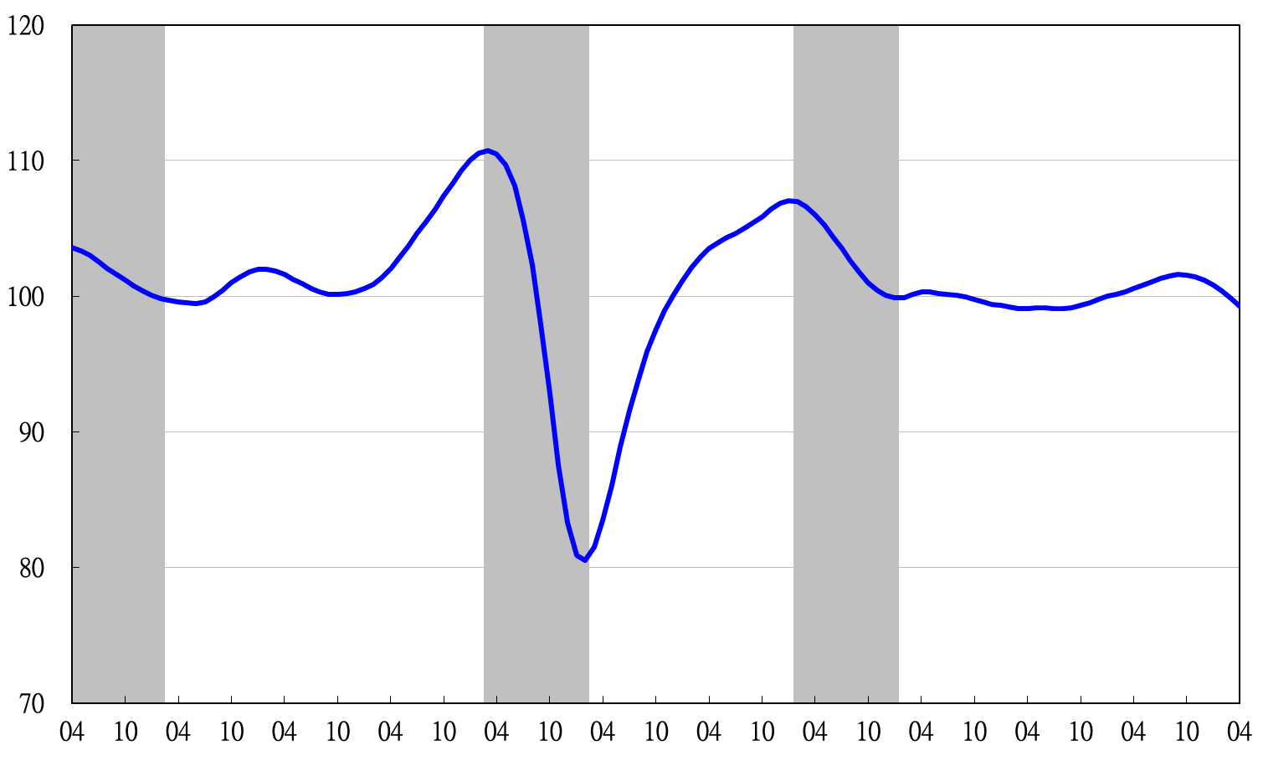

2004 2005 2006 2007 2008 2009 2010 2011 2012 2013 2014 2015

**Figure 4 Trend-adjusted Coincident Index**

**Table 3 Lagging Indicators**

Index

|  |  |  |  |  |  |  |  |
| --- | --- | --- | --- | --- | --- | --- | --- |
|  | 2014 | | | 2015 | | | |
| Oct | Nov | Dec | Jan | Feb | Mar | Apr |
| **Trend adjusted index** | 98.72 | 99.06 | 99.53 | 100.16 | 100.80 | 101.29 | 101.76 |
| Change from preceding month (%) | 0.18 | 0.35 | 0.47 | 0.63 | 0.64 | 0.49 | 0.46 |
| **Components** |  |  |  |  |  |  |  |
| Unemployment rate | 99.94 | 99.99 | 100.05 | 100.09 | 100.13 | 100.15 | 100.16 |
| Regular employees on payrolls  in industry & services | 99.96 | 99.98 | 99.99 | 99.99 | 99.99 | 99.99 | 99.98 |
| The manufacturing unit output labor cost index | 99.06 | 99.16 | 99.42 | 99.91 | 100.44 | 100.82 | 101.19 |
| Interbank overnight call-loan rate | 99.97 | 99.97 | 99.97 | 99.96 | 99.96 | 99.96 | 99.95 |
| Loans and investments of monetary financial institutions | 99.91 | 99.88 | 99.84 | 99.82 | 99.81 | 99.80 | 99.78 |
| Inventories to sales ratio for manufacturing | 99.66 | 99.93 | 100.18 | 100.40 | 100.60 | 100.80 | 101.00 |

2004.3(P) 2005.2(T) 2008.3(P) 2009.2(T) 2011.2(P) 2012.1(T)

2004 2005 2006 2007 2008 2009 2010 2011 2012 2013 2014 2015

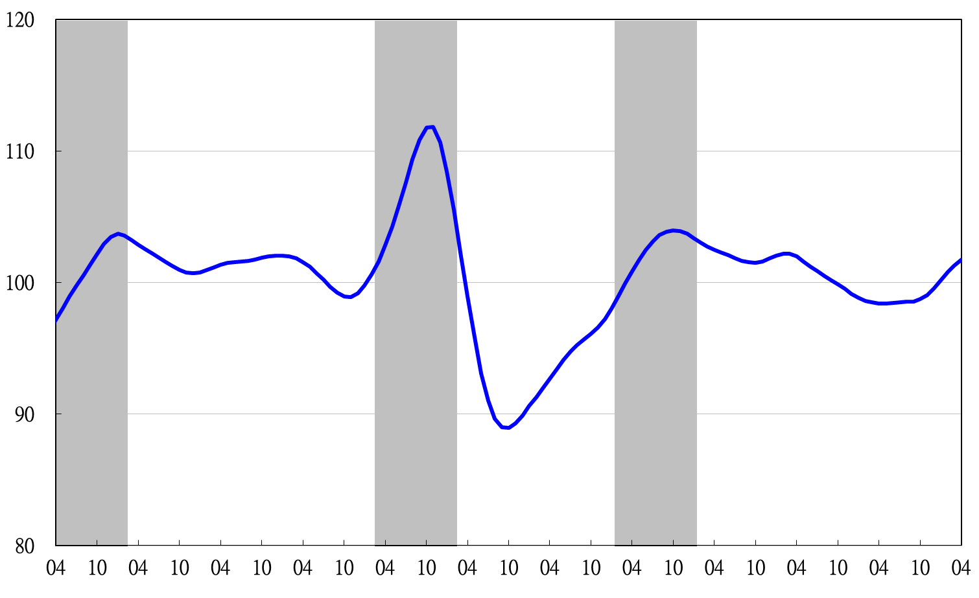

**Figure 5 Trend-adjusted Lagging Index**

2003 2004 2005 2006 2007 2008 2009 2010 2011 2012 2013 2014