Taiwan Business Indicators in June 2013

Press Release

Council for Economic Planning and Development, Executive Yuan

July 26, 2013

In June 2013, the Taiwan Business Indicators showed the economic recovery to remain on the slower track. Among the indicators compiled by the Cabinet’s Council for Economic Planning and Development (CEPD), the annualized six-month rate of change of leading index increased by 0.2 points, the trend-adjusted coincident index increased by 0.4% from the previous month, and the overall monitoring indicator flashed the "green" signal.

1. Leading Indicators: With revised data, the composite leading index stood at 104.2, up by 0.6% from May 2013. Its annualized six-month rate of change increased by 0.2 points to 7.0%. Among the seven indicators making up the trend-adjusted index, the index of producer's inventory for manufacturing (inverted), real monetary aggregates M1B, SEMI book-to-bill ratio, average monthly overtime in industry and services, and the stock price index had positive cyclical movements from the previous month, while the index of export orders and building permits had negative cyclical movement.
2. Coincident Indicators: With revised data, the coincident index stood at 102.8, up by 0.6% from May 2013. Its trend-adjusted index increased by 0.4% to 99.9. Among the seven indicators making up the trend-adjusted index, electric power consumption, real machineries and electrical equipments imports, and real customs-cleared exports had positive cyclical movements from the previous month, while nonagricultural employment, the industrial production index, the index of producer’s shipment for manufacturing, and the sales index of trade and food services had negative cyclical movements.
3. Lagging Indicators: With revised data, the lagging index stood at 102.3, down by 0.3% from May 2013. Its trend-adjusted index decreased by 0.5% to 99.4. Among the six indicators making up the trend-adjusted index, the manufacturing unit output labor cost index had positive cyclical movement from the previous month, while the inventories to sales ratio for manufacturing, the unemployment rate (inverted), regular employees on payrolls in industry and services, loans and investments of monetary financial institutions, and the interbank overnight call-loan rate had negative cyclical movements.
4. The Monitoring Indicators: The total score in June increased by four points to 23, flashing the “green” signal for the first month. Among the nine components, industrial production index and manufacturing sales each changed its individual light signal from “blue” to “yellow-blue”, customs cleared exports and imports of machineries and electrical equipments each changed its individual light signal from “yellow-blue” to “green”, each gained one point. The light signals for the rest of five components remained unchanged.

**T~~ The next release is scheduled for August 27 2013 ~~T**

# **Leading Indicators**

Seasonally adjusted

|  |  |  |  |  |  |  |  |
| --- | --- | --- | --- | --- | --- | --- | --- |
|  | 2012 | 2013 | | | | | |
| Dec | Jan | Feb | Mar | Apr | May | Jun |
| **Composite Index** | 100.8 | 101.4 | 102.0 | 102.5 | 103.0 | 103.6 | 104.2 |
| Change from preceding month (%) | 0.7 | 0.7 | 0.5 | 0.5 | 0.6 | 0.6 | 0.6 |
| Annualized 6-month rate of change (%) | 4.7 | 5.4 | 5.8 | 6.1 | 6.5 | 6.8 | 7.0 |
| Change from preceding month (point) | 0.9 | 0.7 | 0.4 | 0.3 | 0.4 | 0.3 | 0.2 |
| **Components** |  |  |  |  |  |  |  |
| Index of export orders (2011=100) | 112.0 | 106.9 | 103.0 | 99.8 | 102.8 | 102.5 | 102.4 |
| Real monetary aggregates M1B (NT$ billion) | 11,945 | 12,029 | 11,908 | 12,234 | 12,250 | 12,417 | 12,541 |
| Stock price index(1966=100) | 7,631 | 7,759 | 7,933 | 7,907 | 7,893 | 8,272 | 7,989 |
| Index of producer's Inventory for manufacturing*(2011=100) | 108.3 | 107.8 | 108.0 | 110.7 | 110.4 | 106.3 | 105.9p |
| Average monthly overtime in industry and services (hours/month) | 8.2 | 8.2 | 8.4 | 8.3 | 8.4 | 8.4 | 8.4p |
| Building Permits ** (1,000m2) | 2,267 | 2,741 | 2,905 | 2,319 | 3,016 | 3,022 | 2,311 |
| SEMI Book-to-Bill Ratio | 0.92 | 1.11 | 1.10 | 1.11 | 1.08 | 1.08 | 1.10 |

Note：1. p=Preliminary.

2. * This series is inverted while aggregating composite leading index.

** Including only housing, mercantile, business and service, industry warehousing.

# **Coincident Indicators**

Seasonally adjusted

|  |  |  |  |  |  |  |  |
| --- | --- | --- | --- | --- | --- | --- | --- |
|  | 2012 | 2013 | | | | | |
| Dec | Jan | Feb | Mar | Apr | May | Jun |
| **Composite Index** | 101.0 | 101.2 | 101.2 | 101.4 | 101.7 | 102.2 | 102.8 |
| Change from preceding month (%) | 0.1 | 0.1 | 0.1 | 0.1 | 0.3 | 0.5 | 0.6 |
| Trend adjusted index | 99.2 | 99.2 | 99.1 | 99.0 | 99.2 | 99.5 | 99.9 |
| Change from preceding month (%) | -0.1 | -0.1 | -0.1 | -0.0 | 0.2 | 0.3 | 0.4 |
| **Components** |  |  |  |  |  |  |  |
| Industrial production index(2011=100) | 99.5 | 101.7 | 100.1 | 99.2 | 98.2 | 99.0 | 99.7 |
| Electric power consumption (billion kWh) | 11.02 | 12.05 | 11.77 | 11.39 | 11.87 | 11.94 | 12.39 |
| Index of producer’s shipment for manufacturing (2011=100) | 99.3 | 101.5 | 97.5 | 94.9 | 96.3 | 97.9 | 97.7p |
| Sales index of trade and food services (2006=100) | 111.7 | 110.6 | 110.2 | 109.6 | 110.9 | 111.0 | 110.3 |
| Nonagricultural employment (1,000) | 10,373 | 10,381 | 10,400 | 10,404 | 10,408 | 10,412 | 10,421 |
| Real customs-cleared exports (NT$ billion) | 786.2 | 775.4 | 751.1 | 779.3 | 767.9 | 783.9 | 804.7 |
| Real machineries and electrical equipments imports* (NT$ billion) | 204.5 | 217.8 | 211.3 | 211.7 | 207.8 | 216.9 | 218.9 |

Note：*Due to the original statistical bureau no longer compiling “electronic machinery” import price index, this deflator has replaced with “machinery, electrical equipment, TV image & sound recorders, etc.” import price index starting from January 2013.

# **Lagging Indicators**

Seasonally adjusted

|  |  |  |  |  |  |  |  |  |
| --- | --- | --- | --- | --- | --- | --- | --- | --- |
|  | 2012 | | 2013 | | | | | |
| Dec | Jan | | Feb | Mar | Apr | May | Jun |
| **Composite Index** | 102.4 | 102.6 | | 102.8 | 102.9 | 102.8 | 102.6 | 102.3 |
| Change from preceding month (%) | 0.2 | 0.2 | | 0.2 | 0.1 | -0.1 | -0.2 | -0.3 |
| Trend adjusted index | 100.6 | 100.6 | | 100.6 | 100.6 | 100.3 | 99.9 | 99.4 |
| Change from preceding month (%) | -0.0 | 0.0 | | 0.0 | -0.1 | -0.3 | -0.4 | -0.5 |
| **Components** |  |  | |  |  |  |  |  |
| Unemployment rate* (%) | 4.21 | 4.20 | | 4.16 | 4.18 | 4.19 | 4.19 | 4.17 |
| Regular employees on payrolls  in industry & services (Thousand persons) | 6,795 | 6,804 | | 6,819 | 6,820 | 6,827 | 6,835 | 6,843p |
| The manufacturing unit output labor cost index  (index 2006=100) | 85.4 | 78.9 | | 85.6 | 84.5 | 85.4 | 84.6 | 84.3p |
| Interbank overnight call-loan rate  (percent per annum) | 0.388 | 0.387 | | 0.387 | 0.387 | 0.386 | 0.386 | 0.386 |
| Loans and investments of monetary financial institutions (NT$ billion) | 25,510 | 25,602 | | 25,718 | 25,934 | 25,986 | 25,979 | 26,131 |
| Inventories to sales ratio for manufacturing (%) | 69.0 | 68.2 | | 70.1 | 73.2 | 72.0 | 66.8 | 66.5p |

Note： * This series is inverted while aggregating composite lagging index.

**Composite Leading Index**

2004.3(P) 2005.2(T) 2008.3(P) 2009.2(T)

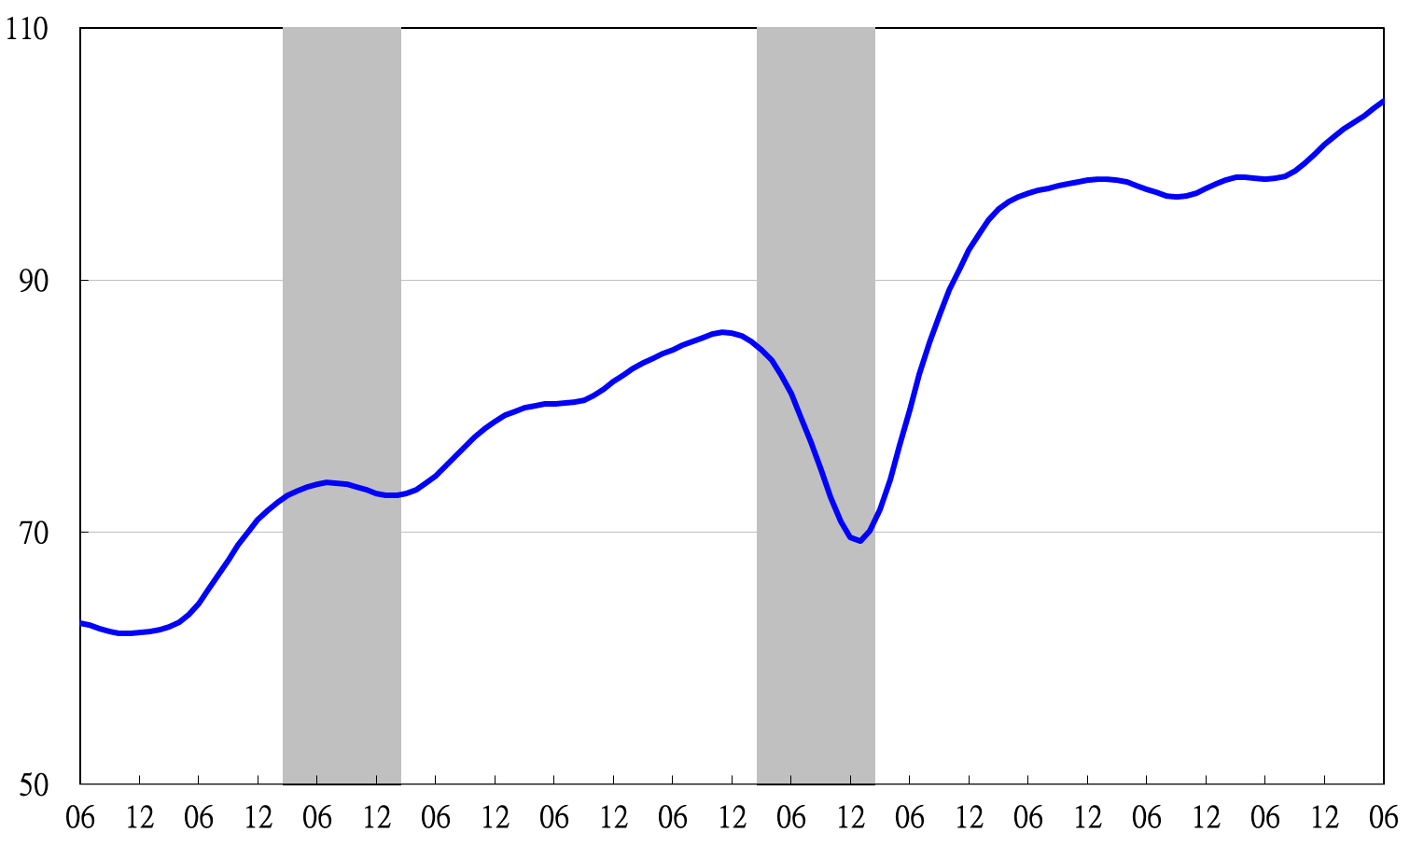

2002 2003 2004 2005 2006 2007 2008 2009 2010 2011 2012 2013

**Annualized 6-month rate of change of composite leading index**

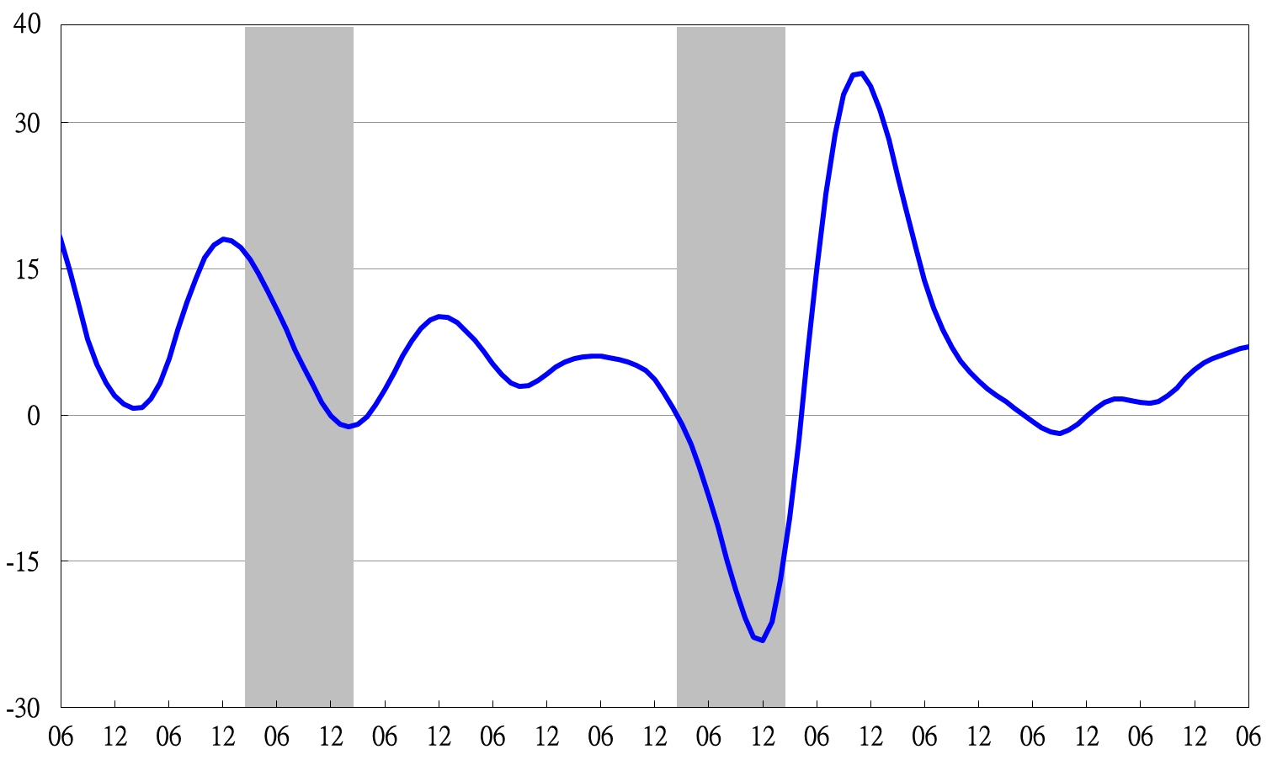

2002 2003 2004 2005 2006 2007 2008 2009 2010 2011 2012 2013

Shaded areas represent recessions.

**Composite Coincident Index**

2004.3(P) 2005.2(T) 2008.3(P) 2009.2(T)

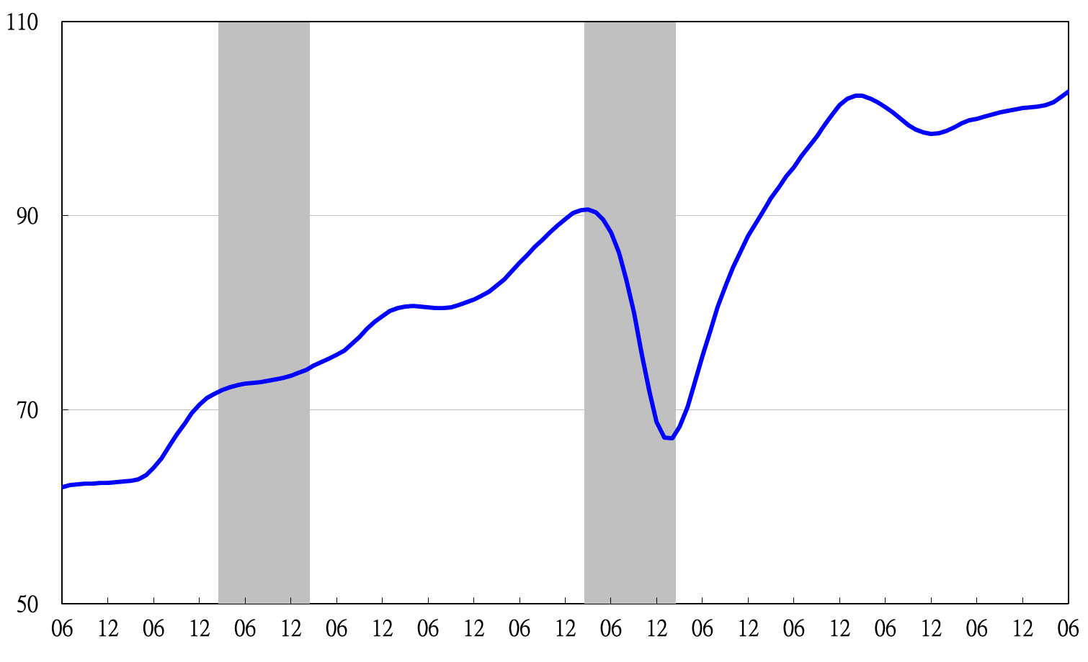

2002 2003 2004 2005 2006 2007 2008 2009 2010 2011 2012 2013

**Trend-adjusted composite coincident index**

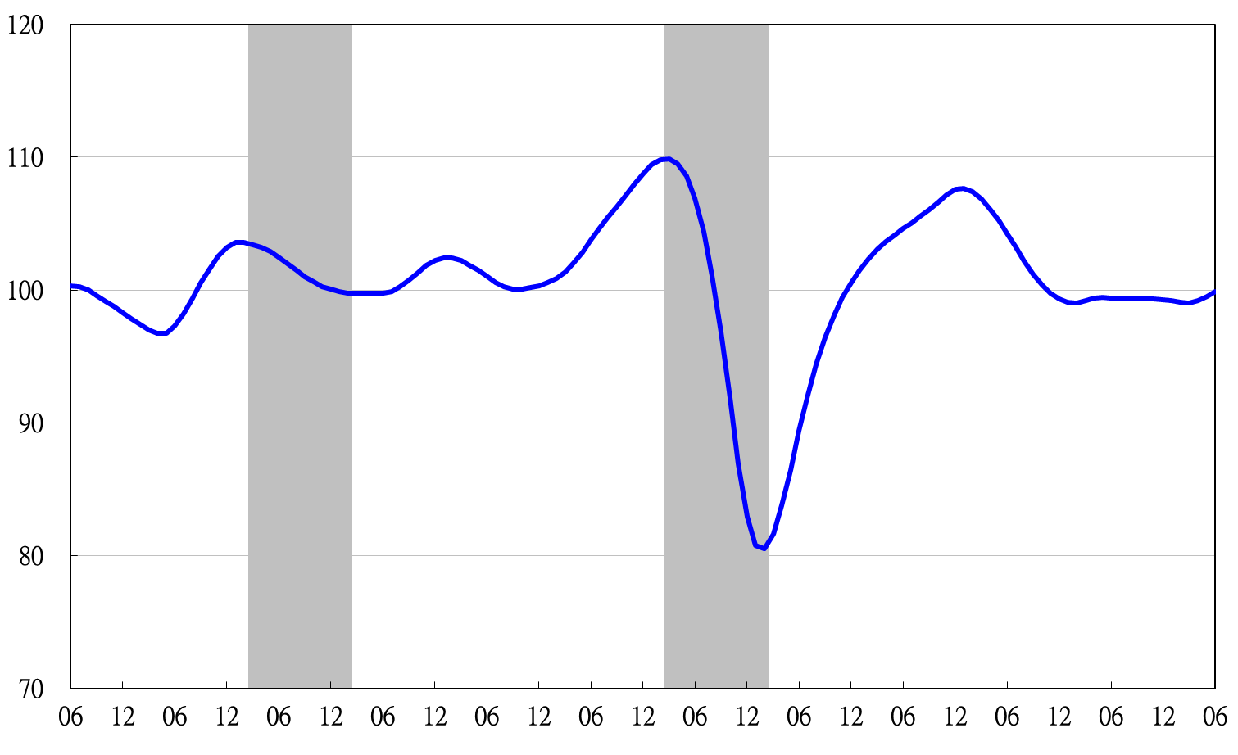

2002 2003 2004 2005 2006 2007 2008 2009 2010 2011 2012 2013

**Composite Lagging Index**

2004.3(P) 2005.2(T) 2008.3(P) 2009.2(T)

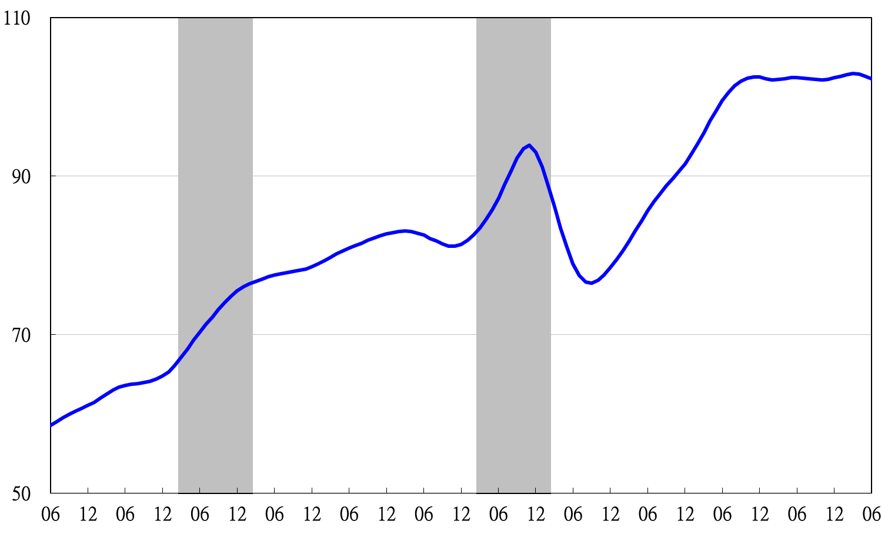

2002 2003 2004 2005 2006 2007 2008 2009 2010 2011 2012 2013

**Trend-adjusted composite lagging index**

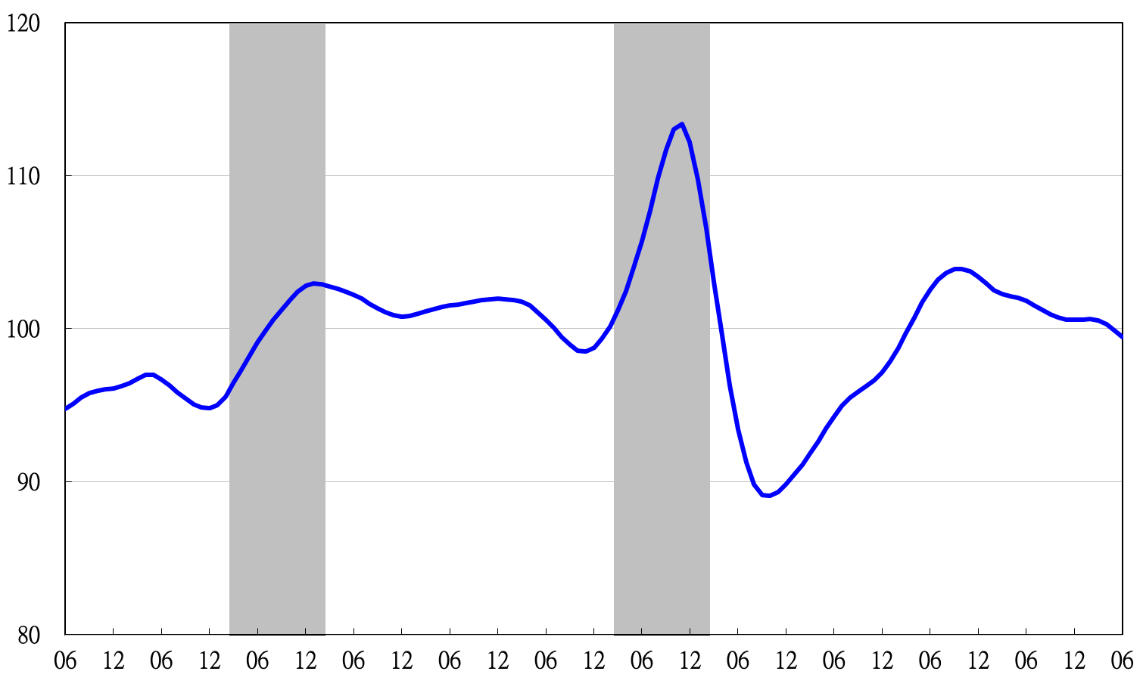

2002 2003 2004 2005 2006 2007 2008 2009 2010 2011 2012 2013

**Monitoring Indicators**

