Taiwan Business Indicators in January 2014

Press Release

National Development Council (NDC)

February 27, 2014

In January 2014, the Taiwan Business Indicators showed that the economy continued its recovery, but some risks remained. Among the indicators compiled by the National Development Council (NDC), the trend-adjusted leading index decreased by 0.05%, the trend-adjusted coincident index increased by 0.43% from the previous month, and the overall monitoring indicator flashed the "yellow-blue" signal.

1. Leading Indicators: With revised data, the composite leading index stood at 103.75, up by 0.07% from December 2013. Its trend-adjusted index decreased by 0.05% to 100.84. Among the seven indicators making up the trend-adjusted index, the TIER manufacturing sector composite indicator, the index of export orders, real monetary aggregates M1B, TAIEX average closing price, and net accession rate of employees on payrolls of industry and services had positive cyclical movements from the previous month, while building permits and SEMI book-to-bill ratio had negative cyclical movements.
2. Coincident Indicators: With revised data, the coincident index stood at 103.89, up by 0.55% from December 2013. Its trend-adjusted index increased by 0.43% to 100.97. Among the seven indicators making up the trend-adjusted index, sales of trade and food services, real machineries and electrical equipments imports, the industrial production index, and the index of producer’s shipment for manufacturing had positive cyclical movements from the previous month, while real customs-cleared exports, nonagricultural employment, and electric power consumption had negative cyclical movements.
3. Lagging Indicators: With revised data, the lagging index stood at 100.46, down by 0.29% from December 2013. Its trend-adjusted index decreased by 0.41% to 97.64. Among the six indicators making up the trend-adjusted index, the unemployment rate(inverted) had positive cyclical movement from the previous month, while the manufacturing unit output labor cost index, loans and investments of monetary financial institutions, the inventories to sales ratio for manufacturing, the interbank overnight call-loan rate, and regular employees on payrolls in industry and services had negative cyclical movements.
4. The Monitoring Indicators: The total score in January 2014 decreased by two points to 22, flashing the “yellow-blue” signal. Among the nine components, the industrial production index changed its individual light signal from “green” to “yellow-blue”, the imports of machineries and electrical equipments changed its individual light signal from “yellow-red” to “green”, the index of producer’s shipment for manufacturing changed its individual light signal from “yellow-blue” to “blue” , each lost one point, while the TIER manufacturing sector composite indicator gained one point to changed its individual light signal from “green” to “yellow-red”. The light signal for the rest of five components remained unchanged.

**T~~ The next release is scheduled for March 27 2014 ~~T**

# **Table 1 Leading Indicators**

Seasonally adjusted

|  |  |  |  |  |  |  |  |
| --- | --- | --- | --- | --- | --- | --- | --- |
|  | 2013 | | | | | | 2014 |
| Jul | Aug | Sep | Oct | Nov | Dec | Jan |
| **Composite Index** | 102.30 | 102.66 | 103.02 | 103.32 | 103.53 | 103.68 | 103.75 |
| Change from preceding month (%) | 0.28 | 0.35 | 0.35 | 0.29 | 0.21 | 0.14 | 0.07 |
| Trend adjusted index | 100.15 | 100.38 | 100.61 | 100.78 | 100.87 | 100.89 | 100.84 |
| Change from preceding month (%) | 0.16 | 0.23 | 0.23 | 0.17 | 0.09 | 0.02 | -0.05 |
| **Components** |  |  |  |  |  |  |  |
| Index of export orders (2011=100) | 103.4 | 105.6 | 108.3 | 109.0 | 112.3 | 118.8 | 106.8 |
| Real monetary aggregates M1B (NT$ billion) | 12,627 | 12,661 | 12,668 | 12,760 | 12,864 | 12,944 | 13,060 |
| TAIEX average closing price (1966=100)* | 8,102 | 7,932 | 8,193 | 8,366 | 8,237 | 8,431 | 8,567 |
| Net accession rate of employees on payrolls of industry and services ** (%) | 0.01 | 0.15 | 0.20 | 0.15 | 0.31 | 0.11 | 0.18p |
| Building permits *** (1,000m2) | 2,950 | 3,310 | 3,485 | 3,265 | 2,305 | 2,831 | 2,431 |
| SEMI Book-to-Bill Ratio | 1.00 | 0.98 | 0.97 | 1.05 | 1.11 | 1.02 | 1.04 |
| The TIER manufacturing sector composite indicator (2006=100) | 98.40 | 98.78 | 97.99 | 96.20 | 95.81 | 98.76 | 101.41 |

Note：1. p = Preliminarily estimated.

2. * TAIEX average closing price is not seasonally adjusted.

** Net accession rate is equal to accession rate minus separation rate.

*** Including only housing, mercantile, business and service, industry warehousing.

# **Table 2 Coincident Indicators**

Seasonally adjusted

|  |  |  |  |  |  |  |  |
| --- | --- | --- | --- | --- | --- | --- | --- |
|  | 2013 | | | | | | 2014 |
| Jul | Aug | Sep | Oct | Nov | Dec | Jan |
| **Composite Index** | 101.15 | 101.39 | 101.75 | 102.20 | 102.74 | 103.32 | 103.89 |
| Change from preceding month (%) | 0.16 | 0.24 | 0.35 | 0.45 | 0.53 | 0.57 | 0.55 |
| Trend adjusted index | 99.03 | 99.14 | 99.37 | 99.69 | 100.10 | 100.54 | 100.97 |
| Change from preceding month (%) | 0.04 | 0.12 | 0.23 | 0.32 | 0.41 | 0.45 | 0.43 |
| **Components** |  |  |  |  |  |  |  |
| Industrial production index (2011=100) | 100.4 | 100.0 | 99.9 | 101.2 | 102.2 | 104.3 | 102.5 |
| Electric power consumption (billion kWh) | 11.81 | 11.91 | 11.94 | 11.80 | 11.91 | 11.68 | 12.08 |
| Index of producer’s shipment for manufacturing (2011=100) | 96.7 | 98.9 | 97.6 | 99.0 | 99.0 | 102.0 | 98.1p |
| Sales of trade and food services (NT$ billion) | 1,185 | 1,186 | 1,196 | 1,206 | 1,217 | 1,228 | 1,239 |
| Nonagricultural employment (thousand persons) | 10,417 | 10,423 | 10,440 | 10,452 | 10,463 | 10,471 | 10,483 |
| Real customs-cleared exports (NT$ billion) | 773.0 | 784.2 | 783.3 | 791.9 | 779.9 | 799.4 | 778.9 |
| Real machineries and electrical equipments imports (NT$ billion) | 206.9 | 193.2 | 218.3 | 210.0 | 208.3 | 246.1 | 219.1 |

# **Table 3 Lagging Indicators**

Seasonally adjusted

|  |  |  |  |  |  |  |  |
| --- | --- | --- | --- | --- | --- | --- | --- |
|  | 2013 | | | | | | 2014 |
| Jul | Aug | Sep | Oct | Nov | Dec | Jan |
| **Composite Index** | 102.32 | 102.00 | 101.70 | 101.40 | 101.08 | 100.76 | 100.46 |
| Change from preceding month (%) | -0.31 | -0.31 | -0.30 | -0.29 | -0.31 | -0.32 | -0.29 |
| Trend adjusted index | 100.17 | 99.74 | 99.32 | 98.91 | 98.48 | 98.05 | 97.64 |
| Change from preceding month (%) | -0.43 | -0.43 | -0.42 | -0.41 | -0.43 | -0.44 | -0.41 |
| **Components** |  |  |  |  |  |  |  |
| Unemployment rate* (%) | 4.19 | 4.18 | 4.18 | 4.18 | 4.15 | 4.14 | 4.07 |
| Regular employees on payrolls  in industry & services (thousand persons) | 6,847 | 6,855 | 6,864 | 6,875 | 6,888 | 6,893 | 6,905p |
| The manufacturing unit output labor cost index  (2006=100) | 83.8 | 84.8 | 83.0 | 85.3 | 84.0 | 81.9 | 83.0p |
| Interbank overnight call-loan rate**  (percent per annum) | 0.386 | 0.386 | 0.386 | 0.387 | 0.386 | 0.387 | 0.388 |
| Loans and investments of monetary financial institutions (NT$ billion) | 26,346 | 26,411 | 26,532 | 26,617 | 26,745 | 26,695 | 26,876 |
| Inventories to sales ratio for manufacturing (%) | 68.9 | 66.8 | 67.7 | 66.6 | 67.0 | 65.9 | 67.1p |

Note： * This series is inverted while aggregating composite lagging index.

** Interbank overnight call-loan rate is not seasonally adjusted.

2004.3(P) 2005.2(T) 2008.3(P) 2009.2(T)

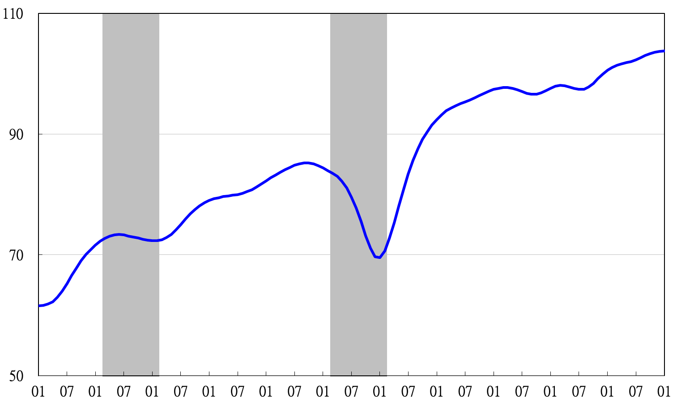

Note: Shaded areas represent recessions.

2003 2004 2005 2006 2007 2008 2009 2010 2011 2012 2013 2014

**Figure 1 Composite Leading Index**

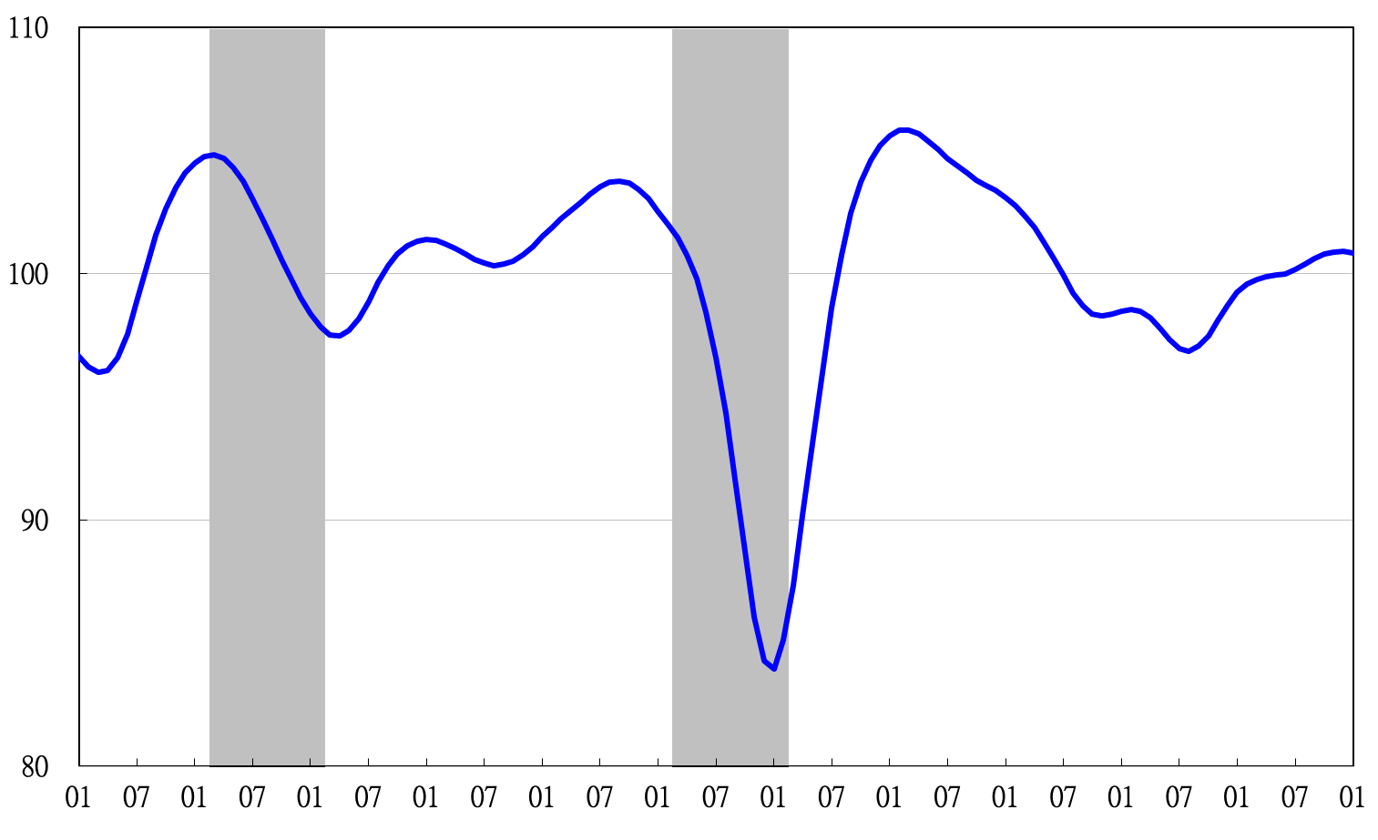

2003 2004 2005 2006 2007 2008 2009 2010 2011 2012 2013 2014

**Figure 2 Trend-adjusted Composite Leading Index**

2004.3(P) 2005.2(T) 2008.3(P) 2009.2(T)

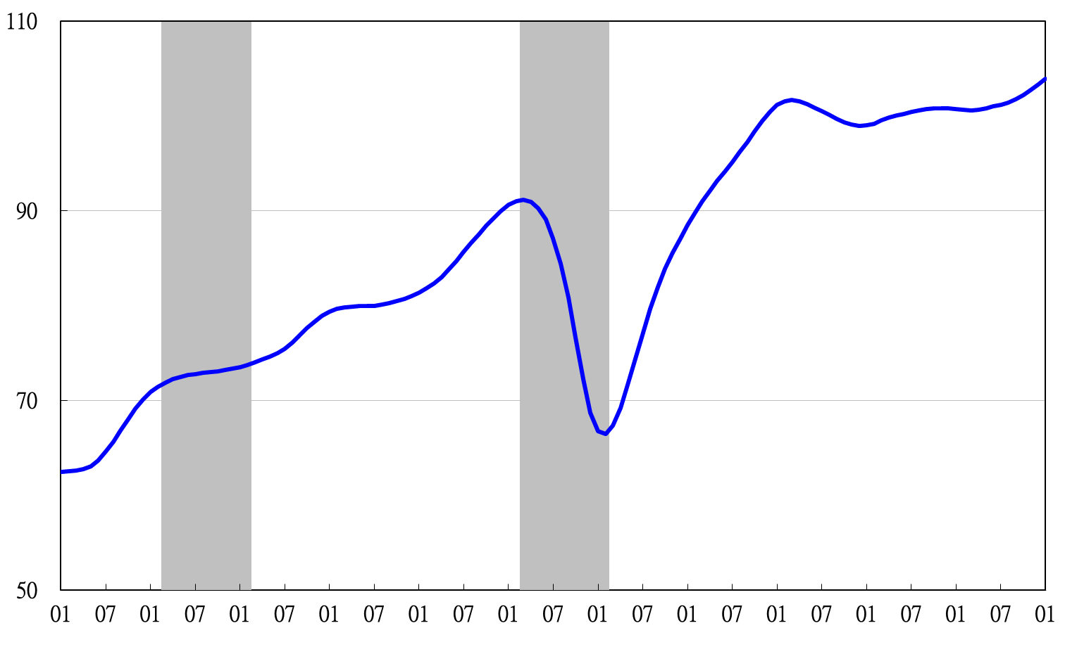

2003 2004 2005 2006 2007 2008 2009 2010 2011 2012 2013 2014

**Figure 3 Composite Coincident Index**

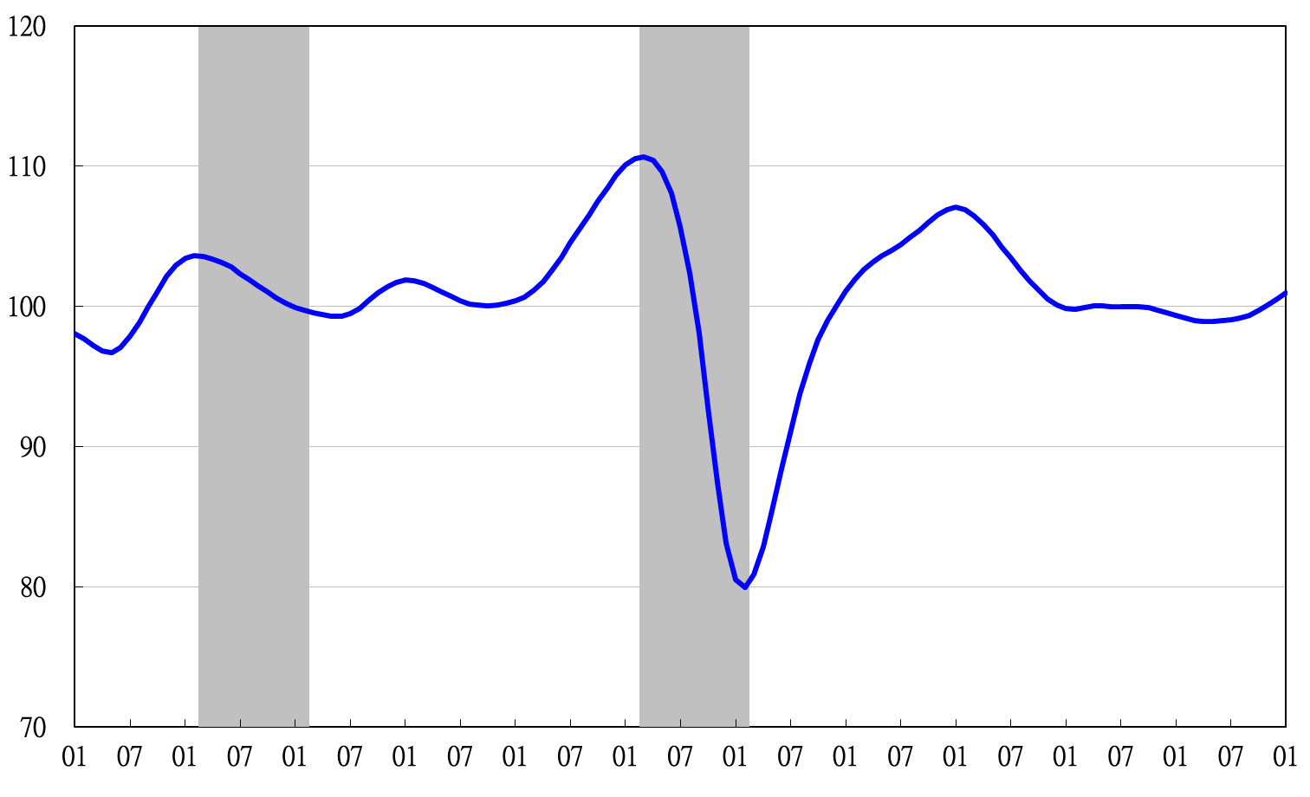

2003 2004 2005 2006 2007 2008 2009 2010 2011 2012 2013 2014

**Figure 4 Trend-adjusted Composite Coincident Index**

2004.3(P) 2005.2(T) 2008.3(P) 2009.2(T)

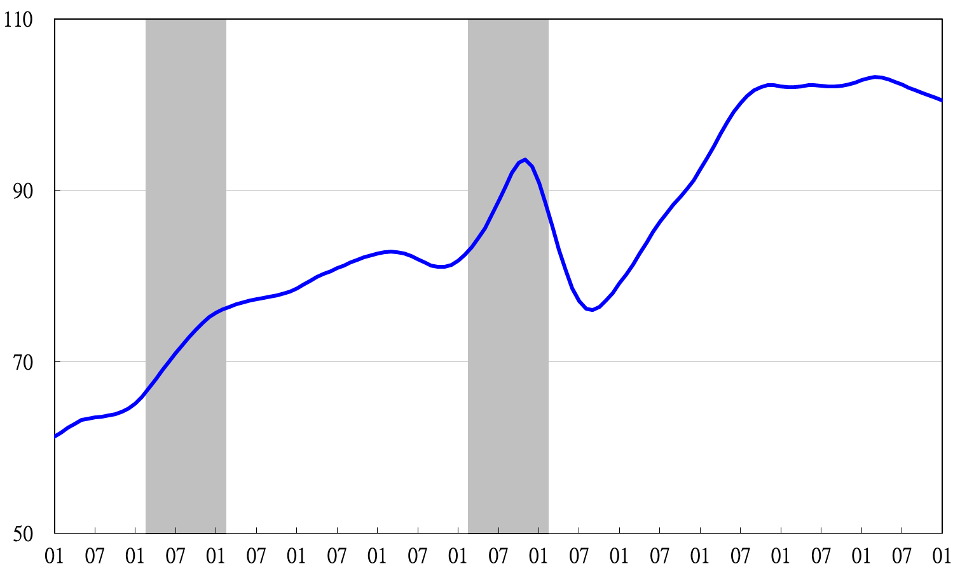

2003 2004 2005 2006 2007 2008 2009 2010 2011 2012 2013 2014

**Figure 5 Composite Lagging Index**

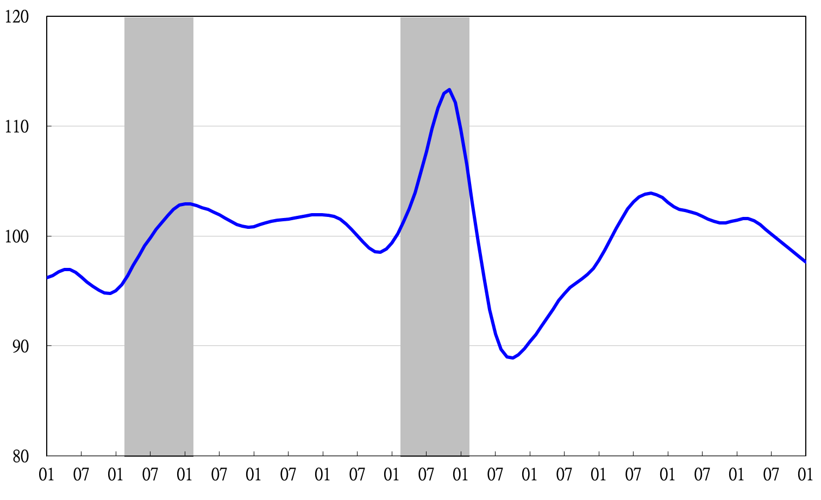

2003 2004 2005 2006 2007 2008 2009 2010 2011 2012 2013 2014

**Figure 6 Trend-adjusted Composite Lagging Index**

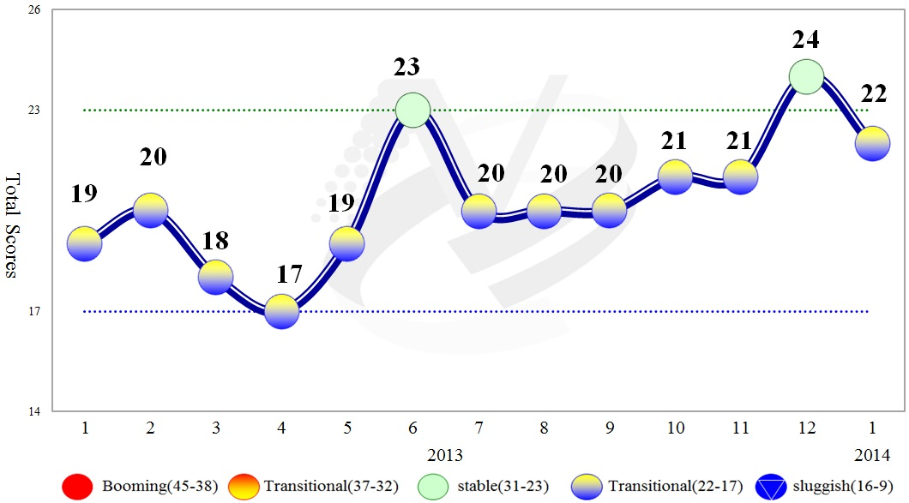

**Figure 7 Total scores in the Past Year**

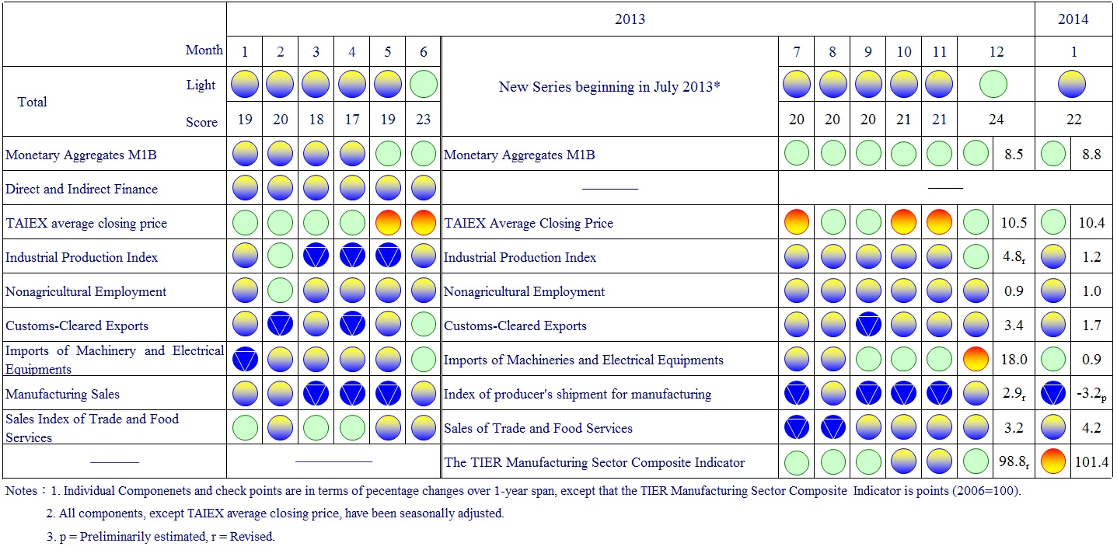

**Figure 8 Monitoring Indicators**