Taiwan Business Indicators in August 2013

Press Release

Council for Economic Planning and Development, Executive Yuan

September 27, 2013

In August 2013, the Taiwan Business Indicators showed the economic recovery to remain on the slower track. Among the indicators compiled by the Cabinet’s Council for Economic Planning and Development (CEPD), the trend-adjusted leading index increased by 0.05%, the trend-adjusted coincident index decreased by 0.23% from the previous month, and the overall monitoring indicator flashed the "yellow-blue" signal.

1. Leading Indicators: With revised data, the composite leading index stood at 102.92, up by 0.19% from July 2013. Its trend-adjusted index increased by 0.05% to 100.49. Among the seven indicators making up the trend-adjusted index, building permits, real monetary aggregates M1B, and the TIER manufacturing sector composite indicator had positive cyclical movements from the previous month, while SEMI book-to-bill ratio, net accession rate of employees on payrolls of industry and services, the index of export orders, and TAIEX average closing price had negative cyclical movements.
2. Coincident Indicators: With revised data, the coincident index stood at 100.79, down by 0.1% from July 2013. Its trend-adjusted index decreased by 0.23% to 98.41. Among the seven indicators making up the trend-adjusted index, electric power consumption, the index of producer’s shipment for manufacturing, and the industrial production index had positive cyclical movements from the previous month, while real machineries and electrical equipments imports, nonagricultural employment, sales of trade and food services, and real customs-cleared exports had negative cyclical movements.
3. Lagging Indicators: With revised data, the lagging index stood at 100.62, down by 0.56% from July 2013. Its trend-adjusted index decreased by 0.69% to 98.25. All six indicators making up the trend-adjusted index had negative cyclical movements from previous month, which were the manufacturing unit output labor cost index, the inventories to sales ratio for manufacturing, the unemployment rate (inverted), regular employees on payrolls in industry and services, loans and investments of monetary financial institutions, and the interbank overnight call-loan rate.
4. The Monitoring Indicators: The total score in August dropped by one point to 19, flashing the “yellow-blue” signal for the second month. Among the nine components, TAIEX average closing price lost one point to change its individual light signal from “yellow-red” to “green”. The light signals for the rest of eight components remained unchanged.

**T~~ The next release is scheduled for October 28 2013 ~~T**

# **Table 1 Leading Indicators**

Seasonally adjusted

|  |  |  |  |  |  |  |  |
| --- | --- | --- | --- | --- | --- | --- | --- |
|  | 2013 | | | | | | |
| Feb | Mar | Apr | May | Jun | Jul | Aug |
| **Composite Index** | 101.72 | 102.05 | 102.30 | 102.46 | 102.58 | 102.73 | 102.92 |
| Change from preceding month (%) | 0.49 | 0.33 | 0.24 | 0.16 | 0.11 | 0.15 | 0.19 |
| Trend adjusted index | 100.12 | 100.31 | 100.42 | 100.44 | 100.42 | 100.44 | 100.49 |
| Change from preceding month (%) | 0.35 | 0.19 | 0.11 | 0.03 | -0.02 | 0.02 | 0.05 |
| **Components** |  |  |  |  |  |  |  |
| Index of export orders (2011=100) | 103.0 | 99.8 | 102.8 | 102.9 | 102.6 | 103.0 | 104.2 |
| Real monetary aggregates M1B (NT$ billion) | 11,908 | 12,234 | 12,250 | 12,418 | 12,542 | 12,643 | 12,661 |
| TAIEX average closing price (1966=100)* | 7,933 | 7,907 | 7,893 | 8,272 | 7,989 | 8,102 | 7,932 |
| Net accession rate of employees on payrolls of industry and services ** (%) | 0.15 | 0.13 | 0.14 | 0.08 | -0.01 | 0.03 | 0.09p |
| Building permits *** (1,000m2) | 2,915 | 2,338 | 3,056 | 3,089 | 2,291 | 2,919 | 3,295 |
| SEMI Book-to-Bill Ratio | 1.10 | 1.11 | 1.08 | 1.08 | 1.10 | 1.00 | 0.98 |
| The TIER manufacturing sector composite indicator (2006=100) | 97.98 | 99.48 | 97.38 | 99.47 | 97.51 | 98.40 | 98.82 |

Note：1. p = Preliminarily estimated.

2. * TAIEX average closing price is not seasonally adjusted.

** Net accession rate is equal to accession rate minus separation rate.

*** Including only housing, mercantile, business and service, industry warehousing.

# **Table 2 Coincident Indicators**

Seasonally adjusted

|  |  |  |  |  |  |  |  |
| --- | --- | --- | --- | --- | --- | --- | --- |
|  | 2013 | | | | | | |
| Feb | Mar | Apr | May | Jun | Jul | Aug |
| **Composite Index** | 100.71 | 100.70 | 100.77 | 100.89 | 100.95 | 100.89 | 100.79 |
| Change from preceding month (%) | -0.02 | -0.01 | 0.07 | 0.11 | 0.06 | -0.06 | -0.10 |
| Trend adjusted index | 99.13 | 98.98 | 98.92 | 98.90 | 98.82 | 98.64 | 98.41 |
| Change from preceding month (%) | -0.16 | -0.15 | -0.06 | -0.02 | -0.07 | -0.19 | -0.23 |
| **Components** |  |  |  |  |  |  |  |
| Industrial production index (2011=100) | 100.1 | 99.2 | 98.2 | 99.0 | 99.7 | 100.5 | 100.2 |
| Electric power consumption (billion kWh) | 11.77 | 11.42 | 11.82 | 11.94 | 12.33 | 11.84 | 11.95 |
| Index of producer’s shipment for manufacturing (2011=100) | 97.5 | 94.9 | 96.2 | 97.8 | 97.3 | 96.9 | 97.7p |
| Sales of trade and food services (NT$ billion) | 1,173 | 1,177 | 1,183 | 1,183 | 1,180 | 1,178 | 1,177 |
| Nonagricultural employment (thousand persons) | 10,399 | 10,403 | 10,406 | 10,409 | 10,418 | 10,416 | 10,421 |
| Real customs-cleared exports (NT$ billion) | 750.0 | 777.5 | 766.2 | 786.5 | 807.8 | 775.7 | 787.4 |
| Real machineries and electrical equipments imports (NT$ billion) | 210.5 | 210.2 | 206.5 | 214.3 | 217.5 | 205.9 | 194.3 |

# **Table 3 Lagging Indicators**

Seasonally adjusted

|  |  |  |  |  |  |  |  |
| --- | --- | --- | --- | --- | --- | --- | --- |
|  | 2013 | | | | | | |
| Feb | Mar | Apr | May | Jun | Jul | Aug |
| **Composite Index** | 102.56 | 102.65 | 102.51 | 102.16 | 101.71 | 101.19 | 100.62 |
| Change from preceding month (%) | 0.22 | 0.08 | -0.13 | -0.34 | -0.45 | -0.51 | -0.56 |
| Trend adjusted index | 100.94 | 100.89 | 100.62 | 100.15 | 99.57 | 98.93 | 98.25 |
| Change from preceding month (%) | 0.08 | -0.05 | -0.27 | -0.47 | -0.58 | -0.64 | -0.69 |
| **Components** |  |  |  |  |  |  |  |
| Unemployment rate* (%) | 4.16 | 4.18 | 4.19 | 4.19 | 4.17 | 4.18 | 4.19 |
| Regular employees on payrolls  in industry & services (thousand persons) | 6,819 | 6,819 | 6,826 | 6,834 | 6,841 | 6,845 | 6,855p |
| The manufacturing unit output labor cost index  (2006=100) | 85.6 | 84.4 | 85.3 | 84.3 | 84.0 | 83.8 | 82.3p |
| Interbank overnight call-loan rate**  (percent per annum) | 0.387 | 0.387 | 0.386 | 0.386 | 0.386 | 0.386 | 0.386 |
| Loans and investments of monetary financial institutions (NT$ billion) | 25,718 | 25,934 | 25,986 | 25,979 | 26,160 | 26,349 | 26,421 |
| Inventories to sales ratio for manufacturing (%) | 70.2 | 73.5 | 72.1 | 67.3 | 67.4 | 68.6 | 67.4p |

Note： * This series is inverted while aggregating composite lagging index.

** Interbank overnight call-loan rate is not seasonally adjusted.

2004.3(P) 2005.2(T) 2008.3(P) 2009.2(T)

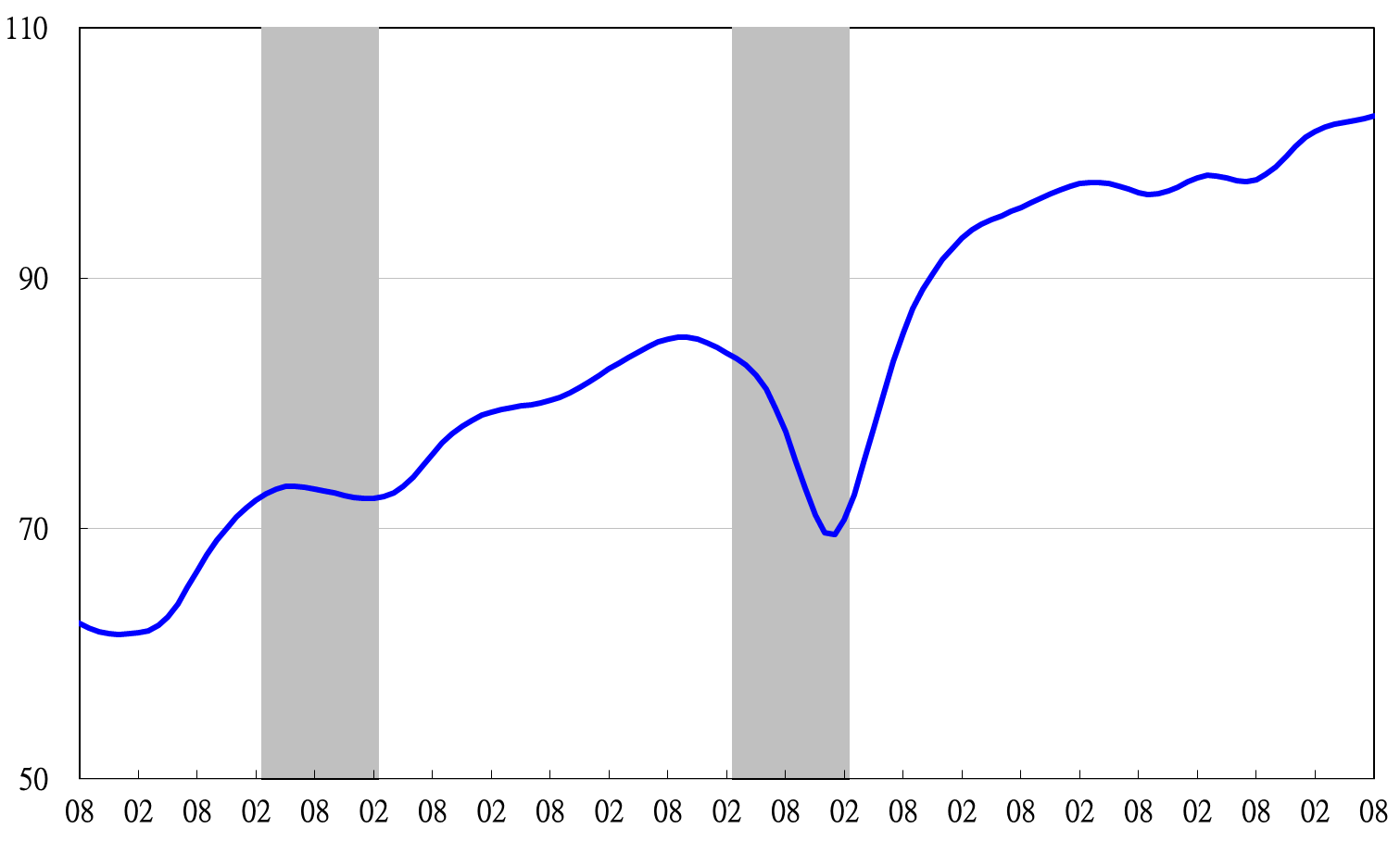

Note: Shaded areas represent recessions.

2002 2003 2004 2005 2006 2007 2008 2009 2010 2011 2012 2013

**Figure 1 Composite Leading Index**

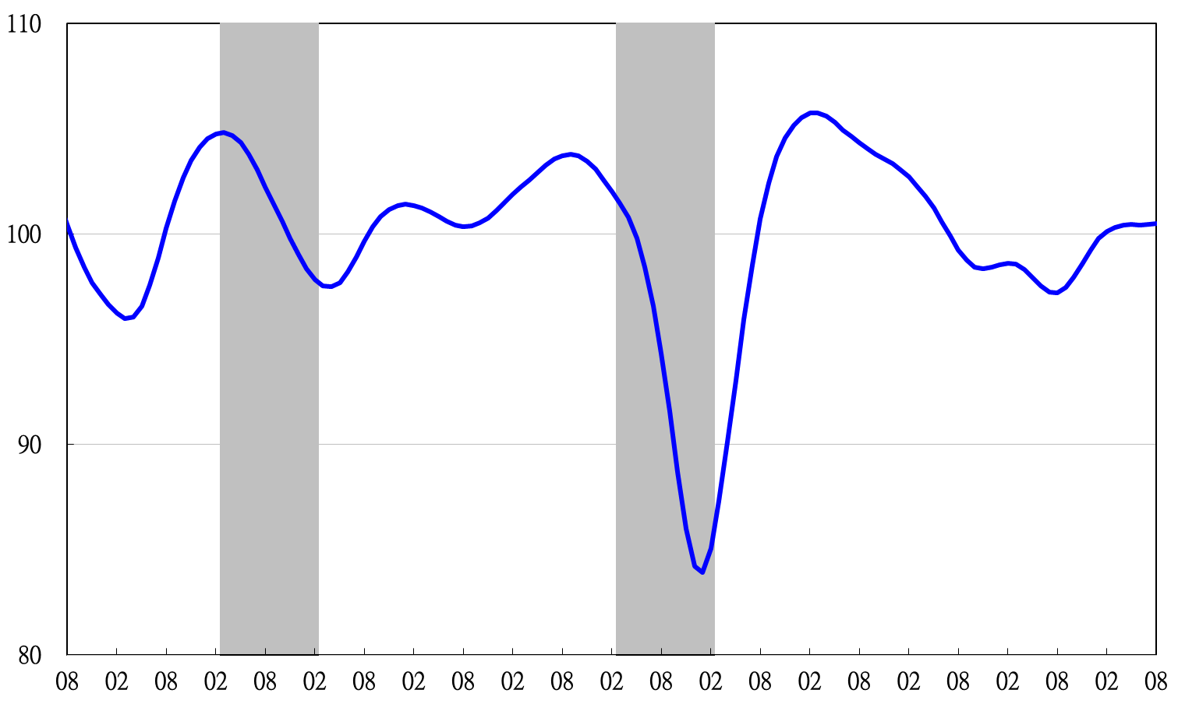

2002 2003 2004 2005 2006 2007 2008 2009 2010 2011 2012 2013

**Figure 2 Trend-adjusted Composite Leading Index**

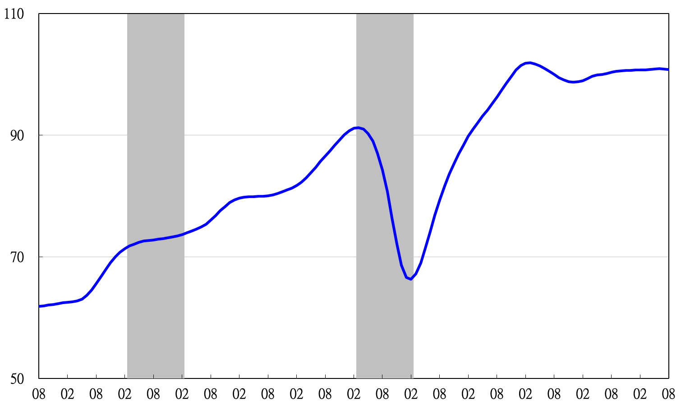

2004.3(P) 2005.2(T) 2008.3(P) 2009.2(T)

2002 2003 2004 2005 2006 2007 2008 2009 2010 2011 2012 2013

**Figure 3 Composite Coincident Index**

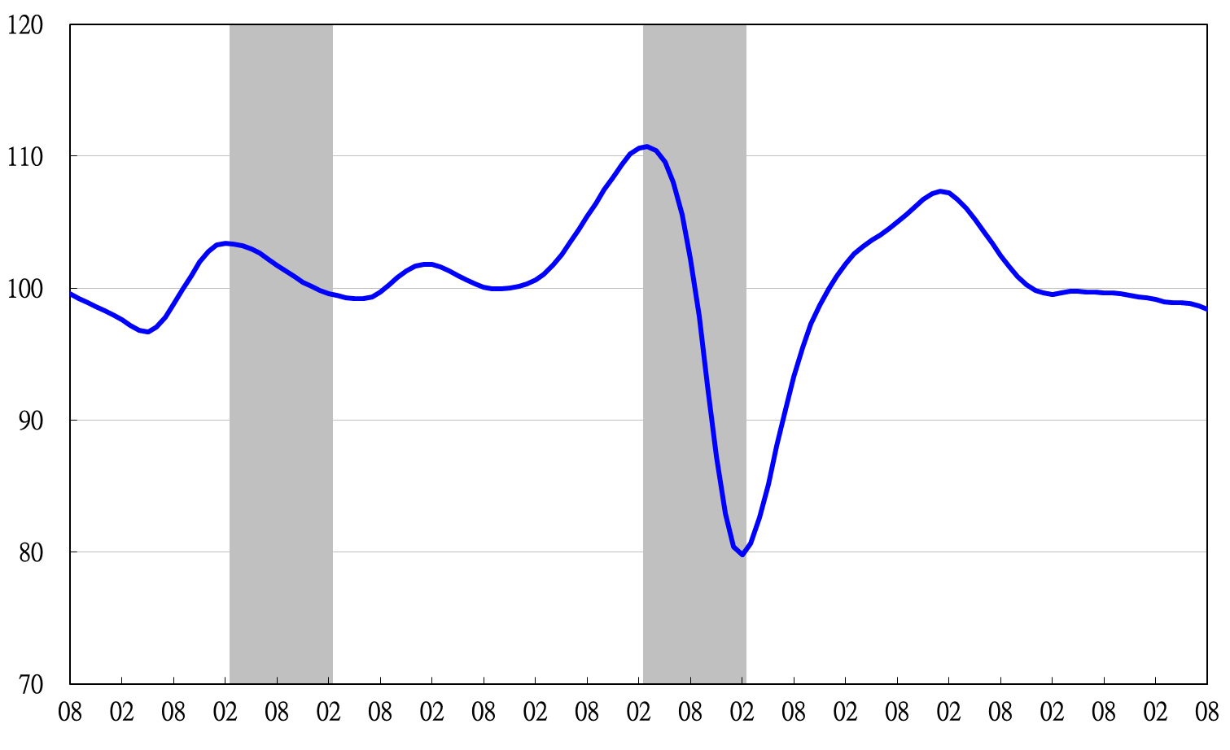

2002 2003 2004 2005 2006 2007 2008 2009 2010 2011 2012 2013

**Figure 4 Trend-adjusted Composite Coincident Index**

2004.3(P) 2005.2(T) 2008.3(P) 2009.2(T)

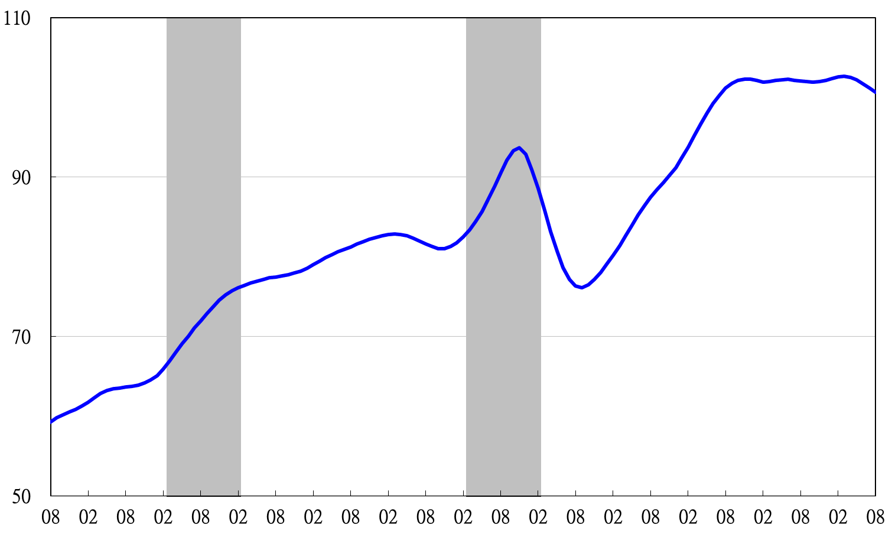

2002 2003 2004 2005 2006 2007 2008 2009 2010 2011 2012 2013

**Figure 5 Composite Lagging Index**

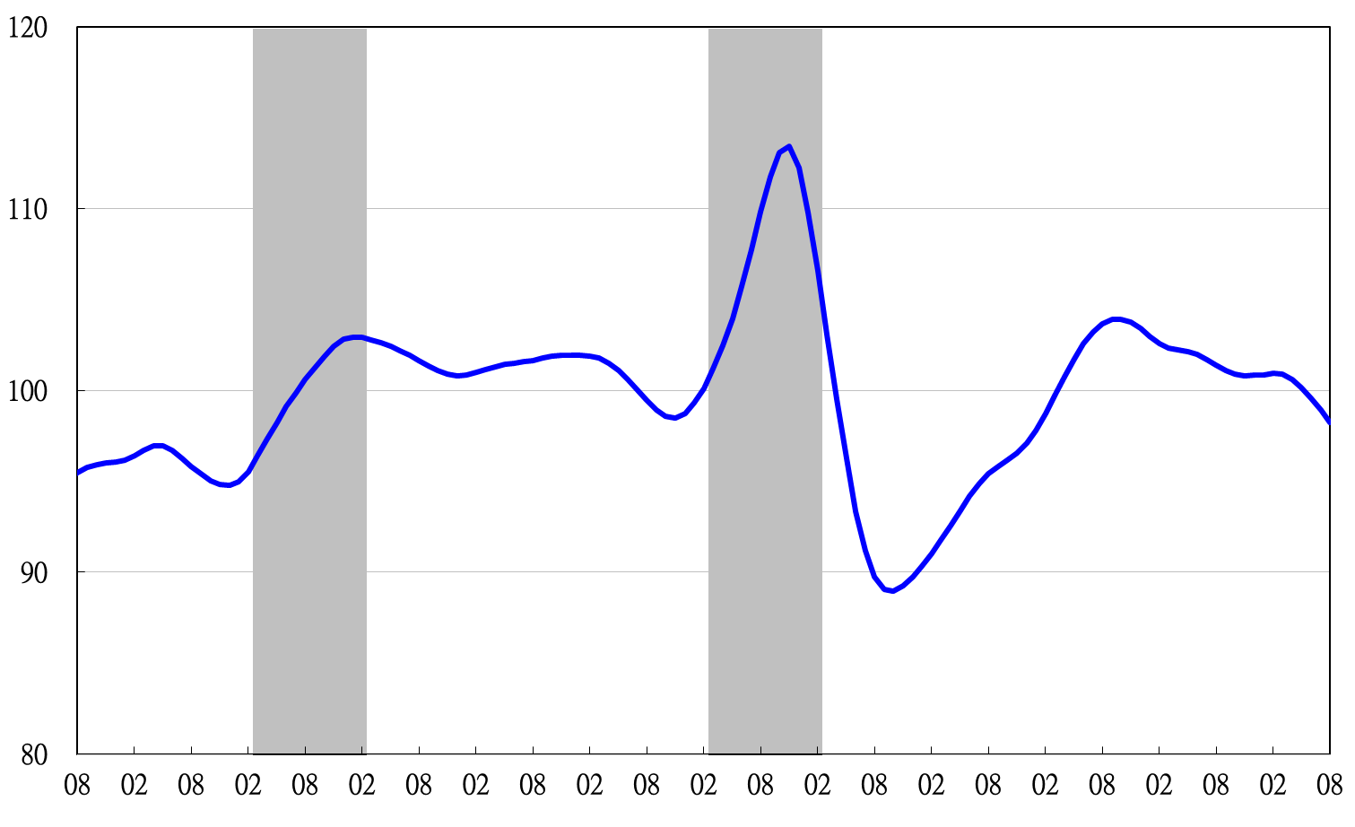

2002 2003 2004 2005 2006 2007 2008 2009 2010 2011 2012 2013

**Figure 6 Trend-adjusted Composite Lagging Index**

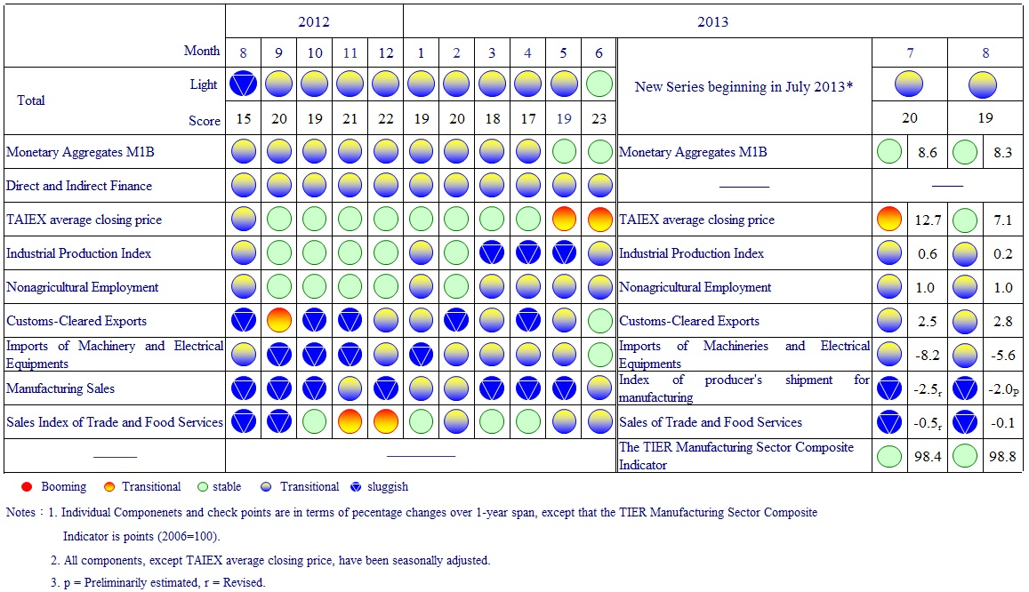

**Figure 7 Monitoring Indicators**