Taiwan Business Indicators in November 2014

Press Release

National Development Council (NDC)

December 26, 2014

In November 2014, the Taiwan Business Indicators showed that the domestic economy continued its moderate growth. Among the indicators compiled by the National Development Council (NDC), the trend-adjusted leading index decreased by 0.17%, the trend-adjusted coincident index increased by 0.26% from the previous month, and the overall monitoring indicator flashed the "green" signal for the tenth consecutive month.

1. The Monitoring Indicators: The total score in November 2014 increased by one point to 25, flashing the “green” signal for the tenth month. Among the nine components, the industrial production index lost one point to change its individual light signal from “yellow-red” to “green”, while the customs-cleared exports changed its individual light signal from “yellow-red” to “green”, and the imports of machineries and electrical equipments changed its individual light signal from “green” to “yellow-red”, each gained one point. The light signal for the rest of six components remained unchanged.
2. Leading Indicators: With revised data, the trend-adjusted leading index stood at 99.55, down by 0.17% from October 2014. Among the seven indicators making up the trend-adjusted index, the index of export orders, and real monetary aggregates M1B had positive cyclical movements from the previous month, while the TIER manufacturing sector composite indicator, building permits, SEMI book-to-bill ratio, TAIEX average closing price, and net accession rate of employees on payrolls of industry and services had negative cyclical movements.
3. Coincident Indicators: With revised data, the trend-adjusted coincident index stood at 101.98, up by 0.26% from October 2014. Among the seven indicators making up the trend-adjusted index, real machineries electrical equipments imports, the industrial production index, electric power consumption, and nonagricultural employment had positive cyclical movements from the previous month, while sales of trade and food services, the index of producer’s shipment for manufacturing, and real customs-cleared exports had negative cyclical movements.
4. Lagging Indicators: With revised data, the trend-adjusted lagging index stood at 99.37, up by 0.23% from October 2014. Among the six indicators making up the trend-adjusted index, the inventories to sales ratio for manufacturing, regular employees on payrolls in industry and services, the unemployment rate (inverted), and the manufacturing unit output labor cost index had positive cyclical movements from the previous month, while loans and investments of monetary financial institutions, and the interbank overnight call-loan rate had negative cyclical movements.

**T~~ The next release is scheduled for January 27 2015 ~~T**

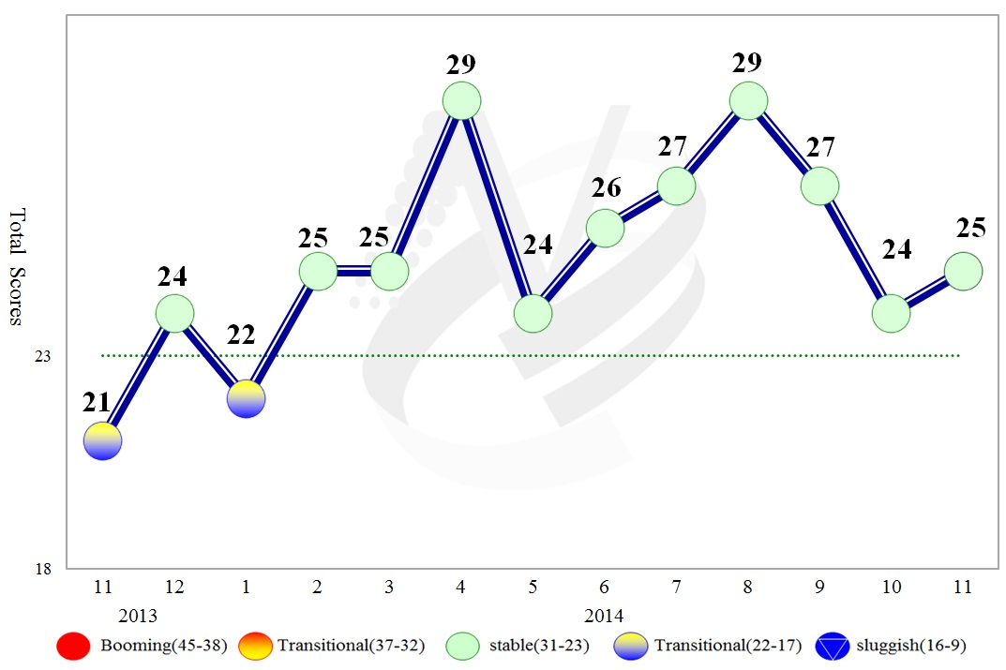

**Figure 1 Total Scores in the Past Year**

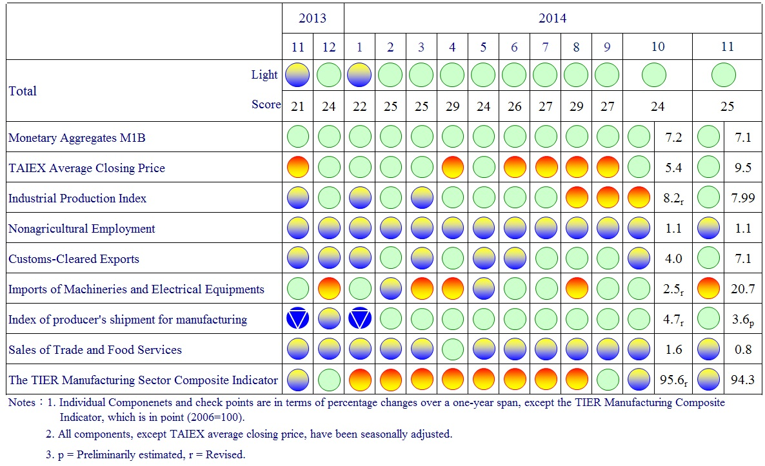

**Figure 2 Monitoring Indicators**

**Table 1 Leading Indicators**

Index

|  |  |  |  |  |  |  |  |
| --- | --- | --- | --- | --- | --- | --- | --- |
|  | 2014 | | | | | | |
| May | Jun | Jul | Aug | Sep | Oct | Nov |
| **Trend adjusted index** | 100.43 | 100.33 | 100.20 | 100.05 | 99.89 | 99.72 | 99.55 |
| Change from preceding month (%) | -0.11 | -0.10 | -0.12 | -0.15 | -0.16 | -0.17 | -0.17 |
| **Components1** |  |  |  |  |  |  |  |
| Index of export orders | 99.63 | 99.74 | 99.99 | 100.41 | 100.98 | 101.58 | 102.16 |
| Real monetary aggregates M1B | 100.06 | 100.06 | 100.07 | 100.08 | 100.10 | 100.14 | 100.18 |
| TAIEX average closing price | 100.30 | 100.35 | 100.35 | 100.31 | 100.24 | 100.14 | 100.04 |
| Net accession rate of employees on payrolls of industry and services 2 | 100.20 | 100.12 | 100.05 | 100.01 | 99.98 | 99.95 | 99.93 |
| Building permits 3 | 99.89 | 99.75 | 99.62 | 99.46 | 99.30 | 99.14 | 98.98 |
| SEMI Book-to-Bill Ratio | 100.18 | 100.14 | 100.04 | 99.89 | 99.71 | 99.56 | 99.44 |
| The TIER manufacturing sector composite indicator | 100.84 | 100.78 | 100.60 | 100.30 | 99.88 | 99.39 | 98.88 |

Note：1.All components are passed through seasonal adjustment, trend-removal, smoothing and normalization.

2. Net accession rate is equal to accession rate minus separation rate.

3. Including only housing, mercantile, business and service, industry warehousing.

2004.3(P) 2005.2(T) 2008.3(P) 2009.2(T) 2011.2(P) 2012.1(T)

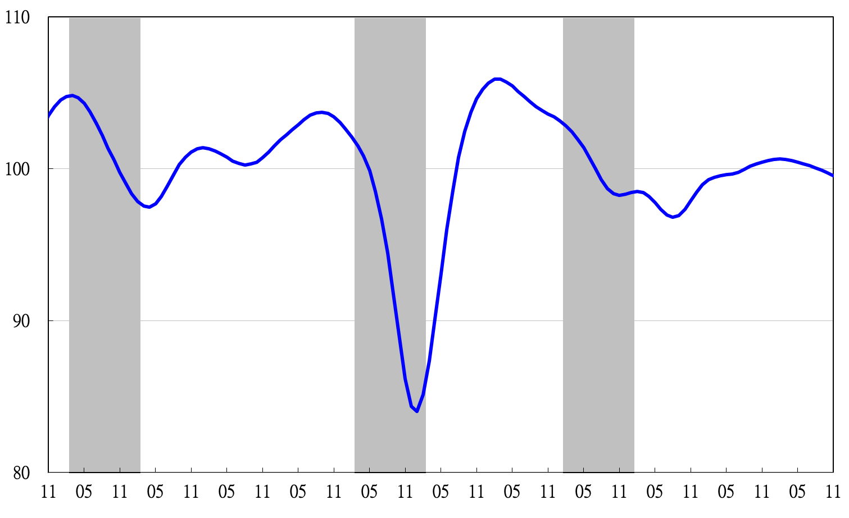

Note: Shaded areas represent recessions.

2003 2004 2005 2006 2007 2008 2009 2010 2011 2012 2013 2014

**Figure 3 Trend-adjusted Leading Index**

**Table 2 Coincident Indicators**

Index

|  |  |  |  |  |  |  |  |
| --- | --- | --- | --- | --- | --- | --- | --- |
|  | 2014 | | | | | | |
| May | Jun | Jul | Aug | Sep | Oct | Nov |
| **Trend adjusted index** | 100.47 | 100.72 | 100.99 | 101.25 | 101.48 | 101.72 | 101.98 |
| Change from preceding month (%) | 0.22 | 0.25 | 0.26 | 0.26 | 0.23 | 0.24 | 0.26 |
| **Components** |  |  |  |  |  |  |  |
| Industrial production index | 99.99 | 100.19 | 100.40 | 100.61 | 100.82 | 101.03 | 101.23 |
| Electric power consumption | 99.55 | 99.74 | 99.98 | 100.22 | 100.42 | 100.61 | 100.82 |
| Index of producer’s shipment for manufacturing | 100.30 | 100.40 | 100.47 | 100.52 | 100.54 | 100.54 | 100.53 |
| Sales of trade and food services | 100.30 | 100.25 | 100.16 | 100.07 | 99.98 | 99.89 | 99.80 |
| Nonagricultural employment | 99.67 | 99.64 | 99.61 | 99.62 | 99.64 | 99.68 | 99.72 |
| Real customs-cleared exports | 100.03 | 100.13 | 100.21 | 100.26 | 100.27 | 100.25 | 100.24 |
| Real machineries and electrical equipments imports | 100.04 | 100.07 | 100.13 | 100.23 | 100.36 | 100.54 | 100.77 |

2004.3(P) 2005.2(T) 2008.3(P) 2009.2(T) 2011.2(P) 2012.1(T)

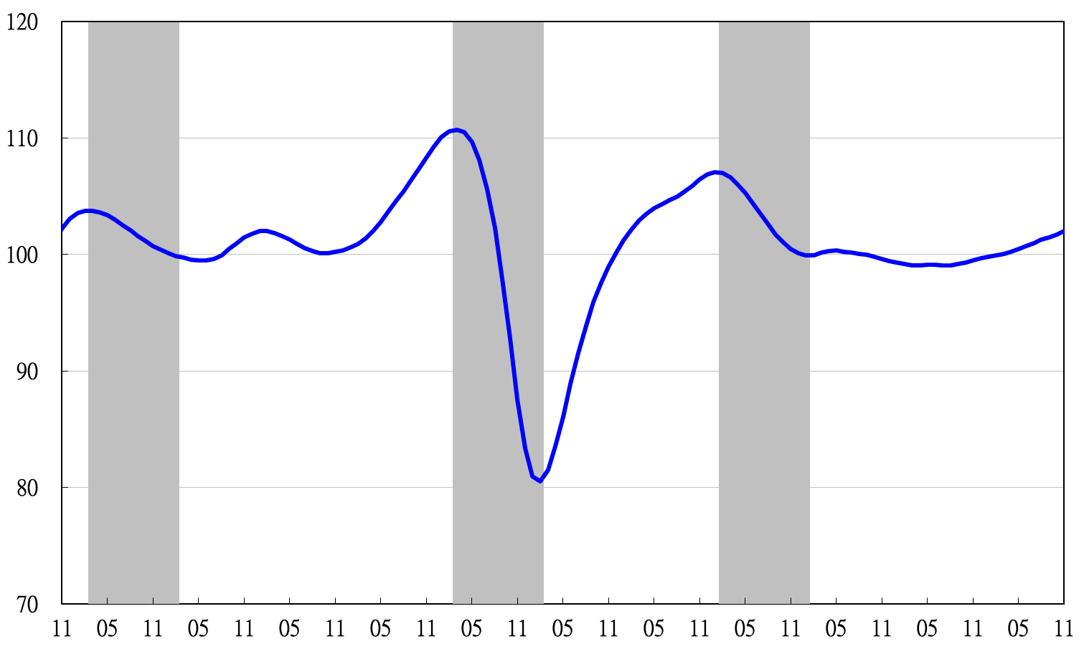

2003 2004 2005 2006 2007 2008 2009 2010 2011 2012 2013 2014

**Figure 4 Trend-adjusted Coincident Index**

**Table 3 Lagging Indicators**

Index

|  |  |  |  |  |  |  |  |
| --- | --- | --- | --- | --- | --- | --- | --- |
|  | 2014 | | | | | | |
| May | Jun | Jul | Aug | Sep | Oct | Nov |
| **Trend adjusted index** | 98.88 | 98.92 | 99.00 | 99.01 | 99.00 | 99.14 | 99.37 |
| Change from preceding month (%) | 0.05 | 0.04 | 0.09 | 0.01 | -0.004 | 0.14 | 0.23 |
| **Components** |  |  |  |  |  |  |  |
| Unemployment rate | 99.82 | 99.86 | 99.90 | 99.94 | 99.98 | 100.01 | 100.05 |
| Regular employees on payrolls  in industry & services | 99.78 | 99.81 | 99.84 | 99.88 | 99.93 | 99.97 | 100.01 |
| The manufacturing unit output labor cost index | 100.03 | 99.99 | 99.93 | 99.73 | 99.49 | 99.39 | 99.394 |
| Interbank overnight call-loan rate | 99.97 | 99.97 | 99.96 | 99.96 | 99.95 | 99.95 | 99.94 |
| Loans and investments of monetary financial institutions | 99.92 | 99.92 | 99.91 | 99.89 | 99.85 | 99.81 | 99.76 |
| Inventories to sales ratio for manufacturing | 99.17 | 99.20 | 99.29 | 99.45 | 99.65 | 99.87 | 100.11 |

2004.3(P) 2005.2(T) 2008.3(P) 2009.2(T) 2011.2(P) 2012.1(T)

2003 2004 2005 2006 2007 2008 2009 2010 2011 2012 2013 2014

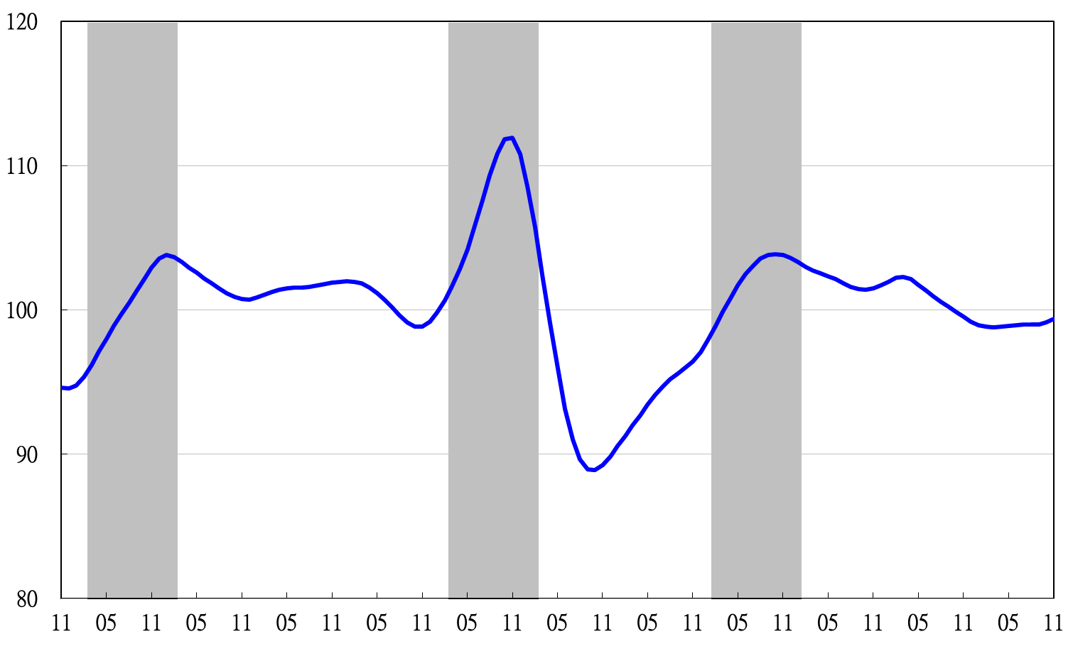

**Figure 5 Trend-adjusted Lagging Index**

2003 2004 2005 2006 2007 2008 2009 2010 2011 2012 2013 2014