Taiwan Business Indicators in January 2015

Press Release

National Development Council (NDC)

March 5, 2015

In January 2015, the Taiwan Business Indicators showed that the domestic economy remained broadly stable. Among the indicators compiled by the National Development Council (NDC), the trend-adjusted leading index increased by 0.1%, the trend-adjusted coincident index decreased by 0.22% from the previous month, and the overall monitoring indicator flashed the "green" signal.

1. The Monitoring Indicators: Total scores in January 2015 increased by one point to 23, flashing the “green” signal for the first month. Among the nine components, the imports of machineries and electrical equipments and the index of producer’s shipment for manufacturing each gained one point to change its individual light from “yellow-blue” to “green”, while the sales of trade and food services lost one point to change its individual light from “yellow-blue” to “blue”. The light signal for the rest of six components remained unchanged.
2. Leading Indicators: With revised data, the trend-adjusted leading index stood at 100.01, up by 0.1% from December 2014. Among the seven indicators making up the trend-adjusted index, the index of export orders, real monetary aggregates M1B, SEMI book-to-bill ratio, and net accession rate of employees on payrolls of industry and services had positive cyclical movements from the previous month, while the TIER manufacturing sector composite indicator, TAIEX average closing price, and building permits had negative cyclical movements.
3. Coincident Indicators: With revised data, the trend-adjusted coincident index stood at 100.88, down by 0.22% from December 2014. Among the seven indicators making up the trend-adjusted index, the index of producer’s shipment for manufacturing and nonagricultural employment had positive cyclical movements from the previous month, while electric power consumption, sales of trade and food services, the industrial production index, real machineries electrical equipments imports, and real customs-cleared exports had negative cyclical movements.
4. Lagging Indicators: With revised data, the trend-adjusted lagging index stood at 99.38, up by 0.12% from December 2014. Among the six indicators making up the trend-adjusted index, the inventories to sales ratio for manufacturing, the unemployment rate (inverted), and regular employees on payrolls in industry and services had positive cyclical movements from the previous month, while the manufacturing unit output labor cost index, loans and investments of monetary financial institutions, and the interbank overnight call-loan rate had negative cyclical movements.

**T~~ The next release is scheduled for March 27 2015 ~~T**

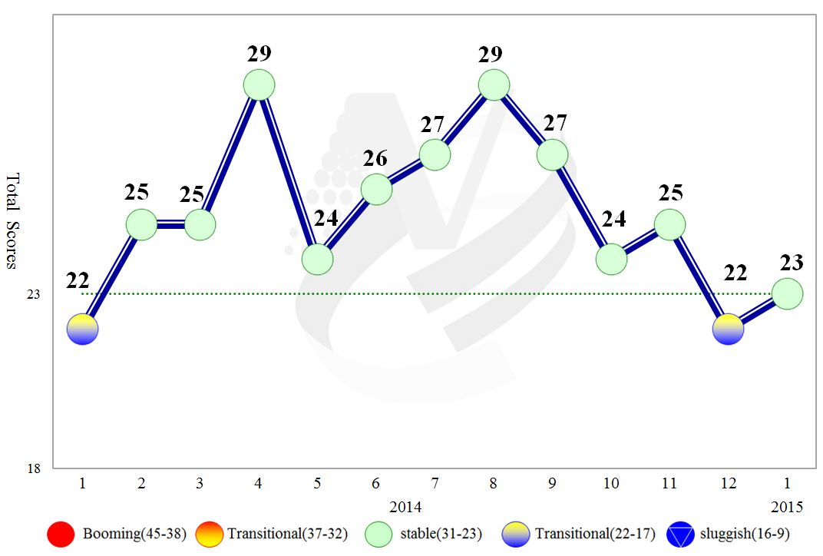

**Figure 1 Total Scores in the Past Year**

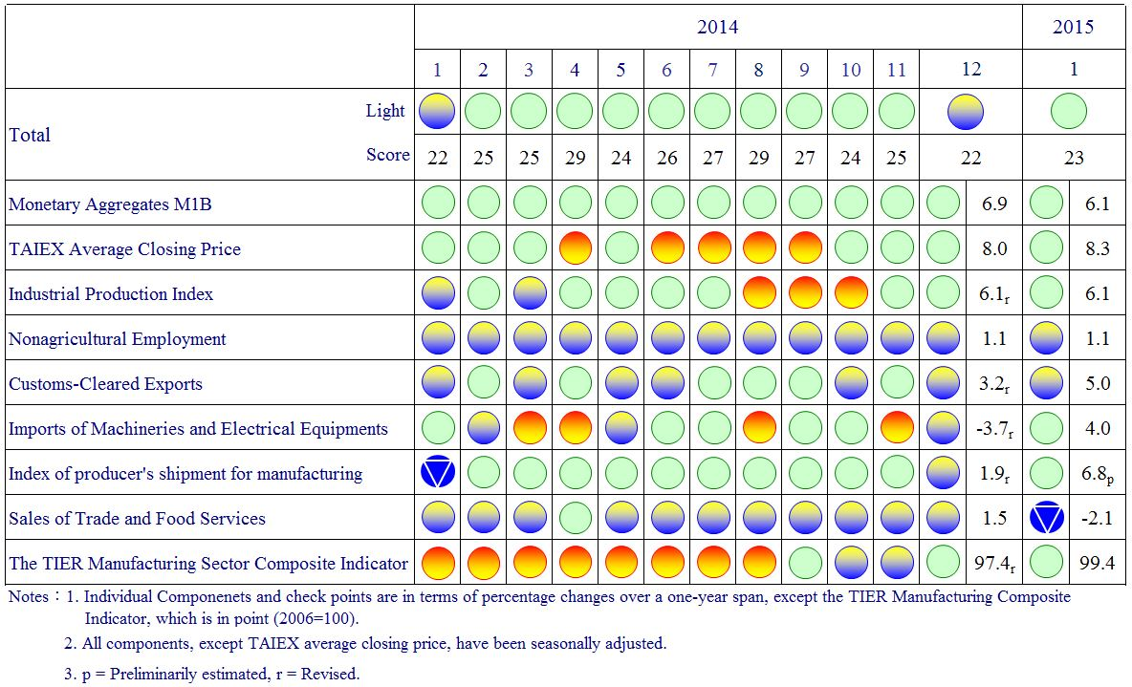

**Figure 2 Monitoring Indicators**

**Table 1 Leading Indicators**

Index

|  |  |  |  |  |  |  |  |
| --- | --- | --- | --- | --- | --- | --- | --- |
|  | 2014 | | | | | | 2015 |
| Jul | Aug | Sep | Oct | Nov | Dec | Jan |
| **Trend adjusted index** | 100.13 | 100.01 | 99.90 | 99.830 | 99.833 | 99.90 | 100.01 |
| Change from preceding month (%) | -0.10 | -0.12 | -0.11 | -0.07 | 0.003 | 0.07 | 0.10 |
| **Components1** |  |  |  |  |  |  |  |
| Index of export orders | 99.79 | 100.19 | 100.66 | 101.09 | 101.43 | 101.70 | 101.91 |
| Real monetary aggregates M1B | 99.98 | 100.00 | 100.04 | 100.10 | 100.18 | 100.27 | 100.37 |
| TAIEX average closing price | 100.33 | 100.29 | 100.23 | 100.16 | 100.10 | 100.06 | 100.02 |
| Net accession rate of employees on payrolls of industry and services 2 | 100.08 | 100.04 | 99.99 | 99.97 | 99.94 | 99.931 | 99.933 |
| Building permits 3 | 99.72 | 99.58 | 99.45 | 99.33 | 99.26 | 99.22 | 99.20 |
| SEMI Book-to-Bill Ratio | 100.05 | 99.92 | 99.78 | 99.70 | 99.67 | 99.68 | 99.71 |
| The TIER manufacturing sector composite indicator | 100.63 | 100.37 | 100.06 | 99.75 | 99.51 | 99.35 | 99.24 |

Note：1.All components are passed through seasonal adjustment, trend-removal, smoothing and normalization.

2. Net accession rate is equal to accession rate minus separation rate.

3. Including only housing, mercantile, business and service, industry warehousing.

2004.3(P) 2005.2(T) 2008.3(P) 2009.2(T) 2011.2(P) 2012.1(T)

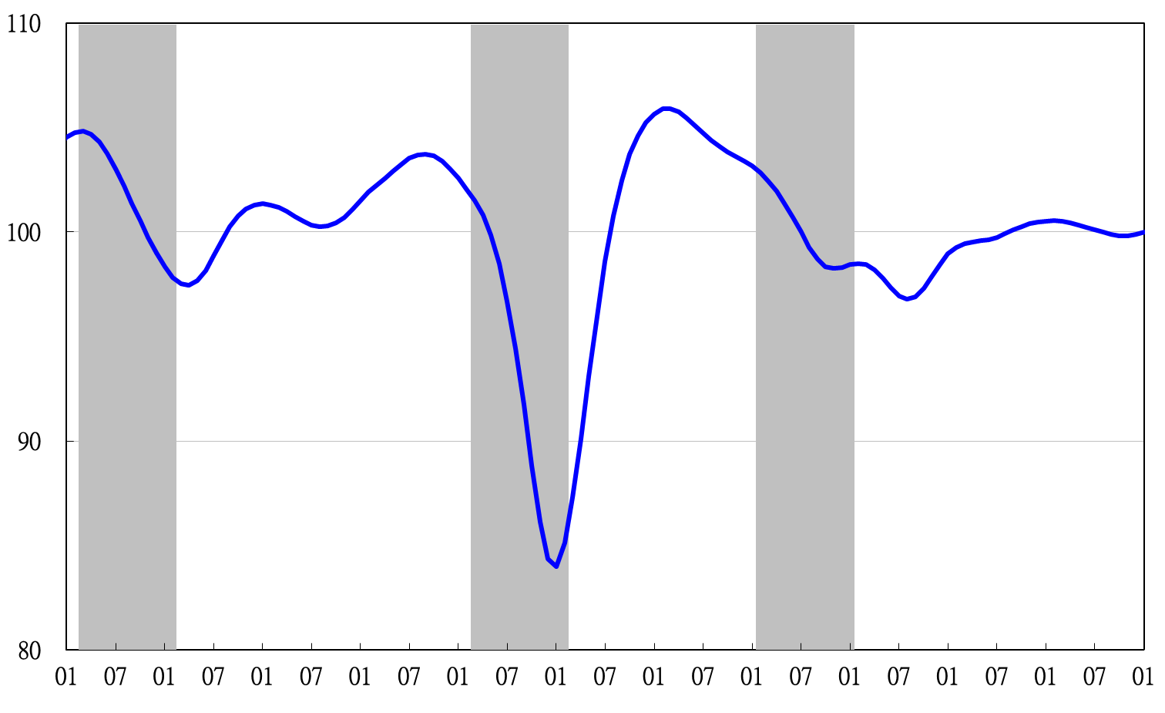

Note: Shaded areas represent recessions.

2004 2005 2006 2007 2008 2009 2010 2011 2012 2013 2014 2015

**Figure 3 Trend-adjusted Leading Index**

**Table 2 Coincident Indicators**

Index

|  |  |  |  |  |  |  |  |
| --- | --- | --- | --- | --- | --- | --- | --- |
|  | 2014 | | | | | | 2015 |
| Jul | Aug | Sep | Oct | Nov | Dec | Jan |
| **Trend adjusted index** | 101.01 | 101.19 | 101.30 | 101.33 | 101.27 | 101.10 | 100.88 |
| Change from preceding month (%) | 0.23 | 0.18 | 0.11 | 0.03 | -0.06 | -0.16 | -0.22 |
| **Components** |  |  |  |  |  |  |  |
| Industrial production index | 100.37 | 100.51 | 100.62 | 100.70 | 100.73 | 100.71 | 100.67 |
| Electric power consumption | 100.19 | 100.34 | 100.37 | 100.28 | 100.07 | 99.75 | 99.40 |
| Index of producer’s shipment for manufacturing | 100.33 | 100.37 | 100.41 | 100.44 | 100.47 | 100.51 | 100.56 |
| Sales of trade and food services | 100.12 | 100.08 | 100.05 | 100.02 | 100.00 | 99.96 | 99.89 |
| Nonagricultural employment | 99.66 | 99.67 | 99.69 | 99.72 | 99.75 | 99.77 | 99.80 |
| Real customs-cleared exports | 100.19 | 100.24 | 100.23 | 100.21 | 100.18 | 100.14 | 100.11 |
| Real machineries and electrical equipments imports | 100.16 | 100.22 | 100.28 | 100.34 | 100.39 | 100.38 | 100.33 |

2004.3(P) 2005.2(T) 2008.3(P) 2009.2(T) 2011.2(P) 2012.1(T)

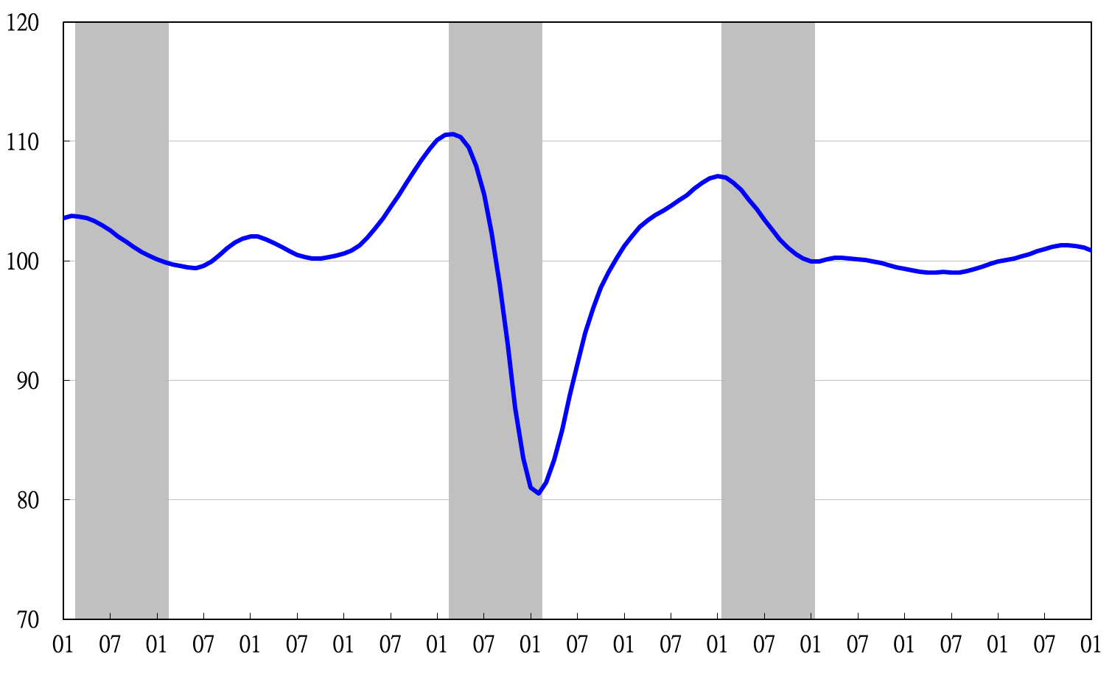

2004 2005 2006 2007 2008 2009 2010 2011 2012 2013 2014 2015

**Figure 4 Trend-adjusted Coincident Index**

**Table 3 Lagging Indicators**

Index

|  |  |  |  |  |  |  |  |
| --- | --- | --- | --- | --- | --- | --- | --- |
|  | 2014 | | | | | | 2015 |
| Jul | Aug | Sep | Oct | Nov | Dec | Jan |
| **Trend adjusted index** | 99.18 | 99.17 | 99.10 | 99.12 | 99.18 | 99.25 | 99.38 |
| Change from preceding month (%) | 0.09 | -0.01 | -0.07 | 0.02 | 0.07 | 0.07 | 0.12 |
| **Components** |  |  |  |  |  |  |  |
| Unemployment rate | 99.85 | 99.89 | 99.93 | 99.98 | 100.03 | 100.10 | 100.17 |
| Regular employees on payrolls  in industry & services | 99.84 | 99.87 | 99.91 | 99.95 | 99.98 | 100.01 | 100.04 |
| The manufacturing unit output labor cost index | 100.22 | 99.97 | 99.62 | 99.35 | 99.13 | 98.91 | 98.77 |
| Interbank overnight call-loan rate | 99.97 | 99.97 | 99.96 | 99.96 | 99.95 | 99.95 | 99.94 |
| Loans and investments of monetary financial institutions | 99.98 | 99.96 | 99.92 | 99.86 | 99.79 | 99.71 | 99.62 |
| Inventories to sales ratio for manufacturing | 99.18 | 99.37 | 99.60 | 99.87 | 100.16 | 100.45 | 100.72 |

2004.3(P) 2005.2(T) 2008.3(P) 2009.2(T) 2011.2(P) 2012.1(T)

2004 2005 2006 2007 2008 2009 2010 2011 2012 2013 2014 2015

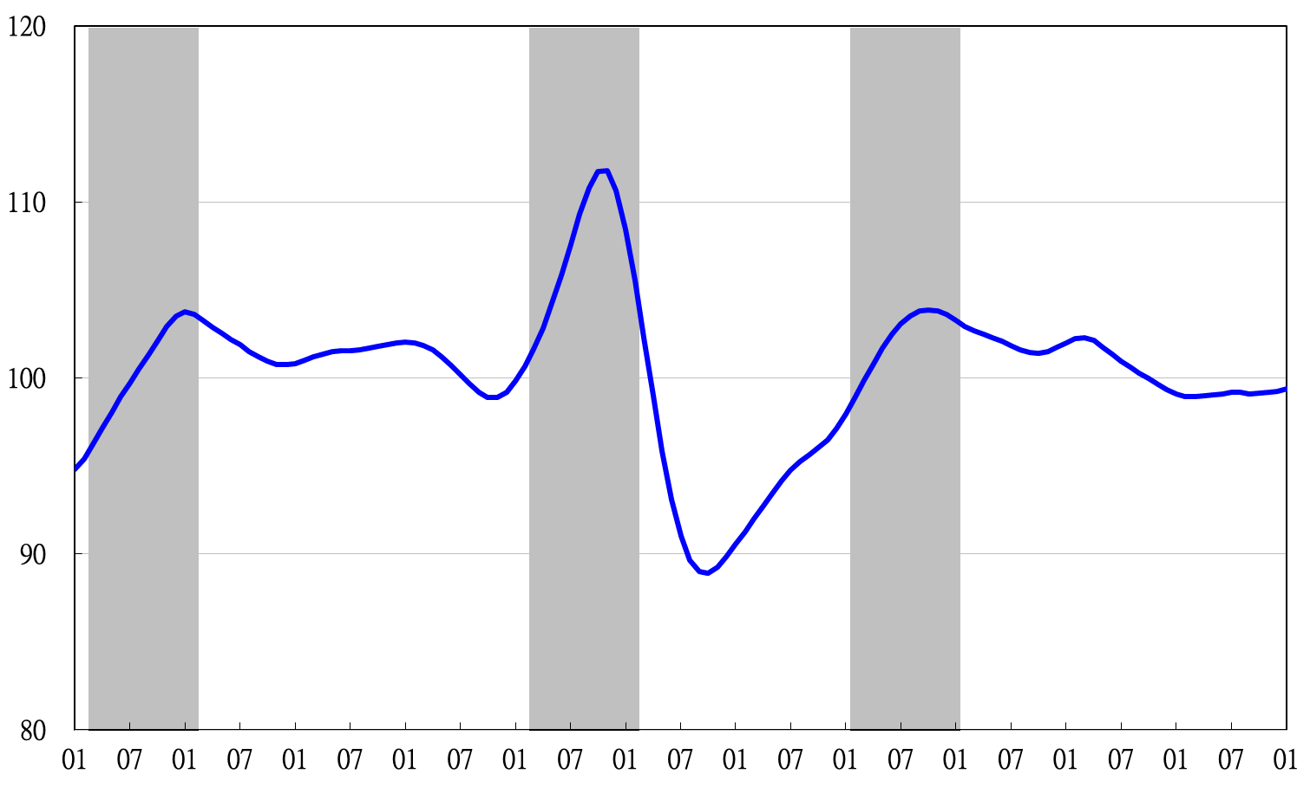

**Figure 5 Trend-adjusted Lagging Index**

2003 2004 2005 2006 2007 2008 2009 2010 2011 2012 2013 2014