Taiwan Business Indicators in May 2013

Press Release

Council for Economic Planning and Development, Executive Yuan

June 27, 2013

In May 2013, the Taiwan Business Indicators showed the domestic economy to still be facing several challenges. Among the indicators compiled by the Cabinet’s Council for Economic Planning and Development (CEPD), the annualized six-month rate of change of leading index increased by 0.5 points, the trend-adjusted coincident index increased by 0.002% from the previous month, and the overall monitoring indicator flashed the " yellow-blue" signal.

1. Leading Indicators: With revised data, the composite leading index stood at 104.5, up by 0.7% from April 2013. Its annualized six-month rate of change increased by 0.5 points to 7.6%. Among the seven indicators making up the trend-adjusted index, the index of producer's inventory for manufacturing (inverted), SEMI book-to-bill ratio, building permits, real monetary aggregates M1B, the stock price index, and average monthly overtime in industry and services had positive cyclical movements from the previous month, while the index of export orders had negative cyclical movement.
2. Coincident Indicators: With revised data, the coincident index stood at 101.9, up by 0.2% from April 2013. Its trend-adjusted index slightly increased by 0.002% to 98.8. Among the seven indicators making up the trend-adjusted index, electric power consumption, real machineries and electrical equipments imports, and the sales index of trade and food services had positive cyclical movements from the previous month, while the index of producer’s shipment for manufacturing, the industrial production index, nonagricultural employment, and real customs-cleared exports had negative cyclical movements.
3. Lagging Indicators: With revised data, the lagging index stood at 103.5, up by 0.03% from April 2013. Its trend-adjusted index decreased by 0.2% to 100.3. Among the six indicators making up the trend-adjusted index, the manufacturing unit output labor cost index had positive cyclical movement from the previous month, while the inventories to sales ratio for manufacturing, the unemployment rate (inverted), regular employees on payrolls in industry and services, loans and investments of monetary financial institutions, and the interbank overnight call-loan rate had negative cyclical movements.
4. The Monitoring Indicators: The total score in May increased by two points to 19, flashing the “yellow-blue” signal for the ninth consecutive month. Among the nine components, monetary aggregates M1B changed its individual light signal from “yellow-blue” to “green”, stock price index changed its individual light signal from “green” to “yellow-red”, and customs-cleared exports changed its individual light signal from “blue” to “yellow-blue”, each gained one point. Sales index of trade and food services lost one point to change its individual light signal from “green” to “yellow-blue”. The light signals for the rest of five components remained unchanged.

**T~~ The next release is scheduled for July 26 2013 ~~T**

# **Leading Indicators**

Seasonally adjusted

|  |  |  |  |  |  |  |  |
| --- | --- | --- | --- | --- | --- | --- | --- |
|  | 2012 | | | 2013 | | | |
| Nov | Dec | Jan | Feb | Mar | Apr | May |
| **Composite Index** | 100.3 | 101.1 | 101.8 | 102.4 | 103.0 | 103.7 | 104.5 |
| Change from preceding month (%) | 0.8 | 0.8 | 0.7 | 0.6 | 0.6 | 0.7 | 0.7 |
| Annualized 6-month rate of change (%) | 4.0 | 4.9 | 5.6 | 6.1 | 6.5 | 7.1 | 7.6 |
| Change from preceding month (point) | 1.0 | 0.9 | 0.7 | 0.5 | 0.4 | 0.5 | 0.5 |
| **Components** |  |  |  |  |  |  |  |
| Index of export orders (2011=100) | 111.5 | 112.0 | 106.9 | 103.0 | 99.8 | 102.8 | 102.7 |
| Real monetary aggregates M1B (NT$ billion) | 11,865 | 11,945 | 11,995 | 11,966 | 12,202 | 12,224 | 12,380 |
| Stock price index(1966=100) | 7,256 | 7,631 | 7,759 | 7,933 | 7,907 | 7,893 | 8,272 |
| Index of producer's Inventory for manufacturing*(2011=100) | 107.5 | 108.6 | 108.2 | 108.4 | 110.5 | 110.9 | 105.6p |
| Average monthly overtime in industry and services (hours/month) | 8.1 | 8.1 | 8.2 | 8.5 | 8.3 | 8.4 | 8.2p |
| Building Permits ** (1,000m2) | 2,689 | 2,254 | 2,744 | 2,915 | 2,308 | 3,058 | 2,930 |
| SEMI Book-to-Bill Ratio | 0.79 | 0.92 | 1.11 | 1.10 | 1.11 | 1.08 | 1.08 |

Note：1. p=Preliminary.

2. * This series is inverted while aggregating composite leading index.

** Including only housing, mercantile, business and service, industry warehousing.

# **Coincident Indicators**

Seasonally adjusted

|  |  |  |  |  |  |  |  |
| --- | --- | --- | --- | --- | --- | --- | --- |
|  | 2012 | | 2013 | | | | |
| Nov | Dec | Jan | Feb | Mar | Apr | May |
| **Composite Index** | 101.3 | 101.4 | 101.5 | 101.5 | 101.6 | 101.7 | 101.9 |
| Change from preceding month (%) | 0.1 | 0.1 | 0.1 | 0.0 | 0.0 | 0.1 | 0.2 |
| Trend adjusted index | 99.4 | 99.3 | 99.2 | 99.0 | 98.8 | 98.8 | 98.8 |
| Change from preceding month (%) | -0.1 | -0.1 | -0.1 | -0.2 | -0.2 | -0.1 | 0.002 |
| **Components** |  |  |  |  |  |  |  |
| Industrial production index(2011=100) | 101.7 | 99.5 | 101.7 | 100.1 | 99.2 | 98.2 | 99.2 |
| Electric power consumption (billion kWh) | 11.60 | 10.98 | 12.00 | 11.73 | 11.35 | 11.80 | 11.86 |
| Index of producer’s shipment for manufacturing (2011=100) | 100.4 | 99.2 | 101.5 | 97.5 | 95.0 | 96.3 | 97.0p |
| Sales index of trade and food services (2006=100) | 111.4 | 111.7 | 110.5 | 109.9 | 109.6 | 111.2 | 112.8 |
| Nonagricultural employment (1,000) | 10,356 | 10,372 | 10,381 | 10,400 | 10,404 | 10,408 | 10,412 |
| Real customs-cleared exports (NT$ billion) | 758.4 | 786.7 | 775.5 | 751.4 | 778.4 | 765.0 | 781.9 |
| Real machineries and electrical equipments imports* (NT$ billion) | 181.6 | 204.4 | 217.8 | 210.9 | 210.9 | 206.8 | 215.5 |

Note：*Due to the original statistical bureau no longer compiling “electronic machinery” import price index, this deflator has replaced with “machinery, electrical equipment, TV image & sound recorders, etc.” import price index starting from January 2013.

# **Lagging Indicators**

Seasonally adjusted

|  |  |  |  |  |  |  |  |
| --- | --- | --- | --- | --- | --- | --- | --- |
|  | 2012 | | 2013 | | | | |
| Nov | Dec | Jan | Feb | Mar | Apr | May |
| **Composite Index** | 102.3 | 102.5 | 102.8 | 103.1 | 103.4 | 103.5 | 103.5 |
| Change from preceding month (%) | 0.1 | 0.2 | 0.2 | 0.3 | 0.3 | 0.1 | 0.03 |
| Trend adjusted index | 100.4 | 100.4 | 100.4 | 100.5 | 100.6 | 100.5 | 100.3 |
| Change from preceding month (%) | -0.1 | -0.0 | 0.0 | 0.1 | 0.0 | -0.1 | -0.2 |
| **Components** |  |  |  |  |  |  |  |
| Unemployment rate* (%) | 4.24 | 4.21 | 4.20 | 4.16 | 4.18 | 4.19 | 4.19 |
| Regular employees on payrolls  in industry & services (Thousand persons) | 6,784 | 6,795 | 6,804 | 6,819 | 6,820 | 6,828 | 6,834p |
| The manufacturing unit output labor cost index  (index 2006=100) | 81.5 | 85.6 | 79.0 | 85.6 | 84.5 | 85.9 | 84.7p |
| Interbank overnight call-loan rate  (percent per annum) | 0.386 | 0.388 | 0.387 | 0.387 | 0.387 | 0.386 | 0.386 |
| Loans and investments of monetary financial institutions (NT$ billion) | 25,339 | 25,507 | 25,602 | 25,724 | 25,941 | 25,997 | 25,987 |
| Inventories to sales ratio for manufacturing (%) | 68.4 | 69.0 | 68.3 | 70.2 | 73.2 | 71.7 | 67.1p |

Note： * This series is inverted while aggregating composite lagging index.

**Composite Leading Index**

2004.3(P) 2005.2(T) 2008.3(P) 2009.2(T)

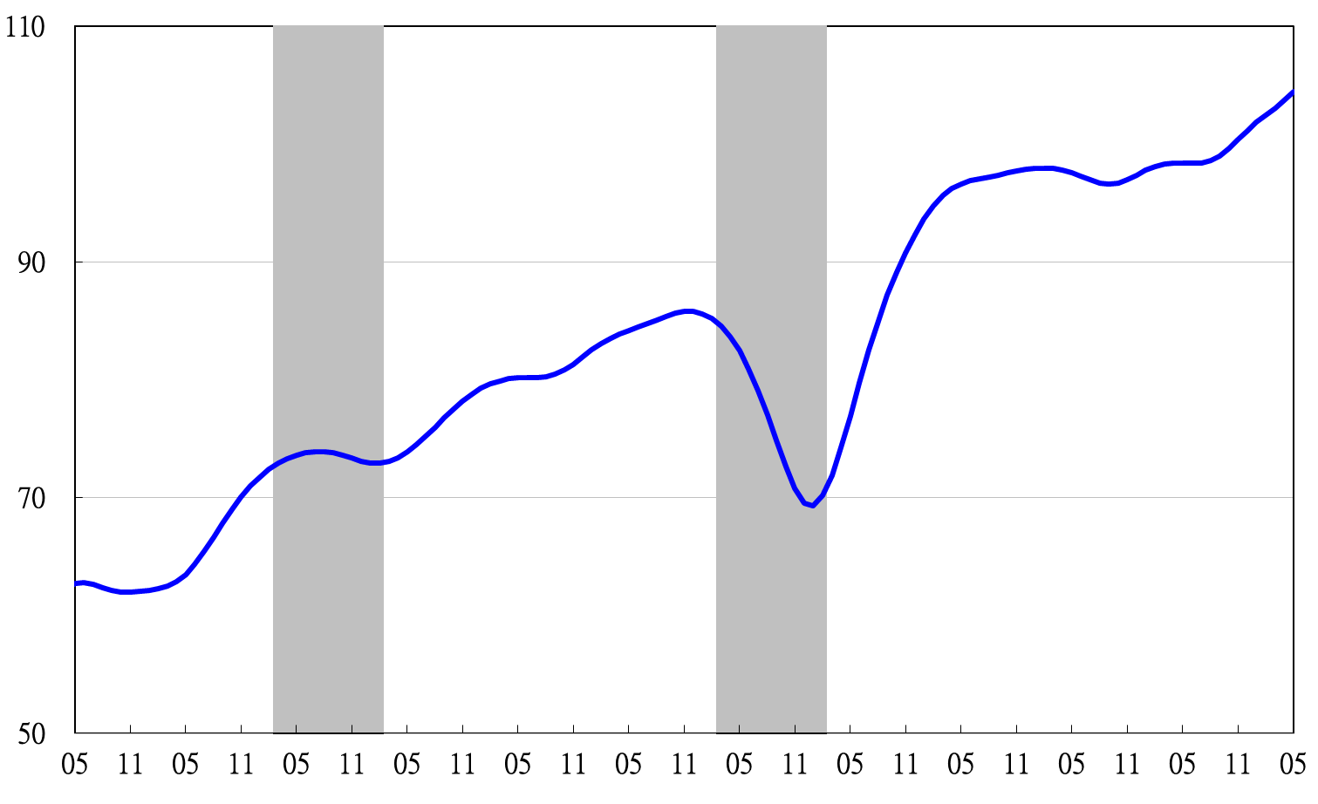

2002 2003 2004 2005 2006 2007 2008 2009 2010 2011 2012 2013

**Annualized 6-month rate of change of composite leading index**

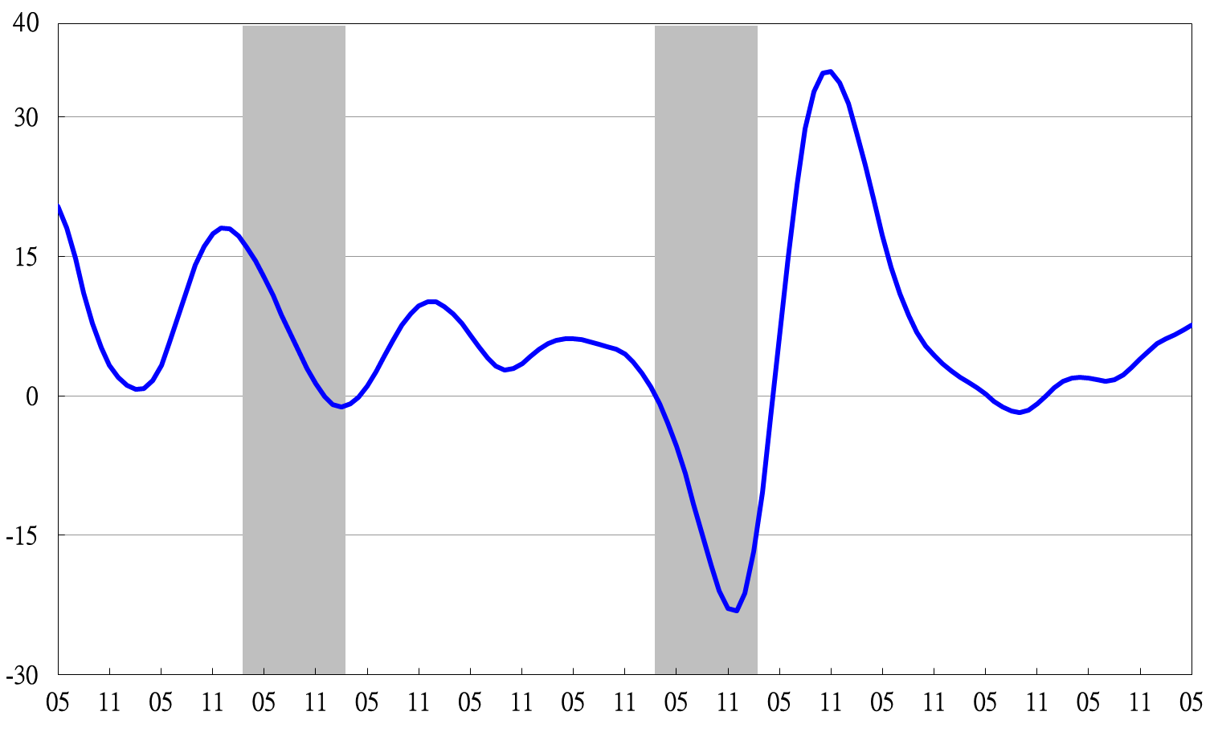

2002 2003 2004 2005 2006 2007 2008 2009 2010 2011 2012 2013

Shaded areas represent recessions.

**Composite Coincident Index**

2004.3(P) 2005.2(T) 2008.3(P) 2009.2(T)

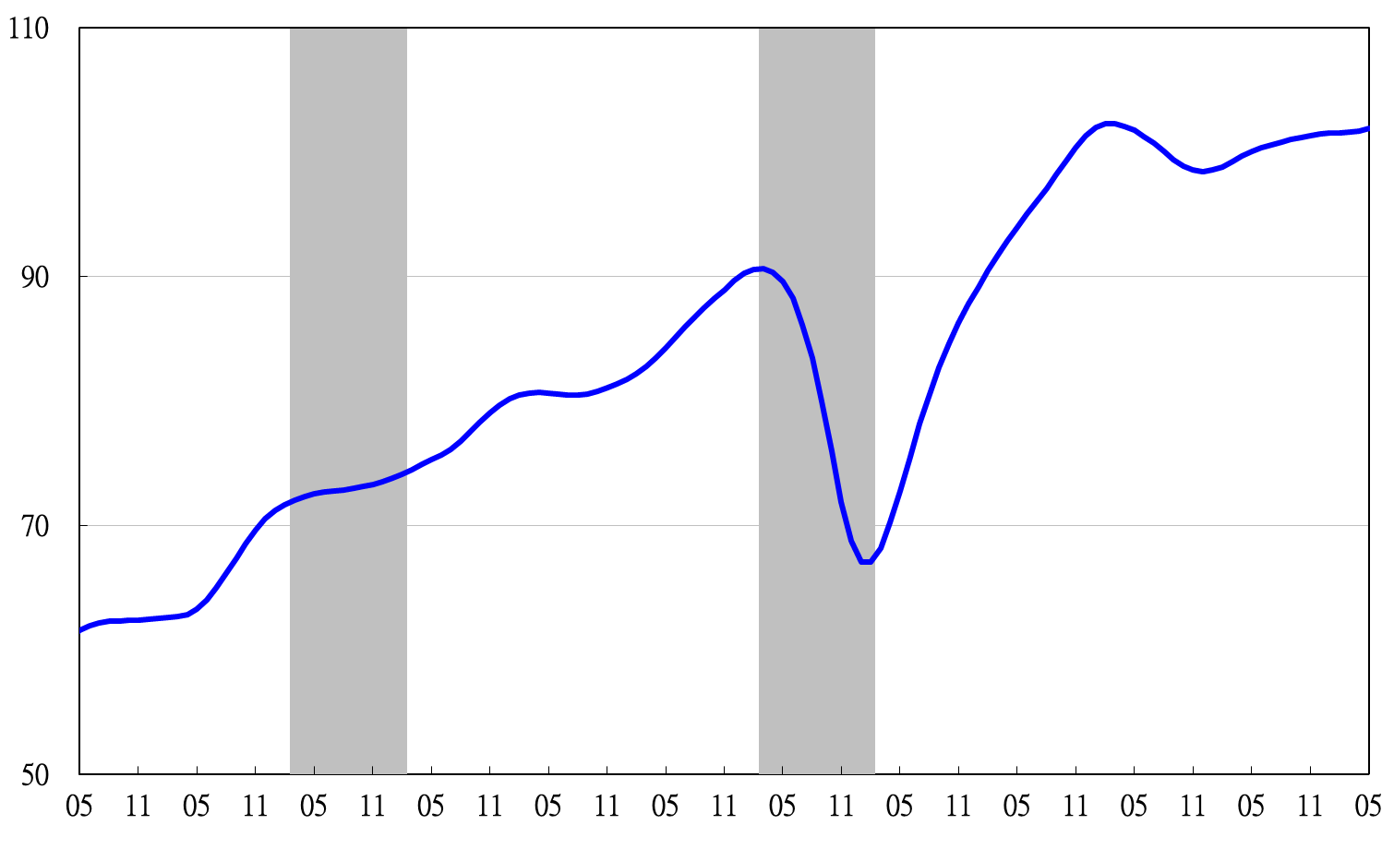

2002 2003 2004 2005 2006 2007 2008 2009 2010 2011 2012 2013

**Trend-adjusted composite coincident index**

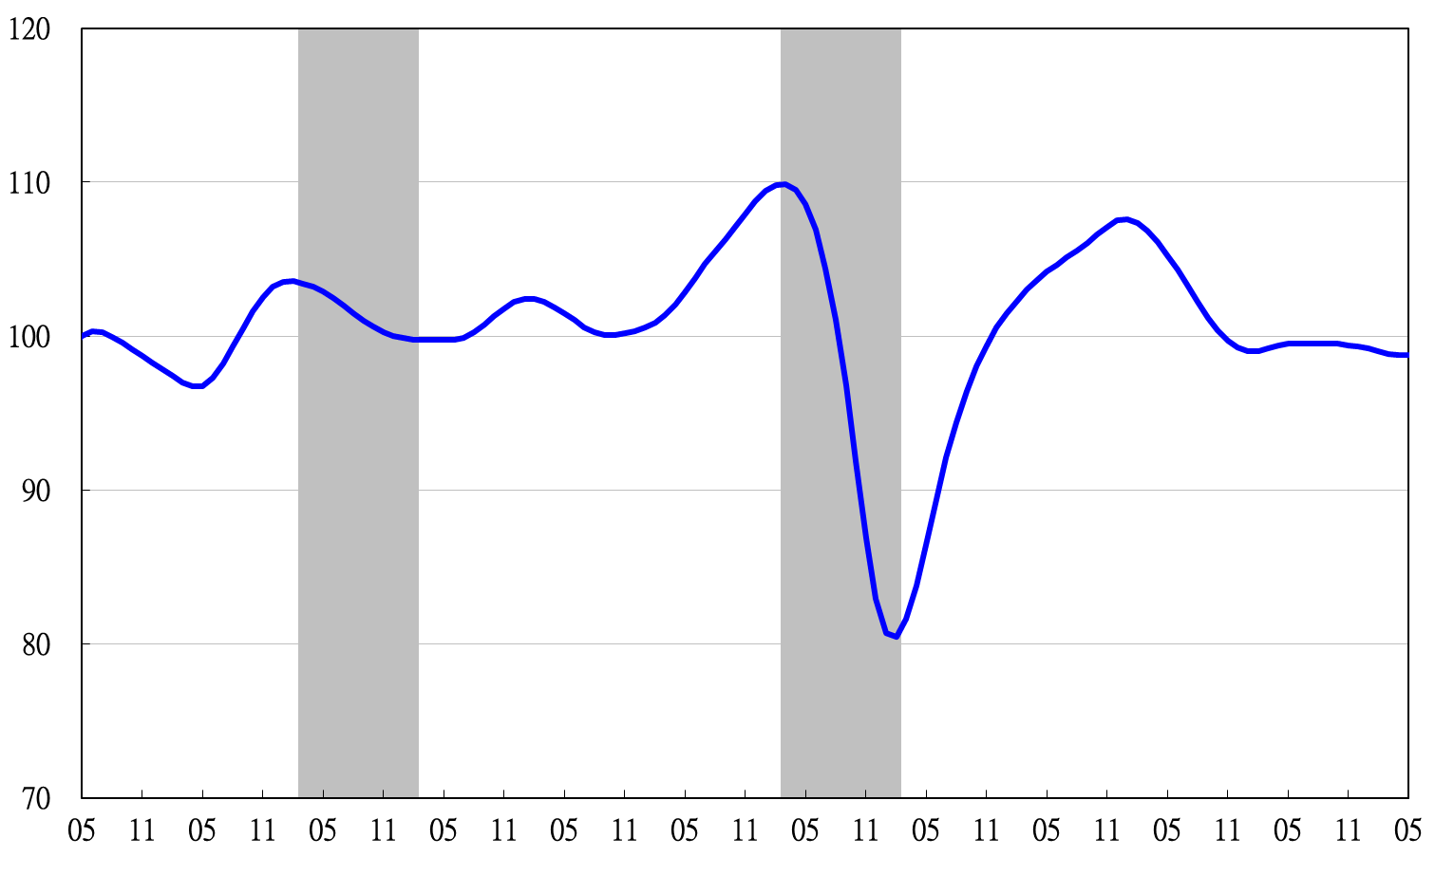

2002 2003 2004 2005 2006 2007 2008 2009 2010 2011 2012 2013

**Composite Lagging Index**

2004.3(P) 2005.2(T) 2008.3(P) 2009.2(T)

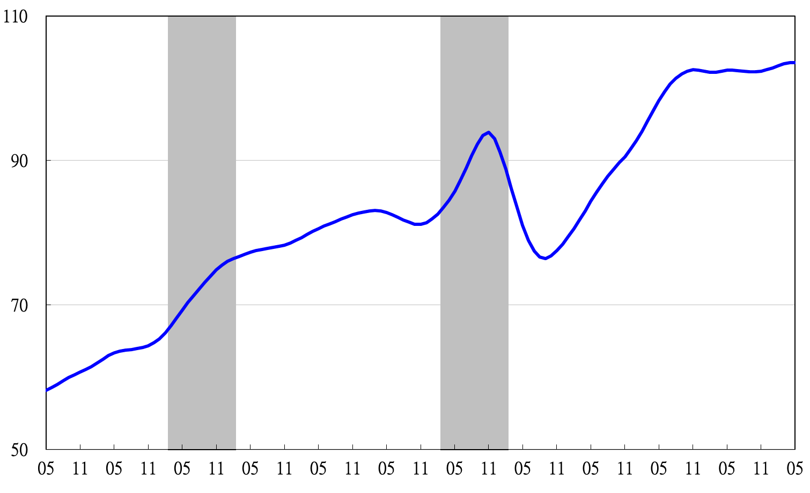

2002 2003 2004 2005 2006 2007 2008 2009 2010 2011 2012 2013

**Trend-adjusted composite lagging index**

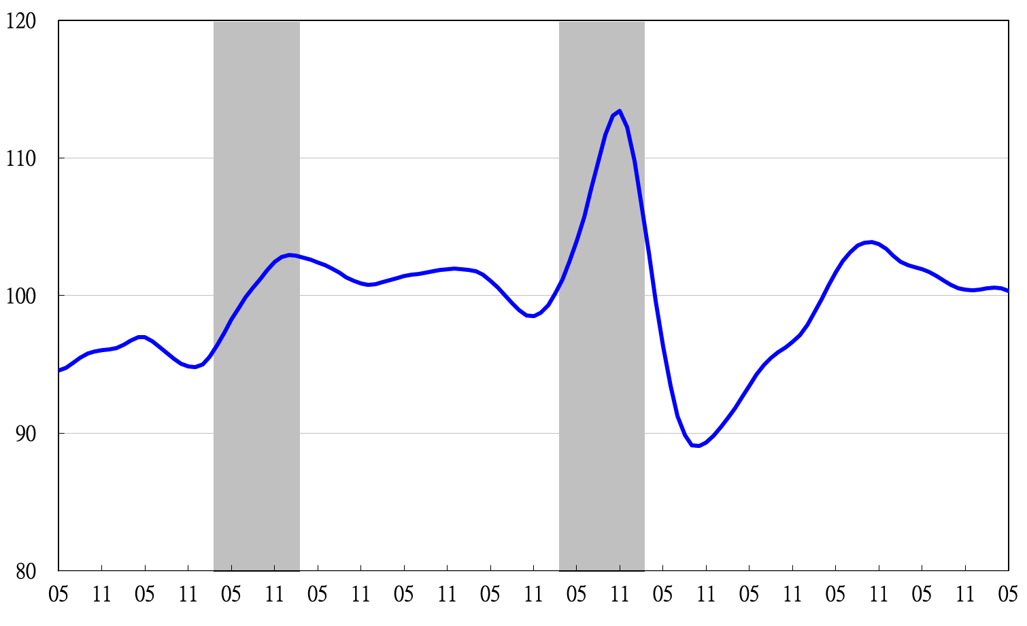

2002 2003 2004 2005 2006 2007 2008 2009 2010 2011 2012 2013

**Monitoring Indicators**

