Taiwan Business Indicators in April 2013

Press Release

Council for Economic Planning and Development

May 27, 2013

In April 2013, Taiwan Business Indicators showed the domestic economy still faced many challenges. Among the indicators compiled by the Cabinet’s Council for Economic Planning and Development (CEPD), the annualized six-month rate of change of leading index increased by 0.08 points, the trend-adjusted coincident index decreased by 0.4% from the previous month, and the overall monitoring indicator flashed the " yellow-blue" signal.

1. Leading Indicators: With revised data, the composite leading index[1] stood at 103.8, up by 0.4% from March 2013. Its annualized six-month rate of change increased by 0.08 points to 6.53%. Among the seven indicators making up the trend-adjusted index, SEMI book-to-bill ratio, building permits, real monetary aggregates M1B, average monthly overtime in industry and services, stock price index, and index of producer's inventory for manufacturing (inverted) had positive cyclical movements from previous month. Index of export orders had negative cyclical movements from previous month.
2. Coincident Indicators: With revised data, the coincident index stood at 101.2, down by 0.2% from March 2013. Its trend-adjusted index decreased by 0.4% to 97.9. Among the seven indicators making up the trend-adjusted index, real machineries and electrical equipments imports, electric power consumption had positive cyclical movements from previous month. Index of producer’s shipment for manufacturing, industrial production index, real customs-cleared exports, nonagricultural employment, and sales index of trade and food services had negative cyclical movements from previous month.
3. Lagging Indicators: With revised data, the lagging index stood at 104.8, up by 0.6% from March 2013. Its trend-adjusted index increased by 0.3% to 101.4. Among the six indicators making up the trend-adjusted index, the manufacturing unit output labor cost index, inventories to sales ratio for manufacturing, loans and investments of monetary financial institutions had positive cyclical movements from previous month. Unemployment rate (inverted), regular employees on payrolls in industry and services, and interbank overnight call-loan rate had negative cyclical movements from previous month.
4. The Monitoring Indicators: The total score in April lost one point to 17, flashing the “yellow-blue” signal for the eighth consecutive month. Among the nine components, customs-cleared exports changed its individual light signal from “yellow-blue” to “blue”, lost one point. The light signals for the rest of eight components remained unchanged.

**T~~ The next release is scheduled for June 27 2013 ~~T**

# **Leading Indicators**

Seasonally adjusted

|  |  |  |  |  |  |  |  |
| --- | --- | --- | --- | --- | --- | --- | --- |
|  | 2012 | | | 2013 | | | |
| Oct | Nov | Dec | Jan | Feb | Mar | Apr |
| **Composite Index** | 100.1 | 100.9 | 101.7 | 102.4 | 102.9 | 103.4 | 103.8 |
| Change from preceding month (%) | 0.7 | 0.8 | 0.8 | 0.7 | 0.5 | 0.4 | 0.4 |
| Annualized 6-month rate of change (%) | 3.5 | 4.5 | 5.4 | 6.0 | 6.4 | 6.46 | 6.53 |
| Change from preceding month (point) | 0.8 | 1.0 | 0.9 | 0.6 | 0.3 | 0.1 | 0.08 |
| **Components** |  |  |  |  |  |  |  |
| Index of export orders (2011=100) | 104.3 | 111.5 | 112.0 | 106.9 | 102.9 | 100.0 | 102.7 |
| Real monetary aggregates M1B (NT$ billion) | 11,795 | 11,865 | 11,945 | 11,995 | 11,965 | 12,201 | 12,225 |
| Stock price index(1966=100) | 7,438 | 7,256 | 7,631 | 7,759 | 7,933 | 7,907 | 7,893 |
| Index of producer's Inventory for manufacturing*(2011=100) | 108.5 | 107.5 | 108.5 | 108.2 | 108.3 | 110.4 | 110.4p |
| Average monthly overtime in industry and services (hours/month) | 8.2 | 8.1 | 8.1 | 8.2 | 8.5 | 8.3 | 8.3p |
| Building Permits ** (1,000m2) | 2,465 | 2,687 | 2,250 | 2,733 | 2,895 | 2,320 | 3,028 |
| SEMI Book-to-Bill Ratio | 0.75 | 0.79 | 0.92 | 1.11 | 1.10 | 1.11 | 1.08 |

Note：1. p=Preliminary.

2. * This series is inverted while aggregating composite leading index.

** Including only housing, mercantile, business and service, industry warehousing.

# **Coincident Indicators**

Seasonally adjusted

|  |  |  |  |  |  |  |  |
| --- | --- | --- | --- | --- | --- | --- | --- |
|  | 2012 | | | 2013 | | | |
| Oct | Nov | Dec | Jan | Feb | Mar | Apr |
| **Composite Index** | 101.5 | 101.6 | 101.7 | 101.7 | 101.6 | 101.4 | 101.2 |
| Change from preceding month (%) | 0.2 | 0.1 | 0.1 | 0.0 | -0.1 | -0.2 | -0.2 |
| Trend adjusted index | 99.5 | 99.4 | 99.3 | 99.1 | 98.7 | 98.3 | 97.9 |
| Change from preceding month (%) | -0.0 | -0.1 | -0.1 | -0.2 | -0.4 | -0.4 | -0.4 |
| **Components** |  |  |  |  |  |  |  |
| Industrial production index(2011=100) | 100.7 | 101.7 | 99.5 | 101.7 | 100.1 | 99.2 | 98.2 |
| Electric power consumption (billion kWh) | 11.90 | 11.59 | 10.97 | 12.00 | 11.71 | 11.33 | 11.79 |
| Index of producer’s shipment for manufacturing (2011=100) | 101.4 | 100.4 | 99.2 | 101.4 | 97.4 | 95.0 | 96.0p |
| Sales index of trade and food services (2006=100) | 109.9 | 111.4 | 111.7 | 110.5 | 109.9 | 109.6 | 110.9 |
| Nonagricultural employment (1,000) | 10,352 | 10,356 | 10,372 | 10,381 | 10,401 | 10,406 | 10,411 |
| Real customs-cleared exports (NT$ billion) | 776.5 | 759.2 | 787.3 | 775.8 | 751.1 | 778.7 | 763.7 |
| Real machineries and electrical equipments imports* (NT$ billion) | 190.7 | 181.3 | 204.1 | 217.4 | 210.2 | 210.2 | 205.7 |

Note：*Due to the original statistical bureau no longer compiling “electronic machinery” import price index, this deflator has replaced with “machinery, electrical equipment, TV image & sound recorders, etc.” import price index starting from January 2013.

# **Lagging Indicators**

Seasonally adjusted

|  |  |  |  |  |  |  |  |
| --- | --- | --- | --- | --- | --- | --- | --- |
|  | 2012 | | | 2013 | | | |
| Oct | Nov | Dec | Jan | Feb | Mar | Apr |
| **Composite Index** | 102.3 | 102.4 | 102.7 | 103.1 | 103.6 | 104.2 | 104.8 |
| Change from preceding month (%) | 0.0 | 0.1 | 0.3 | 0.4 | 0.5 | 0.6 | 0.6 |
| Trend adjusted index | 100.3 | 100.2 | 100.3 | 100.4 | 100.7 | 101.0 | 101.4 |
| Change from preceding month (%) | -0.2 | -0.1 | 0.0 | 0.1 | 0.3 | 0.3 | 0.3 |
| **Components** |  |  |  |  |  |  |  |
| Unemployment rate* (%) | 4.28 | 4.24 | 4.21 | 4.20 | 4.16 | 4.18 | 4.19 |
| Regular employees on payrolls  in industry & services (Thousand persons) | 6,774 | 6,784 | 6,795 | 6,804 | 6,820 | 6,820 | 6,828p |
| The manufacturing unit output labor cost index  (index 2006=100) | 81.1 | 81.6 | 85.6 | 79.0 | 85.6 | 84.4 | 85.4p |
| Interbank overnight call-loan rate  (percent per annum) | 0.388 | 0.386 | 0.388 | 0.387 | 0.387 | 0.387 | 0.386 |
| Loans and investments of monetary financial institutions (NT$ billion) | 25,248 | 25,339 | 25,507 | 25,602 | 25,724 | 25,941 | 26,004 |
| Inventories to sales ratio for manufacturing (%) | 68.6 | 68.4 | 69.3 | 68.8 | 70.9 | 73.2 | 72.4p |

Note： * This series is inverted while aggregating composite lagging index.

**Composite Leading Index**

2004.3(P) 2005.2(T) 2008.3(P) 2009.2(T)

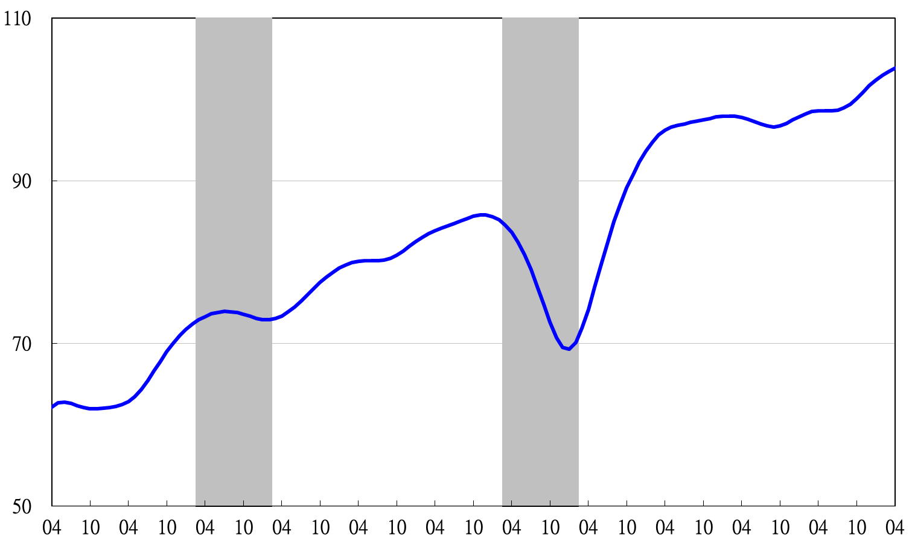

2002 2003 2004 2005 2006 2007 2008 2009 2010 2011 2012 2013

**Annualized 6-month rate of change of composite leading index**

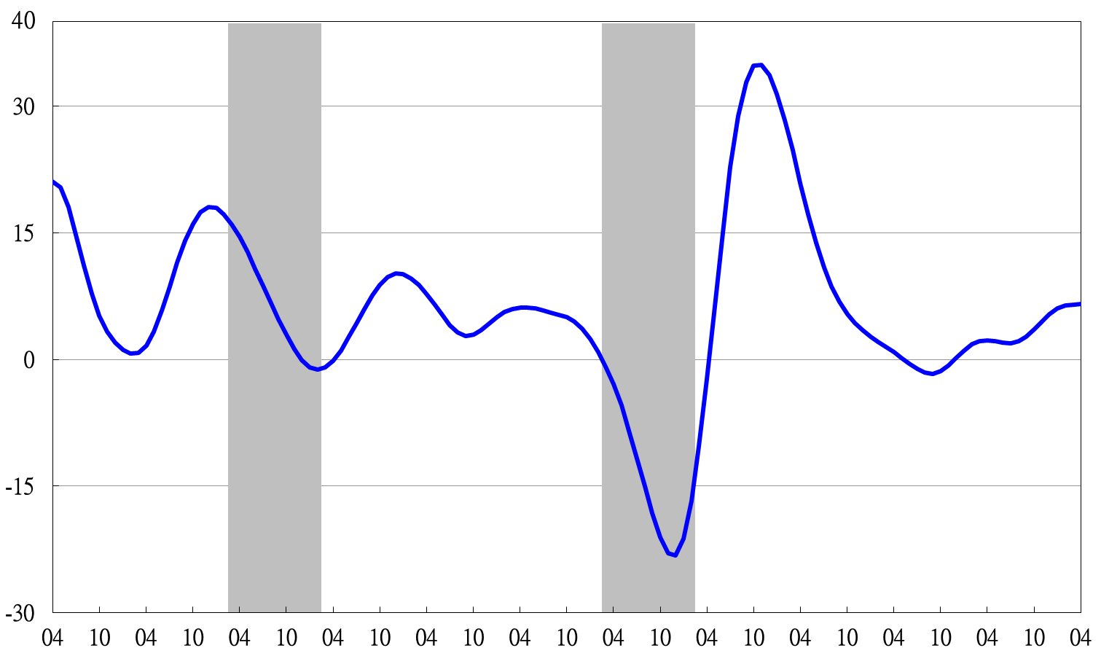

2002 2003 2004 2005 2006 2007 2008 2009 2010 2011 2012 2013

Shaded areas represent recessions.

**Composite Coincident Index**

2004.3(P) 2005.2(T) 2008.3(P) 2009.2(T)

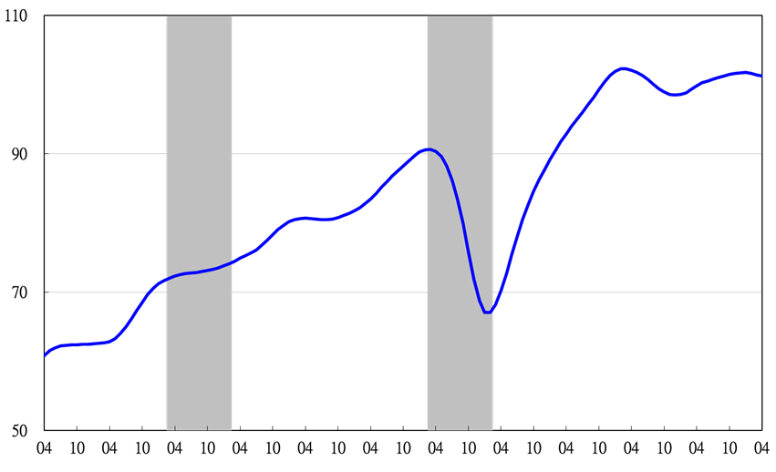

2002 2003 2004 2005 2006 2007 2008 2009 2010 2011 2012 2013

**Trend-adjusted composite coincident index**

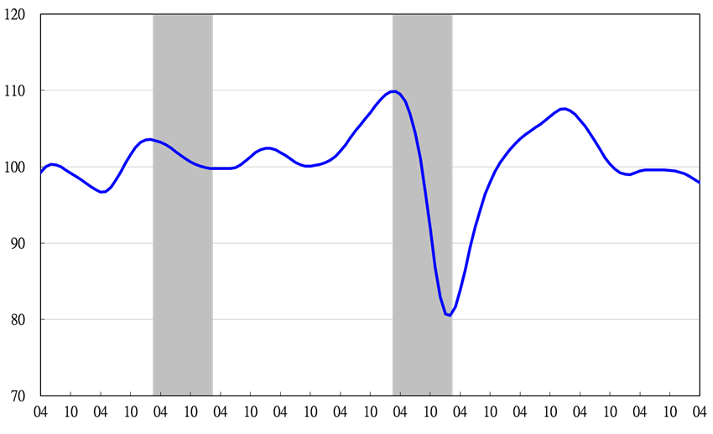

2002 2003 2004 2005 2006 2007 2008 2009 2010 2011 2012 2013

**Composite Lagging Index**

2004.3(P) 2005.2(T) 2008.3(P) 2009.2(T)

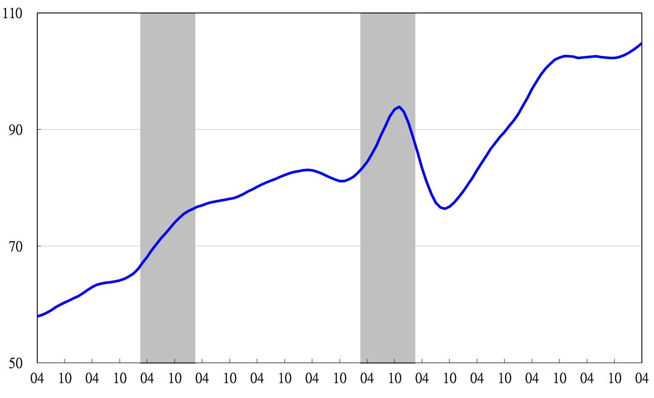

2002 2003 2004 2005 2006 2007 2008 2009 2010 2011 2012 2013

**Trend-adjusted composite lagging index**

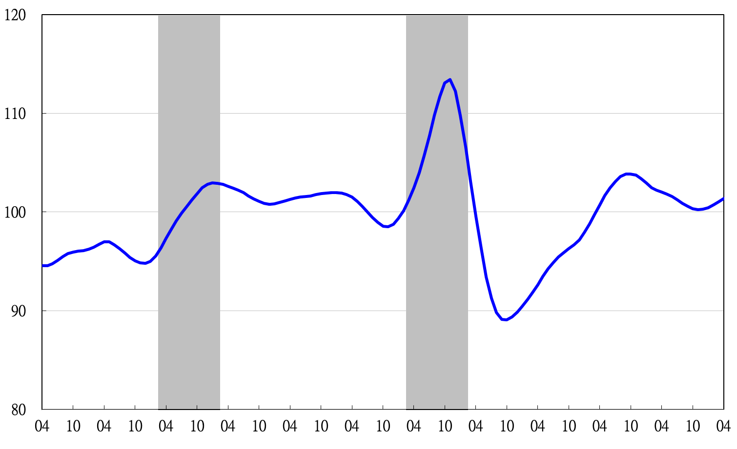

2002 2003 2004 2005 2006 2007 2008 2009 2010 2011 2012 2013

**Monitoring Indicators**

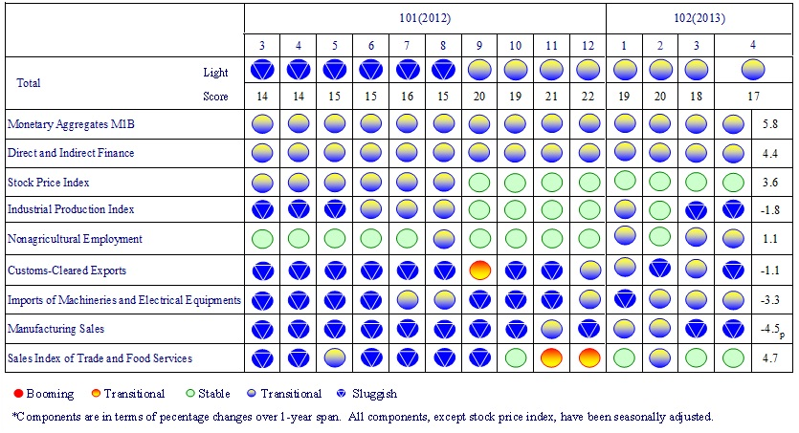

1. In this month’s release, histories of the composite indices were revised downward due to the trend adjustment of reference series with the annual benchmark revisions of the source data-industrial production. These revisions do not change the cyclical properties of the business indicators.