ifo World Economic Climate in the 3rd Quarter 2019
Press Release
National Development Council (NDC)
August 12, 2019
According to latest quarterly World Economic survey released today, ifo World Economic Climate indicator declined from -2.4 to -10.1 points in the third quarter 2019. Both the assessment of the current situation and expectations dropped significantly. The ifo said, the intensification of the trade conflict is having a considerable detrimental effect on the world economy.
In Taiwan, the experts’ assessment of current economic situation has improved slightly. In contrast, the expectations for the coming months have dropped, the government will be closely monitoring the economic situation.
ifo World Economic Climate
 | 2017Q3 | 2017Q4 | 2018Q1 | 2018Q2 | 2018Q3 | 2018Q4 | 2019Q1 | 2019Q2 | 2019Q3
Climate | 13.2 | 17.1 | 26.0 | 16.5 | 2.9 | -2.2 | -13.1 | -2.4 | -10.1
Situation | 12.5 | 17.2 | 28.3 | 27.4 | 17.5 | 12.2 | 2.6 | 1.4 | -5.4
Expectations | 14.0 | 16.9 | 23.9 | 6.1 | -10.6 | -15.7 | -27.7 | -6.1 | -14.7
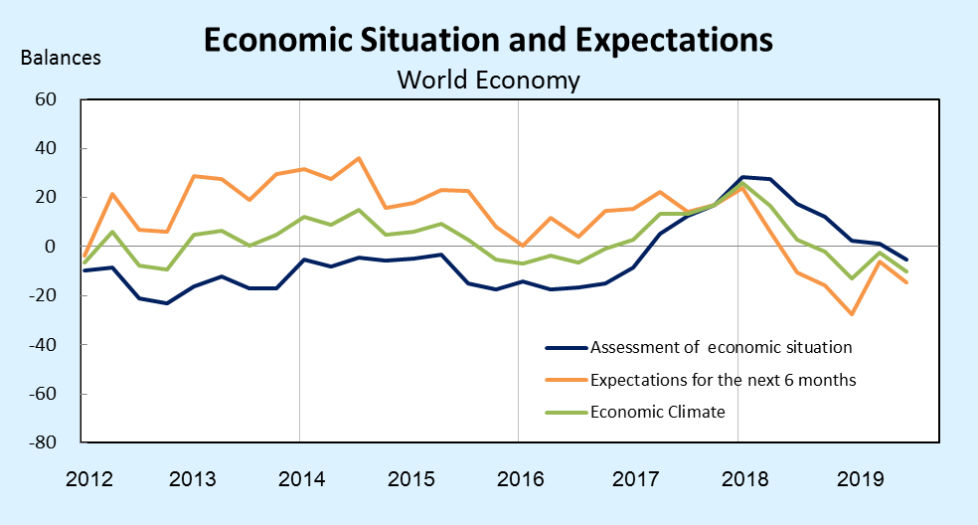
Source: ifo World Economic Survey (WES) III/2019.
Results of the WES for Taiwan
(Present judgement)
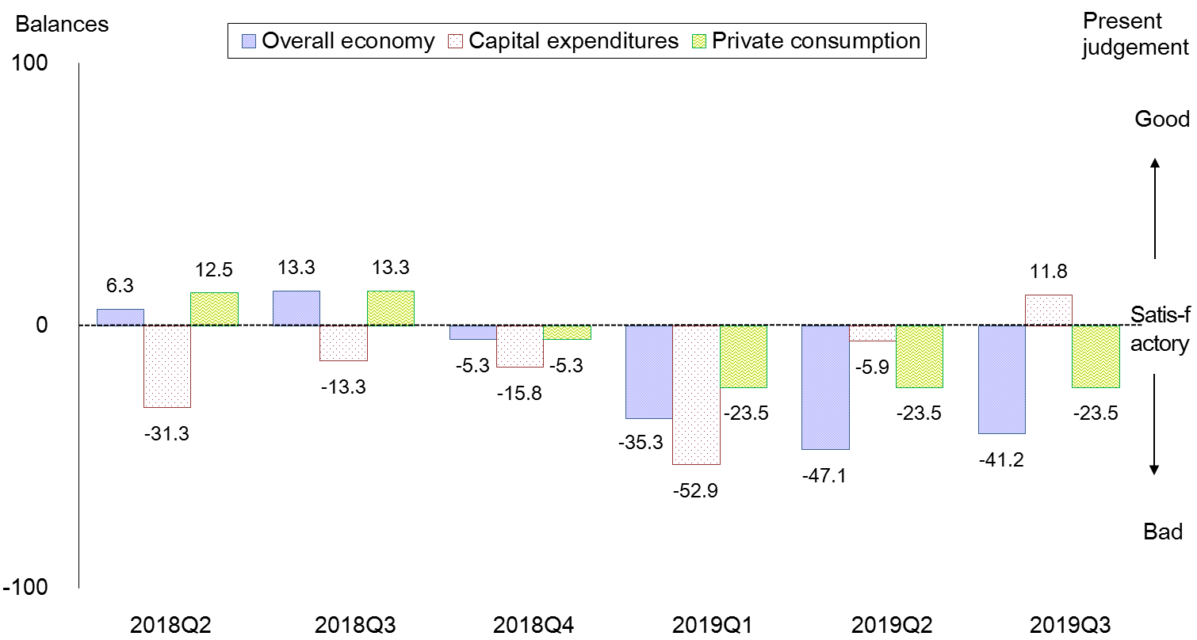
notes: The WES is a qualitative survey. The respondents only need to answer the questions of "good", "satisfactory" and "bad" for the questions. The balance is the difference share between positive assessment responses and negative assessment responses.
Source: ifo World Economic Survey (WES) III/2019.The July 2019 survey received responses from 17 experts in Taiwan.

Results of the WES for Taiwan
(Expectations for the 6 months)
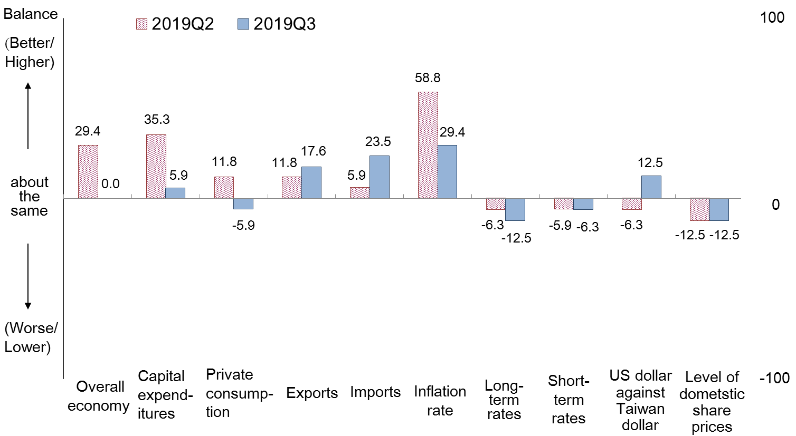
notes: The WES is a qualitative survey. The respondents only need to answer the questions of "better/higher", "about the same" and "worse/lower" for the questions. The balance is the difference share between positive assessment responses and negative assessment responses.
Source: ifo World Economic Survey (WES) III/2019. The July 2019 survey received responses from 17 experts in Taiwan.

For more information, please visit https://www.cesifo-group.de/ifoHome.html

