Taiwan Business Indicators in May 2022
Press Release
National Development Council (NDC)
June 27, 2022
In May 2022, the overall monitoring indicator continued to flash the “green” signal, the total score same as the last month is 28. The trend-adjusted leading index decreased for seven consecutive months and the coincident index decreased for four consecutive months, the government will be closely monitoring the economic situation.
The Monitoring Indicators
- The total score in May 2022 was 28, flashing the “green” signal, same as the last month.
Leading Indicators
- The trend-adjusted leading index decreased by 0.70% in May 2022 to 99.03, falling for seven consecutive months.
Coincident Indicators
- The trend-adjusted coincident index decreased by 0.56% in May 2022 to 100.64, falling for four consecutive months.
Lagging Indicators
- The trend-adjusted lagging index increased by 0.60% in May 2022 to 104.73, rising for nineteen consecutive months.

T~~ Next publication date: July 27 2022 ~~
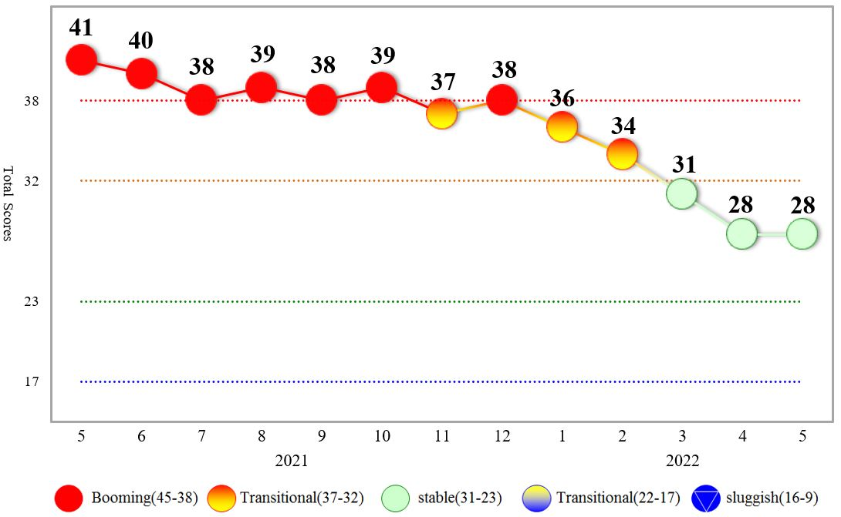
Figure 1 Total Scores in the Past Year
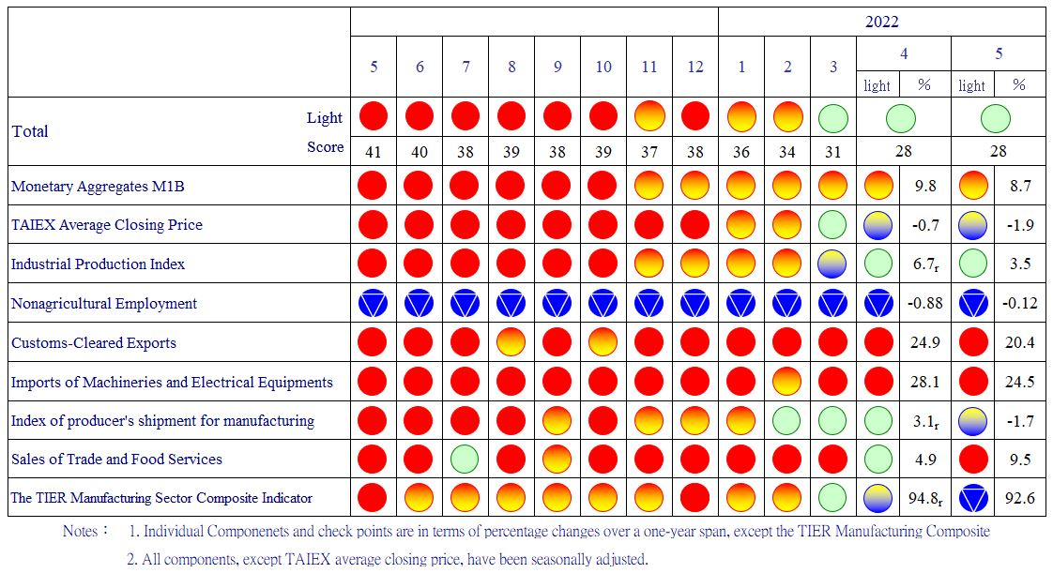
Figure 2 Monitoring Indicators
Table 1 Leading Indicators
Index
 | 2021 |  | 2022
 | Nov | Dec | Jan | Feb | Mar |  | Apr | May
Trend adjusted index | 102.35 | 102.00 | 101.52 | 100.95 |  | 100.36 | 99.72 | 99.03
Change from preceding month (%) | -0.17 | -0.35 | -0.47 | -0.56 |  | -0.58 | -0.64 | -0.70
Components¹
Diffusion Index of export orders² | 100.70 | 100.39 | 100.06 | 99.67 |  | 99.28 | 98.93 | 98.62
Real monetary aggregates M1B | 100.43 | 100.29 | 100.12 | 99.90 |  | 99.62 | 99.31 | 98.99
TAIEX average closing price | 100.45 | 100.34 | 100.20 | 100.00 |  | 99.74 | 99.44 | 99.11
Net accession rate of employees on payrolls of industry and services ³ | 100.72 | 100.69 | 100.60 | 100.49 |  | 100.37 | 100.21 | 100.04
New housing construction started ⁴ | 99.12 | 99.37 | 99.73 | 100.24 |  | 100.91 | 101.55 | 102.12
Real imports of semiconductor equipment | 100.49 | 100.32 | 100.11 | 99.89 |  | 99.71 | 99.60 | 99.51
The TIER manufacturing sector composite indicator | 100.40 | 100.26 | 100.01 | 99.65 |  | 99.17 | 98.62 | 98.05
Note：1. All components are passed through seasonal adjustment, trend-removal, smoothing and normalization.
2. Diffusion Index of export orders by number of firms.
3. Net accession rate is equal to accession rate minus separation rate.
4. Including only housing, mercantile, business and service, industry warehousing.
2011.2(P) 2012.1(T) 2014.10(P) 2016.2(T)
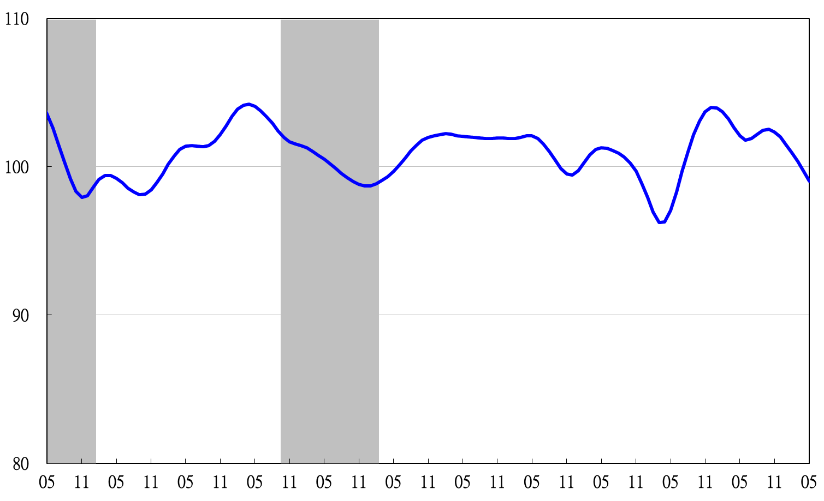

2011 2012 2013 2014 2015 2016 2017 2018 2019 2020 2021 2022
Figure 3 Trend-adjusted Leading Index
Note: Shaded areas represent recessions.
Table 2 Coincident Indicators
Index
 | 2021 |  | 2022
 | Nov | Dec | Jan | Feb | Mar | Apr | May
Trend adjusted index | 101.55 | 101.80 | 101.98 | 101.96 | 101.67 | 101.21 | 100.64
Change from preceding month (%) | 0.28 | 0.25 | 0.17 | -0.02 | -0.29 | -0.45 | -0.56
Components
Industrial production index | 100.49 | 100.37 | 100.26 | 100.11 | 99.89 | 99.67 | 99.44
Electric power consumption | 100.94 | 100.77 | 100.59 | 100.38 | 100.14 | 99.92 | 99.70
Index of producer’s shipment for manufacturing | 100.77 | 100.53 | 100.27 | 99.99 | 99.68 | 99.33 | 98.95
Sales of trade and food services | 101.10 | 101.36 | 101.51 | 101.53 | 101.43 | 101.18 | 100.86
Nonagricultural employment | 99.48 | 99.72 | 99.86 | 99.89 | 99.83 | 99.72 | 99.57
Real customs-cleared exports | 99.34 | 99.91 | 100.54 | 101.07 | 101.38 | 101.57 | 101.70
Real machineries and electrical equipments imports | 100.22 | 100.18 | 100.19 | 100.22 | 100.24 | 100.23 | 100.18

2011.2(P) 2012.1(T) 2014.10(P) 2016.2(T)
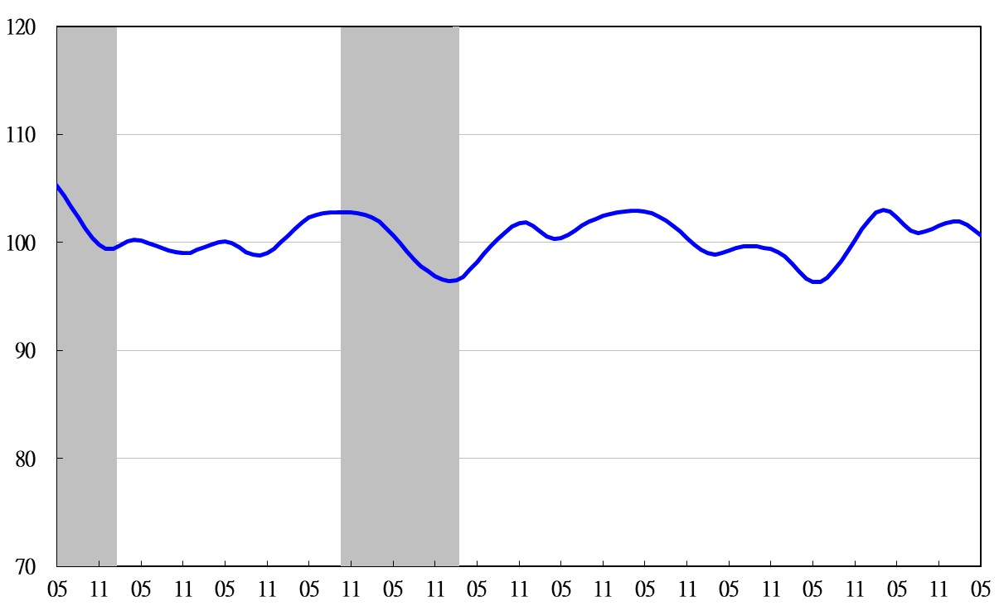
2011 2012 2013 2014 2015 2016 2017 2018 2019 2020 2021 2022
Figure 4 Trend-adjusted Coincident Index

Table 3 Lagging Indicators
Index
 | 2021 |  | 2022
 | Nov | Dec | Jan | Feb | Mar | Apr | May
Trend adjusted index | 101.96 | 102.36 | 102.66 | 103.00 | 103.52 | 104.11 | 104.73
Change from preceding month (%) | 0.55 | 0.39 | 0.30 | 0.33 | 0.50 | 0.57 | 0.60
Components
Unemployment rate | 100.16 | 100.53 | 100.77 | 100.91 | 100.97 | 100.985 | 100.976
The manufacturing unit output labor cost index | 99.89 | 99.86 | 99.87 | 100.00 | 100.35 | 100.81 | 101.31
Interbank overnight call-loan rate | 99.97 | 99.98 | 100.01 | 100.05 | 100.10 | 100.16 | 100.22
Loans and investments of financial institutions | 100.46 | 100.41 | 100.33 | 100.20 | 100.00 | 99.74 | 99.45
Inventory value for manufacturing | 101.60 | 101.72 | 101.85 | 102.05 | 102.33 | 102.69 | 103.09

2011 2012 2013 2014 2015 2016 2017 2018 2019 2020 2021 2022
2011.2(P) 2012.1(T) 2014.10(P) 2016.2(T)

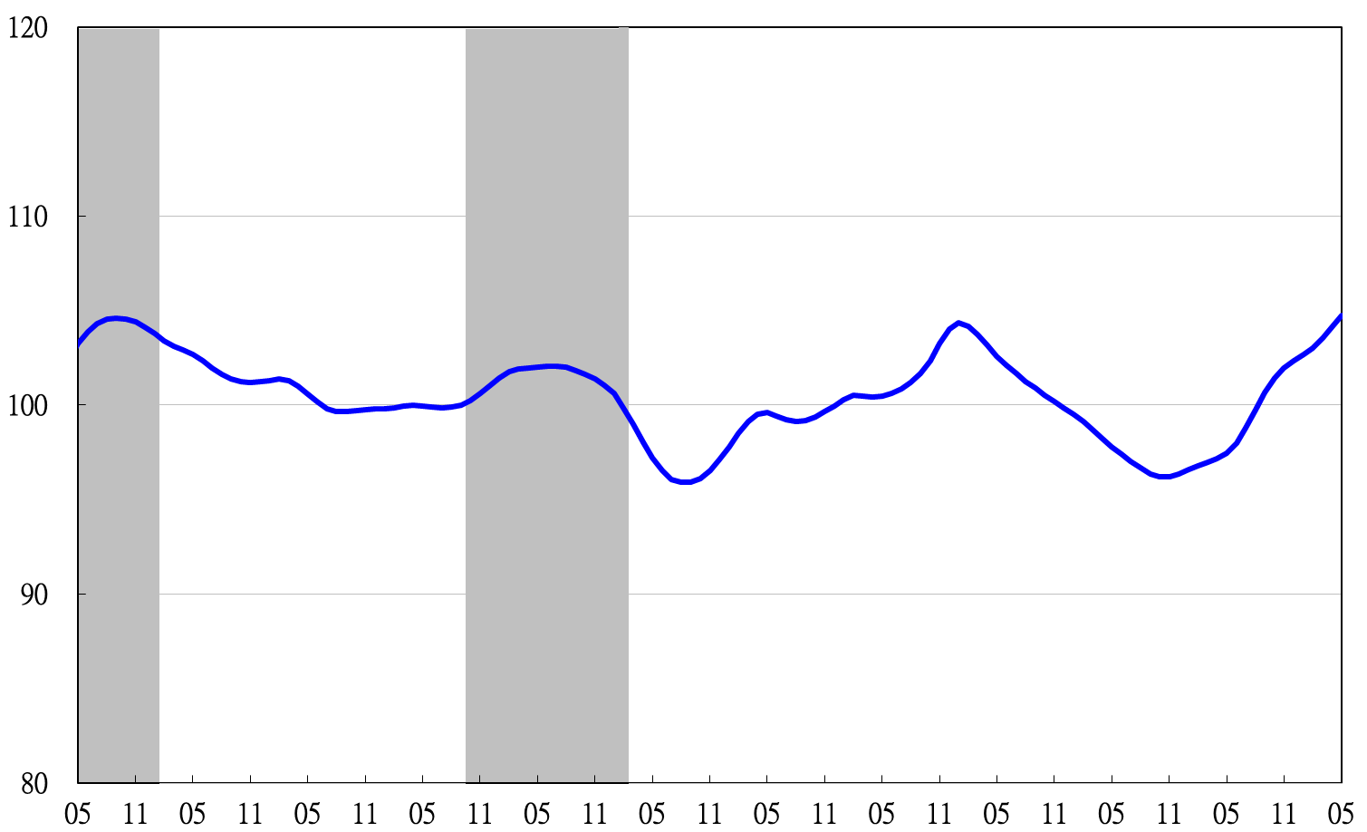
Figure 5 Trend-adjusted Lagging Index

