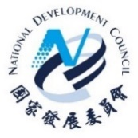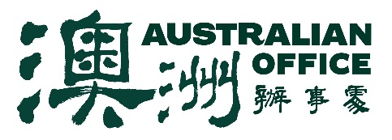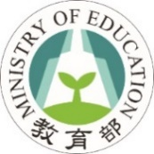

JOINT STATEMENT ON THE AUSTRALIA-TAIWAN DIALOGUE ON ENGLISH LANGUAGE LEARNING
BY THE AUSTRALIAN OFFICE, THE NATIONAL DEVELOPMENT COUNCIL AND THE MINISTRY OF EDUCATION

On 3 March 2022 the Australian Office, the National Development Council and the Ministry of Education hosted the Australia-Taiwan Dialogue on English Language Learning, further deepening the strong education, vocational training and youth links between Australia and Taiwan.
The inaugural Dialogue launched a new English language learning partnership, which will advance education cooperation, promote a range of English language learning initiatives, and connect Australia’s world-leading English language service providers with Taiwanese institutions delivering Taiwan’s Bilingual 2030 policy. Work is already underway towards an Action Plan to support the new partnership.
The partnership will assist to deepen links between Australian providers and Taiwanese institutions, helping to promote Taiwan’s bilingual policy and enhance English language learning. Areas of cooperation will include bilingual teacher training, provision of English language courses, and other support for the ongoing development of Taiwan’s English language learning capabilities. Other objectives of the partnership may also include sister school relationships, joint degree programs, vocational training, and the promotion of student, teacher and academic and professional exchanges.
The Dialogue opened with pre-recorded remarks from Australia’s Acting Minister for Education and Youth and Minister for Employment, Workforce, Skills, Small and Family Business, the Hon Stuart Robert MP, and Taiwan’s Minister of the National Development Council, Ming-Hsin Kung, and Minister of Education, Wen-Chung Pan. The CEO of English Australia, Mr Brett Blacker, was keynote speaker.
During the event, both sides shared lessons in English language learning, explored means of facilitating closer engagement and opportunities to strengthen links, and discussed the promotion of study opportunities, skills development and vocational education and training (VET). They also explored opportunities to strengthen links in Mandarin language learning in Australia.
Australia and Taiwan are longstanding education partners. Over 18,000 Taiwanese students were enrolled in Australian educational institutions immediately pre-COVID, after more than five years of continuous growth. Over 250,000 visas have been issued to young Taiwanese under Australia’s Working Holiday Maker Scheme, and over 1,000 Australian students have studied in Taiwan under the Australian Government’s New Colombo Plan, gaining skills and building life-long friendships and understanding.
Several Taiwanese institutions have already aligned with Australian VET curricula and these links continue to strengthen, with discussion underway about further promotion of Australian vocational training in Taiwan. Australia and Taiwan are also expanding English language learning and teacher training cooperation, including through interactive, innovative online programs, and promoting the circulation of talent and professional skills between the two economies.
As Taiwan works to promote its ambitious Bilingual 2030 goals, Australia is a natural partner in many respects. Australia’s world-leading English language education providers have a long record of high-quality English language education for people from a wide variety of backgrounds. Both sides will continue to work together to take forward significant opportunities to deepen cooperation under this partnership, including through the proposed Action Plan.

