Taiwan Business Indicators in July 2021
Press Release
National Development Council (NDC)
August 27, 2021
In July 2021, the overall monitoring indicator continued to flash the “red” signal, the total score decreased two points to 38. The trend-adjusted leading index decreased for six consecutive months and the coincident index decreased for four consecutive months, the government will be closely monitoring the economic situation.
The Monitoring Indicators
- The total score in July 2021 was 38, flashing the “red” signal, which decreased 2 points from 40 last month.
Leading Indicators
- The trend-adjusted leading index decreased by 0.66% in July 2021 to 100.47, falling for six consecutive months.
Coincident Indicators
- The trend-adjusted coincident index decreased by 0.89% in July 2021 to 101.51, falling for four consecutive months.
Lagging Indicators
- The trend-adjusted lagging index increased by 0.02% in July 2021 to 100.52, rising for one consecutive month.

T~~ Next publication date: September 27 2021 ~~
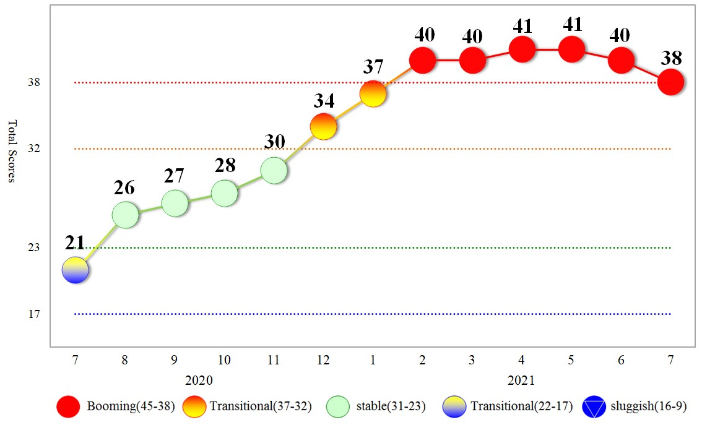
Figure 1 Total Scores in the Past Year

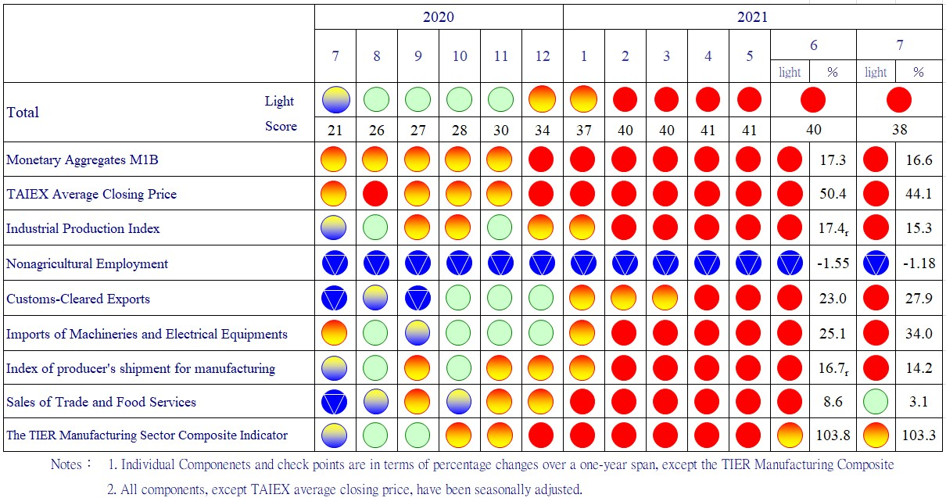
Figure 2 Monitoring Indicators

Table 1 Leading Indicators
Index
 | 2021
 | Jan | Feb | Mar | Apr | May |  | Jun | Jul
Trend adjusted index | 104.75 | 104.44 | 103.83 | 102.98 |  | 102.01 | 101.13 | 100.47
Change from preceding month (%) | 0.01 | -0.30 | -0.58 | -0.82 |  | -0.94 | -0.86 | -0.66
Components¹
Diffusion Index of export orders² | 101.60 | 101.40 | 101.22 | 101.07 |  | 100.94 | 100.85 | 100.78
Real monetary aggregates M1B | 100.78 | 100.86 | 100.90 | 100.91 |  | 100.92 | 100.92 | 100.91
TAIEX average closing price | 100.53 | 100.73 | 100.88 | 100.98 |  | 101.05 | 101.10 | 101.14
Net accession rate of employees on payrolls of industry and services ³ | 101.60 | 101.22 | 100.55 | 99.63 |  | 98.59 | 97.73 | 97.18
New housing construction started ⁴ | 100.12 | 99.79 | 99.46 | 99.17 |  | 98.95 | 98.75 | 98.62
Real imports of semiconductor equipment | 100.25 | 100.35 | 100.36 | 100.29 |  | 100.14 | 99.96 | 99.78
The TIER manufacturing sector composite indicator | 101.41 | 101.42 | 101.33 | 101.16 |  | 100.93 | 100.68 | 100.41
Note：1. All components are passed through seasonal adjustment, trend-removal, smoothing and normalization.
2. Diffusion Index of export orders by number of firms.
3. Net accession rate is equal to accession rate minus separation rate.
4. Including only housing, mercantile, business and service, industry warehousing.

2011.2(P) 2012.1(T) 2014.10(P) 2016.2(T)
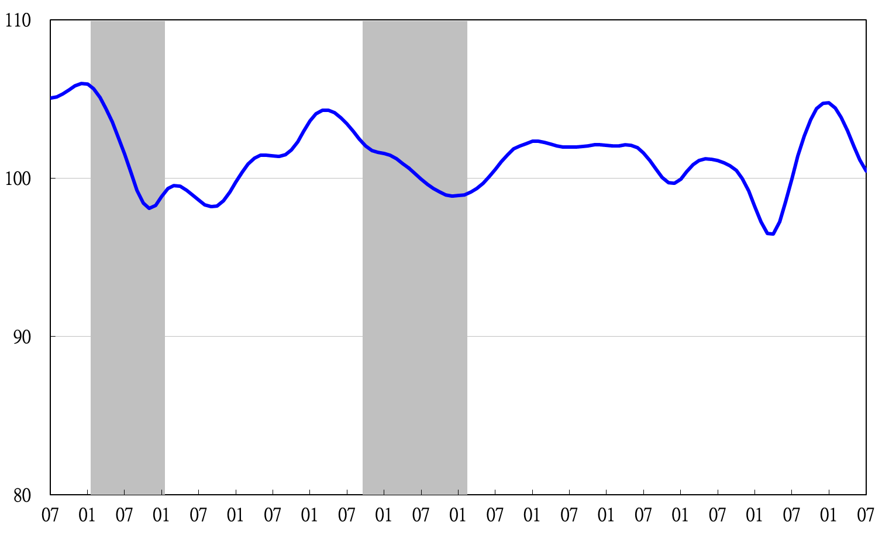

2010 2011 2012 2013 2014 2015 2016 2017 2018 2019 2020 2021
Figure 3 Trend-adjusted Leading Index
Note: Shaded areas represent recessions.
Table 2 Coincident Indicators
Index
 | 2021
 | Jan | Feb | Mar | Apr | May | Jun | Jul
Trend adjusted index | 103.36 | 103.90 | 104.08 | 103.88 | 103.29 | 102.43 | 101.51
Change from preceding month (%) | 0.77 | 0.52 | 0.18 | -0.19 | -0.57 | -0.84 | -0.89
Components
Industrial production index | 100.72 | 101.03 | 101.23 | 101.36 | 101.47 | 101.55 | 101.60
Electric power consumption | 100.57 | 100.80 | 101.00 | 101.16 | 101.23 | 101.17 | 101.11
Index of producer’s shipment for manufacturing | 100.95 | 101.22 | 101.45 | 101.65 | 101.80 | 101.91 | 101.99
Sales of trade and food services | 101.76 | 102.07 | 102.13 | 101.88 | 101.28 | 100.45 | 99.53
Nonagricultural employment | 100.75 | 100.58 | 100.16 | 99.43 | 98.42 | 97.30 | 96.18
Real customs-cleared exports | 100.79 | 100.72 | 100.69 | 100.70 | 100.71 | 100.69 | 100.66
Real machineries and electrical equipments imports | 100.52 | 100.76 | 100.90 | 100.97 | 101.00 | 101.05 | 101.13

2011.2(P) 2012.1(T) 2014.10(P) 2016.2(T)
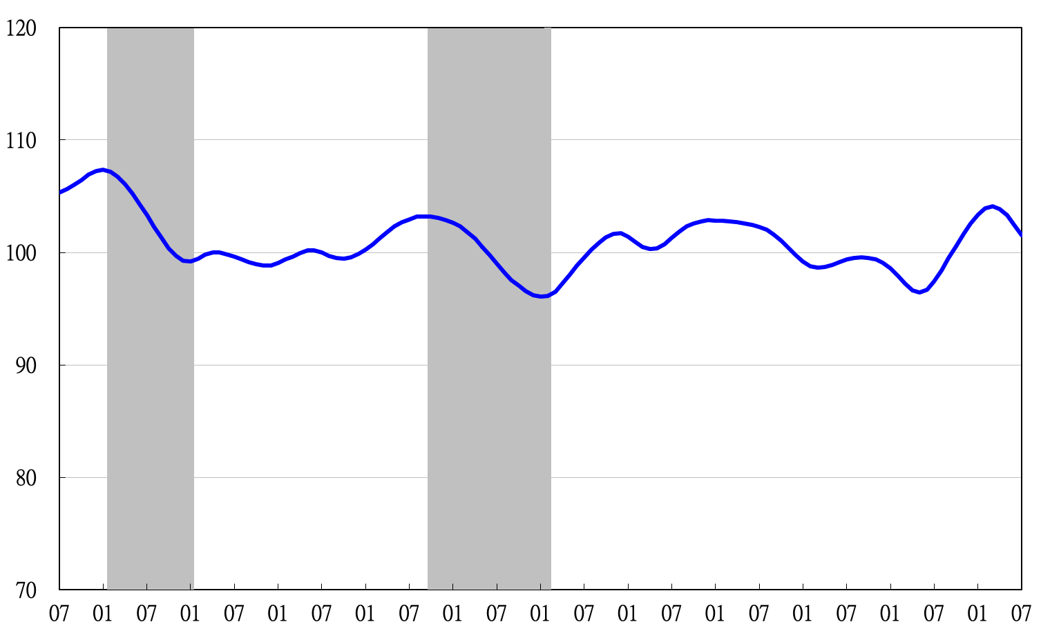
2010 2011 2012 2013 2014 2015 2016 2017 2018 2019 2020 2021
Figure 4 Trend-adjusted Coincident Index

Table 3 Lagging Indicators
Index
 | 2021
 | Jan | Feb | Mar | Apr | May | Jun | Jul
Trend adjusted index | 99.33 | 99.81 | 100.20 | 100.44 | 100.50 | 100.50 | 100.52
Change from preceding month (%) | 0.48 | 0.48 | 0.39 | 0.24 | 0.06 | -0.01 | 0.02
Components
Unemployment rate | 101.04 | 100.88 | 100.52 | 99.93 | 99.13 | 98.27 | 97.47
The manufacturing unit output labor cost index | 99.50 | 99.37 | 99.16 | 98.92 | 98.64 | 98.35 | 98.07
Interbank overnight call-loan rate | 99.96 | 99.97 | 99.98 | 99.99 | 100.00 | 100.02 | 100.03
Loans and investments of financial institutions | 100.26 | 100.38 | 100.52 | 100.67 | 100.85 | 101.04 | 101.21
Inventory value for manufacturing | 98.55 | 99.19 | 100.02 | 100.95 | 101.91 | 102.87 | 103.83

2010 2011 2012 2013 2014 2015 2016 2017 2018 2019 2020 2021
2011.2(P) 2012.1(T) 2014.10(P) 2016.2(T)

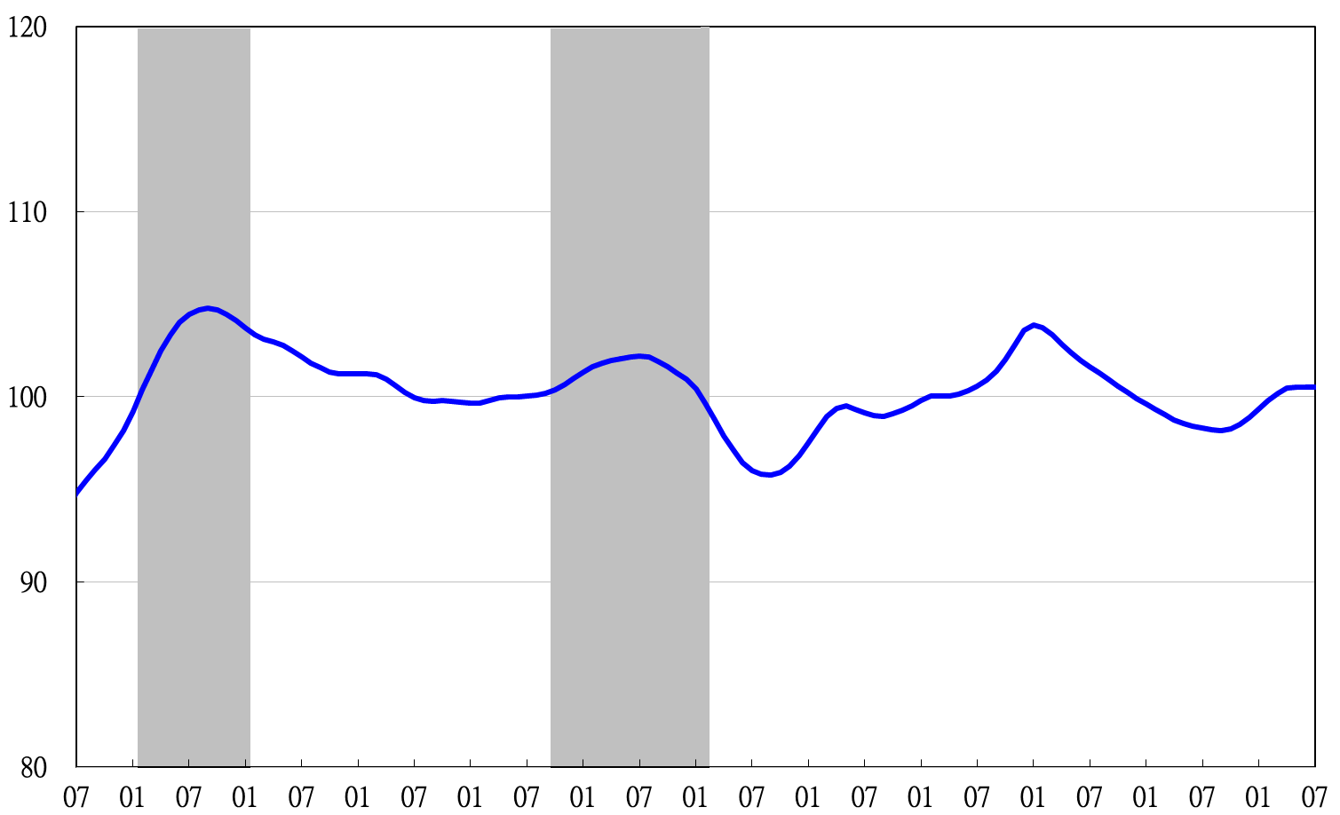
Figure 5 Trend-adjusted Lagging Index

