The NDC holds a seminar on the amended Foreign Professionals Act, to promote widespread awareness of the latest talent recruitment regulations

The NDC held a seminar on the amended Act for the Recruitment and Employment of Foreign Professionals (“the Foreign Professionals Act”) on November 8 to an invited gathering of more than 90 representatives of diplomatic missions, chambers of commerce, business associations, and community groups. The seminar, to explain the Act’s Employment Gold Card, permanent residency, tax preference, and other provisions on subjects of close interest to many, was also livestreamed to 180 people from all walks of life.
In his opening speech, Deputy Minister Shih announced that the Act for the Recruitment and Employment of Foreign Professionals was implemented over three years in 2018, and has successfully recruited over 5,000 Special Professionals (of which 3,319 hold Employment Gold Cards). The amended Act, which took effect on October 25, provides more attractive regulations of work and residency, along with enhanced tax and social security benefits. In addition, the NDC had been working with other government agencies to introduce a number of supporting measures for talent recruitment, including: (1) the launch of a cross-government initiative to help talent from overseas get settled in Taiwan by assisting them to solve problems they encounter in adapting to local life, connecting with local industries, setting up a company, or other aspects of relocating to our country; (2) the establishment of the Employment Gold Card Office, to continue expanding the provision of a one-stop compendium of services for the work and life needs of international talent in Taiwan.
Deputy Minister Shih also expressed his desire to collaborate with the foreign trade and commerce offices in Taiwan, as well multinational corporations, to continue to attract more global talent to Taiwan through the Foreign Professionals Act, with targets to have successfully recruited a total of 10,000 Foreign Special Professionals by the end of 2022, and combined with the group of Foreign Professionals, a total of 100,000 by the end of 2030.
The seminar commenced with an explanation from the NDC’s Department of Human Resources Development detailing the overall content of the Foreign Professionals Act. This was followed, in turn, by an explanation from the Employment Gold Card Office of matters concerning the Employment Gold Card, an explanation from the National Immigration Agency of the rules for foreign professionals’ permanent residency applications, and an explanation from the Ministry of Finance about applying for the tax preference accorded to foreign special professionals. Time was then allotted for a Q&A session, providing an opportunity for government representatives to exchange views with the audience in face-to-face conversation, which generated enthusiastic participation.
The NDC also livestreamed the proceedings on Facebook, so that friends in Taiwan and overseas could go online to be brought up to date with details of the Foreign Professionals Act’s amended provisions. This will be made into a promotional video for posting on video sharing websites. In the future, anyone, anywhere will continue to be able to learn all about the key points of the Foreign Professionals Act’s implementation via an online video platform.
The NDC also expressed the hope that this latest revision of the Foreign Professionals Act will prove efficacious in attracting more high-caliber international talent to Taiwan, promoting the development and transition of Taiwan’s industries, and raising their international competitiveness. Meanwhile, the NDC will continue working hard to create a higher quality environment, so that international talent will be glad to gather together in Taiwan and help make this island into the next-generation Silicon Valley.
Related links: The NDC’s webpage for information about the Act for the Recruitment and Employment of Foreign Professionals (https://foreigntalentact.ndc.gov.tw/en) and the Employment Gold Card Office website (https://goldcard.nat.gov.tw/en).
Contact persons:
Department of Human Resources Development
Director Gloria Lin and Senior Specialist Basma Cheng
Office phone：(02)2316-5379, (02)2316-5600

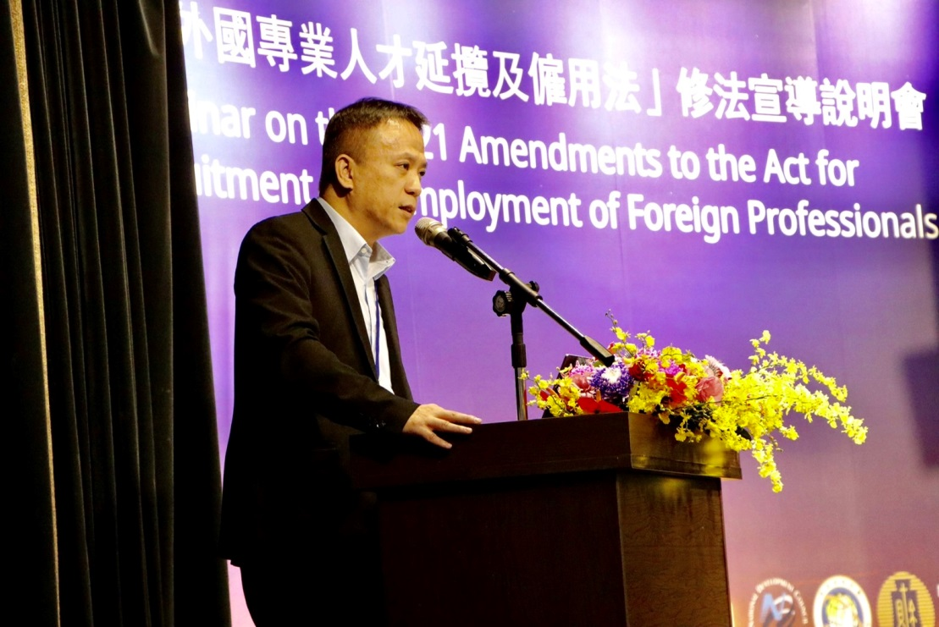
photo 1. NDC Deputy Minister Shih, Keh-Her’s opening speech

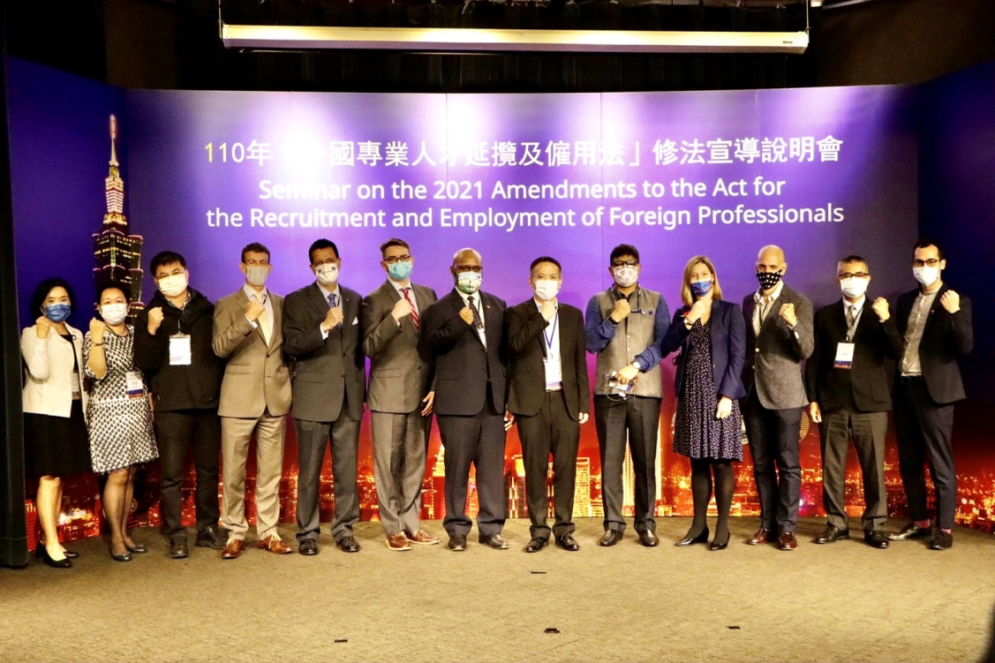
photo 2. Distinguished guests’ group photo

