Taiwan Business Indicators in August 2022
Press Release
National Development Council (NDC)
September 27, 2022
In August 2022, the overall monitoring indicator continued to flash the “green” signal, the total score decreased 1 point to 23. The trend-adjusted leading index decreased for ten consecutive months and the coincident index decreased for seven consecutive months, the government will be closely monitoring the economic situation.
The Monitoring Indicators
- The total score in August 2022 was 23, flashing the “green” signal, which decreased 1 points from 24 last month.
Leading Indicators
- The trend-adjusted leading index decreased by 0.94% in August 2022 to 96.38, falling for ten consecutive months.
Coincident Indicators
- The trend-adjusted coincident index decreased by 1.43% in August 2022 to 96.89, falling for seven consecutive months.
Lagging Indicators
- The trend-adjusted lagging index decreased by 0.003% in August 2022 to 103.82, falling for one consecutive month.

T~~ Next publication date: October 27 2022 ~~
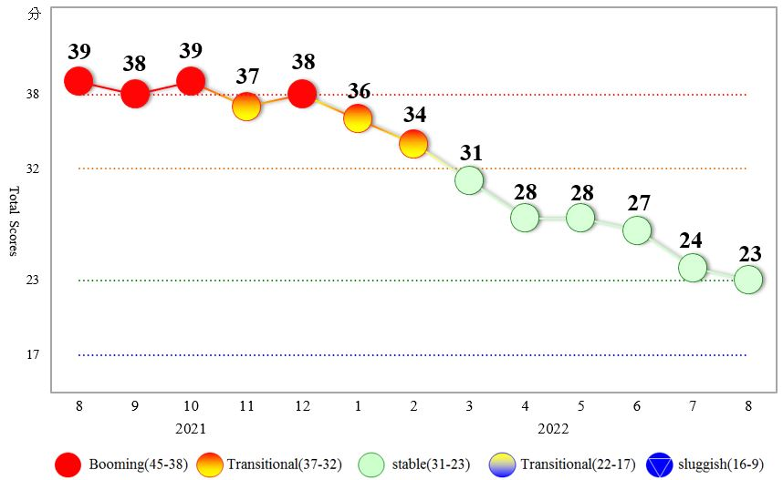
Figure 1 Total Scores in the Past Year
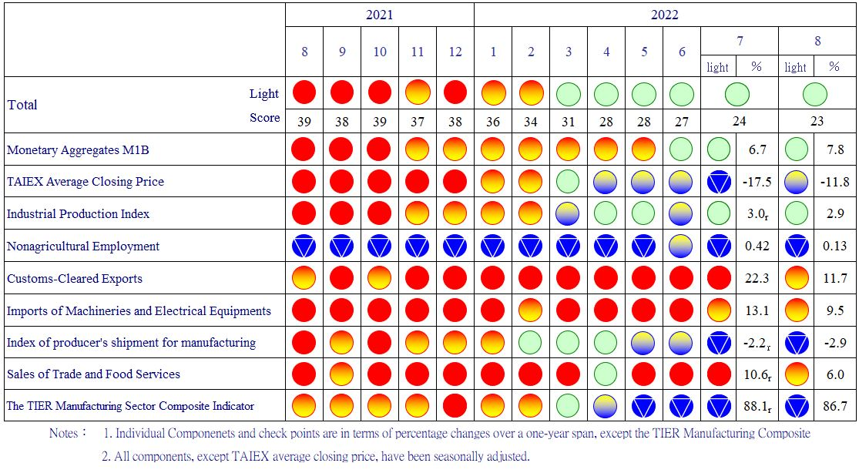
Figure 2 Monitoring Indicators
Table 1 Leading Indicators
Index
 | 2022
 | Feb | Mar | Apr | May | Jun |  | Jul | Aug
Trend adjusted index | 102.11 | 101.37 | 100.46 | 99.41 |  | 98.31 | 97.29 | 96.38
Change from preceding month (%) | -0.62 | -0.73 | -0.89 | -1.05 |  | -1.11 | -1.03 | -0.94
Components¹
Diffusion Index of export orders² | 100.27 | 99.85 | 99.43 | 99.00 |  | 98.53 | 98.06 | 97.60
Real monetary aggregates M1B | 100.21 | 99.98 | 99.72 | 99.45 |  | 99.18 | 98.92 | 98.68
TAIEX average closing price | 100.43 | 100.17 | 99.85 | 99.48 |  | 99.09 | 98.69 | 98.30
Net accession rate of employees on payrolls of industry and services ³ | 100.38 | 100.21 | 100.07 | 99.98 |  | 99.95 | 99.96 | 100.03
New housing construction started ⁴ | 100.43 | 100.76 | 100.84 | 100.62 |  | 100.25 | 99.92 | 99.64
Real imports of semiconductor equipment | 99.79 | 99.67 | 99.67 | 99.77 |  | 99.93 | 100.13 | 100.34
The TIER manufacturing sector composite indicator | 100.37 | 99.93 | 99.40 | 98.84 |  | 98.28 | 97.74 | 97.20
Note：1. All components are passed through seasonal adjustment, trend-removal, smoothing and normalization.
2. Diffusion Index of export orders by number of firms.
3. Net accession rate is equal to accession rate minus separation rate.
4. Including only housing, mercantile, business and service, industry warehousing.
2011.2(P) 2012.1(T) 2014.10(P) 2016.2(T)
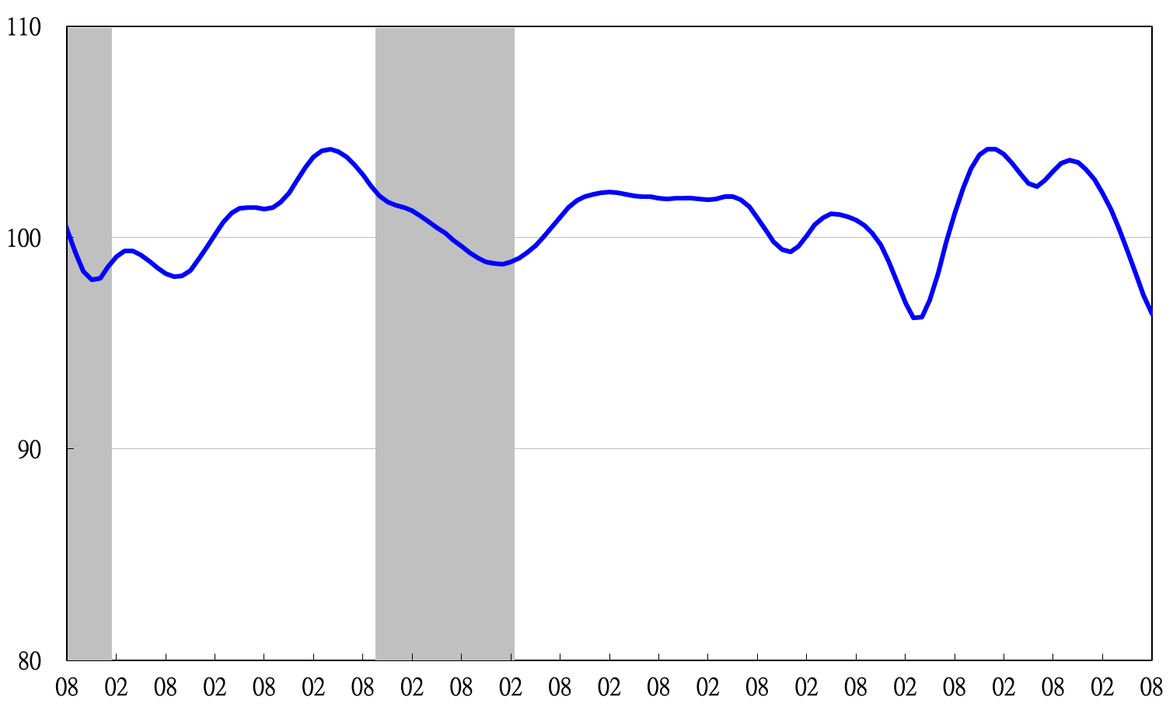

2011 2012 2013 2014 2015 2016 2017 2018 2019 2020 2021 2022
Figure 3 Trend-adjusted Leading Index
Note: Shaded areas represent recessions.
Table 2 Coincident Indicators
Index
 | 2022
 | Feb | Mar | Apr | May | Jun | Jul | Aug
Trend adjusted index | 102.79 | 102.41 | 101.73 | 100.77 | 99.60 | 98.29 | 96.89
Change from preceding month (%) | -0.02 | -0.37 | -0.66 | -0.95 | -1.16 | -1.32 | -1.43
Components
Industrial production index | 100.40 | 100.17 | 99.93 | 99.66 | 99.39 | 99.12 | 98.84
Electric power consumption | 100.39 | 100.19 | 100.06 | 99.97 | 99.92 | 99.91 | 99.86
Index of producer’s shipment for manufacturing | 100.46 | 100.14 | 99.78 | 99.36 | 98.91 | 98.47 | 98.02
Sales of trade and food services | 101.72 | 101.60 | 101.30 | 100.85 | 100.31 | 99.67 | 99.03
Nonagricultural employment | 99.99 | 99.95 | 99.86 | 99.76 | 99.67 | 99.60 | 99.53
Real customs-cleared exports | 101.53 | 101.66 | 101.49 | 101.01 | 100.26 | 99.29 | 98.21
Real machineries and electrical equipments imports | 100.46 | 100.42 | 100.30 | 100.08 | 99.78 | 99.42 | 99.04

2011.2(P) 2012.1(T) 2014.10(P) 2016.2(T)
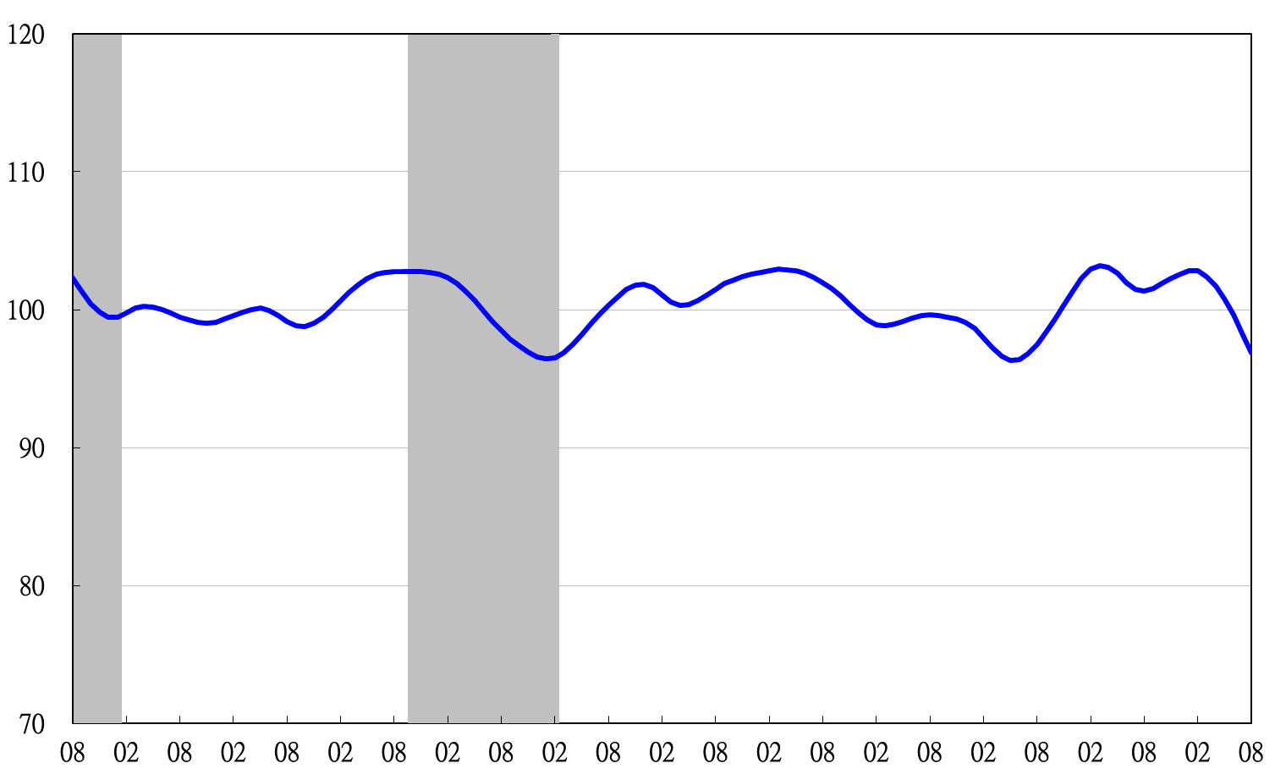
2011 2012 2013 2014 2015 2016 2017 2018 2019 2020 2021 2022
Figure 4 Trend-adjusted Coincident Index

Table 3 Lagging Indicators
Index
 | 2022
 | Feb | Mar | Apr | May | Jun | Jul | Aug
Trend adjusted index | 102.04 | 102.51 | 102.98 | 103.40 | 103.68 | 103.83 | 103.82
Change from preceding month (%) | 0.33 | 0.46 | 0.46 | 0.40 | 0.27 | 0.14 | -0.003
Components
Unemployment rate | 100.71 | 100.74 | 100.73 | 100.69 | 100.66 | 100.64 | 100.62
The manufacturing unit output labor cost index | 99.71 | 100.12 | 100.57 | 101.01 | 101.35 | 101.56 | 101.62
Interbank overnight call-loan rate | 99.93 | 99.99 | 100.06 | 100.15 | 100.24 | 100.33 | 100.43
Loans and investments of financial institutions | 100.63 | 100.40 | 100.06 | 99.64 | 99.18 | 98.73 | 98.29
Inventory value for manufacturing | 101.17 | 101.41 | 101.74 | 102.11 | 102.48 | 102.80 | 103.09

2011 2012 2013 2014 2015 2016 2017 2018 2019 2020 2021 2022
2011.2(P) 2012.1(T) 2014.10(P) 2016.2(T)

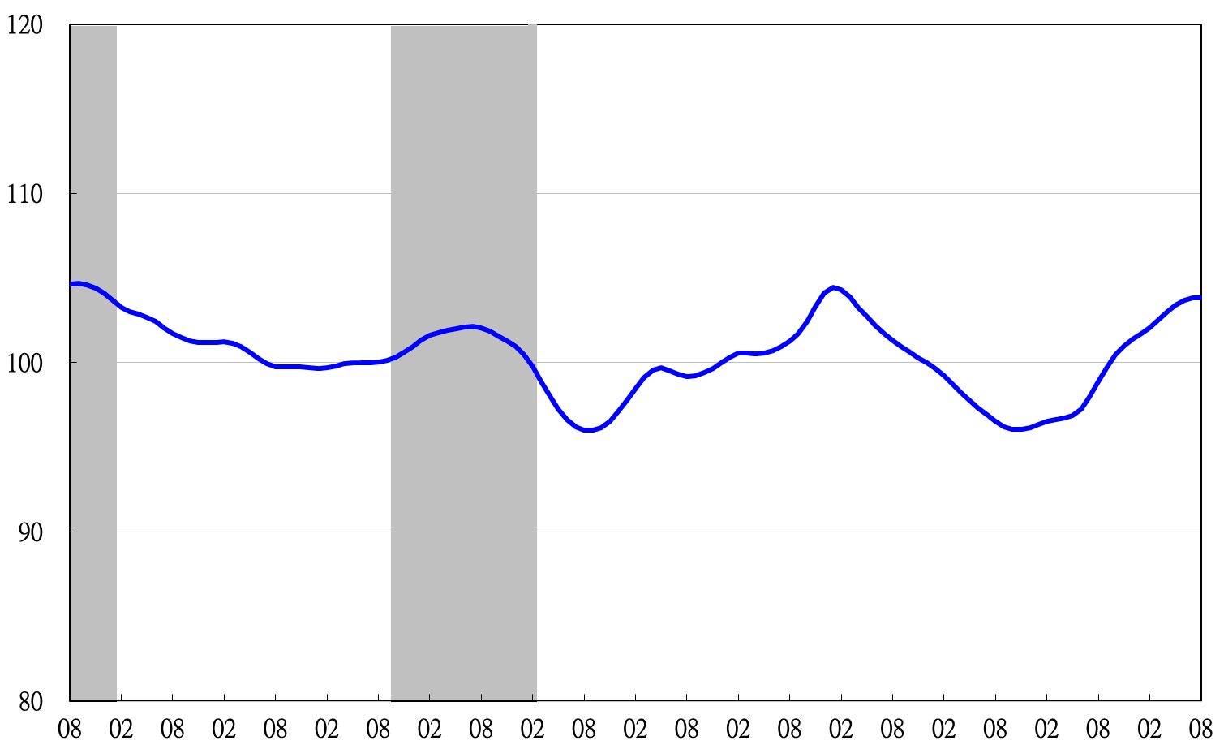
Figure 5 Trend-adjusted Lagging Index

