Taiwan Business Indicators in September 2018
Press Release
National Development Council (NDC)
October 26, 2018
In September 2018, the overall monitoring indicator flashed the “yellow-blue” signal. The total score decreased two points to 22. The trend-adjusted leading index decreased from the previous month, while the coincident index increased. The government will be closely monitoring the economic situation.
- The Monitoring Indicators: The total score in September 2018 was 22, flashing the “yellow-blue” signal. Among the nine components, the import of machineries and electrical equipments flashed “yellow-red” signal. The TAIEX average closing price and customs-cleared exports flashed “green” signals. The monetary aggregates M1B, industrial production index, nonagricultural employments, index of producer’s shipment for manufacturing, sales of trade and food services, and the TIER manufacturing sector composite indicator flashed “yellow-blue” signals.
- Leading Indicators: With revised data, the trend-adjusted leading index stood at 101.26, down by 0.11% from last month. Among the seven indicators making up the trend-adjusted index, real imports of semiconductor equipment, new housing construction started, and net accession rate of employees on payrolls of industry and services had positive cyclical movements from the previous month, while the TIER manufacturing sector composite indicator, diffusion index of export orders, TAIEX average closing price, and real monetary aggregates M1B had negative cyclical movements.
- Coincident Indicators: With revised data, the trend-adjusted coincident index stood at 100.82, up by 0.24% from last month. Among the seven indicators making up the trend-adjusted index, real machineries and electrical equipments imports, real customs-cleared exports, electric power consumption, and the industrial production index had positive cyclical movements, while the index of producer’s shipment for manufacturing, sales of trade and food services, and nonagricultural employments had negative cyclical movements.
- Lagging Indicators: With revised data, the trend-adjusted lagging index stood at 101.37, down by 0.10% from last month. Among five indicators making up the trend-adjusted index, inventory value for manufacturing, loans and investments of financial institutions, and the interbank overnight call-loan rate had positive cyclical movements, while the manufacturing unit output labor cost index, and the unemployment rate (inverted) had negative cyclical movement.
T~~ Next publication date: November 27 2018 ~~T

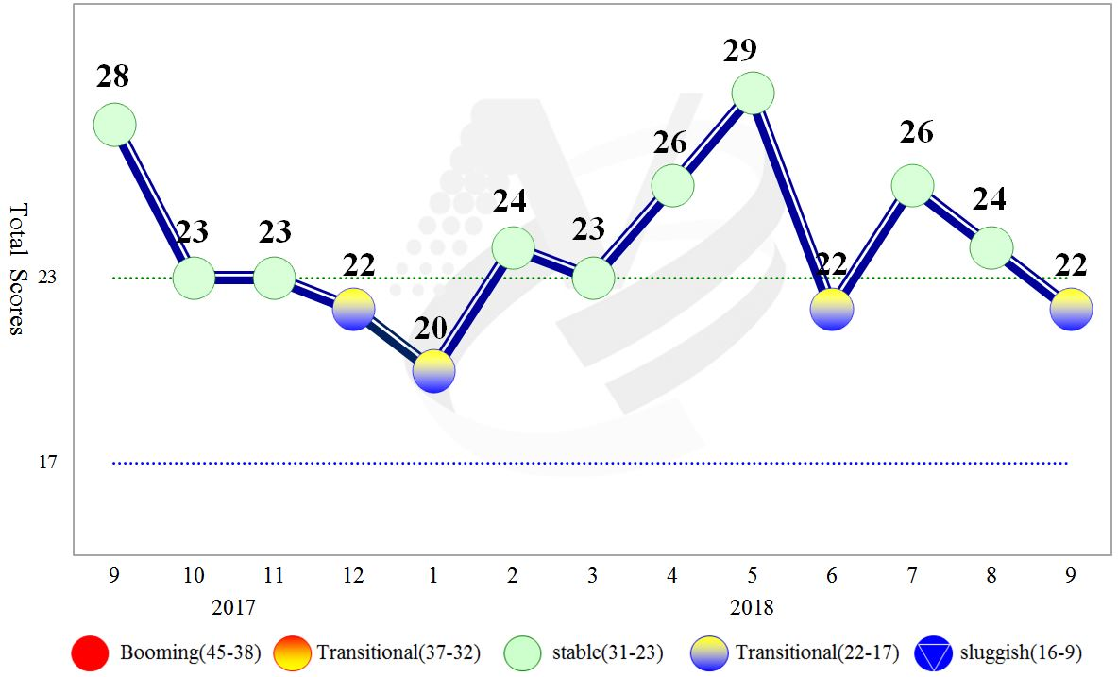
Figure 1 Total Scores in the Past Year
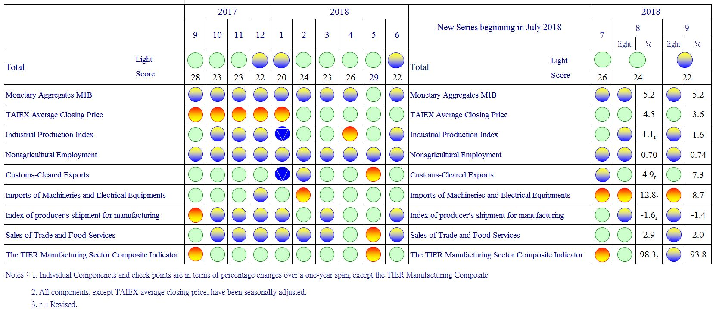
Figure 2 Monitoring Indicators

Table 1 Leading Indicators
Index
 | 2018
 | Mar | Apr | May | Jun | Jul | Aug | Sep
Trend adjusted index | 101.34 | 101.46 | 101.55 | 101.54 | 101.47 | 101.37 | 101.26
Change from preceding month (%) | 0.04 | 0.12 | 0.09 | -0.00 | -0.07 | -0.11 | -0.11
Components¹
Diffusion Index of export orders² | 99.96 | 100.09 | 100.11 | 100.02 | 99.80 | 99.54 | 99.24
Real monetary aggregates M1B | 99.78 | 99.82 | 99.87 | 99.90 | 99.92 | 99.920 | 99.915
TAIEX average closing price | 100.19 | 100.14 | 100.09 | 100.04 | 99.98 | 99.92 | 99.86
Net accession rate of employees on payrolls of industry and services ³ | 99.88 | 99.85 | 99.85 | 99.86 | 99.88 | 99.91 | 99.93
New housing construction started ⁴ | 100.41 | 100.61 | 100.82 | 100.97 | 101.12 | 101.28 | 101.47
Real imports of semiconductor equipment | 99.59 | 99.52 | 99.49 | 99.54 | 99.69 | 99.92 | 100.20
The TIER manufacturing sector composite indicator | 100.20 | 100.18 | 100.15 | 100.05 | 99.86 | 99.59 | 99.26
Note：1. All components are passed through seasonal adjustment, trend-removal, smoothing and normalization.
2. Diffusion Index of export orders by number of firms.
3. Net accession rate is equal to accession rate minus separation rate.
4. Including only housing, mercantile, business and service, industry warehousing.

2008.3(P) 2009.2(T) 2011.2(P) 2012.1(T) 2014.10(P) 2016.2(T)
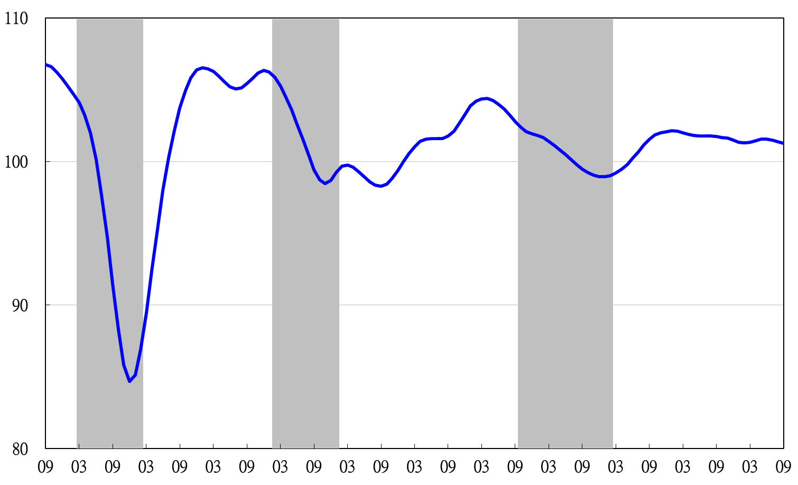
2007 2008 2009 2010 2011 2012 2013 2014 2015 2016 2017 2018
Figure 3 Trend-adjusted Leading Index
Note: Shaded areas represent recessions.
Table 2 Coincident Indicators
Index
 | 2018
 | Mar | Apr | May | Jun | Jul | Aug | Sep
Trend adjusted index | 101.06 | 100.76 | 100.55 | 100.42 | 100.43 | 100.58 | 100.82
Change from preceding month (%) | -0.27 | -0.30 | -0.21 | -0.12 | 0.01 | 0.15 | 0.24
Components
Industrial production index | 100.33 | 100.21 | 100.08 | 99.96 | 99.89 | 99.88 | 99.90
Electric power consumption | 100.19 | 100.04 | 99.90 | 99.83 | 99.82 | 99.94 | 100.14
Index of producer’s shipment for manufacturing | 100.42 | 100.34 | 100.28 | 100.19 | 100.07 | 99.92 | 99.78
Sales of trade and food services | 100.50 | 100.59 | 100.71 | 100.78 | 100.82 | 100.84 | 100.83
Nonagricultural employment | 100.04 | 100.02 | 99.99 | 99.97 | 99.96 | 99.95 | 99.94
Real customs-cleared exports | 100.28 | 100.04 | 99.86 | 99.77 | 99.74 | 99.83 | 99.99
Real machineries and electrical equipments imports | 99.87 | 99.76 | 99.73 | 99.81 | 100.01 | 100.27 | 100.54

2008.3(P) 2009.2(T) 2011.2(P) 2012.1(T) 2014.10(P) 2016.2(T)
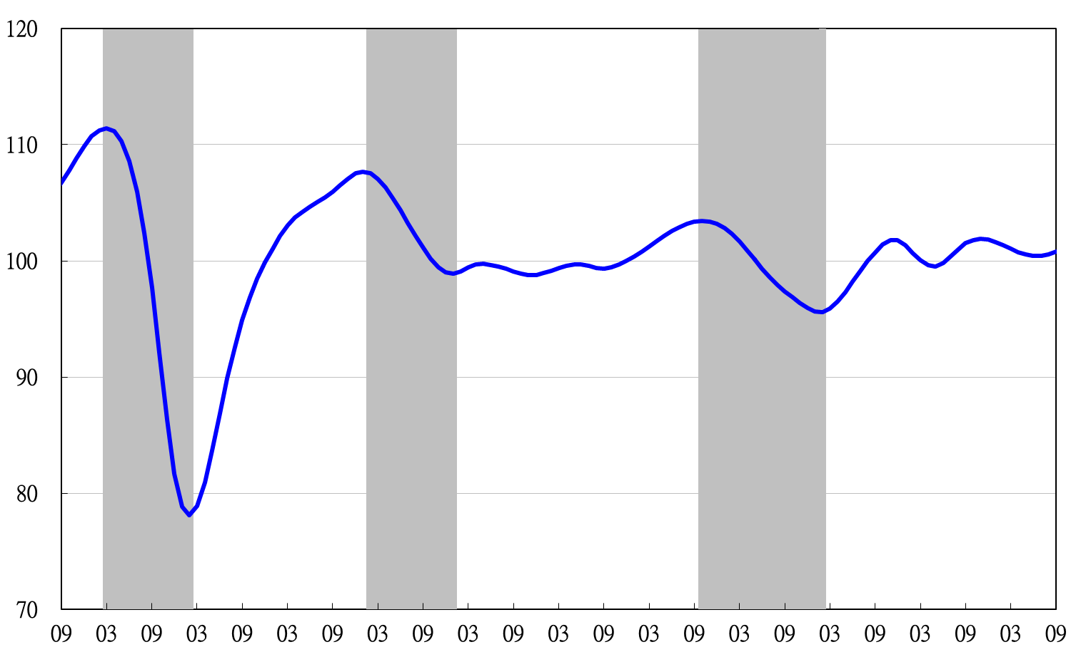
2007 2008 2009 2010 2011 2012 2013 2014 2015 2016 2017 2018
Figure 4 Trend-adjusted Coincident Index

Table 3 Lagging Indicators
Index
 | 2018
 | Mar |  | Apr |  | May | Jun |  | Jul |  | Aug |  | Sep
Trend adjusted index | 101.15 |  | 101.15 |  | 101.23 | 101.38 |  | 101.51 |  | 101.48 |  | 101.37
Change from preceding month (%) | -0.02 |  | -0.01 |  | 0.09 | 0.15 |  | 0.12 |  | -0.03 |  | -0.10
Components
Unemployment rate | 100.16 |  | 100.13 |  | 100.09 | 100.05 |  | 100.01 |  | 99.96 |  | 99.91
The manufacturing unit output labor cost index | 100.35 |  | 100.13 |  | 99.96 | 99.85 |  | 99.69 |  | 99.36 |  | 98.94
Interbank overnight call-loan rate | 100.04 |  | 100.05 |  | 100.06 | 100.07 |  | 100.07 |  | 100.08 |  | 100.08
Loans and investments of financial institutions | 100.38 |  | 100.50 |  | 100.62 | 100.71 |  | 100.79 |  | 100.86 |  | 100.92
Inventory value for manufacturing | 100.25 | 100.36 |  | 100.52 |  | 100.73 | 100.98 |  | 101.25 |  | 101.55

2008.3(P) 2009.2(T) 2011.2(P) 2012.1(T) 2014.10(P) 2016.2(T)

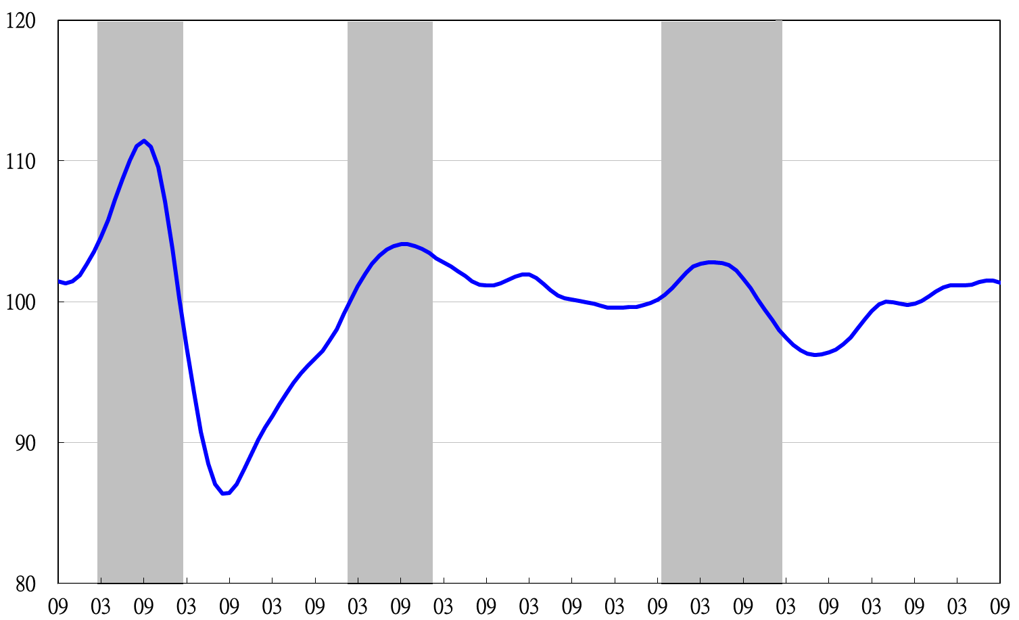
2007 2008 2009 2010 2011 2012 2013 2014 2015 2016 2017 2018
Figure 5 Trend-adjusted Lagging Index

The items of monitoring indicators remain the same, but the checkpoints of each component have been changed since July 2018.
The components of leading indicators have been changed since July 2018. New components include diffusion index of export orders (by number of firms), real monetary aggregate M1B, TAIEX average closing price, net accession rate of employees on payrolls of industry and services, total floor area of new housing construction started (residential houses, commercial offices, industrial warehouses), real imports of semiconductor equipment, and the TIER manufacturing sector composite indicator.
The components of lagging indicators have been changed since July 2018. New components include unemployment rate (reciprocal), the manufacturing unit output labor cost index, interbank overnight call-loan rate, loans and investments of financial institutions, and inventory value for manufacturing.

