Asia Silicon Valley Development Plan
From IT to IoT─ Engineering a New Industrial Transformation for Taiwan
September 2016
- Background
In her inaugural address on May 20, 2016, Taiwan’s President Tsai Ing-wen made a commitment to pursue a new economic model for sustainable development based on the core values of innovation, employment, and equitable distribution.
To realize President Tsai’s commitment, the Taiwan Government is currently building a new economic model by focusing on an Asia Silicon Valley Development Plan and four innovative industries, namely, smart machinery, green energy, biotech and pharmaceuticals, and national defense. By developing these sectors, Taiwan expects to become an innovative startup destination for young Asians and a model of innovation and entrepreneurship, and eventually achieve its vision by becoming a digital nation and smart island.
- Development of IoT
According to an Internet of Things (IoT) market analysis by Market Intelligence & Consulting Institute (MIC) in July of 2016, Taiwan accounted for 3.8% of the global IoT market in 2015. Taiwan has many high-quality engineers and well-developed supply chains, and also has a strong good foundation in the IoT sensor and Internet sectors. McKinsey Global Institute predicted that the IoT market would create a global economic value of between US$2.7 trillion and US$6.2 trillion in 2025, while IoT would have a potential global economic impact of US$3.9 trillion to US$11.1 trillion a year by 2025. Taiwan should thus take this opportunity to turn its industrial focus from information technology (IT) to the IoT, and harness innovation to spur industrial transformation and economic growth.
- Vision and Framework
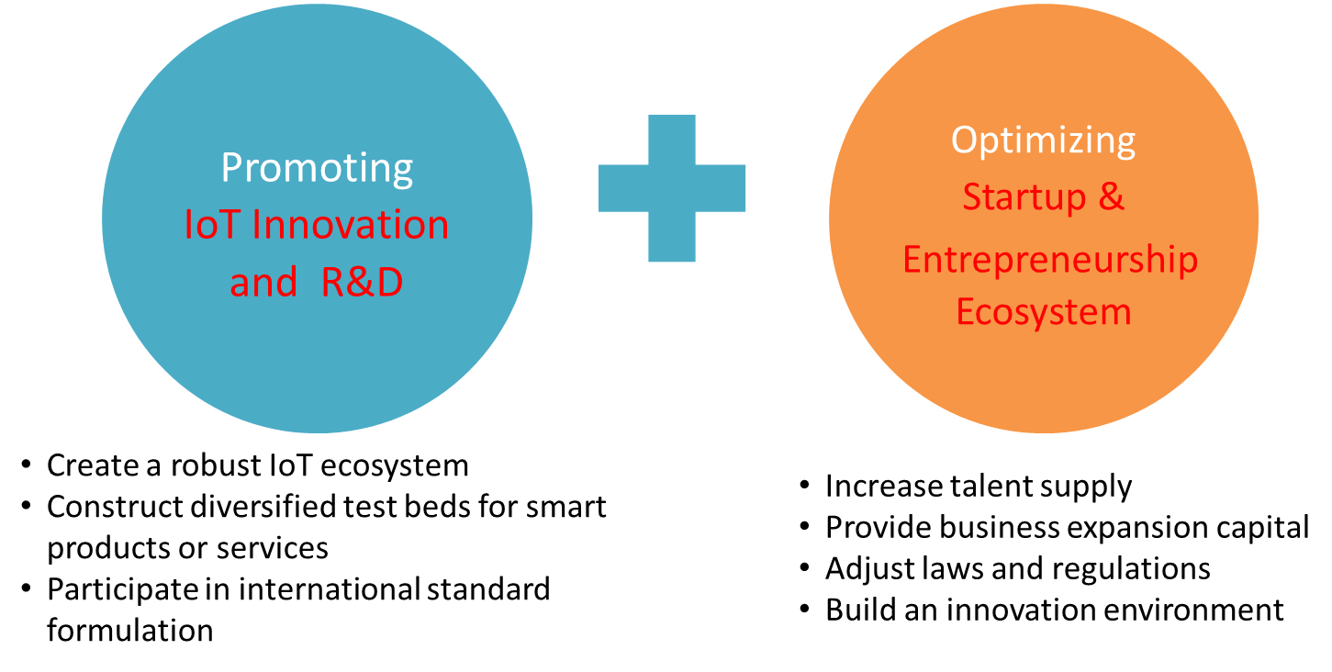
To connect globally prominent tech clusters and seize a position in the next-generation industrial ecosystem, the Executive Yuan approved the Asia Silicon Valley Development Plan on September 8, 2016. The plan’s objective is to build an IoT & startup ecosystem with a heavy emphasis on R&D. Utilizing three links (local, global, and future) and the following four strategies, the plan is expected to transform and upgrade Taiwan’s industrial structure through IoT, and drive economic growth through innovation and entrepreneurship.
- Implementation Strategies

- Optimize Taiwan’s startup and entrepreneurship ecosystem
Improve Taiwan’s startup and entrepreneurship ecosystem by cultivating innovative talent, providing business expansion capital, and adjusting laws and regulations to create a friendlier startup environment.
- Enhance linkages with renowned tech clusters worldwide
Establish a one-stop service center to forge connections with the R&D capabilities of Silicon Valley and other global innovation clusters, and actively participate in international standards formulation and the certification of IoT-related technologies.
- Build a complete IoT supply chain
Integrate Taiwan’s hardware advantages into software applications, and commercialize research findings of universities and research institutes.
- Construct diversified demonstration sites for smart products and services
Establish a quality Internet environment, build diversified smart demo sites, and give priority to the development of applications based on smart logistics, smart transport, and smart healthcare.

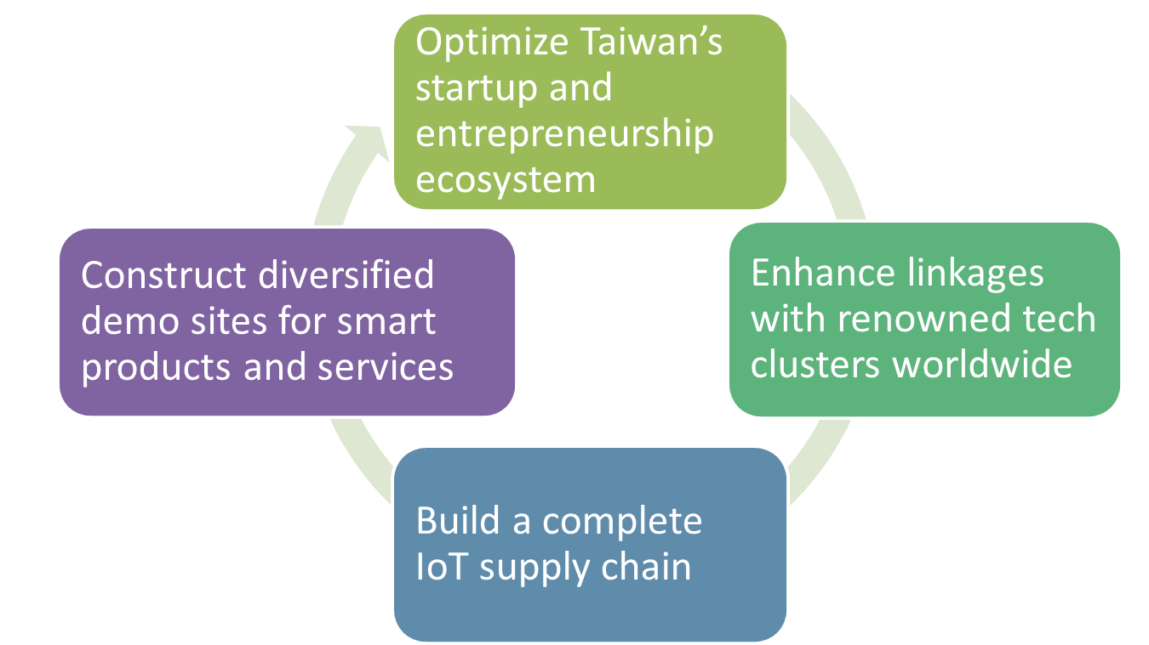
- Goals
The implementation period runs from 2016 to 2023, and upon completion, the plan is expected to achieve the following goals.
Qualitative Goals:
- Connect to Silicon Valley and other global tech clusters
Forge connections with their advanced R&D capabilities and make Taiwan the best partner for global corporations with good potential
- Develop industries for the next generation
Make Taiwan a leading global tech cluster for the Internet, Big Data, IoT and other new industries
- Become an innovative startup destination for young Asians
Optimize Taiwan’s startup ecosystem by incubating local startup teams and bringing outstanding global talent to Taiwan
Quantitative Goals:
- Increase Taiwan’s IoT global market share from 3.8% in 2015 to 4.2% in 2020 and 5% in 2025
- Grow 100 successful companies, either local startups that have successful exits or local R&D centers set up by large corporations
- Develop and establish three global systems integrators in Taiwan
- Successfully attract investments from two world-class companies
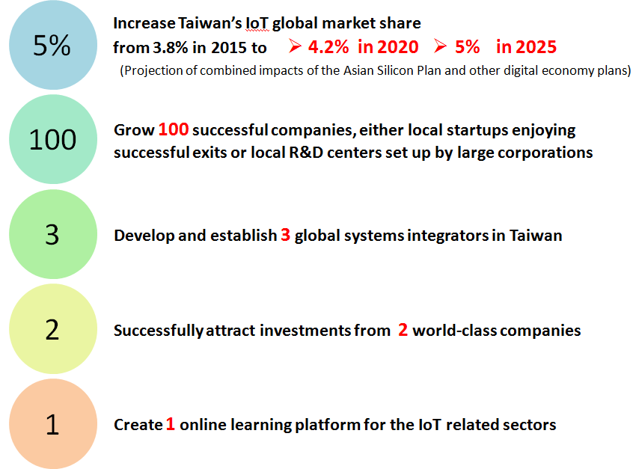
- Create one online learning platform for IoT related sectors

