Taiwan Business Indicators in November 2021
Press Release
National Development Council (NDC)
December 27, 2021
In November 2021, the overall monitoring indicator continued to flash the “red” signal, the total score decreased one point to 38. The trend-adjusted leading index increased for five consecutive months and the coincident index increased for four consecutive months, the government will be closely monitoring the economic situation.
The Monitoring Indicators
- The total score in November 2021 was 38, flashing the “red” signal, which decreased 1 point from 39 last month.
Leading Indicators
- The trend-adjusted leading index increased by 0.36% in November 2021 to 103.11, rising for five consecutive months.
Coincident Indicators
- The trend-adjusted coincident index increased by 0.49% in November 2021 to 103.22, rising for four consecutive months.
Lagging Indicators
- The trend-adjusted lagging index increased by 1.03% in November 2021 to 105.39, rising for thirteen consecutive months.

T~~ Next publication date: January 27 2022 ~~
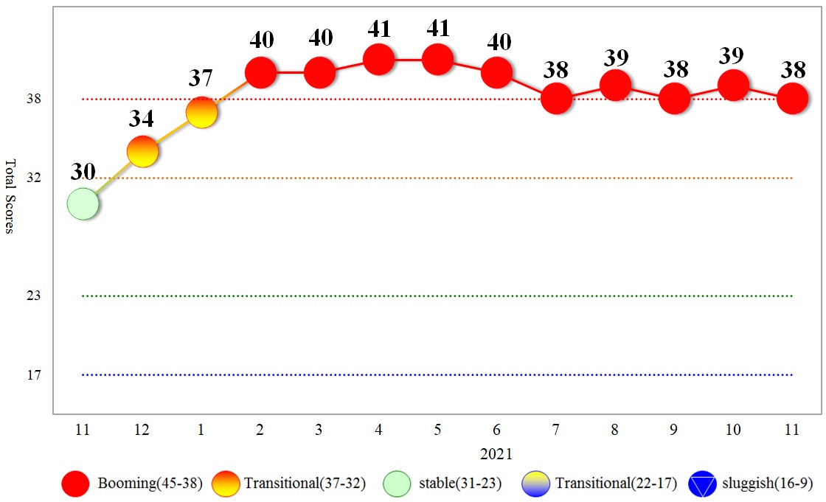
Figure 1 Total Scores in the Past Year

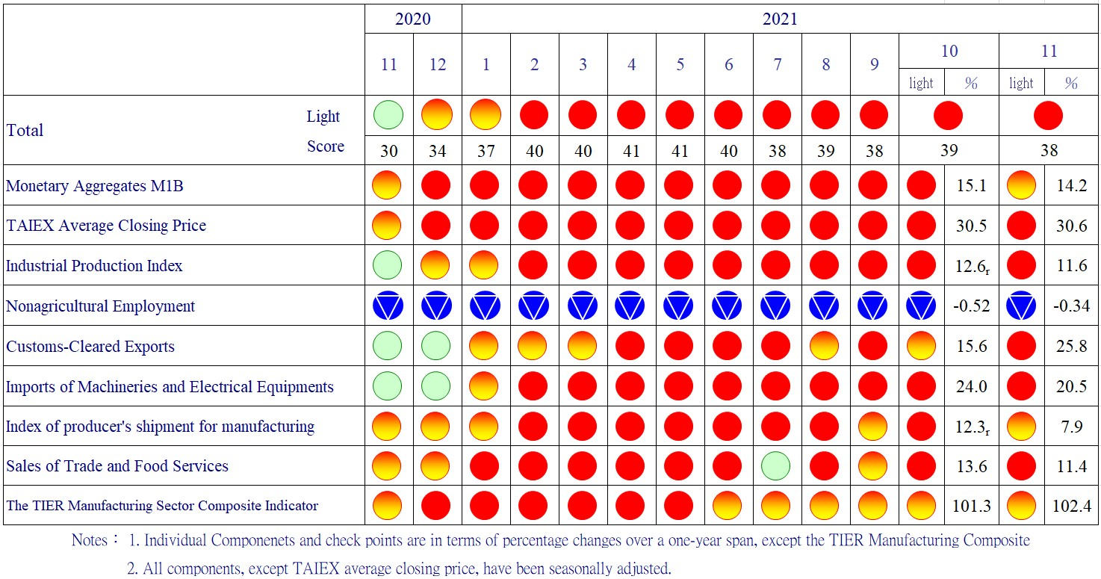
Figure 2 Monitoring Indicators

Table 1 Leading Indicators
Index
 | 2021
 | May | Jun | Jul | Aug | Sep |  | Oct | Nov
Trend adjusted index | 101.50 | 101.17 | 101.35 | 101.77 |  | 102.26 | 102.74 | 103.11
Change from preceding month (%) | -0.65 | -0.32 | 0.17 | 0.42 |  | 0.48 | 0.47 | 0.36
Components¹
Diffusion Index of export orders² | 100.65 | 100.59 | 100.58 | 100.60 |  | 100.65 | 100.69 | 100.70
Real monetary aggregates M1B | 100.77 | 100.71 | 100.61 | 100.50 |  | 100.38 | 100.26 | 100.14
TAIEX average closing price | 100.88 | 100.83 | 100.74 | 100.60 |  | 100.45 | 100.28 | 100.13
Net accession rate of employees on payrolls of industry and services ³ | 98.19 | 98.15 | 98.83 | 99.82 |  | 100.81 | 101.69 | 102.48
New housing construction started ⁴ | 99.19 | 99.08 | 99.08 | 99.14 |  | 99.28 | 99.54 | 99.73
Real imports of semiconductor equipment | 99.95 | 99.95 | 100.04 | 100.21 |  | 100.41 | 100.59 | 100.75
The TIER manufacturing sector composite indicator | 101.00 | 100.75 | 100.49 | 100.24 |  | 99.99 | 99.76 | 99.55
Note：1. All components are passed through seasonal adjustment, trend-removal, smoothing and normalization.
2. Diffusion Index of export orders by number of firms.
3. Net accession rate is equal to accession rate minus separation rate.
4. Including only housing, mercantile, business and service, industry warehousing.

2011.2(P) 2012.1(T) 2014.10(P) 2016.2(T)
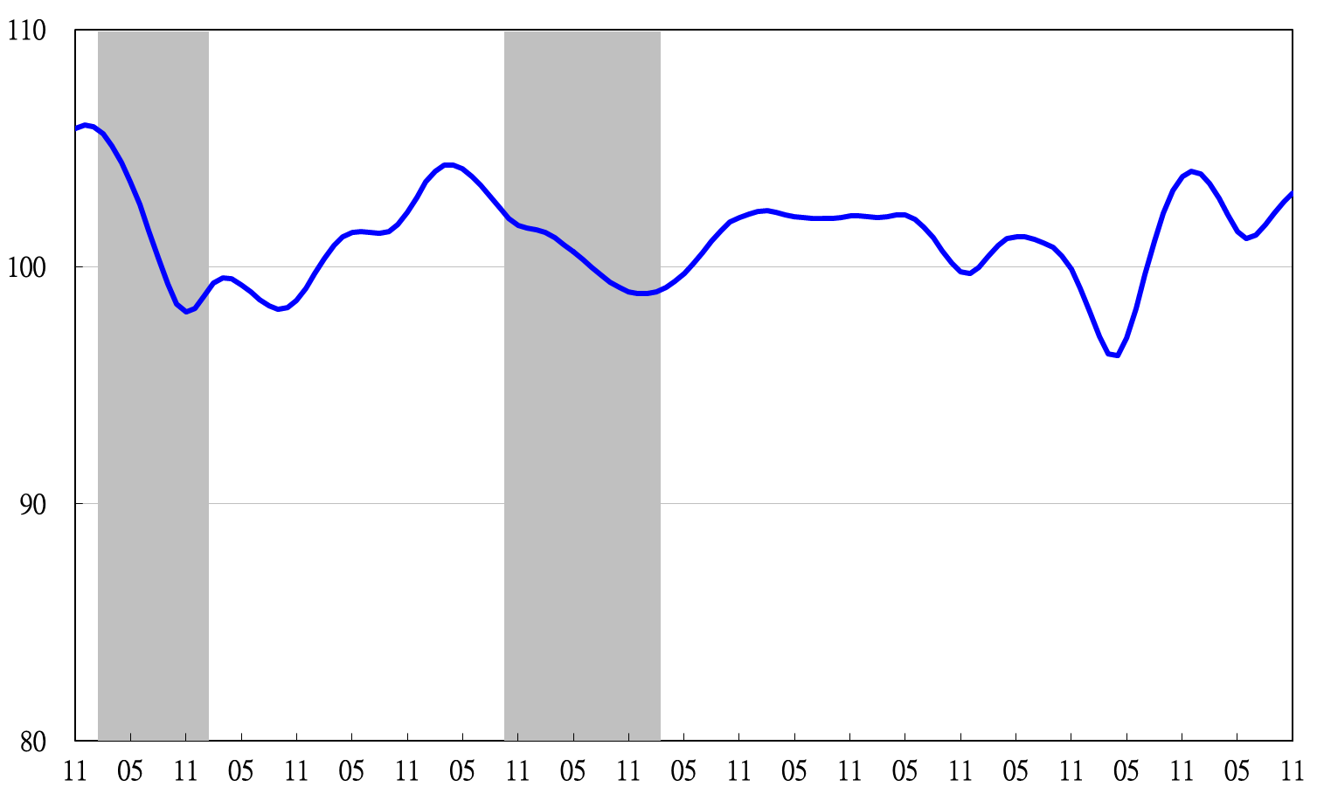

2010 2011 2012 2013 2014 2015 2016 2017 2018 2019 2020 2021
Figure 3 Trend-adjusted Leading Index
Note: Shaded areas represent recessions.
Table 2 Coincident Indicators
Index
 | 2021
 | May | Jun | Jul | Aug | Sep | Oct | Nov
Trend adjusted index | 102.30 | 101.89 | 101.71 | 101.84 | 102.22 | 102.72 | 103.22
Change from preceding month (%) | -0.35 | -0.40 | -0.17 | 0.13 | 0.37 | 0.49 | 0.49
Components
Industrial production index | 101.17 | 101.13 | 101.01 | 100.86 | 100.71 | 100.56 | 100.41
Electric power consumption | 100.51 | 100.53 | 100.65 | 100.86 | 101.15 | 101.48 | 101.71
Index of producer’s shipment for manufacturing | 101.39 | 101.37 | 101.28 | 101.15 | 100.99 | 100.81 | 100.63
Sales of trade and food services | 100.70 | 100.38 | 100.30 | 100.54 | 101.00 | 101.58 | 102.22
Nonagricultural employment | 99.00 | 98.51 | 98.29 | 98.35 | 98.61 | 98.98 | 99.39
Real customs-cleared exports | 100.26 | 100.26 | 100.33 | 100.49 | 100.74 | 101.04 | 101.36
Real machineries and electrical equipments imports | 100.85 | 100.83 | 100.78 | 100.68 | 100.51 | 100.30 | 100.08

2011.2(P) 2012.1(T) 2014.10(P) 2016.2(T)
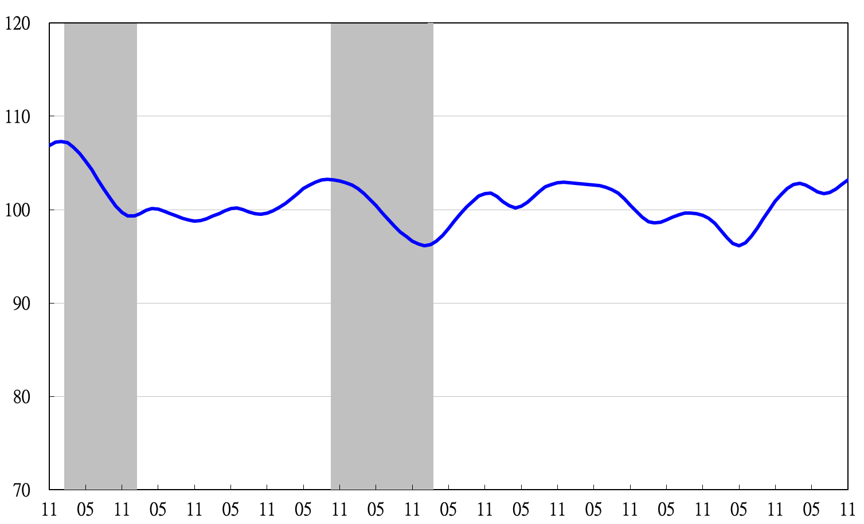
2010 2011 2012 2013 2014 2015 2016 2017 2018 2019 2020 2021
Figure 4 Trend-adjusted Coincident Index

Table 3 Lagging Indicators
Index
 | 2021
 | May | Jun | Jul | Aug | Sep | Oct | Nov
Trend adjusted index | 99.19 | 99.86 | 100.84 | 102.01 | 103.19 | 104.32 | 105.39
Change from preceding month (%) | 0.45 | 0.67 | 0.99 | 1.16 | 1.15 | 1.09 | 1.03
Components
Unemployment rate | 99.11 | 98.78 | 98.81 | 99.16 | 99.71 | 100.37 | 101.07
The manufacturing unit output labor cost index | 99.01 | 99.23 | 99.55 | 99.89 | 100.16 | 100.33 | 100.45
Interbank overnight call-loan rate | 99.99 | 100.00 | 100.01 | 100.02 | 100.03 | 100.036 | 100.044
Loans and investments of financial institutions | 100.66 | 100.74 | 100.74 | 100.68 | 100.56 | 100.40 | 100.23
Inventory value for manufacturing | 100.38 | 101.12 | 101.79 | 102.39 | 102.93 | 103.44 | 103.92

2010 2011 2012 2013 2014 2015 2016 2017 2018 2019 2020 2021
2011.2(P) 2012.1(T) 2014.10(P) 2016.2(T)

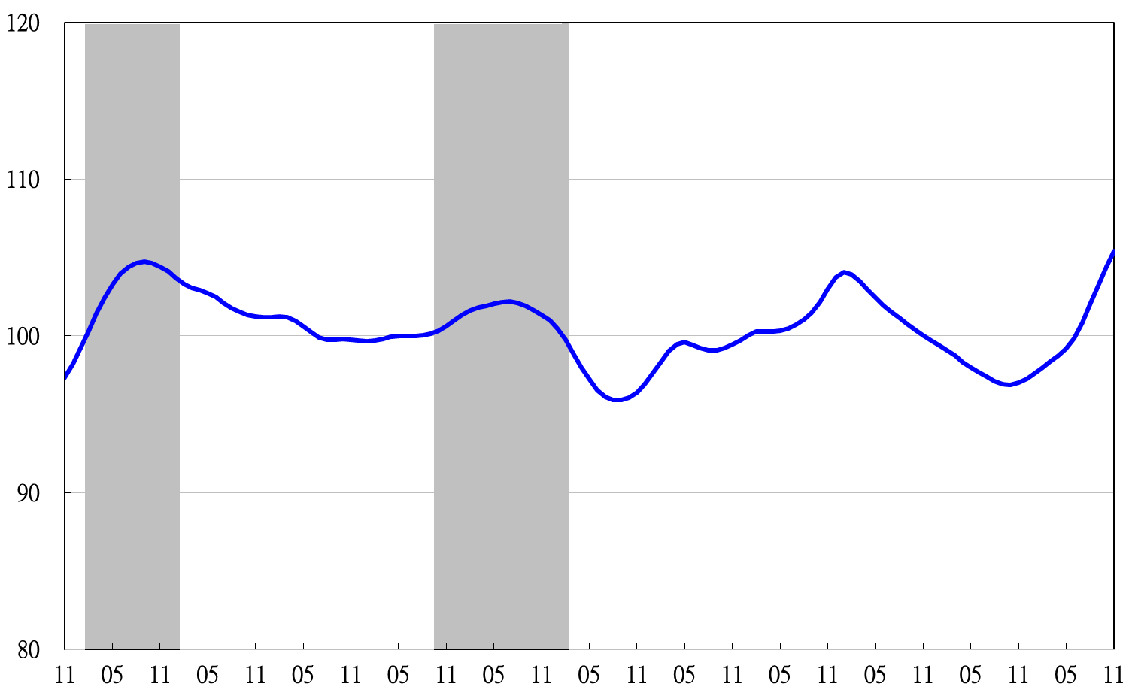
Figure 5 Trend-adjusted Lagging Index

