Taiwan Business Indicators in January 2022
Press Release
National Development Council (NDC)
March 1, 2022
In January 2022, the overall monitoring indicator changed to the “yellow-red” signal from the “red” signal last month, as the total score decreased two points to 36. The trend-adjusted leading index decreased for two consecutive months and the coincident index increased for six consecutive months, the government will be closely monitoring the economic situation.
The Monitoring Indicators
- The total score in January 2022 was 36, flashing the “yellow-red” signal, which decreased 2 points from 38 last month.
Leading Indicators
- The trend-adjusted leading index decreased by 0.06% in January 2022 to 102.08, falling for two consecutive months.
Coincident Indicators
- The trend-adjusted coincident index increased by 0.32% in January 2022 to 103.16, rising for six consecutive months.
Lagging Indicators
- The trend-adjusted lagging index increased by 0.62% in January 2022 to 105.18, rising for fifteen consecutive months.

T~~ Next publication date: March 28 2022 ~~
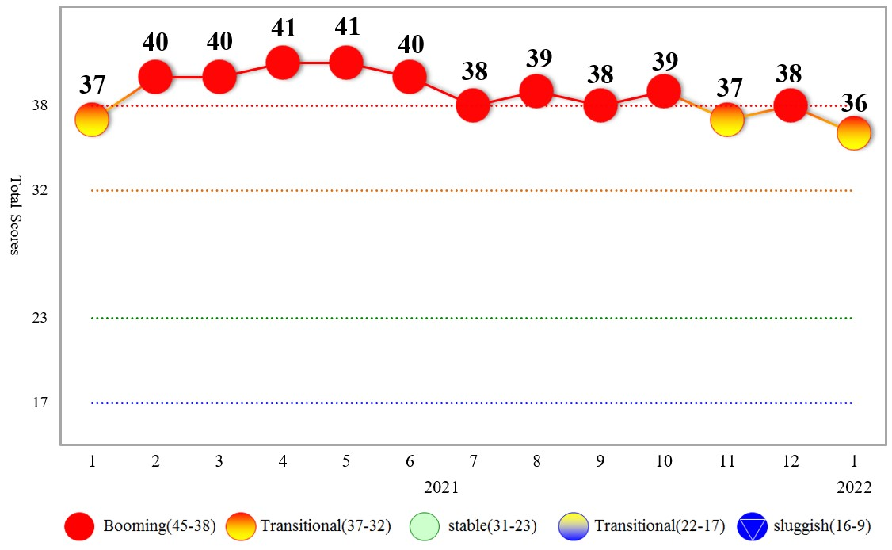
Figure 1 Total Scores in the Past Year

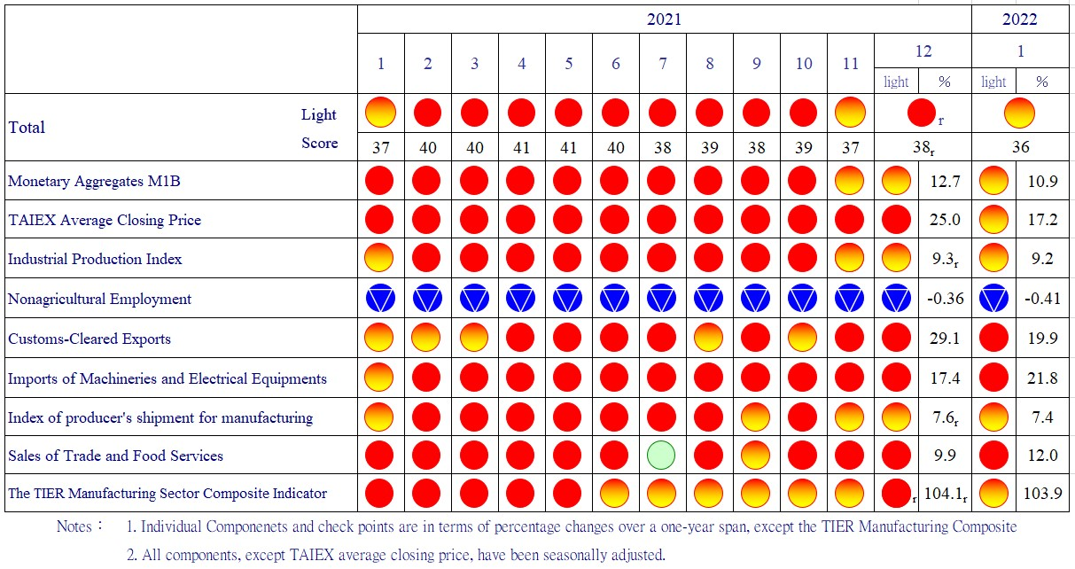
Figure 2 Monitoring Indicators

Table 1 Leading Indicators
Index
 | 2021 |  |  |  |  |  |  | 2022
 | Jul | Aug | Sep | Oct | Nov |  | Dec | Jan
Trend adjusted index | 101.28 | 101.62 | 101.95 | 102.18 |  | 102.21 | 102.15 | 102.08
Change from preceding month (%) | 0.13 | 0.34 | 0.33 | 0.23 |  | 0.02 | -0.06 | -0.06
Components¹
Diffusion Index of export orders² | 100.44 | 100.44 | 100.48 | 100.51 |  | 100.54 | 100.61 | 100.76
Real monetary aggregates M1B | 100.61 | 100.50 | 100.39 | 100.28 |  | 100.16 | 100.05 | 99.93
TAIEX average closing price | 100.69 | 100.56 | 100.43 | 100.31 |  | 100.22 | 100.15 | 100.10
Net accession rate of employees on payrolls of industry and services ³ | 98.76 | 99.62 | 100.38 | 100.88 |  | 101.13 | 101.25 | 101.35
New housing construction started ⁴ | 99.17 | 99.23 | 99.34 | 99.53 |  | 99.59 | 99.60 | 99.56
Real imports of semiconductor equipment | 100.07 | 100.22 | 100.35 | 100.41 |  | 100.38 | 100.30 | 100.17
The TIER manufacturing sector composite indicator | 100.48 | 100.25 | 100.06 | 99.92 |  | 99.84 | 99.81 | 99.78
Note：1. All components are passed through seasonal adjustment, trend-removal, smoothing and normalization.
2. Diffusion Index of export orders by number of firms.
3. Net accession rate is equal to accession rate minus separation rate.
4. Including only housing, mercantile, business and service, industry warehousing.
2011.2(P) 2012.1(T) 2014.10(P) 2016.2(T)
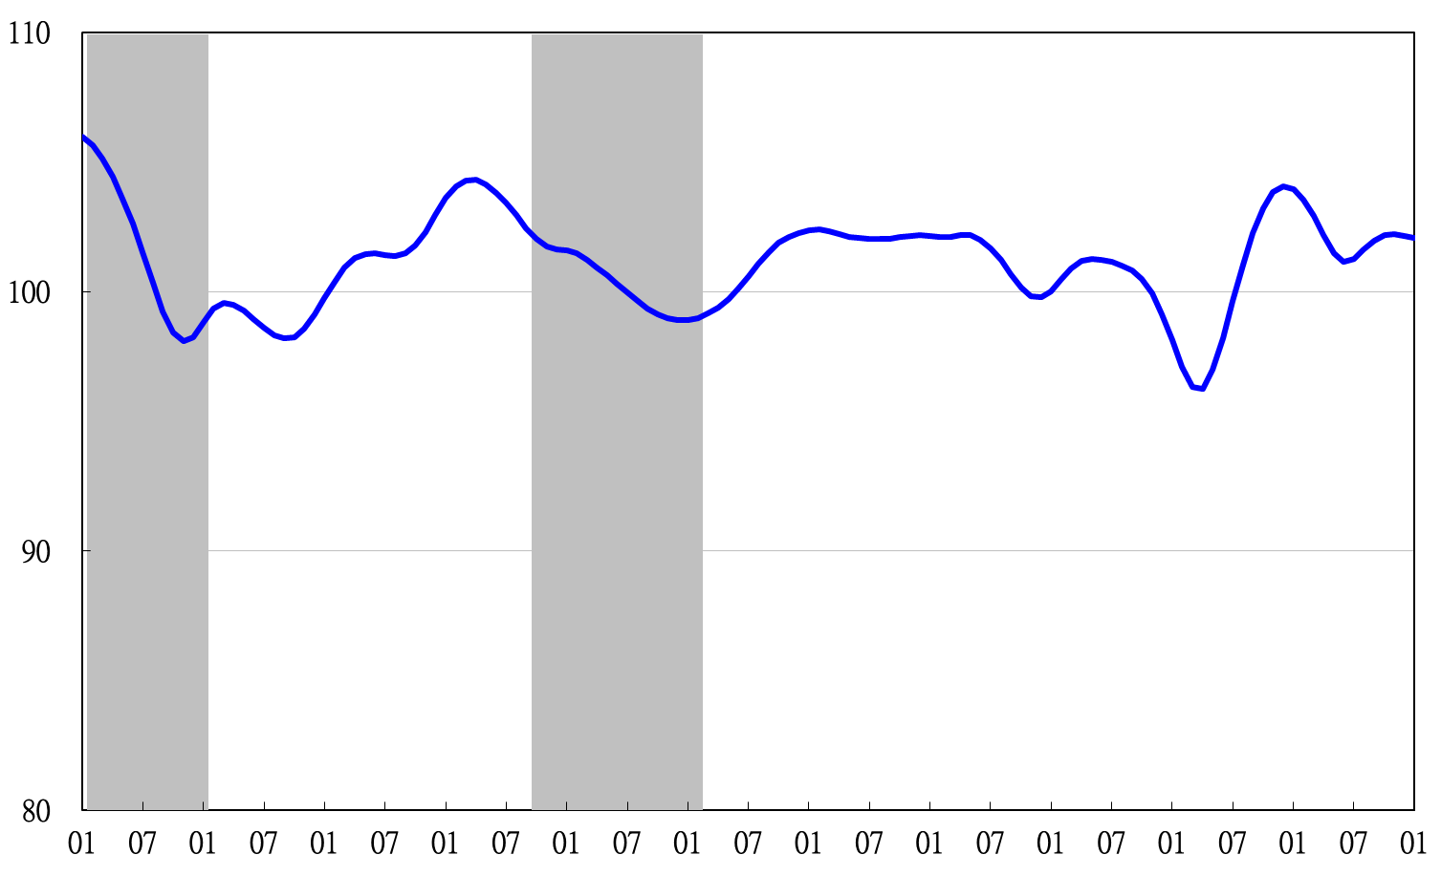

2011 2012 2013 2014 2015 2016 2017 2018 2019 2020 2021 2022
Figure 3 Trend-adjusted Leading Index
Note: Shaded areas represent recessions.
Table 2 Coincident Indicators
Index
 | 2021 |  |  |  |  |  | 2022
 | Jul | Aug | Sep | Oct | Nov | Dec | Jan
Trend adjusted index | 101.30 | 101.42 | 101.75 | 102.16 | 102.51 | 102.84 | 103.16
Change from preceding month (%) | -0.17 | 0.12 | 0.33 | 0.40 | 0.35 | 0.31 | 0.32
Components
Industrial production index | 100.94 | 100.78 | 100.62 | 100.48 | 100.37 | 100.31 | 100.28
Electric power consumption | 100.49 | 100.65 | 100.86 | 101.05 | 101.10 | 101.12 | 101.18
Index of producer’s shipment for manufacturing | 101.21 | 101.07 | 100.91 | 100.75 | 100.58 | 100.44 | 100.31
Sales of trade and food services | 99.88 | 100.14 | 100.58 | 101.12 | 101.70 | 102.27 | 102.85
Nonagricultural employment | 98.32 | 98.37 | 98.62 | 98.97 | 99.37 | 99.75 | 100.12
Real customs-cleared exports | 100.24 | 100.40 | 100.63 | 100.84 | 100.98 | 100.99 | 100.92
Real machineries and electrical equipments imports | 100.72 | 100.64 | 100.52 | 100.38 | 100.25 | 100.16 | 100.07

2011.2(P) 2012.1(T) 2014.10(P) 2016.2(T)
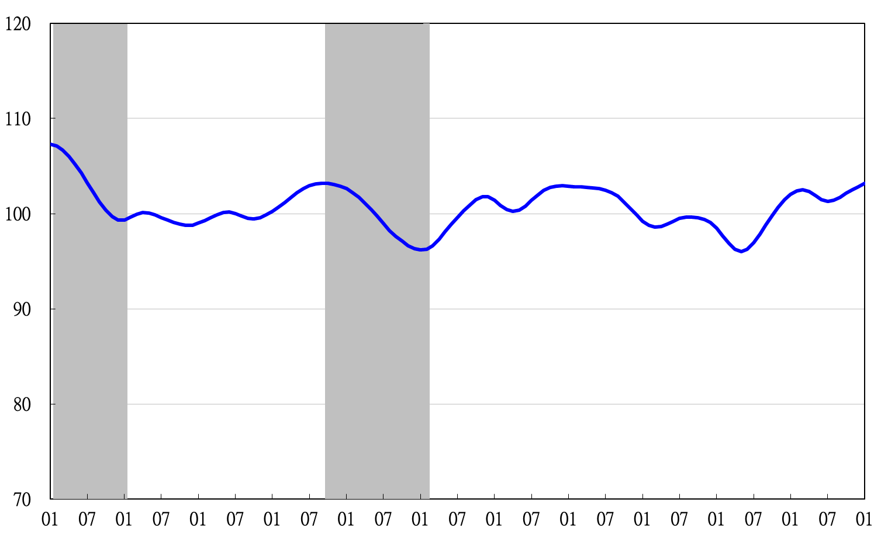
2011 2012 2013 2014 2015 2016 2017 2018 2019 2020 2021 2022
Figure 4 Trend-adjusted Coincident Index

Table 3 Lagging Indicators
Index
 | 2021 |  |  |  |  |  |  | 2022
 | Jul | Aug | Sep | Oct | Nov | Dec | Jan
Trend adjusted index | 99.99 | 101.07 | 102.12 | 103.05 | 103.83 | 104.52 | 105.18
Change from preceding month (%) | 0.94 | 1.09 | 1.04 | 0.91 | 0.76 | 0.66 | 0.62
Components
Unemployment rate | 98.56 | 98.89 | 99.41 | 100.01 | 100.60 | 101.16 | 101.70
The manufacturing unit output labor cost index | 99.58 | 99.90 | 100.11 | 100.21 | 100.22 | 100.20 | 100.18
Interbank overnight call-loan rate | 100.00 | 100.01 | 100.02 | 100.03 | 100.03 | 100.04 | 100.05
Loans and investments of financial institutions | 100.62 | 100.57 | 100.49 | 100.41 | 100.36 | 100.35 | 100.37
Inventory value for manufacturing | 101.24 | 101.78 | 102.23 | 102.58 | 102.85 | 103.06 | 103.22

2011 2012 2013 2014 2015 2016 2017 2018 2019 2020 2021 2022
2011.2(P) 2012.1(T) 2014.10(P) 2016.2(T)

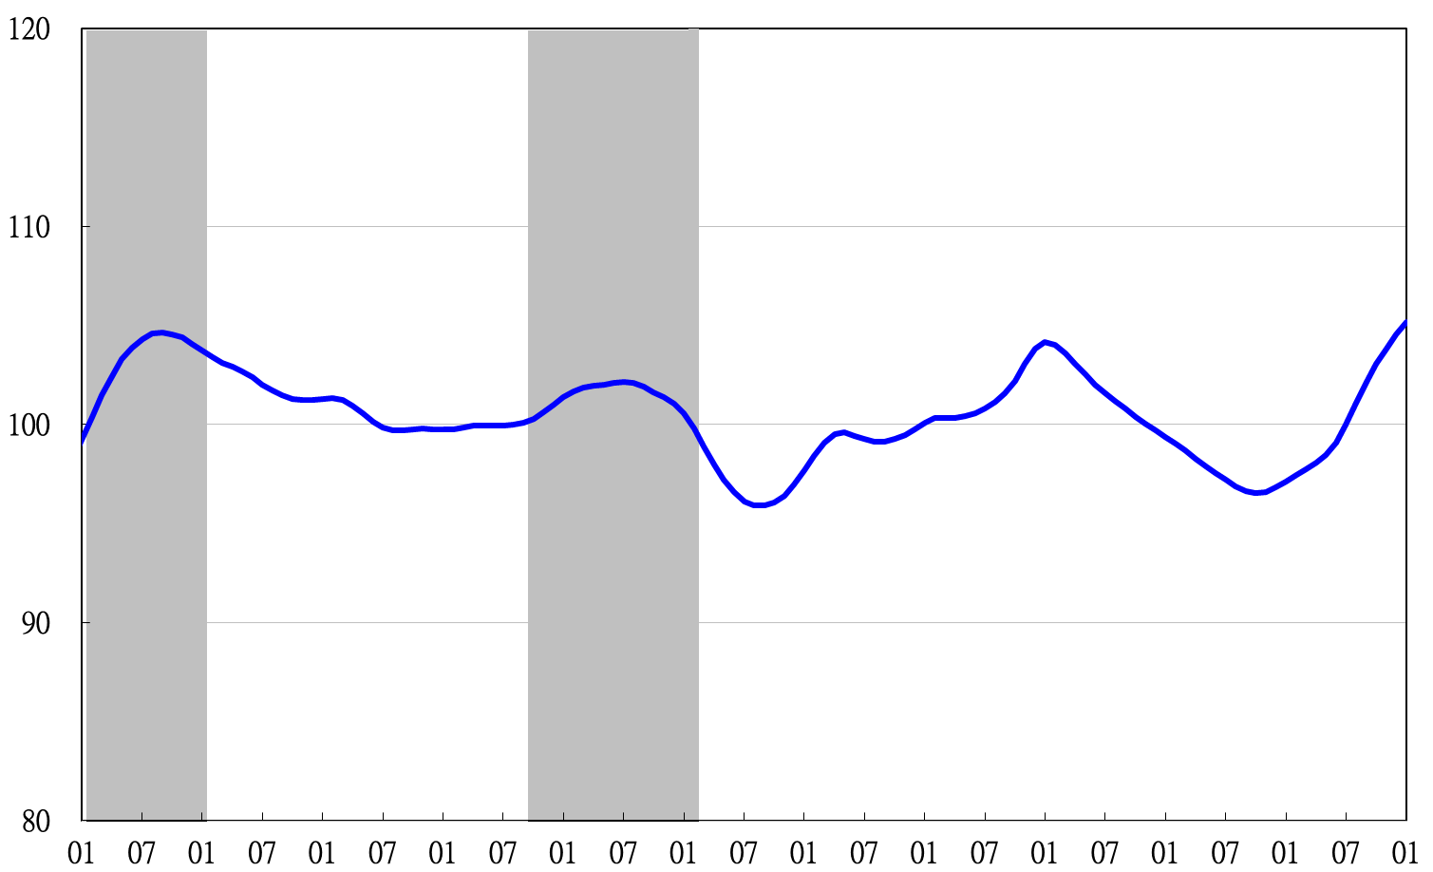
Figure 5 Trend-adjusted Lagging Index

