NEXT BIG to Convey Taiwan's Entrepreneurial Energy to the World

To strengthen Taiwan startups’ international reputation, on top of the national startup brand Startup Island TAIWAN, the National Development Council (NDC) launched the NEXT BIG project. Together, the startup communities and industry key opinion leaders jointly nominated nine startups to become NEXT BIG representatives. With NEXT BIG leading the way, Taiwan hopes to see more young people be inspired and Taiwan’s thriving entrepreneurial energy be conveyed to the world.
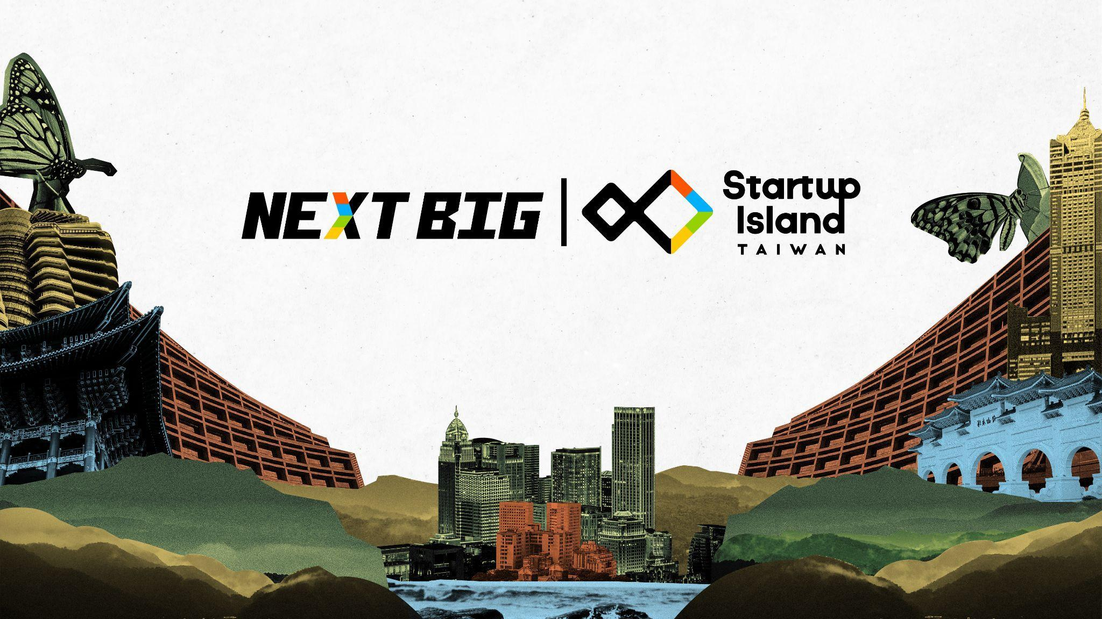
The National Development Council launches the NEXT BIG project to showcase Taiwan’s endless entrepreneurial energy to the world
The nine NEXT BIG are:
- CoolBitX: founded in 2014, CoolBitX is committed to blockchain security technology’s innovation and development. They produced the world’s first cold wallet “CoolWallet” and provided tailor-made software services for the product Sygna Bridge, simplifying the compliance process while allowing dealers to comply with the anti-money laundering regulations in various countries.
- Gogoro: founded in 2011 to rethink urban energy and inspire the world to move through cities in smarter and more sustainable ways, Gogoro leverages the power of innovation to change the way they distribute and consume urban energy. Gogoro’s battery swapping and vehicle platforms offer a smart, proven and sustainable long-term ecosystem for delivering a new approach to urban mobility. Gogoro has quickly become an innovation leader in vehicle design and electric propulsion, smart battery design, battery swapping, and advanced cloud services that utilize artificial intelligence to intelligently manage battery availability and safety. The challenge is massive, but the opportunity to disrupt the status quo, establish new standards, and achieve new levels of sustainable transportation growth in the cities is even greater.
- Greenvines: established in 2011, Greenvines is a skincare brand, also the third B corp in Taiwan. It is also the only B corp in Asia that has won the "Best for the World" environmental award for five consecutive years. Relying on science and sustainability, they discarded more than 2,700 non-essential ingredients and streamlined the daily skincare routine, making it a sustainable practice.
- iKala: established in 2011, iKala’s mission is "AI Empowerment". They provide AI-driven solutions for companies to achieve business transformation, acceleration, and creation of new business models. They currently provide services to more than 400 companies and 15,000 advertisers and brand owners across 8 countries in Asia.
- KDAN MOBILE: established in 2009, KDAN MOBILE provides enterprise cloud solutions. Their products have already achieved more than 200 million downloads and have accumulated more than 10 million registered members worldwide. 65% of their users are based in Europe and America. They are devoted to helping enterprises create mobile offices.
- KKday: established in 2014, KKday has become Asia’s largest in-depth travel e-commerce platform covering more than 30,000 itineraries in 92 countries, and 550 cities around the world. They have received US$75 million of C round investment from Cool Japan Fund, National Development Fund, CDIB Capital Group, Darwin Venture, and others.
- Pinkoi: established in 2011, Pinkoi is the leading design e-commerce platform in Asia, helping more design brands to enter the international market. By providing digital transformation online, and brand experience offline, they continue to make an impact on the current and future generations of designers.
- 17LIVE: established in 2015, 17LIVE is the largest live streaming platform in Asia. Starting from Taiwan, it has expanded to Japan, Hong Kong, Southeast Asia, the United States and other regional markets. It combines AI and machine learning technology applications to provide more authentic, zero time difference streaming services.
- 91APP: established in 2013, 91APP is the first to provide Online Merge Offline (OMO) new retail software cloud service in Taiwan. They provide three self-developed retail software clouds, helping brands to quickly enter the e-commerce market. In May this year, it became the first SaaS company listed in Taiwan, with a market value exceeding NT$40 billion.
Startup Island TAIWAN is the national startup brand co-created by the NDC and the startup communities. Its primary goal is to promote Taiwan’s entrepreneurial ecosystem and to assist startups in expanding to international markets. Going forward, the brand will continue to bring the startup communities together to enhance Taiwan’s visibility to the world as the “Startup Island”. For more information, please follow Startup Island TAIWAN on its social media:
Facebook: https://www.facebook.com/startupislandtw/
Twitter: https://twitter.com/startupislandtw
Instagram: https://www.instagram.com/startupisland.tw/

Contact Information:
Fang-Guan Jan, Director General, Department of Industrial Development
Office: (886-2)2316-5850

