Taiwan Business Indicators in February 2017
Press Release
National Development Council (NDC)
March 27, 2017
In February 2017, the Taiwan Business Indicators showed some scattered signs of economic improvement. Among the indicators compiled by the National Development Council (NDC), the trend-adjusted leading and coincident index decreased by 0.10% and 0.11% from the previous month, and the overall monitoring indicator flashed the "green" signal.
- The Monitoring Indicators: The total score in February 2017 decreased by one point to 28, flashing the “green” signal for the eighth month. Among the nine components, the monetary aggregate M1B and the sales of trade and food services each gained one point to change its individual light from “yellow-blue” to “green”. Meanwhile, the industrial production index lost two points to change its individual light from “red” to “green”, the index of producer’s shipment for manufacturing lost one point to change its individual light from “yellow-red” to “green”. The light signal for the rest of five components remained unchanged.
- Leading Indicators: With revised data, the trend-adjusted leading index stood at 101.88, down by 0.10% from January 2017. Among the seven indicators making up the trend-adjusted index, building permits and TAIEX average closing price had positive cyclical movements from the previous month, while the index of export orders, real imports of semiconductor equipment, real monetary aggregates M1B, net accession rate of employees on payrolls of industry and services, and the TIER manufacturing sector composite indicator had negative cyclical movements.
- Coincident Indicators: With revised data, the trend-adjusted coincident index stood at 103.35, down by 0.11% from January 2017. Among seven indicators making up the trend-adjusted index, real customs-cleared exports, nonagricultural employment, and the index of producer’s shipment for manufacturing had positive cyclical movements, while real machineries and electrical equipments imports, electric power consumption, the industrial production index, and sales of trade and food services had negative cyclical movements.
- Lagging Indicators: With revised data, the trend-adjusted lagging index stood at 98.66, up by 0.35% from January 2017. Among the six indicators making up the trend-adjusted index, the inventories to sales ratio for manufacturing, the unemployment rate (inverted), regular employees on payrolls in industry and services, the interbank overnight call-loan rate, and loans and investments of monetary financial institutions had positive cyclical movements from the previous month, while the manufacturing unit output labor cost index had negative cyclical movement.
T~~ Next publication date: April 27 2017 ~~T

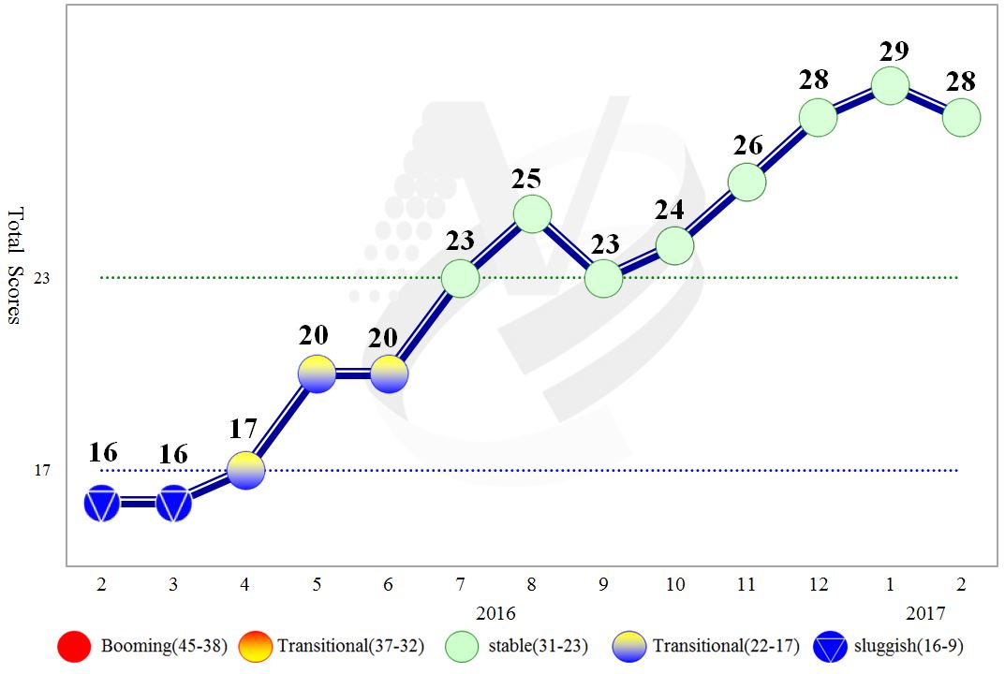
Figure 1 Total Scores in the Past Year

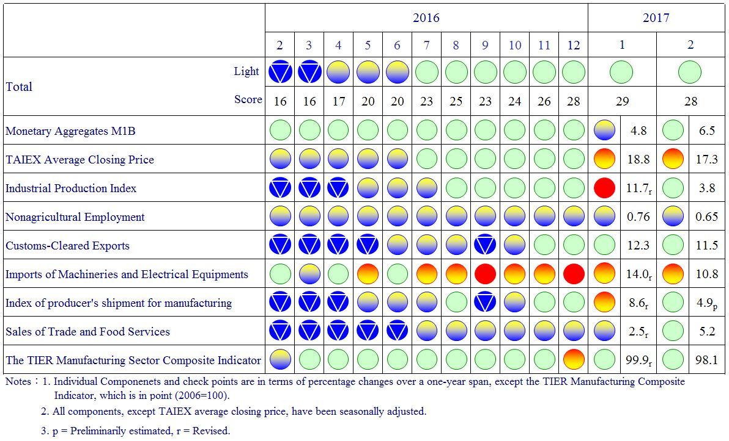
Figure 2 Monitoring Indicators
Table 1 Leading Indicators
Index
 | 2016 |  |  |  |  | 2017
 | Aug | Sep | Oct | Nov | Dec | Jan | Feb
Trend adjusted index | 101.20 | 101.62 | 101.85 | 101.96 | 102.00 | 101.98 | 101.88
Change from preceding month (%) | 0.63 | 0.42 | 0.22 | 0.11 | 0.04 | -0.02 | -0.10
Components¹ | 0.00 | 0.00 | 0.00 | 0.00 | 0.00 | 0.00 | 0.00
Index of export orders | 100.19 | 100.42 | 100.51 | 100.48 | 100.36 | 100.21 | 100.04
Real monetary aggregates M1B | 100.04 | 100.03 | 99.99 | 99.92 | 99.82 | 99.72 | 99.61
TAIEX average closing price | 99.94 | 100.03 | 100.11 | 100.18 | 100.25 | 100.33 | 100.42
Net accession rate of employees on payrolls of industry and services ² | 99.98 | 100.09 | 100.20 | 100.30 | 100.37 | 100.40 | 100.36
Building permits ³ | 99.99 | 100.02 | 99.97 | 99.98 | 100.10 | 100.29 | 100.47
Real imports of semiconductor equipment ⁴ | 100.50 | 100.73 | 100.86 | 100.91 | 100.88 | 100.79 | 100.67
The TIER manufacturing sector composite indicator | 100.34 | 100.39 | 100.46 | 100.52 | 100.57 | 100.57 | 100.55
Note：1. All components are passed through seasonal adjustment, trend-removal, smoothing and normalization.
2. Net accession rate is equal to accession rate minus separation rate.
3. Including only housing, mercantile, business and service, industry warehousing.
4. SEMI ceased publishing the monthly North America Book-to-Bill report in January 2017. The NDC replaced SEMI Book-to-Bill Ratio with real imports of semiconductor equipment since February 2017.
2008.3(P) 2009.2(T) 2011.2(P) 2012.1(T) 2014.10(P)
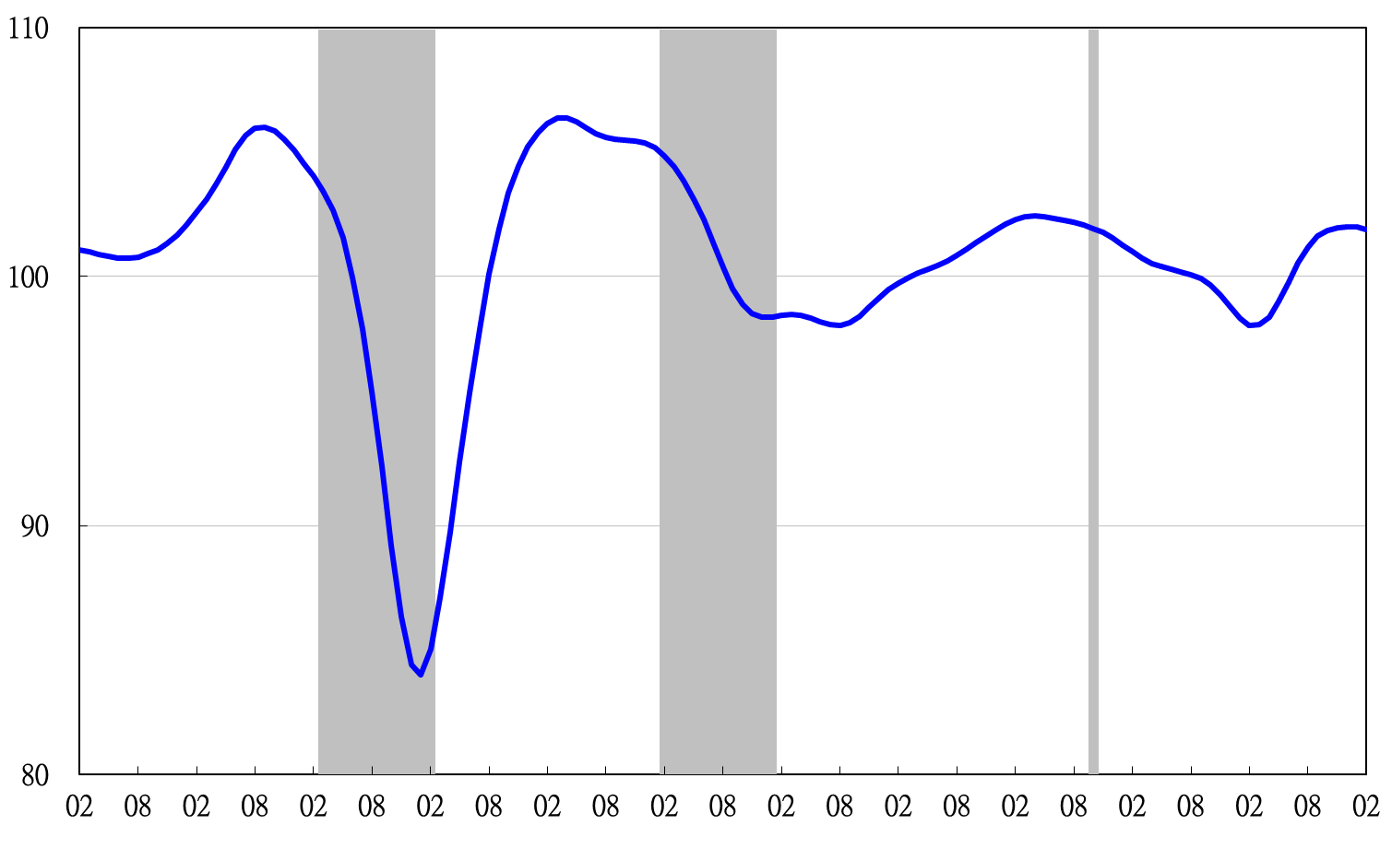
2006 2007 2008 2009 2010 2011 2012 2013 2014 2015 2016 2017
Note: Shaded areas represent recessions.
Figure 3 Trend-adjusted Leading Index
Table 2 Coincident Indicators
Index
 | 2016 |  |  |  |  | 2017
 | Aug | Sep | Oct | Nov | Dec | Jan | Feb
Trend adjusted index | 100.66 | 101.51 | 102.31 | 102.96 | 103.36 | 103.46 | 103.35
Change from preceding month (%) | 0.90 | 0.84 | 0.79 | 0.63 | 0.39 | 0.10 | -0.11
Components
Industrial production index | 100.08 | 100.28 | 100.48 | 100.66 | 100.78 | 100.85 | 100.83
Electric power consumption | 100.25 | 100.52 | 100.81 | 101.03 | 101.19 | 101.16 | 100.98
Index of producer’s shipment for manufacturing | 100.04 | 100.23 | 100.47 | 100.70 | 100.86 | 100.96 | 100.98
Sales of trade and food services | 99.98 | 100.32 | 100.65 | 100.90 | 101.02 | 101.05 | 101.04
Nonagricultural employment | 99.66 | 99.67 | 99.69 | 99.72 | 99.76 | 99.80 | 99.84
Real customs-cleared exports | 99.97 | 100.25 | 100.56 | 100.88 | 101.17 | 101.44 | 101.69
Real machineries and electrical equipments imports | 100.85 | 101.36 | 101.70 | 101.84 | 101.80 | 101.54 | 101.21

2008.3(P) 2009.2(T) 2011.2(P) 2012.1(T) 2014.10(P)
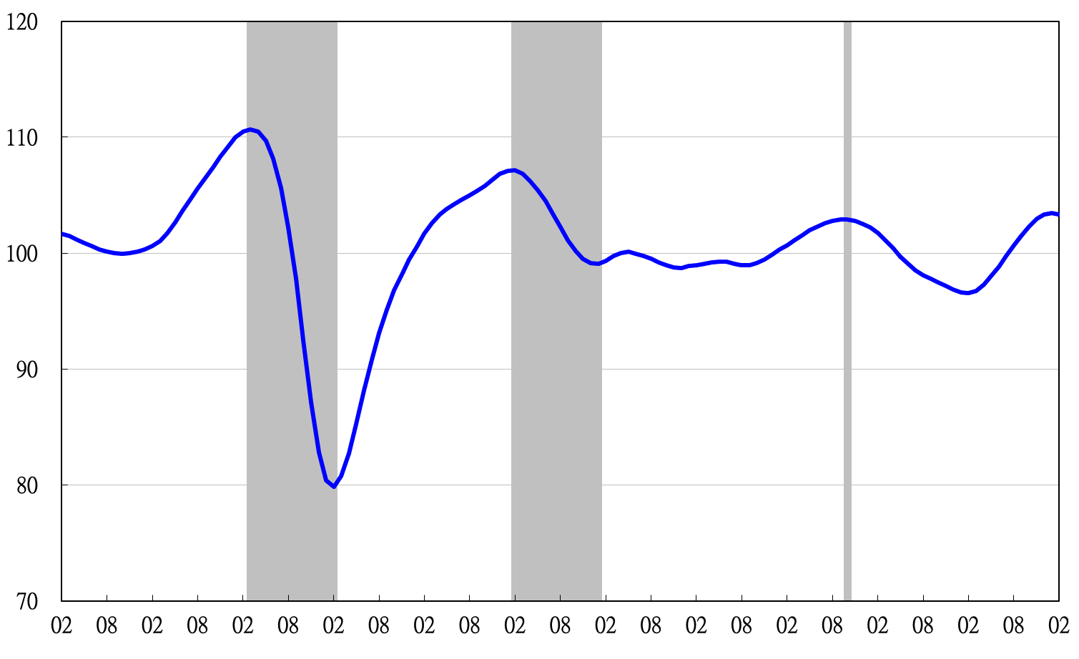
2006 2007 2008 2009 2010 2011 2012 2013 2014 2015 2016 2017
Figure 4 Trend-adjusted Coincident Index
Table 3 Lagging Indicators
Index
 | 2016 |  |  |  |  |  | 2017
 | Aug | Sep | Oct |  | Nov | Dec | Jan | Feb
Trend adjusted index | 98.43 | 98.21 | 98.05 | 98.00 |  | 98.09 | 98.31 | 98.66
Change from preceding month (%) | -0.29 | -0.23 | -0.16 | -0.05 |  | 0.09 | 0.23 | 0.35
Components | 0.00 | 0.00 | 0.00 | 0.00 |  | 0.00 | 0.00 | 0.00
Unemployment rate | 99.59 | 99.68 | 99.78 | 99.88 |  | 99.97 | 100.05 | 100.12
Regular employees on payrolls  in industry & services | 99.75 | 99.74 | 99.75 | 99.78 |  | 99.82 | 99.86 | 99.92
The manufacturing unit output labor cost index | 99.68 | 99.39 | 99.12 | 98.88 |  | 98.70 | 98.58 | 98.54
Interbank overnight call-loan rate | 99.91 | 99.92 | 99.94 | 99.95 |  | 99.97 | 99.99 | 100.00
Loans and investments of monetary financial institutions | 99.87 | 99.87 | 99.87 | 99.87 |  | 99.87 | 99.87 | 99.88
Inventories to sales ratio for manufacturing | 99.33 | 99.25 | 99.21 | 99.24 |  | 99.39 | 99.63 | 99.93

2008.3(P) 2009.2(T) 2011.2(P) 2012.1(T) 2014.10(P)

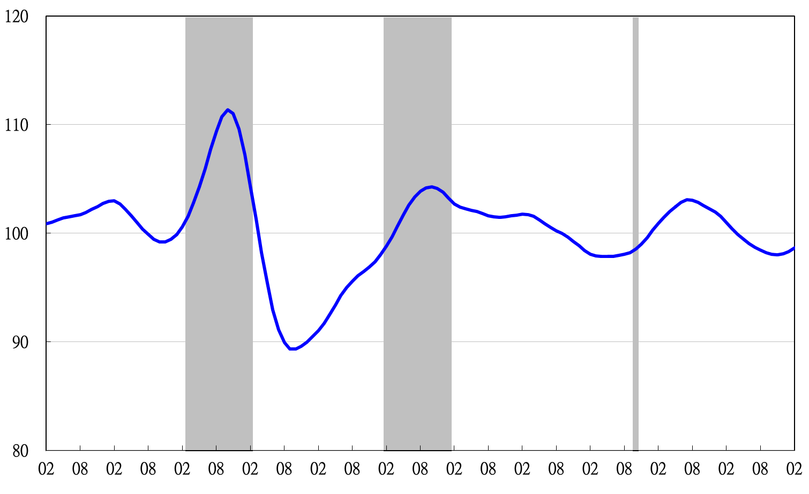
2006 2007 2008 2009 2010 2011 2012 2013 2014 2015 2016 2017
Figure 5 Trend-adjusted Lagging Index

SEMI ceased publishing the monthly North America Book-to-Bill report in January 2017. The NDC replaced SEMI Book-to-Bill Ratio with real imports of semiconductor equipment since February 2017.

