Startup Island TAIWAN
Showcases the Nation’s Startup Dynamism to the World
Taipei, December 18, 2019
Startup Island TAIWAN, Taiwan’s national startup brand, was launched on December 18th, 2019. Minister of the National Development Council (NDC) Ms. Mei-Ling Chen and some 100 young entrepreneurs joined together to celebrate the brand launch in a vibrant and relaxed party.
Recognized as a unified brand by all the startup communities in Taiwan, Startup Island TAIWAN is also supported by Minister without Portfolio Audrey Tang and various ministries including Ministry of Economic Affairs, Financial Supervisory Commission, Overseas Community Affairs Council, Ministry of Culture, Ministry of Science and Technology, and Ministry of Foreign Affairs. It is the wish shared by both public and private sectors that the brand which will showcase the dynamism of Taiwan’s startups to the world will help Taiwan startups expand into global markets.
“For two years in a row”, said Minister Chen in the brand launch party, “Taiwan was selected as one of the four super innovators by World Economic Forum, along with Germany, the U.S. and Switzerland. According to Global Entrepreneurship Monitor: 2018/19 Global Report released by Babson College and London Business School, Taiwan was ranked 4th in the Index of National Entrepreneurship Context. It indicated that we have great innovation capabilities, and we should be more confident of ourselves. ” Creating an identity system for the startups based in Taiwan is a key policy of the Action Plan for Enhancing Taiwan’s Startup Ecosystem. As an outstanding example of public-private partnership, Startup Island TAIWAN is the result of extensive discussions with Taiwan startup communities by the Government. “This is indeed a brand from startups, with startups, and for startups,” said Minister Chen. “The brand belongs to all Taiwanese startups, and we welcome all startups in Taiwan to carry this brand when going global.”
The logo of Startup Island TAIWAN displays an image of the island through mountains and their reflection in the ocean. The image also symbolizes infinity and DNA, which reflect the unlimited dynamism that Taiwan startups possess and the entrepreneurship that exists in the genes of Taiwan’s people. As for the auxiliary designs which correspond to the four colors of the logo, the images of mountains and the ocean depict Taiwan’s difficult terrain, where mountains lie close by the sea. They also symbolize the adventurous spirit and perseverance of Taiwanese entrepreneurs. The dancing butterfly represents Taiwan's cultural diversity while the light bulb suggests Taiwan's endless creativity.
Dr. I. C. Jan shared his insights as the Ambassador of Startup Genome in Taiwan. Being a frequent participant in international startup exhibitions and conferences, he emphasized the importance of a unified and consistent identity when promoting and marketing Taiwan’s startups. He believed the brand Startup Island TAIWAN could reflect the uniqueness and diversity of Taiwan with emotional connections and resonance. He expected the brand would help Taiwan to have a voice in the global startup communities in the future. He also urged full support from both public and private sectors.
As former brand consultant of 2017 Summer Universiade, Backer-Founder CEO Tahan Lin pointed out that Taiwan needed storytelling capabilities as well as tolerance and consensus building. “In any cases,” he said, “we all hope the country will change for the better. With the brand Startup Island TAIWAN, we may introduce more about the dynamism of Taiwan startups to the world.”
The brand launch event was well recognized by startup communities and attended by more than 100 startup representatives coming from AppWorks, Garage+, Meet Startup, AAMA Taipei Cradle Program, Taiwan Startup Stadium, DIT Startup, TechOrange, BE Accelerator, Anchor Taiwan, Startboard, TAVAR, StarFab, Zashare, Taiwan Tech Arena and Startup Terrace.
Since October 2018, the NDC has organized some 10 meetings and/or workshops, consulting and exchanging ideas with over 100 Taiwan startup communities, teams and opinion leaders in order to explore the DNA of Taiwan's innovation and entrepreneurship, which would in turn serve as the basis for the brand positioning and image. The NDC also consulted other government agencies such as the Ministry of Science and Technology and Ministry of Economic Affairs on branding. By extensively collecting and analyzing opinions and information over the course of a year, the NDC has worked out a consensus in terms of the general perception of brand image as well as expectations for the brand’s future development. The NDC and the Taiwan startup communities have jointly built up the Taiwan national startup brand, Startup Island TAIWAN.
The brand will make its world debut at Consumer Electronics Show (CES) in January 2020. In the future, NDC will, in collaboration with other ministries and startup communities, continue to promote Taiwan’s budding entrepreneurs and startup ecosystem to the world under the brand Startup Island TAIWAN.

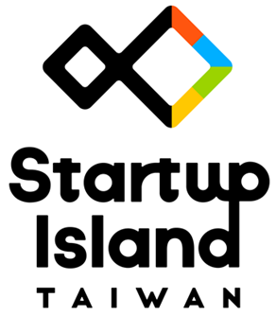
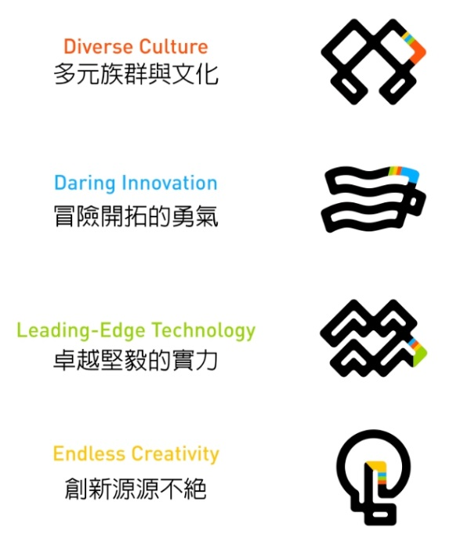
The Logo of Startup Island TAIWAN

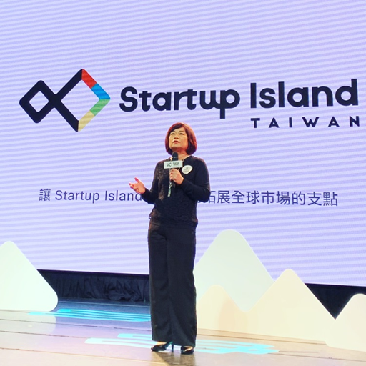
NDC Minister Mei-ling Chen indicated that Startup Island TAIWAN was a brand from startups, with startups, and for startups.

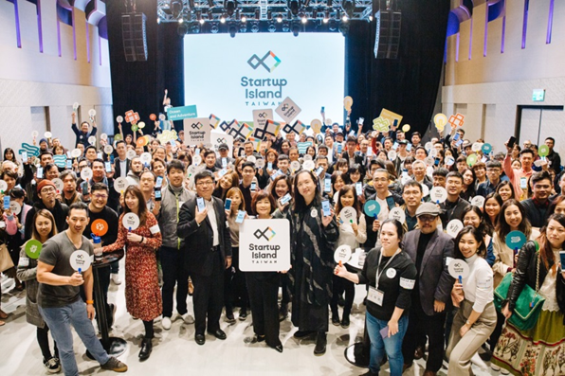
Minister Chen, various ministries’ officials and startup communities joined together to celebrate the brand launch.

