Taiwan Business Indicators in November 2019
Press Release
National Development Council (NDC)
December 27, 2019
In November 2019, the overall monitoring indicator changed to the “green” signal from the “yellow-blue” signal last month, as the total score increased five points to 24. The trend-adjusted leading index increased for eleven consecutive months and the coincident index increased for seven consecutive months, the government will be closely monitoring the economic situation.
The Monitoring Indicators
- The total score in November 2019 was 24, flashing the “green” signal, which increased 5 points from 19 last month.
Leading Indicators
- The trend-adjusted leading index increased by 0.36% in November 2019 to 102.62, rising for eleven consecutive months.
Coincident Indicators
- The trend-adjusted coincident index increased by 0.24% in November 2019 to 100.58, rising for seven consecutive months.
Lagging Indicators
- The trend-adjusted lagging index declined by 0.67% in November 2019 to 97.68, falling for eleven consecutive months.
T~~ Next publication date: February 3 2020 ~~
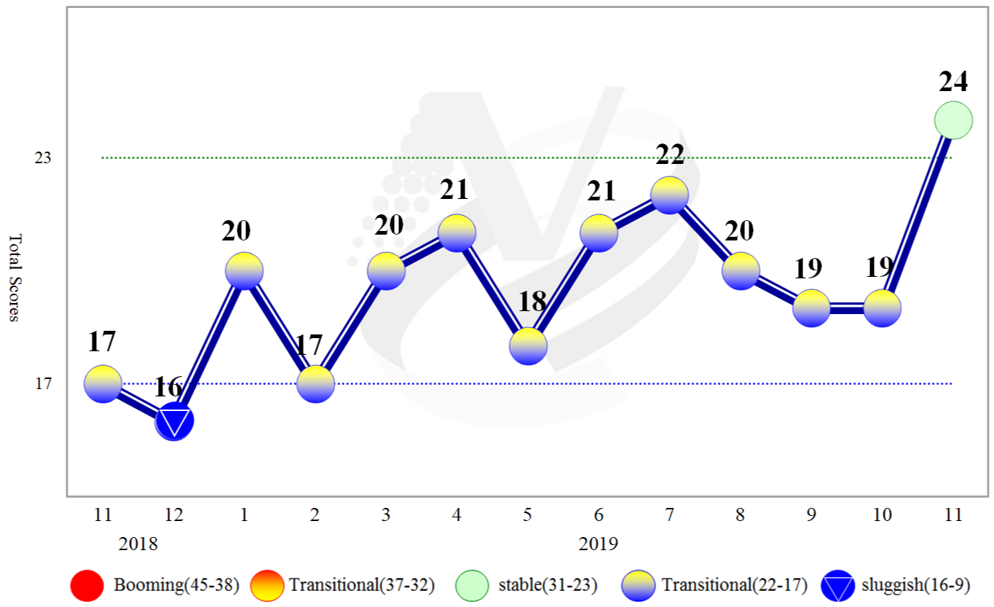
Figure 1 Total Scores in the Past Year

Figure 2 Monitoring Indicators
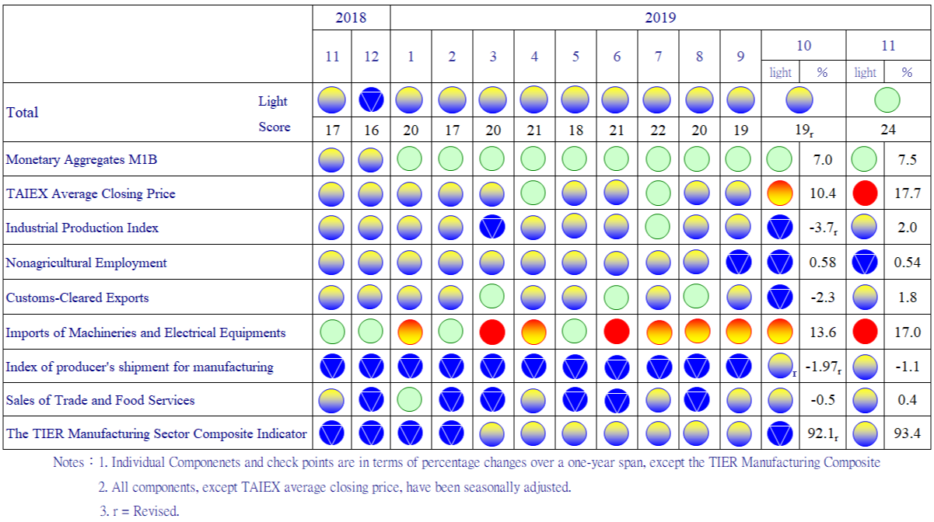

Table 1 Leading Indicators
Index
 | 2019
 | May | Jun | Jul | Aug | Sep |  | Oct |  | Nov
Trend adjusted index | 101.31 | 101.42 | 101.52 | 101.68 |  | 101.94 |  | 102.25 | 102.62
Change from preceding month (%) | 0.18 | 0.11 | 0.10 | 0.16 |  | 0.25 |  | 0.31 | 0.36
Components¹
Diffusion Index of export orders² | 99.71 | 99.71 | 99.72 | 99.79 |  | 99.91 |  | 100.11 | 100.36
Real monetary aggregates M1B | 100.23 | 100.27 | 100.28 | 100.28 |  | 100.27 |  | 100.26 | 100.25
TAIEX average closing price | 99.78 | 99.83 | 99.88 | 99.93 |  | 100.02 |  | 100.13 | 100.25
Net accession rate of employees on payrolls of industry and services ³ | 99.96 | 99.97 | 100.00 | 100.03 |  | 100.07 |  | 100.10 | 100.14
New housing construction started ⁴ | 100.13 | 100.07 | 100.00 | 99.94 |  | 99.91 |  | 99.87 | 99.82
Real imports of semiconductor equipment | 100.20 | 100.21 | 100.27 | 100.42 |  | 100.67 |  | 101.00 | 101.36
The TIER manufacturing sector composite indicator | 99.92 | 100.06 | 100.16 | 100.20 |  | 100.18 |  | 100.13 | 100.08
Note：1. All components are passed through seasonal adjustment, trend-removal, smoothing and normalization.
2. Diffusion Index of export orders by number of firms.
3. Net accession rate is equal to accession rate minus separation rate.
4. Including only housing, mercantile, business and service, industry warehousing.

2008.3(P) 2009.2(T) 2011.2(P) 2012.1(T) 2014.10(P) 2016.2(T)
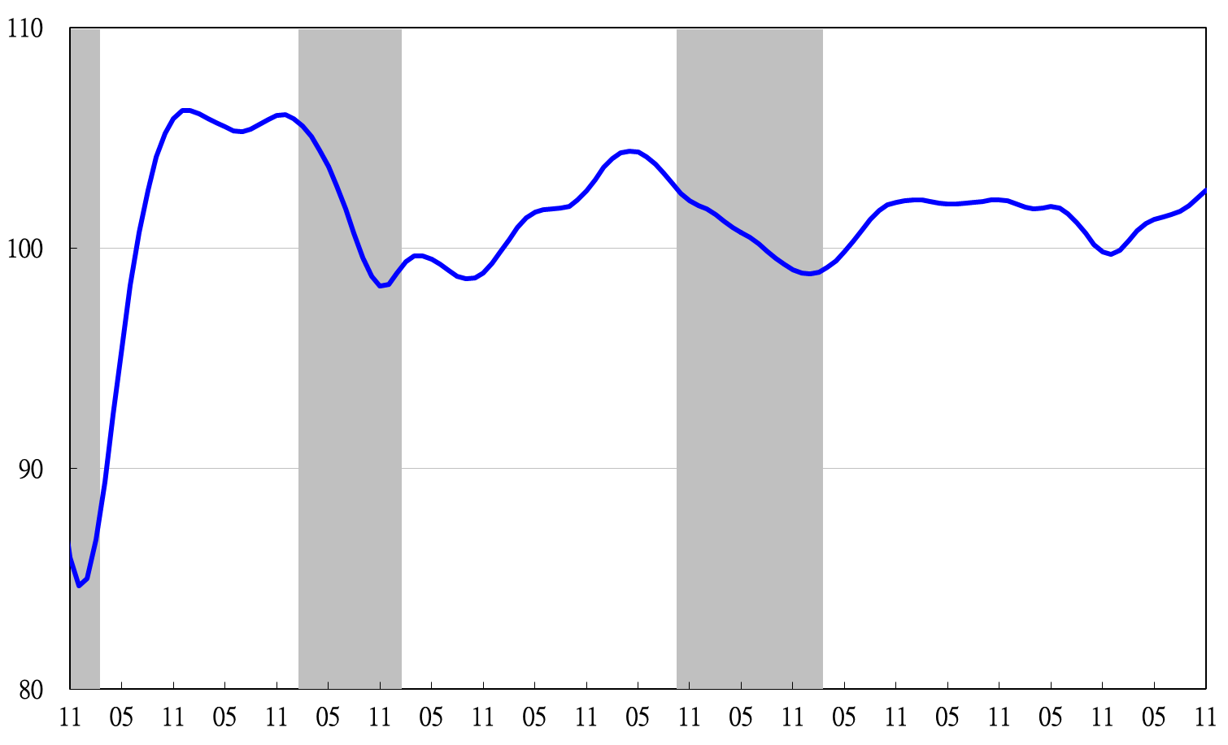
2008 2009 2010 2011 2012 2013 2014 2015 2016 2017 2018 2019
Figure 3 Trend-adjusted Leading Index
Note: Shaded areas represent recessions.
Table 2 Coincident Indicators
Index
 | 2019
 | May | Jun | Jul | Aug | Sep | Oct | Nov
Trend adjusted index | 98.82 | 99.15 | 99.52 | 99.84 | 100.10 | 100.33 | 100.58
Change from preceding month (%) | 0.19 | 0.33 | 0.37 | 0.32 | 0.26 | 0.23 | 0.24
Components
Industrial production index | 99.27 | 99.46 | 99.67 | 99.83 | 99.94 | 100.06 | 100.20
Electric power consumption | 99.57 | 99.48 | 99.40 | 99.34 | 99.26 | 99.20 | 99.17
Index of producer’s shipment for manufacturing | 98.98 | 99.19 | 99.43 | 99.64 | 99.83 | 100.01 | 100.18
Sales of trade and food services | 99.38 | 99.53 | 99.67 | 99.71 | 99.70 | 99.65 | 99.57
Nonagricultural employment | 99.98 | 99.96 | 99.93 | 99.89 | 99.85 | 99.80 | 99.74
Real customs-cleared exports | 99.76 | 99.94 | 100.07 | 100.19 | 100.29 | 100.37 | 100.48
Real machineries and electrical equipments imports | 99.59 | 99.69 | 99.85 | 100.09 | 100.36 | 100.64 | 100.91

2008.3(P) 2009.2(T) 2011.2(P) 2012.1(T) 2014.10(P) 2016.2(T)
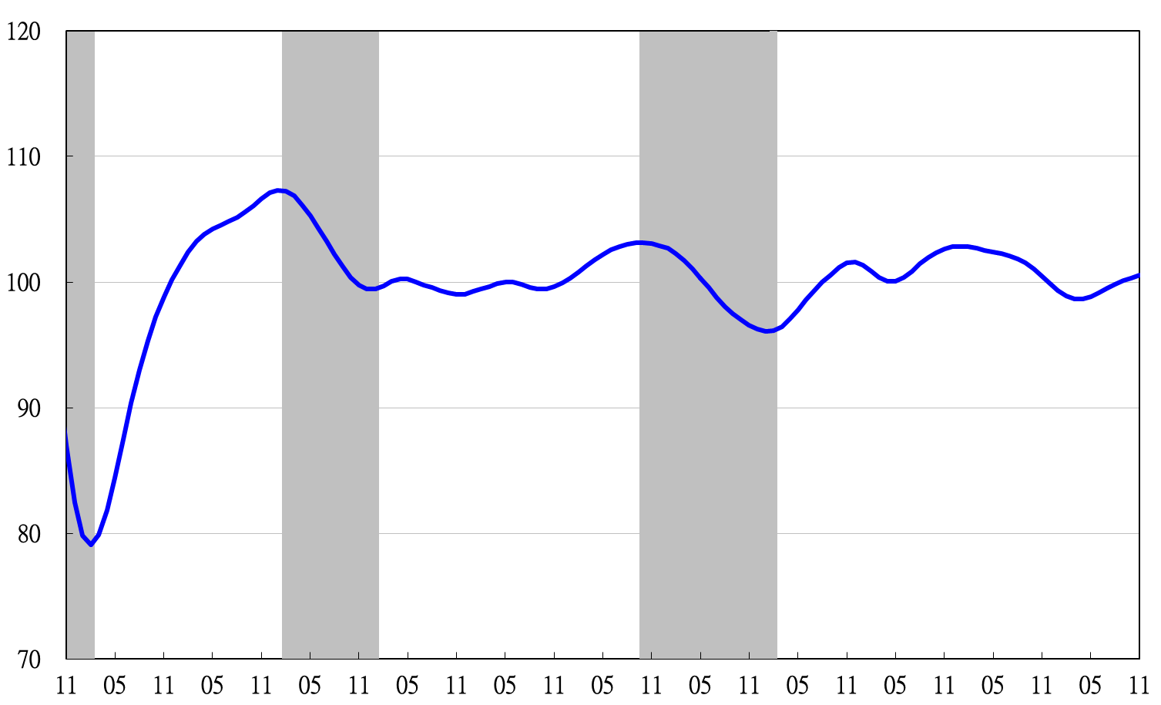
2008 2009 2010 2011 2012 2013 2014 2015 2016 2017 2018 2019
Figure 4 Trend-adjusted Coincident Index

Table 3 Lagging Indicators
Index
 | 2019
 | May |  | Jun | Jul | Aug | Sep | Oct | Nov
Trend adjusted index | 100.76 |  | 100.29 | 99.87 | 99.45 | 98.95 | 98.34 | 97.68
Change from preceding month (%) | -0.54 |  | -0.47 | -0.42 | -0.42 | -0.49 | -0.62 | -0.67
Components | 0.00 |  | 0.00 | 0.00 | 0.00 | 0.00 | 0.00 | 0.00
Unemployment rate | 99.89 |  | 99.87 | 99.86 | 99.86 | 99.85 | 99.853 | 99.851
The manufacturing unit output labor cost index | 100.29 |  | 99.96 | 99.71 | 99.48 | 99.22 | 98.87 | 98.46
Interbank overnight call-loan rate | 100.04 |  | 100.04 | 100.04 | 100.03 | 100.03 | 100.02 | 100.01
Loans and investments of financial institutions | 100.26 |  | 100.28 | 100.32 | 100.39 | 100.48 | 100.57 | 100.68
Inventory value for manufacturing | 100.32 | 100.15 |  | 99.93 | 99.66 | 99.32 | 98.95 | 98.56

2008.3(P) 2009.2(T) 2011.2(P) 2012.1(T) 2014.10(P) 2016.2(T)

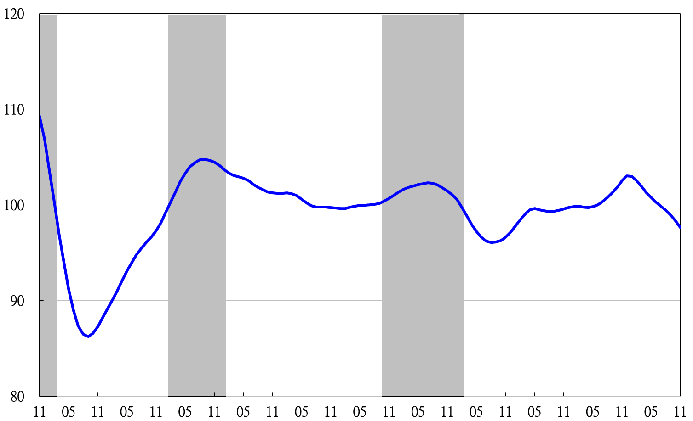
2008 2009 2010 2011 2012 2013 2014 2015 2016 2017 2018 2019
Figure 5 Trend-adjusted Lagging Index

