Guidelines for the Use of the Brand
Startup Island TAIWAN
January 2, 2020
Please read these guidelines carefully before downloading and using the logo of Startup Island TAIWAN.
- The Taiwan national startup brand Startup Island TAIWAN aims to showcase the dynamism of Taiwan’s startups to the world, and help Taiwan's startups expand into global markets. Both the public and private sectors are welcome to use the brand for their startup events and activities including international exhibitions and conferences, business visits or matchmaking, promotion and marketing, and reception of international guests. Nevertheless, the brand does not endorse or guarantee the quality and/or legality of any product, service, company, organization, channel, or specific subject.
- Companies, organizations, institutions, individuals believing in the spirit of Startup Island TAIWAN shall respect the brand ownership and intellectual property right of National Development Council, and follow the terms and conditions listed below when using the brand:
- The brand’s logo shall only appear in the following three standard combinations. Please feel free to use any of the combinations as is when needed.
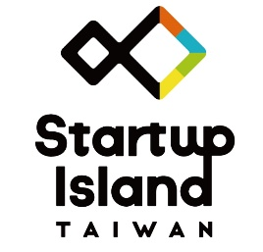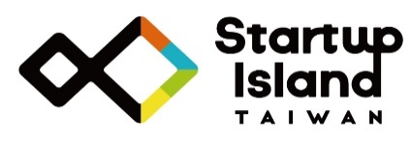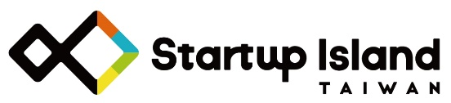

- Please consult and comply with the Startup Island TAIWAN VIS Guidebook when duplicating, resizing, changing colors, or placing the brand’s logo, so that the brand is always in consistency when displayed in different locations or under any circumstances.
- Use of the brand may not violate good morals, damage Taiwan’s reputation for innovation and entrepreneurship, damage the reputation or rights of any government agencies, or harm Taiwan's overall image.

