Taiwan Business Indicators in January 2023
Press Release
National Development Council (NDC)
March 1, 2023
In January 2023, the overall monitoring indicator continued to flash the “blue” signal, the total score decreased 1 point to 11. The trend-adjusted leading index increased for three consecutive months and the coincident index decreased for twelve consecutive months, the government will be closely monitoring the economic situation.
The Monitoring Indicators
- The total score in January 2023 was 11, flashing the “blue” signal, same as the last month.
Leading Indicators
- The trend-adjusted leading index increased by 0.85% in January 2023 to 99.24, rising for three consecutive months.
Coincident Indicators
- The trend-adjusted coincident index decreased by 2.57% in January 2023 to 89.82, falling for twelve consecutive months.
Lagging Indicators
- The trend-adjusted lagging index decreased by 0.17% in January 2023 to 102.48, falling for five consecutive months.

T~~ Next publication date: March 27 2023 ~~
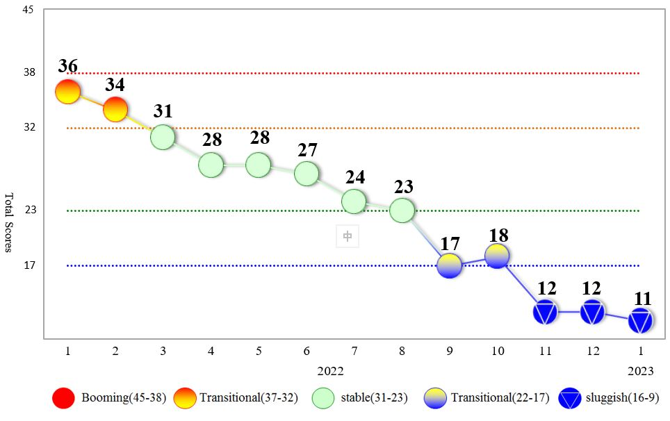
Figure 1 Total Scores in the Past Year
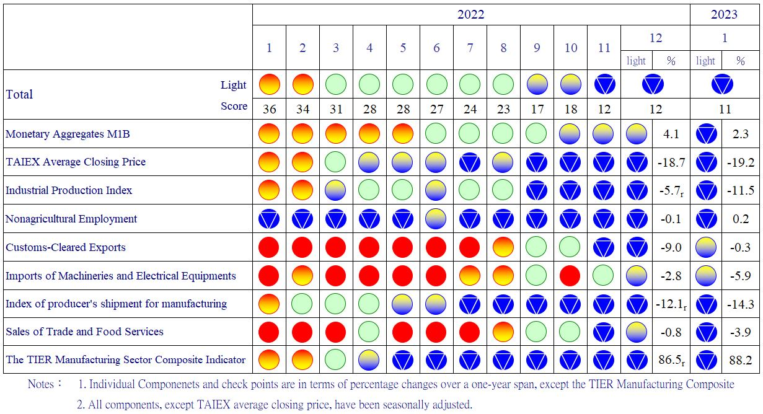
Figure 2 Monitoring Indicators
Table 1 Leading Indicators
Index
 | 2022 |  |  |  |  |  |  | 2023
 | Jul | Aug | Sep | Oct | Nov |  | Dec | Jan
Trend adjusted index | 98.74 | 98.08 | 97.66 | 97.54 |  | 97.81 | 98.41 | 99.24
Change from preceding month (%) | -0.93 | -0.67 | -0.43 | -0.11 |  | 0.27 | 0.61 | 0.85
Components¹
Diffusion Index of export orders² | 98.16 | 97.79 | 97.66 | 97.87 |  | 98.50 | 99.56 | 100.99
Real monetary aggregates M1B | 99.70 | 99.51 | 99.31 | 99.10 |  | 98.86 | 98.59 | 98.31
TAIEX average closing price | 99.46 | 99.17 | 98.93 | 98.77 |  | 98.69 | 98.67 | 98.67
Net accession rate of employees on payrolls of industry and services ³ | 99.87 | 99.89 | 99.90 | 99.91 |  | 99.95 | 100.00 | 100.04
New housing construction started ⁴ | 100.12 | 99.95 | 99.81 | 99.70 |  | 99.63 | 99.61 | 99.63
Real imports of semiconductor equipment | 99.90 | 100.03 | 100.14 | 100.23 |  | 100.30 | 100.35 | 100.36
The TIER manufacturing sector composite indicator | 98.74 | 98.47 | 98.33 | 98.32 |  | 98.42 | 98.60 | 98.81
Note：1. All components are passed through seasonal adjustment, trend-removal, smoothing and normalization.
2. Diffusion Index of export orders by number of firms.
3. Net accession rate is equal to accession rate minus separation rate.
4. Including only housing, mercantile, business and service, industry warehousing.
2012.1(T) 2014.10(P) 2016.2(T)
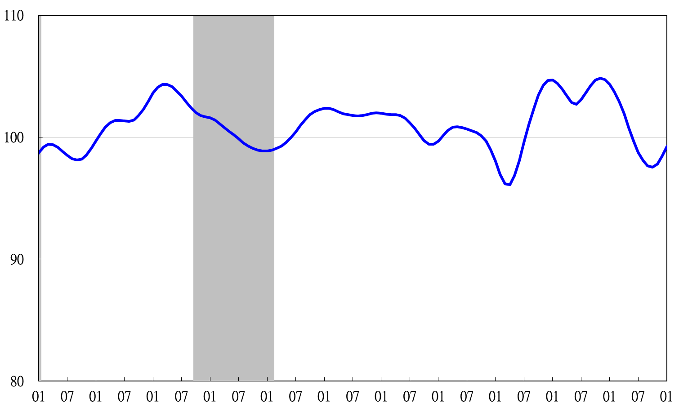

2012 2013 2014 2015 2016 2017 2018 2019 2020 2021 2022 2023
Figure 3 Trend-adjusted Leading Index
Note: Shaded areas represent recessions.
Table 2 Coincident Indicators
Index
 | 2022 |  |  |  |  |  | 2023
 | Jul | Aug | Sep | Oct | Nov | Dec | Jan
Trend adjusted index | 101.60 | 100.17 | 98.49 | 96.60 | 94.46 | 92.19 | 89.82
Change from preceding month (%) | -1.13 | -1.41 | -1.67 | -1.92 | -2.22 | -2.41 | -2.57
Components
Industrial production index | 100.15 | 99.66 | 99.09 | 98.49 | 97.84 | 97.16 | 96.44
Electric power consumption | 101.30 | 100.92 | 100.26 | 99.29 | 97.98 | 96.39 | 94.58
Index of producer’s shipment for manufacturing | 100.03 | 99.42 | 98.74 | 98.00 | 97.24 | 96.46 | 95.68
Sales of trade and food services | 100.78 | 100.29 | 99.77 | 99.20 | 98.54 | 97.87 | 97.18
Nonagricultural employment | 99.51 | 99.58 | 99.72 | 99.91 | 100.17 | 100.47 | 100.80
Real customs-cleared exports | 100.25 | 99.67 | 99.03 | 98.36 | 97.67 | 97.04 | 96.46
Real machineries and electrical equipments imports | 100.35 | 99.92 | 99.44 | 98.93 | 98.38 | 97.81 | 97.24

2012.1(T) 2014.10(P) 2016.2(T)
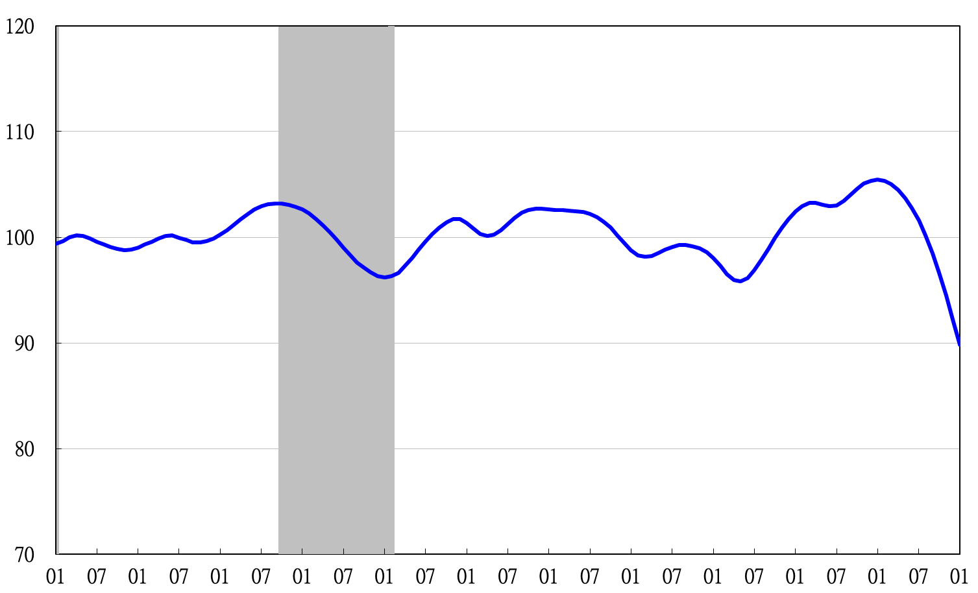
2012 2013 2014 2015 2016 2017 2018 2019 2020 2021 2022 2023
Figure 4 Trend-adjusted Coincident Index

Table 3 Lagging Indicators
Index
 | 2022 |  |  |  |  |  | 2023
 | Jul | Aug | Sep | Oct | Nov | Dec | Jan
Trend adjusted index | 102.95 | 103.04 | 102.98 | 102.87 | 102.77 | 102.65 | 102.48
Change from preceding month (%) | 0.28 | 0.09 | -0.06 | -0.11 | -0.09 | -0.12 | -0.17
Components
Unemployment rate | 100.41 | 100.42 | 100.43 | 100.45 | 100.47 | 100.49 | 100.50
The manufacturing unit output labor cost index | 101.02 | 101.40 | 101.70 | 101.97 | 102.25 | 102.49 | 102.70
Interbank overnight call-loan rate | 100.07 | 100.15 | 100.23 | 100.32 | 100.41 | 100.51 | 100.61
Loans and investments of financial institutions | 99.58 | 99.24 | 98.95 | 98.73 | 98.59 | 98.50 | 98.44
Inventory value for manufacturing | 101.98 | 101.94 | 101.77 | 101.50 | 101.15 | 100.75 | 100.32

2012 2013 2014 2015 2016 2017 2018 2019 2020 2021 2022 2023
2012.1(T) 2014.10(P) 2016.2(T)

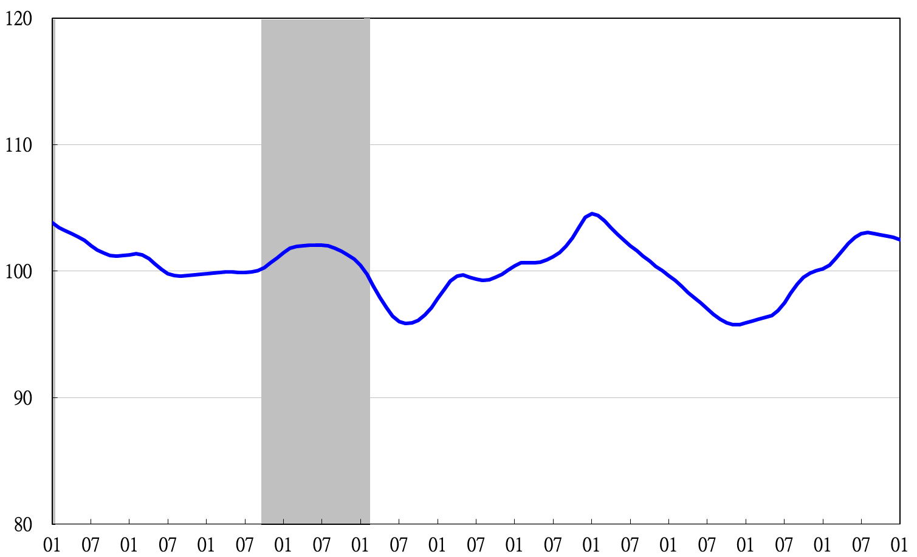
Figure 5 Trend-adjusted Lagging Index

