Taiwan Business Indicators in April 2020
Press Release
National Development Council (NDC)
May 27, 2020
In April 2020, the overall monitoring indicator continued to flash the “yellow-blue” signal, as the total score decreased one point to 19. The trend-adjusted leading index decreased for six consecutive months and the coincident index decreased for five consecutive months, the government will be closely monitoring the economic situation.
The Monitoring Indicators
- The total score in April 2020 was 19, flashing the “yellow-blue” signal, which decreased 1 point from 20 last month.
Leading Indicators
- The trend-adjusted leading index decreased by 1.94% in April 2020 to 96.07, falling for six consecutive months.
Coincident Indicators
- The trend-adjusted coincident index decreased by 0.87% in April 2020 to 98.62, falling for five consecutive months.
Lagging Indicators
- The trend-adjusted lagging index decreased by 0.61% in April 2020 to 97.29, falling for fifteen consecutive months.
T~~ Next publication date: June 29 2020 ~~
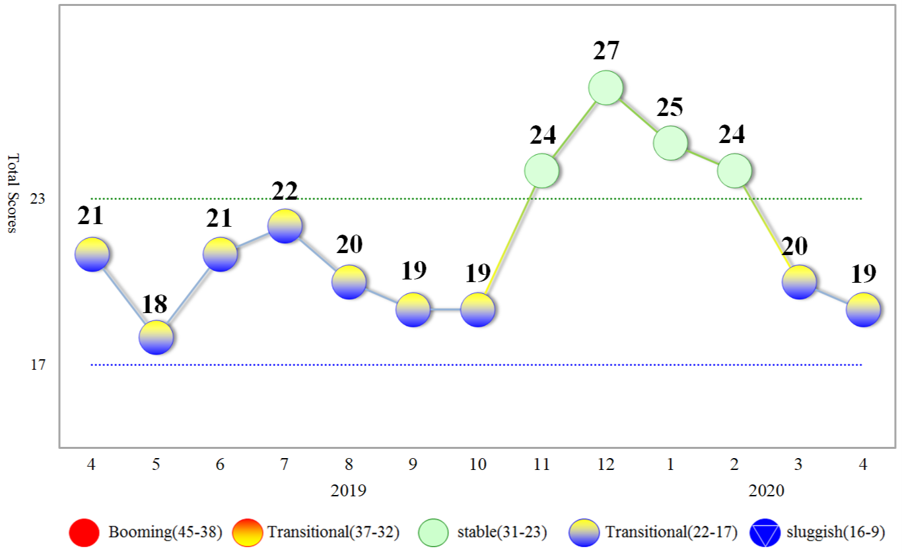
Figure 1 Total Scores in the Past Year

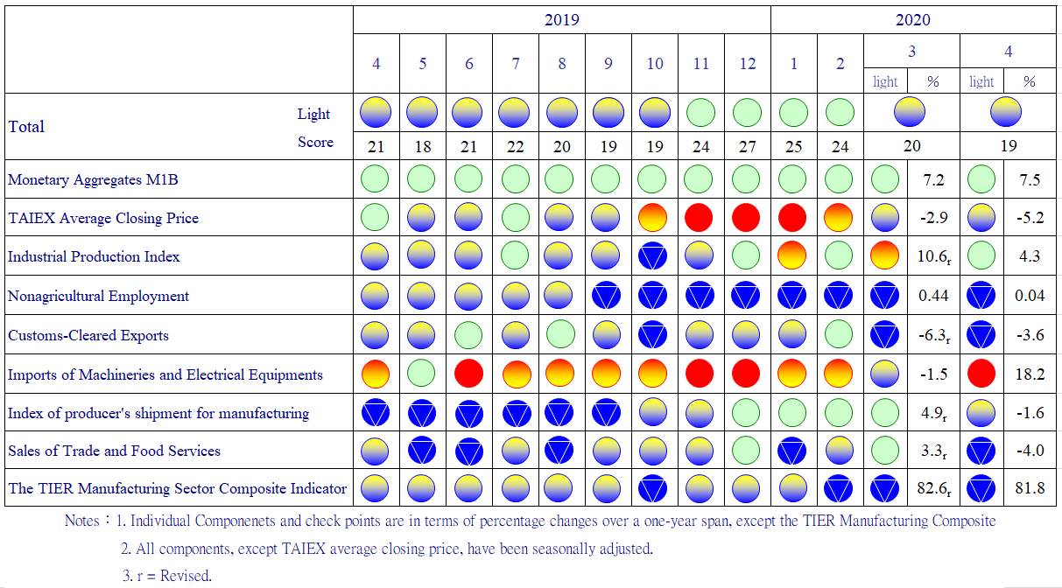
Figure 2 Monitoring Indicators

Table 1 Leading Indicators
Index
 | 2019 |  |  | 2020
 | Oct | Nov | Dec | Jan | Feb |  | Mar |  | Apr
Trend adjusted index | 103.21 | 103.00 | 102.38 | 101.33 |  | 99.84 |  | 97.97 | 96.07
Change from preceding month (%) | 0.05 | -0.20 | -0.60 | -1.03 |  | -1.47 |  | -1.87 | -1.94
Components¹
Diffusion Index of export orders² | 101.32 | 100.73 | 99.76 | 98.58 |  | 97.16 |  | 95.50 | 93.85
Real monetary aggregates M1B | 100.02 | 100.04 | 100.09 | 100.18 |  | 100.32 |  | 100.51 | 100.71
TAIEX average closing price | 100.22 | 100.29 | 100.30 | 100.21 |  | 100.02 |  | 99.76 | 99.49
Net accession rate of employees on payrolls of industry and services ³ | 100.38 | 100.26 | 100.06 | 99.78 |  | 99.44 |  | 98.98 | 98.52
New housing construction started ⁴ | 100.04 | 100.08 | 100.12 | 100.10 |  | 100.03 |  | 99.94 | 99.86
Real imports of semiconductor equipment | 100.72 | 101.02 | 101.20 | 101.16 |  | 100.91 |  | 100.48 | 99.99
The TIER manufacturing sector composite indicator | 100.64 | 100.55 | 100.35 | 99.99 |  | 99.48 |  | 98.87 | 98.26
Note：1. All components are passed through seasonal adjustment, trend-removal, smoothing and normalization.
2. Diffusion Index of export orders by number of firms.
3. Net accession rate is equal to accession rate minus separation rate.
4. Including only housing, mercantile, business and service, industry warehousing.

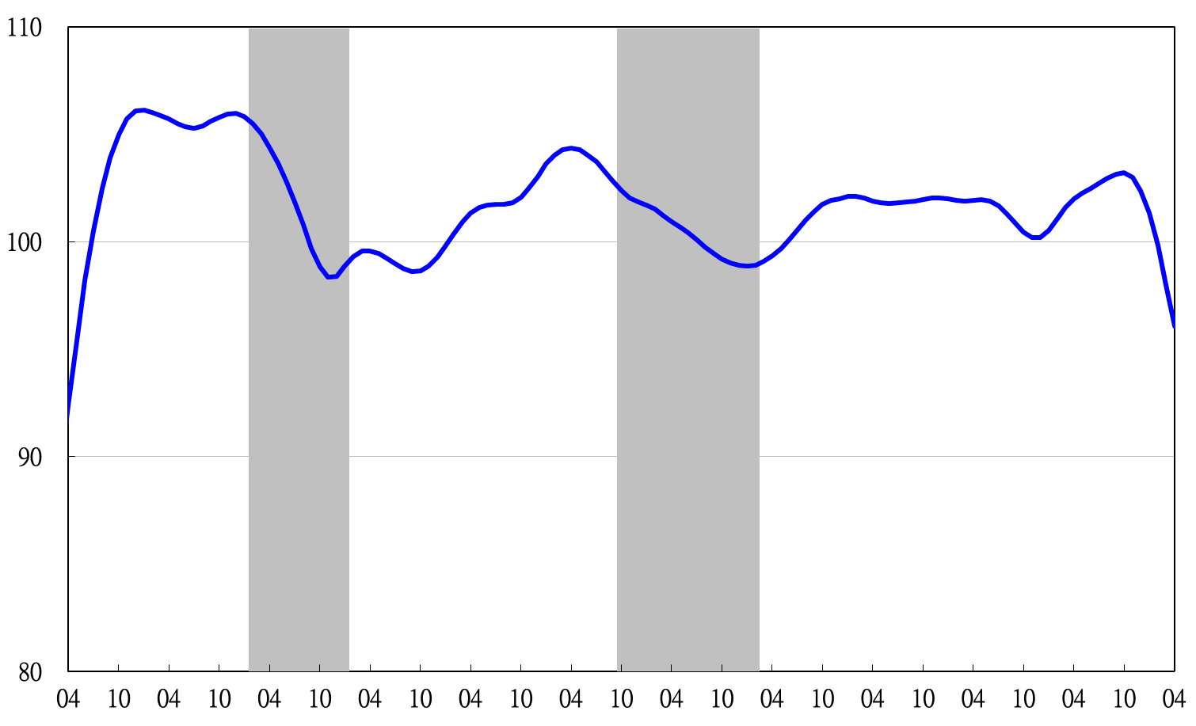
2011.2(P) 2012.1(T) 2014.10(P) 2016.2(T)
2009 2010 2011 2012 2013 2014 2015 2016 2017 2018 2019 2020
Figure 3 Trend-adjusted Leading Index
Note: Shaded areas represent recessions.
Table 2 Coincident Indicators
Index
 | 2019 |  |  | 2020
 | Oct | Nov | Dec | Jan | Feb | Mar | Apr
Trend adjusted index | 100.83 | 100.98 | 100.97 | 100.73 | 100.23 | 99.49 | 98.62
Change from preceding month (%) | 0.22 | 0.15 | -0.01 | -0.24 | -0.49 | -0.74 | -0.87
Components
Industrial production index | 100.13 | 100.30 | 100.41 | 100.44 | 100.35 | 100.22 | 100.07
Electric power consumption | 99.36 | 99.60 | 99.85 | 100.09 | 100.16 | 99.98 | 99.68
Index of producer’s shipment for manufacturing | 100.21 | 100.25 | 100.24 | 100.15 | 99.98 | 99.74 | 99.45
Sales of trade and food services | 100.07 | 99.95 | 99.78 | 99.57 | 99.35 | 99.02 | 98.61
Nonagricultural employment | 100.10 | 100.03 | 99.94 | 99.81 | 99.63 | 99.38 | 99.10
Real customs-cleared exports | 100.37 | 100.28 | 100.12 | 99.90 | 99.68 | 99.46 | 99.23
Real machineries and electrical equipments imports | 100.52 | 100.69 | 100.72 | 100.58 | 100.34 | 100.12 | 99.93

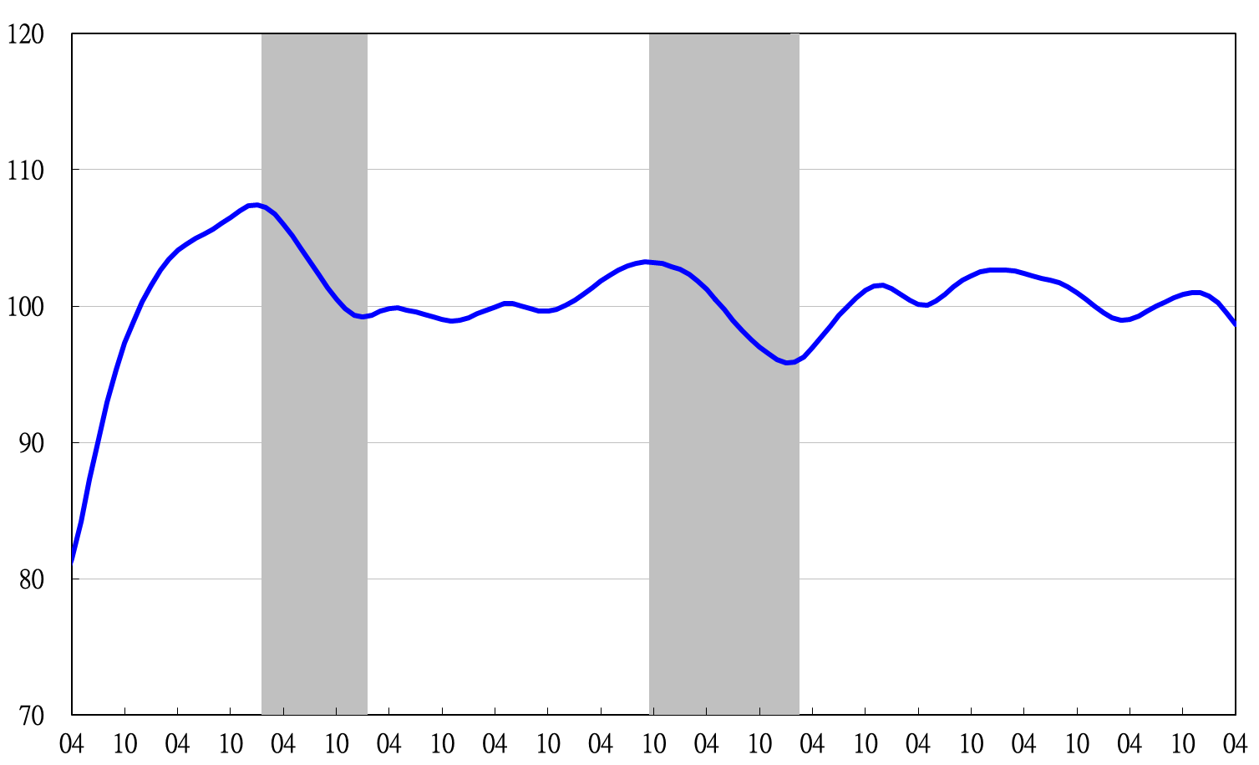
2011.2(P) 2012.1(T) 2014.10(P) 2016.2(T)
2009 2010 2011 2012 2013 2014 2015 2016 2017 2018 2019 2020
Figure 4 Trend-adjusted Coincident Index

Table 3 Lagging Indicators
Index
 | 2019 |  |  |  | 2020
 | Oct |  | Nov | Dec | Jan | Feb | Mar |  | Apr
Trend adjusted index | 99.73 |  | 99.48 | 99.21 | 98.82 | 98.40 | 97.88 | 97.29
Change from preceding month (%) | -0.26 |  | -0.25 | -0.27 | -0.40 | -0.42 | -0.53 | -0.61
Components
Unemployment rate | 100.13 |  | 100.13 | 100.09 | 99.97 | 99.76 | 99.45 | 99.07
The manufacturing unit output labor cost index | 99.54 |  | 99.36 | 99.18 | 98.96 | 98.87 | 98.83 | 98.80
Interbank overnight call-loan rate | 100.05 |  | 100.04 | 100.03 | 100.01 | 99.98 | 99.94 | 99.89
Loans and investments of financial institutions | 100.16 |  | 100.32 | 100.49 | 100.66 | 100.80 | 100.89 | 100.98
Inventory value for manufacturing | 99.82 | 99.60 |  | 99.38 | 99.15 | 98.91 | 98.66 | 98.41

2011.2(P) 2012.1(T) 2014.10(P) 2016.2(T)

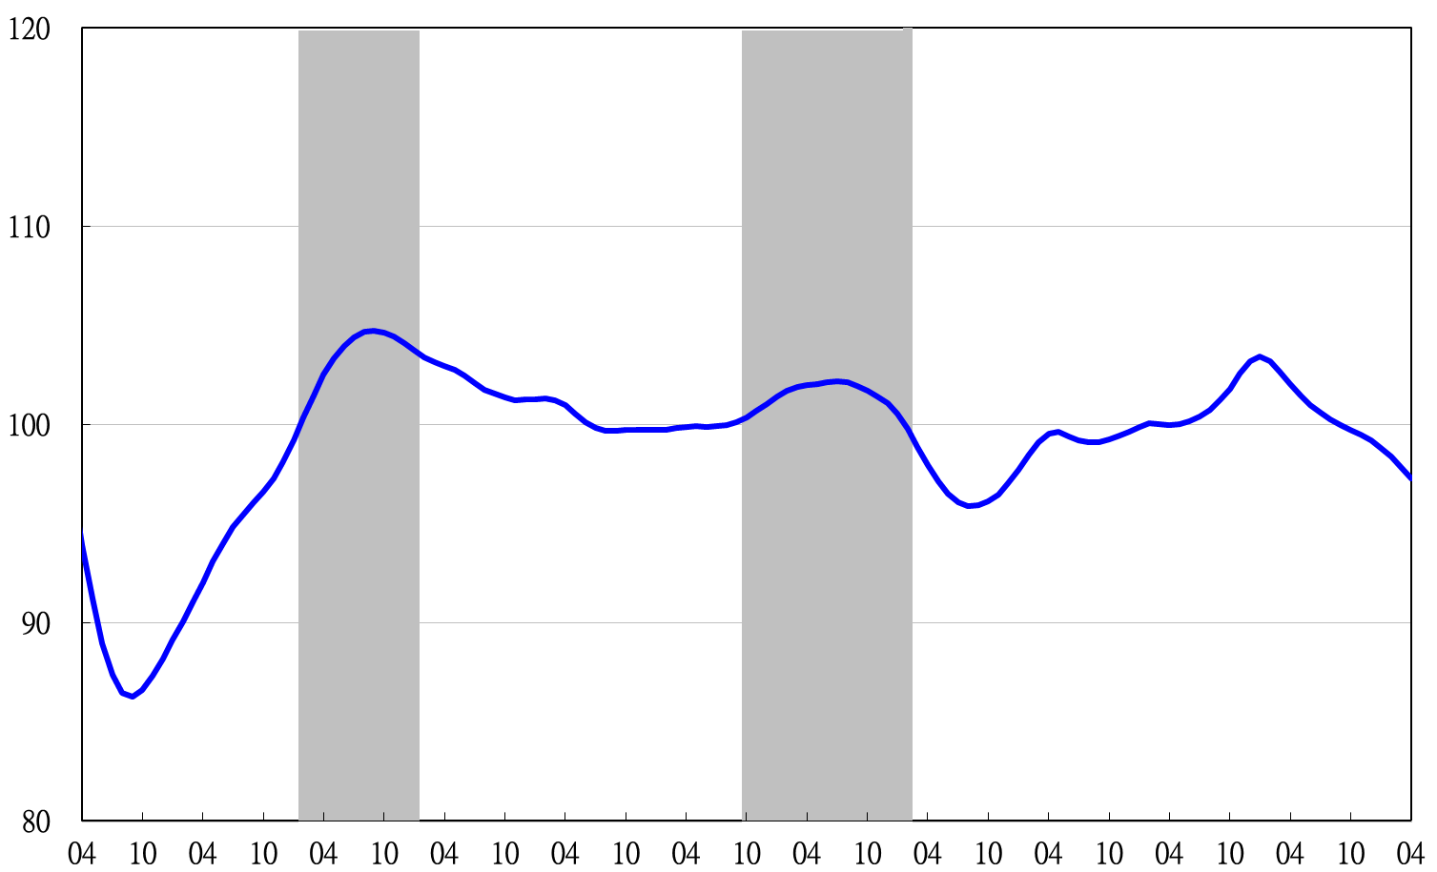
2009 2010 2011 2012 2013 2014 2015 2016 2017 2018 2019 2020
Figure 5 Trend-adjusted Lagging Index

