
National Development Council Press Release

2nd Anniversary Event of the Act for the Recruitment and Employment of Foreign Professionals – NDC launches updated Employment Gold Card

Date of release: February 8, 2020
Released by: Department of Human Resources Development
The Act for the Recruitment and Employment of Foreign Professionals (“Foreign Professionals Act”) has come into effect on February 8, 2018. It has been 2 years since then. Among Foreign Professionals Act, the issuance of Employment Gold Card has achieved remarkable results. Employment Gold Card provides an open personal work permit for foreign special professionals. Card holders do not need a specific employer. These measures are more friendly for foreign special professionals to freely seek and take up employment in Taiwan.

In order to increase identification and anti-counterfeiting function of Employment Gold Card, the new version of Employment Gold Card are officially revised and issued today. The latest version of Employment Gold Card follows the original card design, and its color has been revised to rose-gold. In addition, English characters have been added to the professional field to strengthen its identification (Image 1).

To express the government's great attention to Employment Gold Card holders, National Development Council (NDC) Minister Mei-ling Chen personally welcomed and issued the new version of Employment Gold Card to Mr. Frank Hojerslev, Australian, CEO of Formosa Solar Renewable Power Company, and Mr. Johannes Wolfgang Mueller, German (Image 2-4).

584 Employment Gold Cards have been issued up to January 30, 2020. The breakdown by field of expertise of recipients is as follows: the highest proportion, 318 cards constituting 55% of the total, have been issued to specialists in the economic field; next is 106 cards (18%) in the science & technology field, followed by 65 (11%) in the cultural field, 49 (8%) in the financial field, and 41 (7%) in the educational field (see Figure 5). In terms of nationality, Americans come top, with 134 approvals, constituting 23% of the total, followed by Hong Kong residents with 90 (15%), UK nationals with 44 (8%), Malaysians with 37 (6%), Danes with 32 (6%), and Singaporeans with 26 (4%) (see Figure 6).

Contact person: Gyh-mei Lin, Director-General of the Department of Human Resources
Liaison: (02) 2316-5379
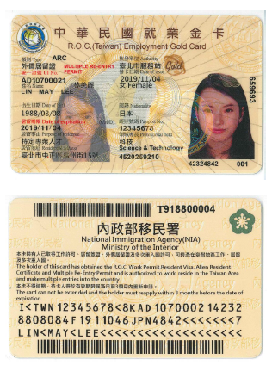


Image 1: The New Version of the Employment Gold Card
Image 2: NDC Minister Mei-ling Chen welcomed card holders
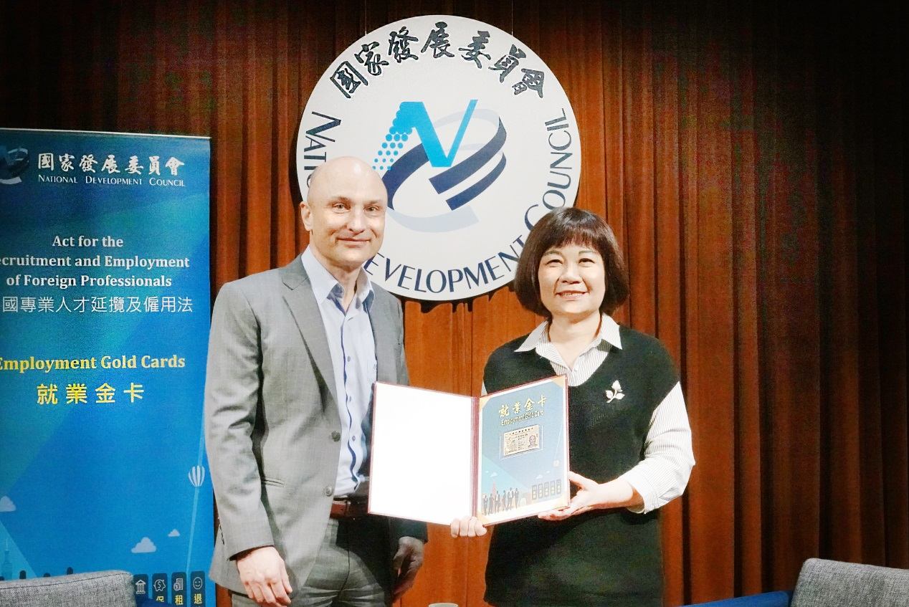
Image 3: NDC Minister Mei-ling Chen issued the card to Mr. Frank Hojerslev
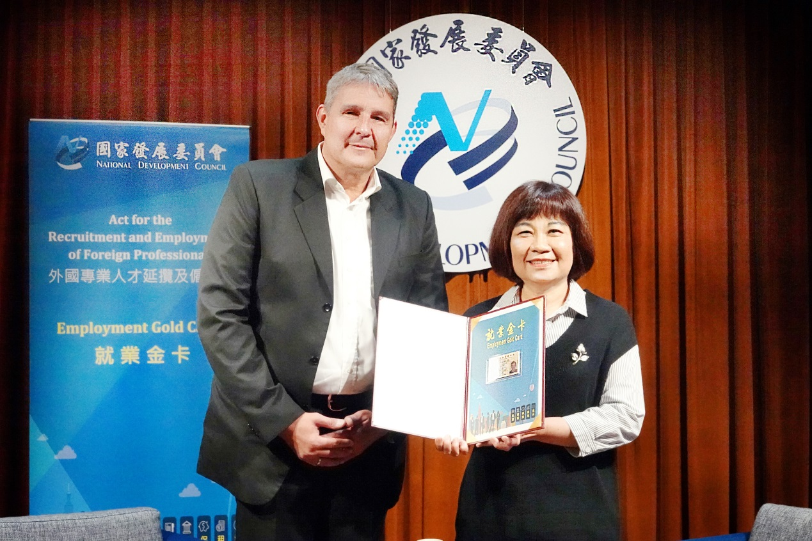
Image 4: NDC Minister Mei-ling Chen issued the card to Mr. Johannes Wolfgang Mueller

Units: No. of cards (people) %

Figure 5: Employment Gold Card holders by field of expertise
Source: Compiled from data of NIA and NDC
Units: No. of cards (people) %
Figure 6: Employment Gold Card holders by nationality
Source: compiled from data of NIA and NDC

