
ifo World Economic Climate in the 2nd Quarter 2019
Press Release
National Development Council (NDC)
May 8, 2019
According to latest quarterly World Economic survey released today, ifo World Economic Climate indicator rose from -13.1 to -2.4 points in the second quarter 2019, having previously fallen four times in a row. Expectations for the coming months have brightened considerably, the assessment of the current situation has deteriorated only slightly. The ifo said, the global economy should gradually strengthen again over the course of the year.
In Taiwan, the experts’ assessment of current economic situation has deteriorated further. In contrast, the expectations for the coming months have improved significantly, which implied that the economy expansion should gradually strengthen in the second half of the year.
ifo World Economic Climate
 | 2017Q2 | 2017Q3 | 2017Q4 | 2018Q1 | 2018Q2 | 2018Q3 | 2018Q4 | 2019Q1 | 2019Q2
Climate | 13.5 | 13.2 | 17.1 | 26.0 | 16.5 | 2.9 | -2.2 | -13.1 | -2.4
Situation | 5.1 | 12.5 | 17.2 | 28.3 | 27.4 | 17.5 | 12.2 | 2.6 | 1.4
Expectations | 22.2 | 14.0 | 16.9 | 23.9 | 6.1 | -10.6 | -15.7 | -27.7 | -6.1
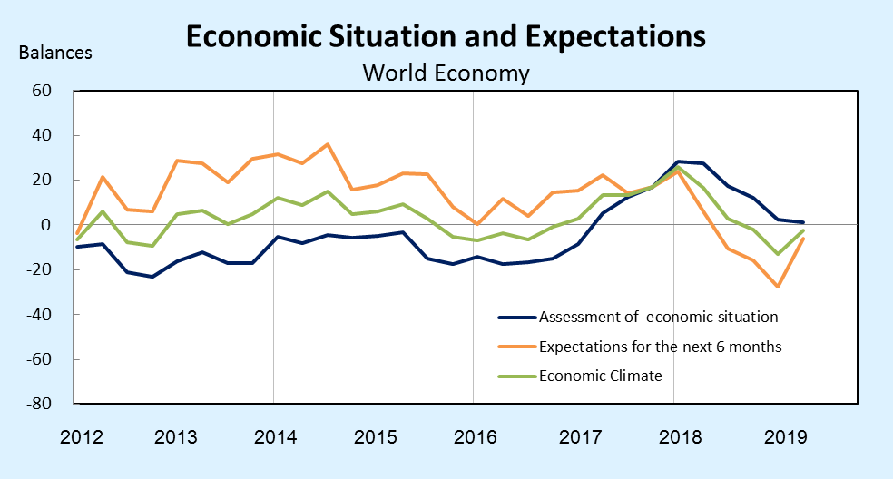
Source: ifo World Economic Survey (WES) II/2019.

Results of the WES for Taiwan
(Present judgement)
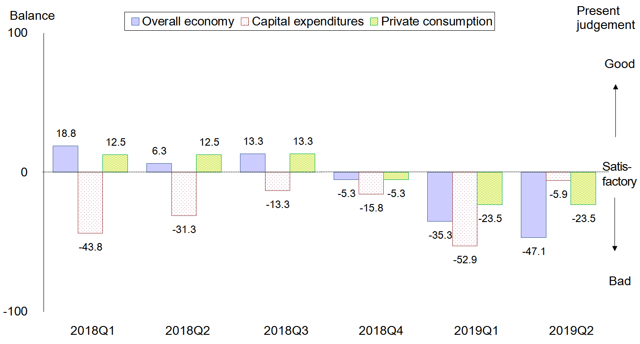
notes: The WES is a qualitative survey. The respondents only need to answer the questions of "good", "satisfactory" and "bad" for the questions. The balance is the difference share between positive assessment responses and negative assessment responses.
Source: ifo World Economic Survey (WES) II/2019.The April 2019 survey received responses from 17 experts in Taiwan.

Results of the WES for Taiwan
(Expectations for the 6 months)
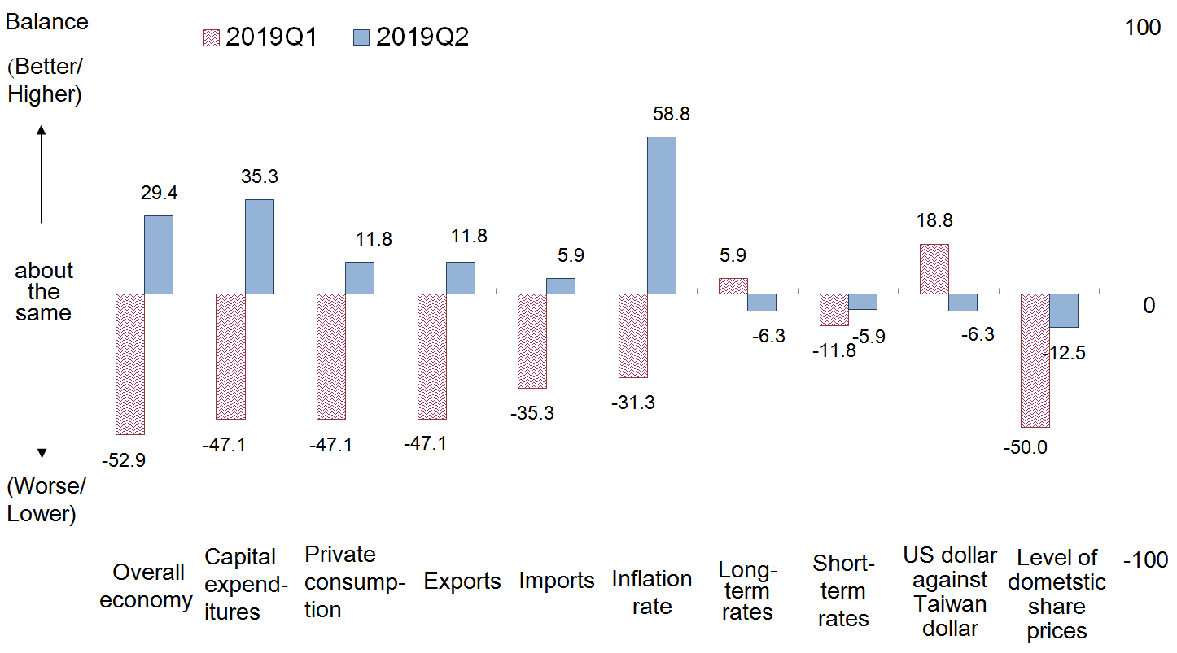
notes: The WES is a qualitative survey. The respondents only need to answer the questions of "better/higher", "about the same" and "worse/lower" for the questions. The balance is the difference share between positive assessment responses and negative assessment responses.
Source: ifo World Economic Survey (WES) II/2019. The April 2019 survey received responses from 17 experts in Taiwan.

For more information, please visit https://www.cesifo-group.de/ifoHome.html

